PURPOSE:

To provide instructions for processing images in the Spelling Errors Queue in OnBase.

OBJECTIVE:

- To provide the necessary direction to ensure error slips are prepared and routed to the appropriate supervisor.

EVENT DRIVER:

- Images are routed to the OnBase Spelling Errors Queue by the EDM QC Auditors when a spelling error is detected in the case caption.

PROCEDURES:

- Locate the Spelling/Case # Errors Queue in the OnBase workflow: COSC Adult Courts Indexing Life Cycle (See Figure 1).

Figure 1, Spelling/Case # Errors Queue
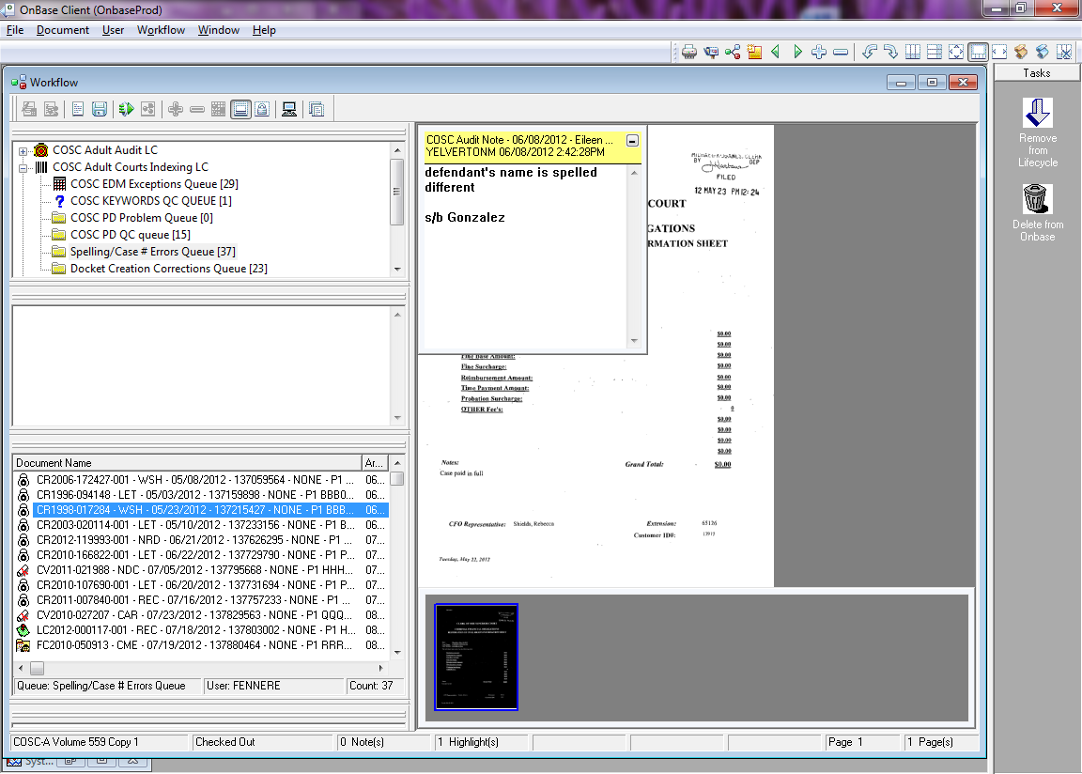

- Enter the queue and organize the images to be processed:
- Filter the queues by the docket code being worked on.
- Right click in the Document Name area of the screen.
- Select Filter Inbox. Filter by any or all keywords.
- Enter the Docket Code to be reviewed (See Figure 2).

Figure 2, Docket code search
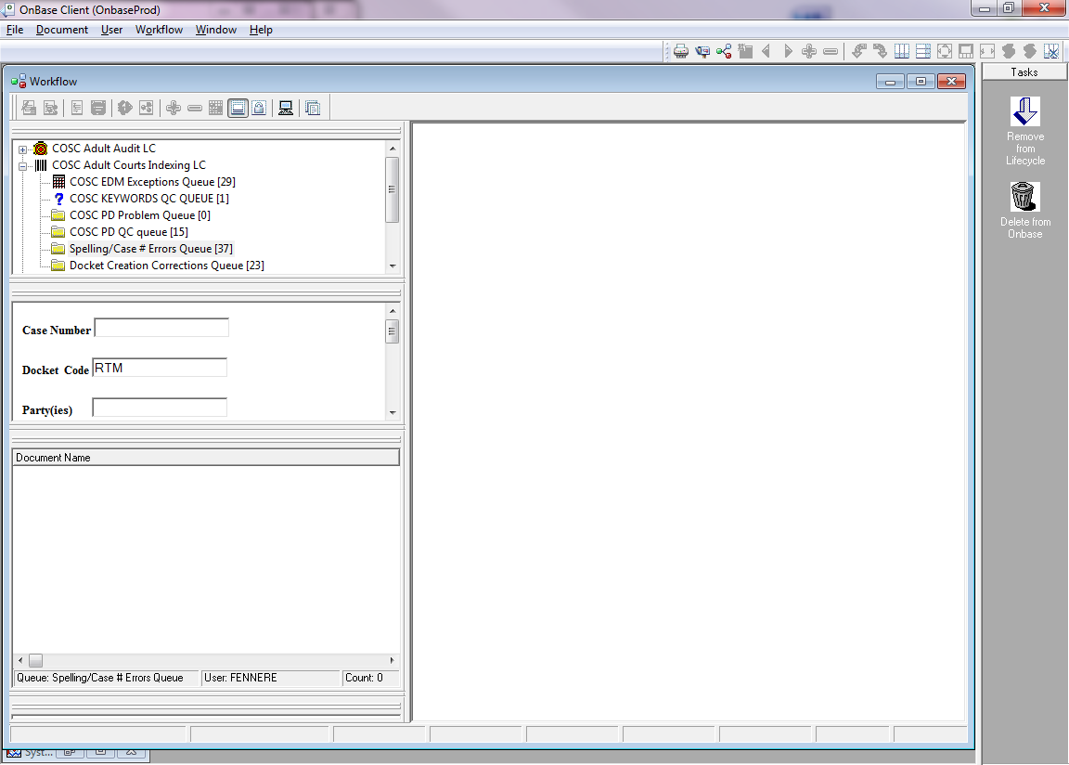

- After reviewing the RTM documents, search for the other docket codes listed below in Steps 5 through 13, until all the documents in the queue have been processed.
- Ensure that the document is truly an error for the person who prepared it by checking iCIS and previous images in the case. Errors should not be given if the caption spellings were incorrect in iCIS or on earlier documents used as a reference to create the document in question.

- Returned/Remailed Mail (RTM) & Criminal Affidavit of Service/Attempted Service (AFS/AAS):
- Print page one only.
- Use a yellow highlighter to mark the incorrect spelling on the printed document; then use a red pen to print the correct spelling under the misspelled name.
- On Criminal AFS/AAS (Affidavit of Service/Attempted Service), check the spelling on the green card (certified mail card) as well as the caption on the AFS/AAS. If the spelling is incorrect on the green card, then two errors occurred: One for the person who created the green card, the other for the person who created the returned mail form.
- At the end of the month when preparing to distribute the errors, sort the errors and group any with an ATLAS number that were filed by Family Support Department; route to the Manager of Family Court Services (See Figure 3):

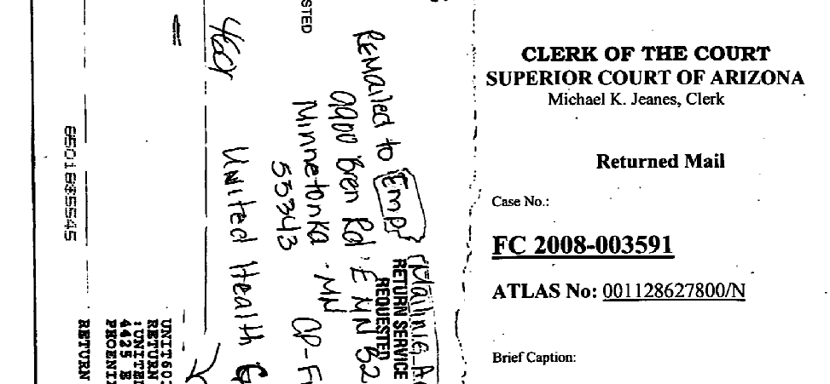
Figure 3, Returned Mail Containing ATLAS #

- Group the remaining error slips by the Prepared By initials at the bottom of the form. The initials indicate which person receives the error. If there are no initials on document, group by scanner letter and send to the appropriate Manager:
    - SE: Manager, Document Services
    - NE/NW: Manager, Court Operations
    - DT: Manager, Court Services
- Credit Memos (CAN, IVF, REC, CME):
- Print page one only.
- Use a yellow highlighter to mark the incorrect spelling on the printed document; then use a red pen to print the correct spelling under the misspelled name on the caption.
- Send to the appropriate Filing Counter Supervisor; use the Employee Listing to determine supervisor’s name.

- Civil Court Admin Notices (047, 311, etc.) (See Figure 4):

Figure 4, Civil Court Admin Notice
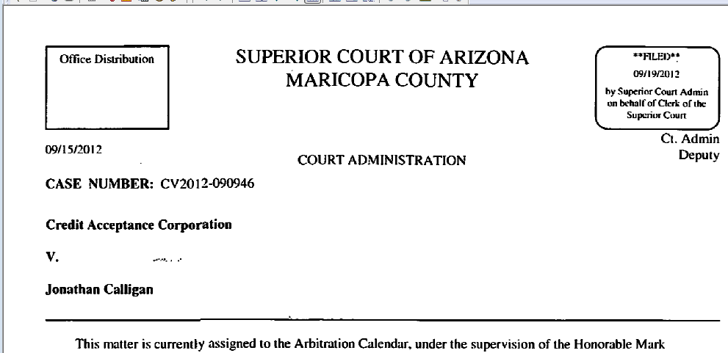

- Email the image to the Civil Court Administration Supervisor, explaining the error in the body of the email.
- Enter the case number on the subject line of the email.
- Sample message: The plaintiff’s name on the attached notice is spelled CHRITINE but on iCIS it is spelled CHRISTINE. This is provided for your information; we are not requesting a correction unless you deem it necessary.
- Disposition of Exhibits Worksheet (DEW) and 2.8(d) Letter (LED):
- Print page one only.
- Use a yellow highlighter to mark the incorrect spelling on the printed document; then use a red pen to print the correct spelling under the misspelled name on the caption.
- Send to the Supervisor of Exhibits.
- Documents Prepared by COC Appeals Department:
- E-mail the image to the Appeals Department Lead, explaining the error in the body of your email.
- Enter the case number on the subject line of the email.
- Sample message: The plaintiff’s name on the attached notice is spelled CHRITINE but on iCIS it is spelled CHRISTINE. This is provided for your information; we are not requesting a correction unless you deem it necessary.
- Restoration of Civil Rights Info Worksheet (WSH) (See Figure 5):

Figure 5, Restoration of Civil Rights Worksheet
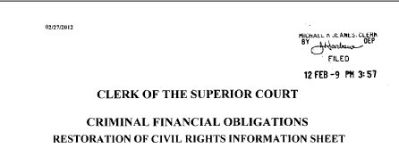

- Print page one only.
- Use a yellow highlighter to mark the incorrect spelling on the printed document; then use a red pen to print the correct spelling under the misspelled name on the caption.
- Send to the Supervisor of Criminal Operations.
- Interest – Civil Judgment Account (LET, but may be NOT or STA) (See Figure 6):

Figure 6, Interest – Civil Judgment Account
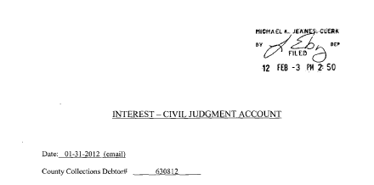

- Email image to County Collections, explaining the error in the body of your email.
- Enter the case number on the subject line of the email.
- Sample message: The defendant’s name on the attached document is spelled GERMAN but in iCIS it is spelled GERMAIN. This is provided for your information; we are not requesting a correction unless you deem it necessary.

- Notice of Deposit (or Release of Deposit) with the Court (NDR or NDC) (See Figure 7):

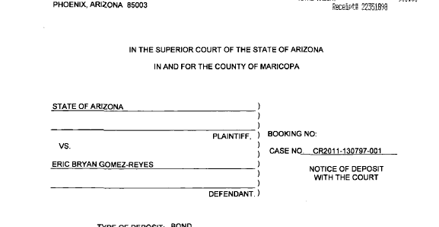
Figure 7, Notice of Deposit with the Court

- Email image to trustresponse@mail.maricopa.gov, explaining the error in the body of your email.
- Enter the case number on the subject line of the email.
- Sample message: The defendant’s name on the attached document is spelled ERIC but in iCIS it is spelled ERIK. This is provided for your information; we are not requesting a correction unless you deem it necessary.
- Documents Prepared by the Family Court Conference Center (CSR)(See Figure 8):

Figure 8, Case Status Report
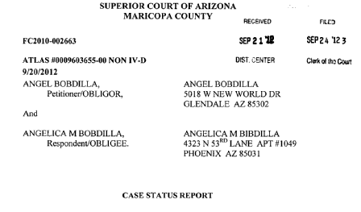

- Email the image to the Deputy Family Court Administrator.
- Enter the case number on the subject line of the email.
- Sample message: The defendant’s name on the attached document is spelled ERIC but in iCIS it is spelled ERIK. This is provided for your information; we are not requesting a correction unless you deem it necessary.
- Miscellaneous Documents not Listed Above: Consult with the EDM QC Manager.

POLICIES / RELATED DOCUMENTS:

- None

OTHER PARTIES INVOLVED:

- EDM QC Auditors
- COSC Adult Courts Supervisors
- Manager of COC Family Court Services
- SE: Manager, Document Services
- NE/NW: Manager, Court Operations
- DT: Manager, Court Services
- Filing Counter Supervisors
- Civil Court Administration Supervisor
- Supervisor of Exhibits
- COC Appeals Department, Appeals Department Lead
- Supervisor of Criminal Operations
- Supervisor of County Collections
- Manager of Accounting Operations
- Family Court Conference Center Supervisor
- Deputy Family Court Administrator
- EDM QC Manager

TIME / VOLUME:

- Approximately 50-75 images are routed to the queue monthly; may decrease as people receive error slips and respond by eliminating these errors.

FREQUENCY:

- Work the queue weekly; distribute errors monthly.

PERFORMANCE MEASURE:

- N/A

SYSTEM ACCESS REQUIRED:

- OnBase
- iCIS
- email

REPORTS / FORMS:

- N/A

DEFINITIONS:

- None

APPLICABILITY:

This procedure applies to all employees of the Clerk of the Court.

REVISION HISTORY:

Revision Number | Revision Author | Summary of Changes | Approval Date
- | N/A | Document Origination | 02/22/2013
A | Chris Cerrato | Revised to show a different notification under section 12. | 07/23/2014
B | Eileen Fenner | Reviewed | 03/01/2019
C

