PURPOSE:

To provide instructions for Electronically Correcting or Changing Images.

OBJECTIVE:

- To provide the necessary direction to ensure that Electronic Corrections and Image Changes are correctly and accurately done,
- To ensure that Electronic Corrections and Image Changes are consistently done over time.

EVENT DRIVER:

- As of 1/19/07, approval was given to correct documents electronically, for those documents that only exist electronically. Approval was later expanded to include electronic corrections and image changes on documents filed prior to 01/01/07.
- Electronic Corrections: The following items may be corrected electronically:
  - Case Numbers
    - Incorrect case numbers are identified during the docketing process or in the Stage 3 audits.
  - File Stamps
    - File stamps are corrected when they are illegible, incorrect, such as “future” file dates, or missing.
  - Docket Codes on Minute Entries
    - These are usually requested by a courtroom clerk or a courtroom services manager.
  - Court-Ordered Corrections
    - These court orders are usually minute entries which endorse EDM QC. Examples: Changes to the text of a plea agreement or other document.

PROCEDURES:
- Correcting Caption Discrepancies
- An electronic stamp has been created for use when processing a document with a mismatch between the case number and the caption (See Figure 1). Use the stamp if a document has an incorrect caption that could be misleading.
Figure 1
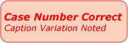

  - When it is certain that a document corresponds to a particular case, the electronic stamp (See Figure 1) is to be applied to the image to indicate that the case number is correct and that the document is attached to the correct case.
- Example: An attorney uses a template and forgets to change the defendant’s name. The document is completely correct except for defendant’s name; therefore, it looks like the document was meant to be filed on a different case.
- It is not necessary to use the stamp if a document has no caption or only part of a caption.
  - Place the stamp in the case caption area. Size the stamp so it is proportional to the caption.

- Correcting Case Numbers
- Line through the entire case number, including the letter prefix (e.g.: CR2006-101296-002 DT), not just the part being corrected (e.g. 001).
- Place a text box as close to the case number as possible.
- Enter the correct case number in the text box. Enter the entire number (e.g.: CR2006-101296-001 DT), not just the part being corrected (e.g. 001).
- Insert the correction stamp (See Figure 2) as close to the correction as possible. Size the stamp so it is proportional to the correction.
Figure 2
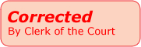

- Correcting File Stamps
- Line through the date or time to be corrected.
- Place a text box as close to the file stamp as possible.
- Enter the corrected information in the text box.
- Insert the correction stamp (See Figure 2) as close to the correction as possible. Size the stamp so that it is proportional to the correction.

- Adding File Stamps
- Place a text box at the upper right corner of the document.
- Copy the file stamp template (See Figure 3) and paste it in the text box.

Figure 3
Clerk of Court
FILED
Kim Dollins
04/23/2012 5:00 p.m.

- Enter the date and time. Enter 5:00 PM if the actual time is not known.

- Correcting Docket Codes - Docket codes on minute entries are corrected when requested by a courtroom clerk.
- On the first page of the minute entry, line through the docket code to be corrected.
- Place a text box as close to the docket code as possible.
- Enter the correct information in the text box in this manner (e.g.: 005).
- Insert the correction stamp (See Figure 2) as close to the correction as possible. Size the stamp so that it is proportional to the correction.
- Correct the docket code in the iCIS docket screen.
- Notify the courtroom clerk and their manager when the correction has been completed.

VI. Corrections Pursuant to Court Order
- Check the court’s order carefully to determine exactly what should be changed.
- Line through whatever text is being corrected.
- Place the correction as close to the original text as possible. (In documents where the correction must be made within a paragraph, use the call-out tool with an arrow to the content being corrected.)
- If it is too complicated to correct a document electronically, print the document from the image, correct the document manually, and rescan.
- Insert the correction stamp (See Figure 4) as close to the correction as possible. Size the stamp so that it is proportional to the correction.
Figure 4
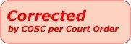

  - Exporting, Modifying, and Re-importing Documents - For TIFF and Adobe PDF images:
      - Open the document in OnBase.
      - Choose Print from the File option on the menu bar.
      - From the dialog box, select Adobe PDF from the Print Queue drop-down box (See Figure 5).

Figure 5
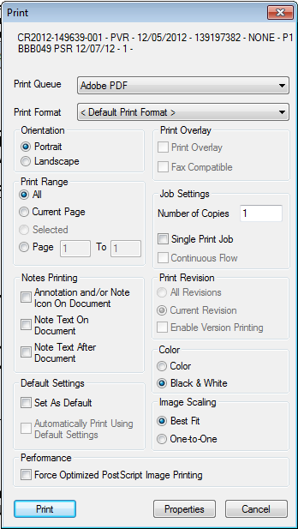

      - Click Print.

      - The Save PDF File As dialog box will be displayed (See Figure 6).
Figure 6
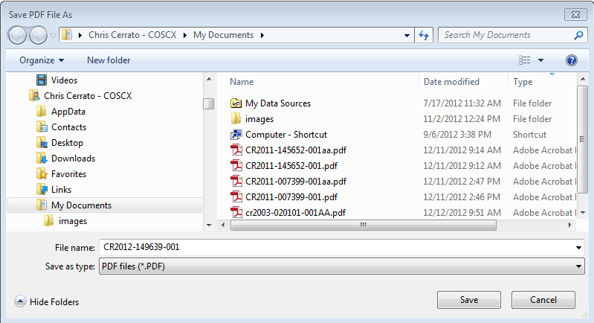
      - Select the location for the image to be saved and then name the document. Click Save.
      - The document will open as a PDF document. Right click on the menu bar and make sure that the Line and Text Box tools from the Drawing Markups section, and the Stamps tool from the Annotations section, are available under Quick Tools.
Figure 7
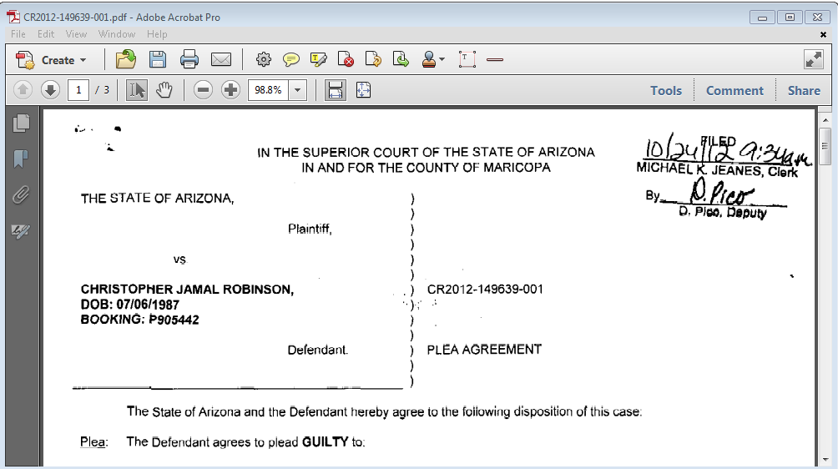

      - Select the Line tool (See Figure 7).

      - Draw a line through the incorrect content (wrong number, wrong file date, etc.).

NOTE: The line tool defaults to red. In order to change the default to black, right click on the line; a dialog box will appear. Click on Format Text Box and select black as the color of the line. Close the box and draw the line. Again right click on the line and choose Set AutoShape Defaults.

      - Click on the Text Box tool (See Figure 8).
Figure 8
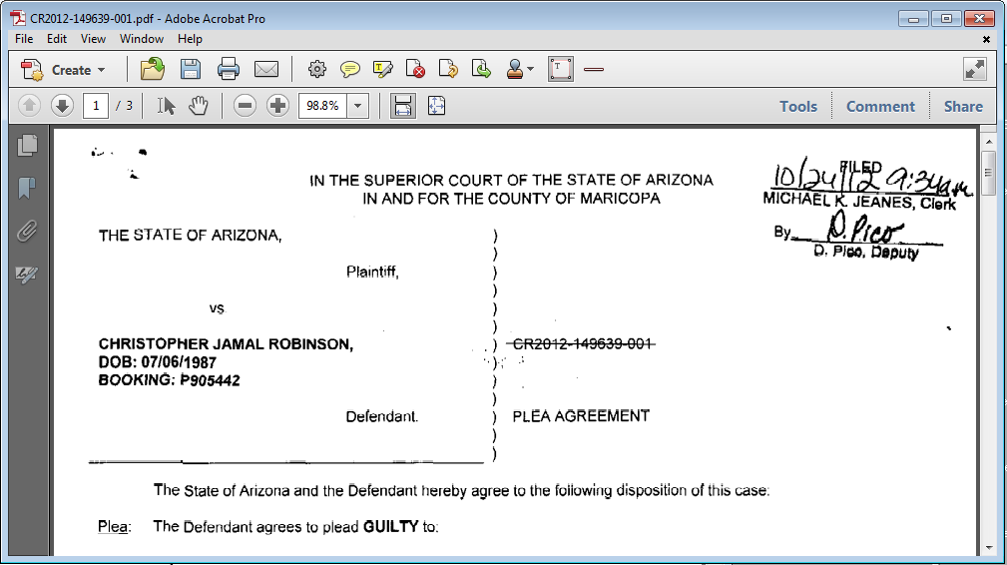

      - A text box will open. Resize it and enter the correct data.

NOTE: The text box defaults to yellow fill with a black border. Right click on the text box, click on Format Text Box and select No Color as the fill color and No Color as the border color. Click OK, then right click on the text box again and choose Set AutoShape Defaults.

      - Click on the Stamps tool (see Figure 9).
Figure 9
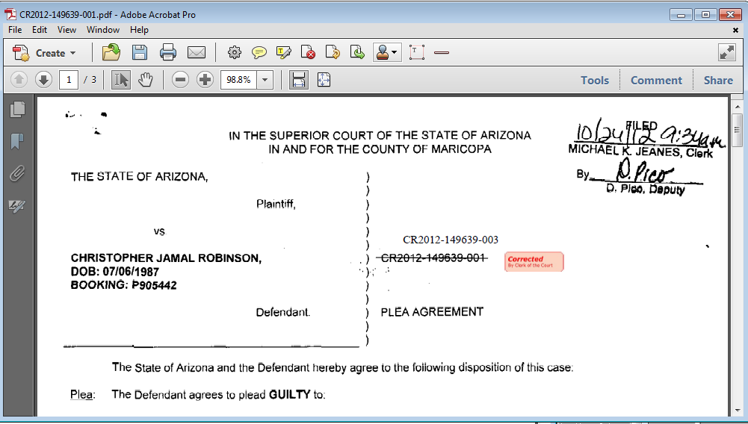
      - Select the appropriate stamp according to sections I – VI above. Size the stamp and place it as close to the correction as possible.
      - Click on File>Print. Print the document as a PDF with the Document and Markups option selected. (See Figure 10.)
Figure 10
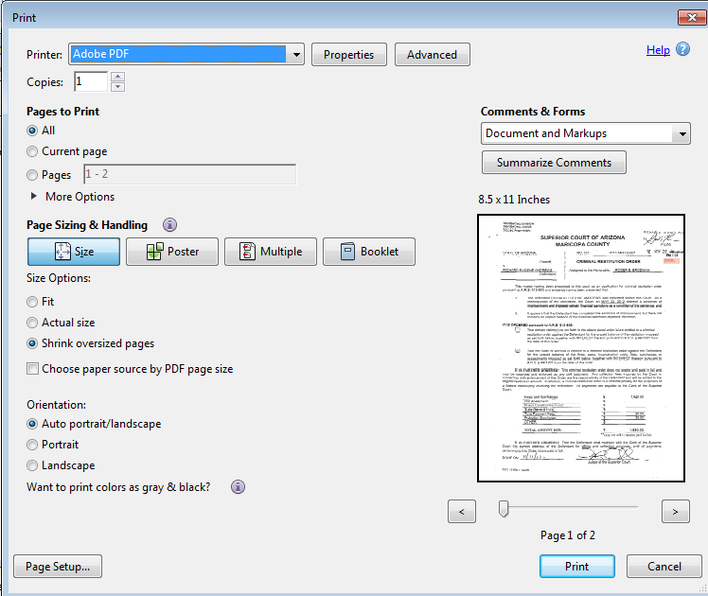

      - Save the document and assign it a different file name.

NOTE: The Document and Markups option has to be selected in order to save the correction that was made to the document.

      - If required, docket the image in iCIS.
      - Make sure OnBase Thick Client is open. Click the document but do not open it. Drag the document into a gray area in OnBase.
      - The Import Document dialog box will be displayed (see Figure 11).

Figure 11
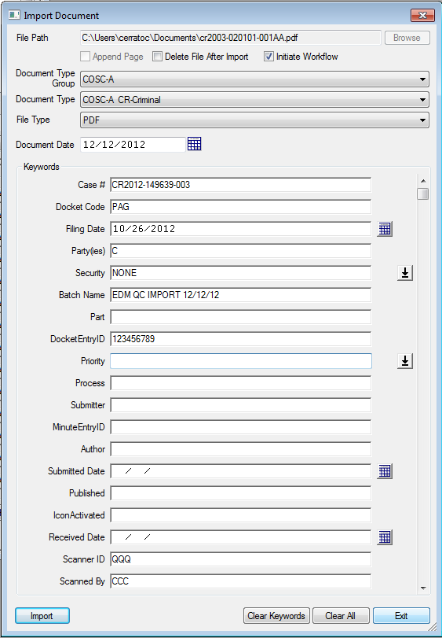

      - Select the Document Type Group in the Document Type Group field, and the Document Type in the Document Type field. This will open the keyword fields.
      - Fill in the keyword fields with the following information, taken from iCIS:
    - Case number
    - Docket code
    - Filing date
    - Parties
    - Security: enter NONE, unless original image had other security keyword.
    - Batch name:
        - For scanned documents, use EDM-QC IMPORT mm/dd/yy
        - For eFiled documents, use EFILING ID followed by the eFILE ID number.
    - Part: For eFiled documents only, use the Part keyword on the original image
    - Docket Entry ID: From the corresponding docket entry in iCIS.
    - Submitter: For eFiled documents only, enter EFILINGBROKER.
    - Scanner ID: QQQ
    - Scanned by: Your initials

NOTE: For specific and detailed instruction on eFiling corrections, see the EFiling Corrections work instruction.

      - Click on Import.
      - Delete the original document from OnBase.
      - To finish, test the link. Click on the icon in iCIS and retrieve the corrected document.

POLICIES / RELATED DOCUMENTS:

- PRO-EDMQC-1011: eFiling Corrections – Clerk Review
- PRO-EDMQC-1013: eFiling Corrections – eFile Audit QC Maibox
- PRO-EDMQC-1014: eFiling Corrections – Courtroom Clerk Review

OTHER PARTIES INVOLVED:

- N/A

TIME / VOLUME:

- Varied

FREQUENCY:

- Daily

PERFORMANCE MEASURE:

- N/A

SYSTEM ACCESS REQUIRED:

- iCIS
- OnBase
- Internet Access

REPORTS / FORMS:

- N/A

DEFINITIONS:

- Predocket: An iCIS docket entry and image for certain generic docket codes that is viewable before being fully docketed.

APPLICABILITY:

This procedure applies to all EDM QC employees of the Clerk of the Court.

REVISION HISTORY:

Revision Number | Revision Author | Summary of Changes | Approval Date
- | N/A | Document Origination | 01/29/2007
A | N/A | N/A | N/A
B | Chris Cerrato | Updated format for the Document Control System | 01/04/2013
C | Eileen Fenner | Reviewed | 03/01/2019

