PURPOSE:

To provide instructions for correcting the case number on a receipt in the Cash Receipting System.

OBJECTIVE:

- To provide the necessary direction to ensure accurate and consistent corrections in the Cash System over time.

EVENT DRIVER:

- EDM QC receives a request for a receipt correction.

PROCEDURES:

- Open the COSC Receipting Application:
- Open the COSC Receipting application listed under the Secured Applications section of the COC Web page.
- Click Cashiering>Open Drawer>Open. See Figures 1 and 2.

Figure 1
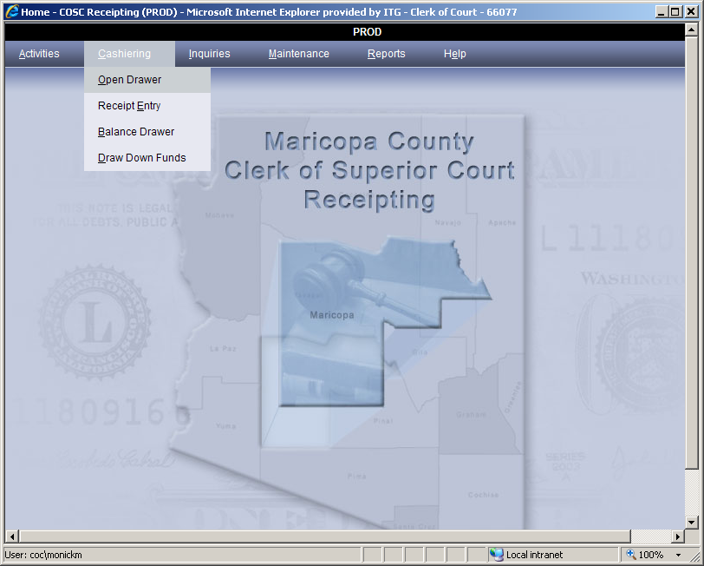

Figure 2
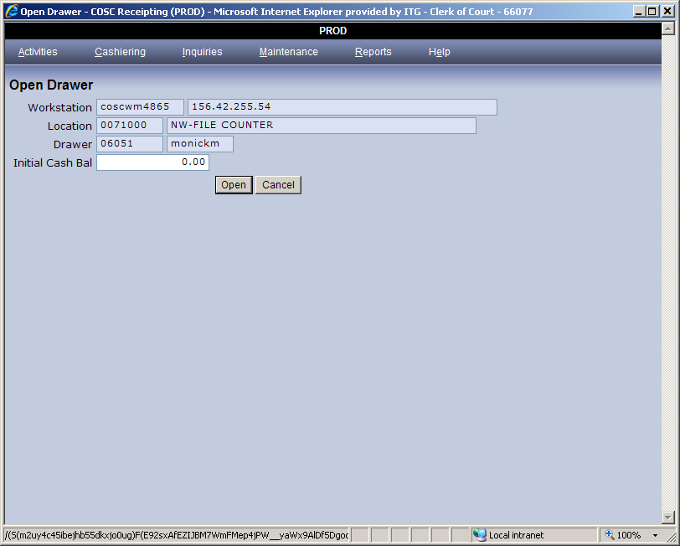

- To obtain a new receipt number:
- Enter Case #, the Service Code, and then click Add. See Figure 3.
  - Case # (enter the correct case number);
  - Service Code (enter 9999);
  - Click Add.

Figure 3
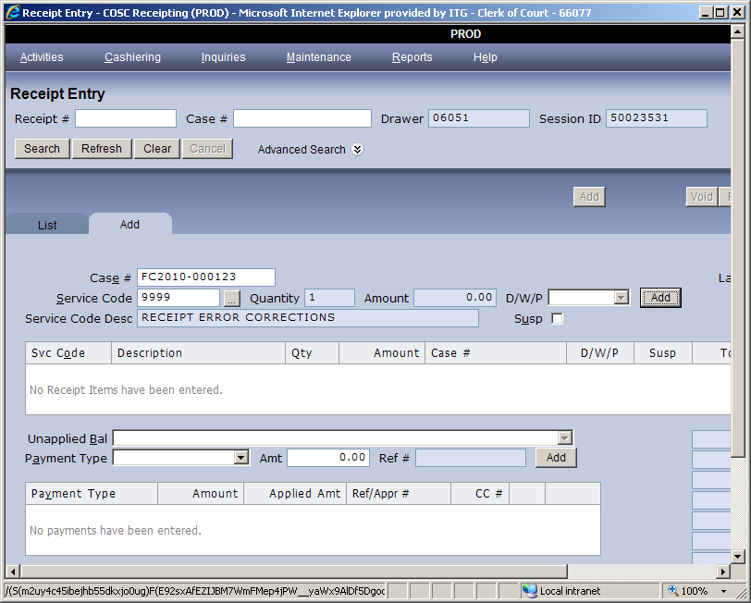
- Next to the Comments line, enter the following.
  - See receipt # [enter number of receipt with wrong case number], wrong case #.
- Click Save.
- Go to the List tab to locate the new receipt number. See Figure 4.
Figure 4
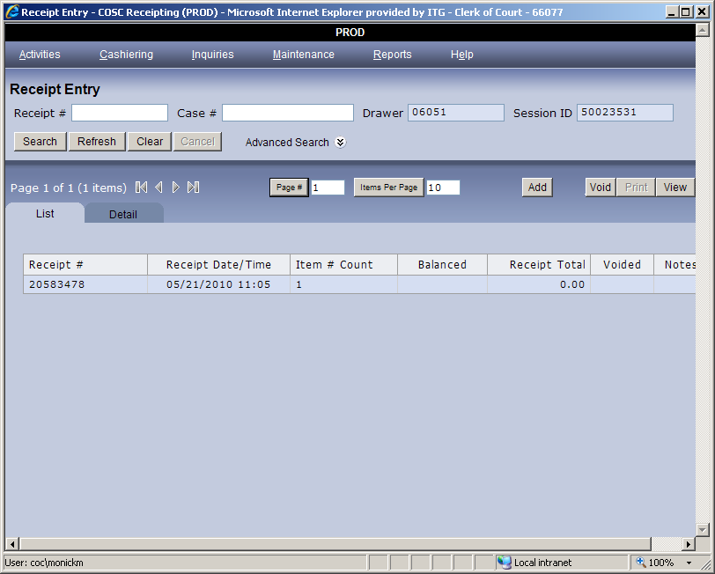

- After noting the new receipt number, an additional entry has to be made to cross reference the old receipt number.
- To create an additional entry, click Cashiering>Receipt Entry .
- Enter Case #, the Service Code, and then click Add.
  - Case # (enter the incorrect case number, that was on the original receipt);
  - Service Code (enter 9999);
  - Click Add.
- Next to the Comment line, enter the following: See Receipt #[enter new receipt number noted], wrong #, s/b [enter correct case number].

Note: Case number format for Case Management System
- All new cases for the year 2000 DR2000-XXXXXX
- Format for Criminal and Lower Court Appeal CR2003-XXXXXX-XXX
- All new cases for the years 1999 back DR99XXXXX
CR99XXXXX
POLICIES / RELATED DOCUMENTS:

- None

OTHER PARTIES INVOLVED:

- None

TIME / VOLUME:

- Approximately 4 minutes for each correction.

FREQUENCY:

- Approximately 10 corrections per month.

PERFORMANCE MEASURE:

- N/A

SYSTEM ACCESS REQUIRED:

- Cash Receipting System

REPORTS / FORMS:

- N/A

DEFINITIONS:

- N/A

APPLICABILITY:

- This procedure applies to all employees of the Clerk of the Court.

REVISION HISTORY:

Revision Number | Revision Author | Summary of Changes | Approval Date
- | N/A | Document Origination | 11/19/2012
A | Eileen Fenner | Reviewed | 03/01/2019
B
C

