PURPOSE:

To provide instructions for splitting a document image in OnBase.

OBJECTIVE:

- To provide the necessary direction to ensure that document images in OnBase are properly split and the correct keywords are applied to the split image.

EVENT DRIVER:

- An audit of the Electronic Court Record reveals an image which contains more than one document.

PROCEDURES:

- Open the image in OnBase.
- Right click on the image to bring up a menu.
- Select the Send To option.
- Select the Create New Document option.
- Enter the page number or numbers which will be in the new document into the Create from pages field. (see Figure 1)

Figure 1
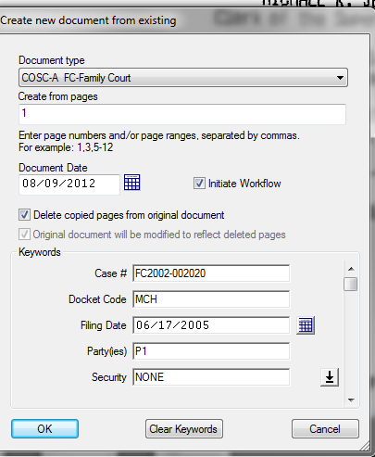
- Click OK.
- The image consisting of the split off pages will open.
- Add the docket code, filing date, party, security, and docket entry ID number if there is a docket event for the image. If there is not, add the generic docket code, add EI in the parties field and the image will automatically go through workflow.

POLICIES / RELATED DOCUMENTS:

- None

OTHER PARTIES INVOLVED:

- None

TIME / VOLUME:

- Time to complete: One minute each.
- Volume: In the current ECR images, 5 per month. In the AMCAD back scan project, 343 per week.

FREQUENCY:

- Daily

PERFORMANCE MEASURE:

- N/A

SYSTEM ACCESS REQUIRED:

- OnBase

REPORTS / FORMS:

- N/A

DEFINITIONS:

- AMCAD: Vendor completing back scan of pre-2002 files.
- ECR: Electronic Court Record

APPLICABILITY:

This procedure applies to all employees of the Clerk of the Court.

REVISION HISTORY:

Revision Number | Revision Author | Summary of Changes | Approval Date
- | N/A | Document Origination | 08/14/2012
A | Eileen Fenner | Reviewed | 03/01/2019
B
C

