PURPOSE:

It is the purpose of this procedure to provide instructions for using the Express Indexing software application to generate barcodes for scanning documents.

OBJECTIVE:

- To provide the necessary direction to prepare barcode sheets for documents that will be scanned prior to being docketed.

EVENT DRIVER:

- Receipt of sorted batches of documents that have not been barcoded but will be scanned prior to docketing.

PROCEDURES:

- Review the batch of documents to determine case type, docket code, case year, and file date (if applicable).
- Ensure the printer has yellow paper loaded.
- Prepare barcodes for each document using the Express Indexing application. To begin, click on the desktop icon for the Express Indexing application. See Figure 1.

Figure 1
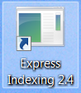

- The example pop-up window shown in Figure 2 will be displayed.

Figure 2
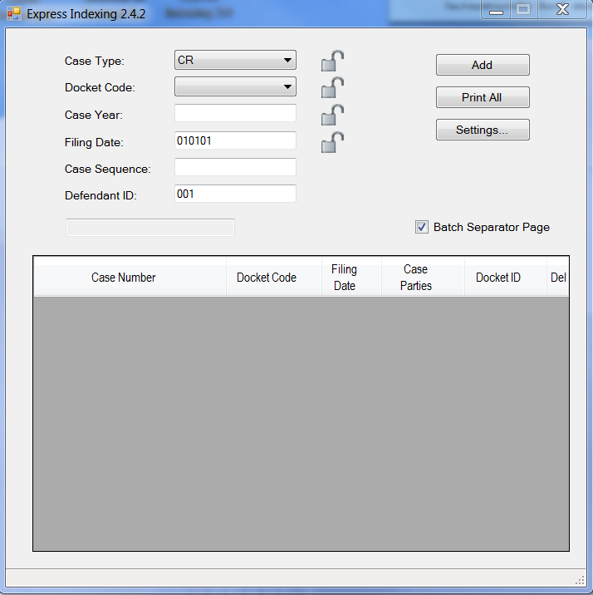

- Enter the values for the specific documents to be barcoded. If there are several documents of the same case type, docket code, case year and filing date to be barcoded, click the lock icon to save the dropdown selected. The Filing Date box must me filled in: therefore, if no filing date is entered, the box will default to 010101. And this value will be removed after scanning. After the values for the first barcode have been entered, click the Add button and go to the next barcode, repeating the process. Figure 3 below shows the list of barcodes entered. Once all the barcode information has been entered, select the Print All button, go to the printer, log on and select Start to print the barcodes. If a coversheet is desired to separate the documents from others, ensure that the Batch Separator Page box is checked.

Figure 3
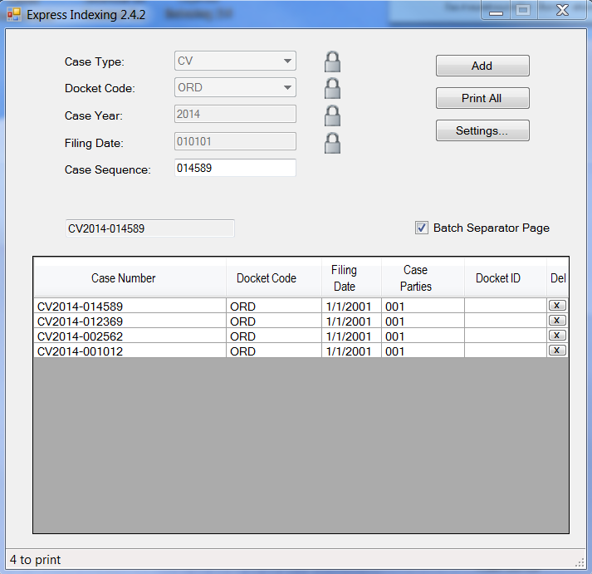

- Once the barcodes are printed, place the barcode page on top of the document to be scanned, ensuring that the barcode matches the document.
- Check the printed barcode sheets periodically to ensure they are clear and dark. Replace the printer’s toner or clean the printer as necessary to ensure quality barcodes. If printing to a Ricoh, report print issues to your supervisor so that the machine can be serviced.
- Discard any gray or streaky barcode sheets and re-print.

POLICIES / RELATED DOCUMENTS:

- PRO-EDMQC-1002: AMCAD Scanning of Misfiled Documents.

OTHER PARTIES INVOLVED:

- N/A

TIME / VOLUME:

- Monthly volume: Approximately 112,500

FREQUENCY:

- Use as needed. Many areas use this process on a daily basis.

PERFORMANCE MEASURE:

- EI Barcode and Merge = 0.5 minutes each.

SYSTEM ACCESS REQUIRED:

- Express Indexing Program

REPORTS / FORMS:

- N/A

DEFINITIONS:

- N/A

APPLICABILITY:

This procedure applies to all employees of the Clerk of the Court.

REVISION HISTORY:

Revision Number | Revision Author | Summary of Changes | Approval Date
- | Scott Mandel | Document Origination | 10/06/2014
A
B
C

