PURPOSE:

To provide instructions on how to perform a Draw Down to remove and deposit excess cash from a cash drawer prior to close-of-business.

OBJECTIVE:

- To provide clear and concise, step by step instruction on how to perform a Draw Down for a cash drawer, complying with Minimum Accounting Standards (MAS).

EVENT DRIVER:

- A Cashier has receipted a total cash amount greater than $3,000.00 in their drawer and needs to perform a Draw Down.

PROCEDURES:
When cash transactions for a drawer reach a total amount greater than $3,000.00, they must be deposited as soon as possible using the Draw Down process. A Draw Down records the deposit of a sum of cash prior to closing out the drawer with the final TTL.

Performing a Sub-Balance before proceeding with a Draw Down is strongly advised.

Use the following procedure to perform a Draw Down of cash funds:
- Select Draw Down Funds from the Cashiering menu. The screen will populate with your Drawer number, Workstation, Location, Initial Cash Bal, and Current Balance.
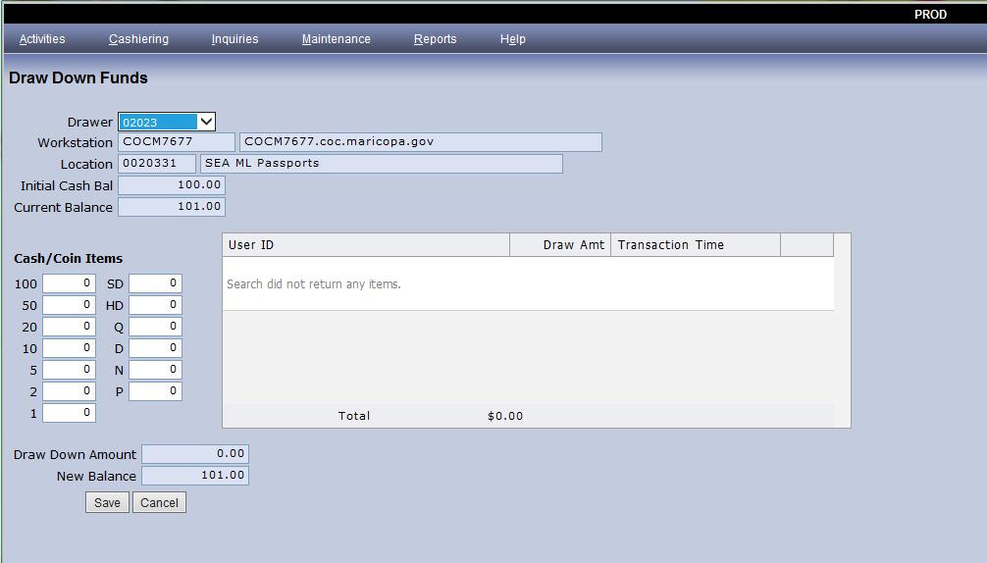
- Count out the cash and coin amount to be deposited, then enter the denomination quantities into the Cash/Coin Items fields.
DO NOT INCLUDE YOUR DRAWER’S INITIAL CASH AMOUNT.
- The total entered cash will populate in the Draw Down Amount field.
- A preview of the cash amount that will remain after the Draw Down is complete will be shown in the New Balance field.
  - The New Balance amount should never be less than your assigned Initial Cash Bal amount.
- Click Save to complete the Draw Down. Two Draw Down receipts will print.
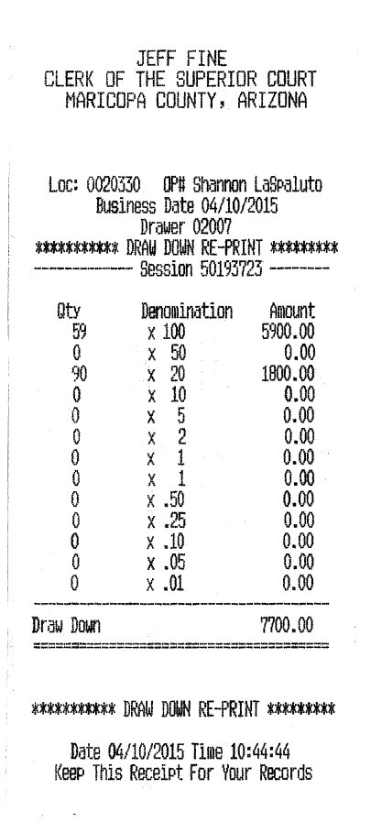

- If a reprint of this receipt is needed, select Activity Inquiries from the Inquiries menu.
  - Click Clear All to uncheck all of the preselected search option boxes.
  - Check Draw Down, then click Advanced Search.
  - Enter the Session ID shown on the original receipt then click Search.
- If the original receipt is not available, search by Activity Date and Drawer ID.
  - The Draw Down Activity entry will open in the Detail Tab.
  - Click Print to generate a re-print of the two Draw Down receipts.
- The Deposit Slip will be filled out in duplicate as follows:
- The Deposit Date is written on the Date line at the top of the slip. It should coincide with the Business Date that is found on the Draw Down receipts.
- Fill in the separate amounts for cash and coin totals on the Currency and Coin lines, using the Dollars and Cents columns.
    - Determine and make note of these amounts when performing the Draw Down because Cash and Coin totals will combine into the Draw Down total on the receipt.
    - Verify that the currency and coin amounts written on the deposit slip equal the total amount of cash listed for the Draw Down total.
- The total dollar amount of currency and coin for bank deposit is written twice on the Deposit Slip; first in the TOTAL line at the bottom of the Dollar/Cents column then again in the Total Deposit box.
- Enter the number zero (0) in the Total Items box.
- Write Draw Down on the Deposit Slip to identify the deposit as such.
- Initial the Deposit Slip above the Total Deposit box to indicate verification.
- Remove the white original deposit slip and the yellow deposit record copy from the deposit book, carefully tearing at the perforation. The pink copy will stay attached to the book for the cashier’s records.
- Obtain a bank deposit bag and write the Customer Name, Account Number, Deposit Date, and the Cash, Coin, and Total amounts in the designated areas. The Customer Name is location specific.
- Assemble the Deposit Slip, Draw Down receipts, funds for deposit, and the bank deposit bag together and submit them to the Deposit Clerk immediately.
- The end-of-day TTL will be a completely separate deposit and will not include this Draw Down amount.

POLICIES / RELATED DOCUMENTS:

- ACJA 1-401: Arizona Code of Judicial Administration: Minimum Accounting Standards (MAS)

OTHER PARTIES INVOLVED:

- N/A
TIME / VOLUME:

- Varied

FREQUENCY:

- As Needed

PERFORMANCE MEASURE:

- N/A

SYSTEM ACCESS REQUIRED:

- COSC Receipting System

REPORTS / FORMS:

- N/A

DEFINITIONS:

- N/A

APPLICABILITY:

This procedure applies to all employees of the Clerk of the Court.

REVISION HISTORY:

Revision Number | Revision Author | Summary of Changes | Approval Date
- | Nikki Swiss | Document Origination | 6/18/20
A
B
C

