PURPOSE:

In order to assure uniformity, and the ability to track bank differences, it is necessary to follow explicit steps when creating the deposit.

OBJECTIVE:

- To provide a cashier with instructions on preparing daily bank deposits of total daily receipts, generated through their cash drawer, at their work station.

EVENT DRIVER:

- A cashier needs to prepare a daily deposit for their assigned cash drawer.

PROCEDURES:
- This procedure applies to any employee who accepts and cashiers court ordered funds as part of their job. It is the responsibility of a cashier to create a daily bank deposit of their receipted funds and to turn it in daily, to the Deposit Clerk, for bank deposit. The deposit slip will serve as a record of their receipted work for the day.
- The cashier will be held responsible for their deposit’s accuracy.
- No employee shall be permitted to accept funds on a regular basis unless they are assigned a cash drawer and are able to make a daily deposit using a deposit slip book and/or manual receipt book specifically assigned to them by the Clerk of the Court. See Receipt Book Procedure for direction on manual receipt book usage.
- Deposit funds are not to be held longer than 24 hours after the cashier has completed their final TTL for the day without direction and authorization by management.

- The following procedure is to be used to prepare a daily deposit:
- Complete the final Total (TTL) in COSC Receipting to balance and close the drawer for the day. The Bank Deposit Summary and Deposit TTL receipts will print. See Receipting Procedure for steps on how to balance and TTL a drawer.
- Obtain a book of deposit slips from the designated location where they are stored for the area or from Accounting (email TrustResponse@mail.maricopa.gov).
  - Each deposit slip has three parts, the white original, the yellow deposit record carbon copy, and the pink drawer carbon copy. Always use the included divider card under the pink page of the current deposit slip to avoid information transfer between entries.
  - All deposit slips are micro-encoded with the cashier's unique cash drawer number. They are to be secured by the cashier and are not to be used by any other cashier unless specifically authorized by management.

Deposit TTL Bank Deposit Summary
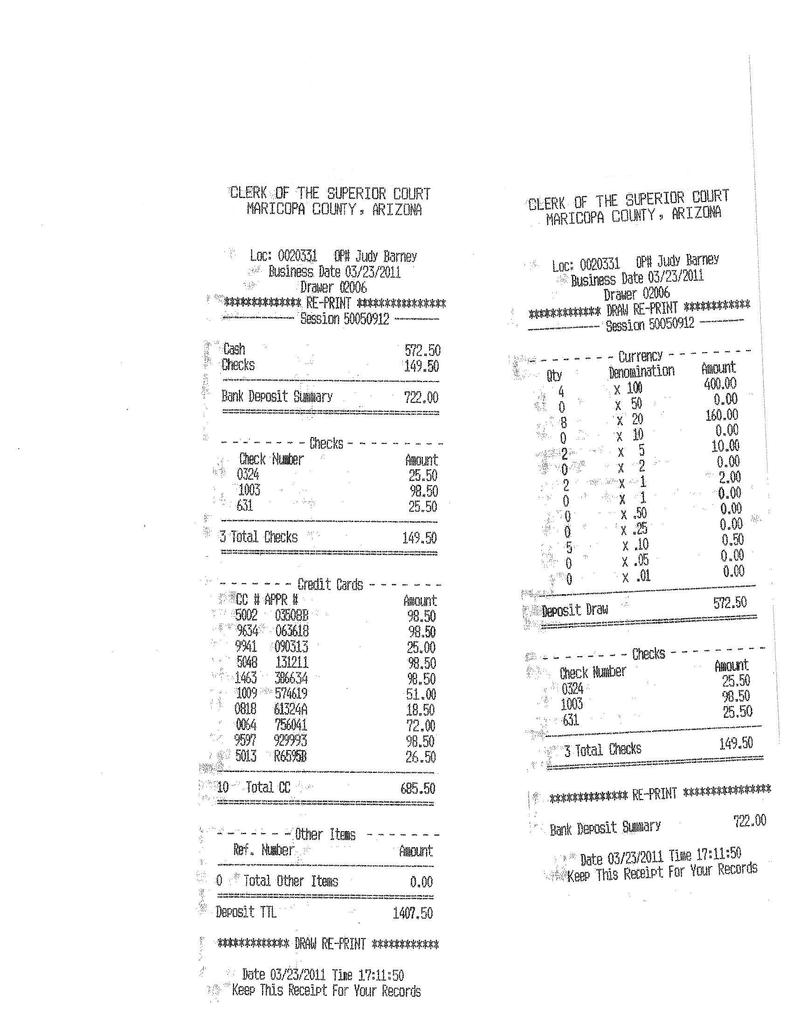

Deposit Slip
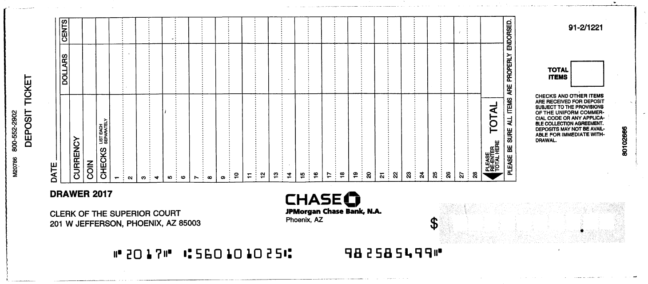

- The Deposit Slip will be filled out in duplicate as follows:
- The Deposit Date is written on the Date line at the top of the slip. It should coincide with the Business Date that is found on the Deposit TTL and Bank Deposit Summary receipts.
- Fill in the separate amounts for cash and coin totals on the Currency and Coin lines, using the Dollars and Cents columns.
    - Determine and make note of these amounts when performing the drawer balance and final Total because Cash and Coin totals will combine into the Deposit Draw total on the Bank Deposit Summary receipt.
      - For example: Your Deposit Draw total is $47.50, so you would write $47.00 in the Currency line and $0.50 in the Coin line. Always write the amount of coin deposited on the Coin line, even if the amount is in whole dollar amounts (ex: $2.00 in quarters).
    - Verify that the currency and coin amounts written on the deposit slip equal the total amount of cash listed for the Deposit Draw total.
- Physically count the number of checks you are sending to the bank, then verify the total number counted to the number printed in the Check section of the Bank Deposit Summary receipt. These numbers should agree. If they do, write the number of checks and money orders (ex: 3 Checks) on Line 5 of the Deposit Slip. On the same line, to the right of the check items number, write the total dollar amount in the Dollars/Cents column.
- Write the total check item number in the Total Items box on the deposit slip. The number of items must agree to the number of checks sent. Check items must all be listed on the Bank Deposit Summary receipt so the bank can confirm the items received with the items reported sent.
- If no checks or money orders were receipted, write No Checks on line 5 of the Deposit Slip and the number zero (0) in the Total Items box.
- If the physical check count does not match the receipted check total:
    - Verify each check to the Bank Deposit Summary receipt using the check number and check amount.
    - Pull any checks not entered into the system; they must be entered and deposited on the next business day’s deposit.
NOTE: An exception would be checks received that include payments for several cases, i.e., Collection Agency, Tax Intercepts, ADJC, and JCORP
- The total dollar amount of currency, coin, and checks for bank deposit is written twice on the Deposit Slip; first in the TOTAL line at the bottom of the Dollar/Cents column then again in the Total Deposit box. The cashier must be mindful to pick up the Bank Deposit amount from the Bank Deposit Summary receipt, not the check amount or Deposit TTL amount.
- The cashier will initial the Deposit Slip above the Total Deposit box to indicate verification.
- Remove the white original deposit slip and the yellow deposit record copy from the deposit book, carefully tearing at the perforation. The pink copy will stay attached to the book for the cashier’s records.
- Obtain a bank deposit bag and write the Customer Name, Account Number, Deposit Date, and the Cash, Coin, Check, and Total amounts in the designated areas. The Customer Name is location specific.
- Assemble the Deposit Slip, TTL receipts, credit receipts, funds for deposit, and the bank deposit bag together to submit to the Deposit Clerk.

NOTE: If a cashier opens a drawer in COSC Receipting, but no funds are receipted and no bank deposit is required, they must still balance and close the drawer at the close of that business day. Initial the top of the Deposit TTL receipt and staple it to the Bank Deposit Summary. The same would apply for a drawer with only credit card transactions. The signature receipts are to be stapled behind the two deposit receipts. They will then be turned in to the Deposit Clerk for reconciliation. This does not apply when batch processing Lockbox/DOC payments.

- Items for deposit are brought to the Deposit Clerk, Vault Cashier, or other designated employee for verification.
Deposits are to be accepted from only the Cashier to whom the cash drawer is assigned. In the absence of the assigned cashier, a manager, supervisor, or lead may have access to verify their cash drawer make the deposit on behalf of the cashier.
  - Verification of the absent cashier’s cash drawer and deposit must be handled in accordance to standard operation procedure under dual control.
  - When retrieving the deposit, the remaining cash in the drawer will be counted to verify it equals the initial cash assigned to that drawer. Both verifying parties will then sign the Daily Cash Drawer Audit form in lieu of the cashier, then mark the boxes indicating Clerk Absent and Secured deposit.

- The Deposit Clerk will perform the following steps in the presence of the cashier:
  - Verify that the cashier used the correct Deposit Slip (reflects their assigned drawer number).
  - Verify that the date on the Deposit Slip reflects the date payments were receipted and the Business Date that is found on the Deposit TTL and Bank Deposit Summary receipts.

  - Verify that the Total Deposit amount on the Deposit Slip agrees with the Bank Deposit Summary receipt and the Sub Total on the Deposit Statistics report from the COSC Receipting system.
  - Write the bank deposit bag number on the Deposit Slip between the Deposit Total and Total Items box.
  - Count then verify that the total amount of currency and coin agrees with the Deposit Slip amount total and the denomination quantities on the Bank Deposit Summary receipt.
  - Physically count the number of checks presented. While counting, look to make sure the checks are filled out properly (ex: “pay to the order of” is filled in, check is signed, etc). Verify that the amount counted matches the number of checks indicated on the Deposit Slip on Line 5 and in the Total Items box.
  - If any discrepancies are found, the deposit will be rejected and must be corrected by the cashier. After the corrections have been made, the deposit may then be resubmitted to the Deposit Clerk.
  - Initial the Deposit Slip then the Deposit TTL receipt near the Bank Deposit Summary line to indicate verification.

NOTE: If the deposit is a result of a cash Draw Down, write Draw Down on the deposit slip to identify it as such. Since a Draw Down deposit represents only a portion of a cashier’s deposit for the day, the Draw Down deposit will be held until the cashier has completed their final TTL and will then be sent to the bank together with the cashier’s TTL deposit. The Deposit Statistics report from the COSC Receipting system will show their Draw Down and final TTL amounts as one combined entry.

  - Before the deposit is placed into the bank deposit bag, verify that the Location, Account Number, Deposit Date, and the Cash, Coin, Check, and Total amounts are written accurately in the designated areas on the bag. Remove the top plastic strip of the deposit bag that contains the bag number and set aside.
  - Separate the white original deposit slip from the yellow deposit record copy and set aside.
  - Cut or separate the Currency and Check portions of the Bank Deposit Summary receipt.
  - Place the Check portion of the Bank Deposit Summary receipt with the checks and the white original deposit slip in the lower check pouch of the bank deposit bag. Remove the liner tape to expose the adhesive and seal the check pouch.
  - Place the Currency portion of the Bank Deposit Summary receipt with the cash and coin in the upper cash pouch of the bank deposit bag. Remove the liner tape to expose the adhesive and seal the cash pouch.
  - Place the Deposit TTL receipt on top of the yellow deposit record copy, lining it up at the top edge. Place the credit card slips in the same position behind the deposit slip. Drape the plastic strip of the deposit bag (from step i) over the top and bottom of the pile and staple them together. Forward all deposit records to Accounting Operations within two business days.
  - Place the sealed deposit bag in the designated lockable containment unit.
- If a cashier opens a drawer in COSC Receipting, but no funds are receipted and no bank deposit is required, they must still balance and close the drawer at the close of that business day. The cashier must initial the top of the Deposit TTL receipt and staple it to the Bank Deposit Summary. The same would apply for a drawer with only credit card transactions. The signature receipts are to be stapled behind the two deposit receipts. They will then be turned in to the Deposit Clerk for reconciliation.
  - The Deposit Clerk will verify that the Deposit TTL receipt agrees with the information on the Deposit Statistics report from the COSC Receipting system then initial next to the cashier’s initials.
- After the last cashier deposit has been made, the Deposit Clerk will log each deposit bag on the Bank Deposit Bag Log and print 2 copies.
  - The log header will reflect the Location, Deposit Date, Courier Bank Bag serial number, Armored Car Deposit Log number, and Deposit Clerk name. The body of the log will have a table that will list the deposit bag number, drawer number, cashier ID, total cash, total checks, and deposit total for each cashier. The Deposit Total is listed at the bottom of the table and should agree with the Grand Total of the Sub Total column listed on the Deposit Statistics report from the COSC Receipting system.
NOTE: The Courier Bank Bag and its contents are to be kept under dual control at all times until all funds for deposit are in the bag, at which time it is sealed and securely stored to await delivery to the bank.
- The Deposit Clerk will prepare the Courier Bank Bag which will contain one copy of the Bank Deposit Bag Log and all of the cashier deposit bags for the day.
  - Remove the top plastic strip of the Courier Bank Bag that contains the serial number and set aside.
  - Enter the Customer Name, Account Number, Deposit Date, and the Total Deposit amount in the designated areas. The Customer Name is location specific.
  - Insert all cashier deposit bags and one copy of the Bank Deposit Bag Log into the upper portion of the bag. Remove the liner tape to expose the adhesive and seal the bag. Seal the empty lower pouch as well.
- The Deposit Clerk will complete following on the Armored Car Deposit Log:
  - Enter the Courier Bank Bag serial number.
  - Enter a description of the shipment (ex. COSC).
  - Enter the dollar amount of the deposit (this will be the total of all individual cashier deposits in the Courier Bank Bag).
  - Peel the barcode label from the corresponding line and apply to the Courier Bank Bag.
- Place the sealed Courier Bank Bag in the designated lockable containment unit until it is picked up by the Bank Courier.
- The second copy of the Bank Deposit Bag Log will be stored with the Deposit Statistics report, Courier Bank Bag strip, and any other required documentation in a secure location by the Deposit Clerk.
- Upon the appearance of the Bank Courier, the Deposit Clerk will retrieve the Courier Bank Bag and the Armored Car Deposit Log from the lockable containment unit.
- The Bank Courier will then sign, date and record the time where indicated on the Armored Car Deposit Log and return to the Deposit Clerk. The Armored Car Deposit Log is retained by the Deposit Clerk. The Bank Courier will have the Deposit Clerk sign their electronic log indicating that the deposit has been picked up.
- All deposit bags can then be released to the Bank Courier for delivery to the Clerk of Court’s servicing bank.

- Each cashier will receive a monthly rating based on the accuracy of their bank deposits.
  - Any Bank Advice that comes back from the bank will be researched by Accounting then included in Accounting’s Over/Short report. Bank Advices are notices from the bank of cashier deposit errors that were not discovered until the deposit was processed by the bank.
  - Overages and shortages discovered by cashiers prior to the TTL and recorded in the system during the TTL process will also be included in Accounting’s Over/Short report.
  - The Accuracy Rating will reflect in the number of Bank Advices, or shortage and/or overages they generate where the error was the cashiers fault. They will be rated monthly by Accounting and the rating will accumulate into a quarterly percentage based on the following:

Monthly # Rating YTD % Rating
0 = 4 100-93% = Excellent
1 = 2 92-85% = Outstanding
2 = 1 84-70% = Standard
3+= 0 < 70% = Below Standard

POLICIES / RELATED DOCUMENTS:

- ACJA 1-401: Arizona Code of Judicial Administration: Minimum Accounting Standards (MAS)
- ACJA 3-402: Arizona Code of Judicial Administration: Superior Court Records Retention and Disposition

OTHER PARTIES INVOLVED:

- Accounting Operations
- Document and Cash Management Services
- Armored car service
- Vault Cashier

TIME / VOLUME:

- Varied

FREQUENCY:

- Daily

PERFORMANCE MEASURE:

- N/A

SYSTEM ACCESS REQUIRED:

- COSC Receipting System

REPORTS / FORMS:

- N/A

DEFINITIONS:

- N/A

APPLICABILITY:

This procedure applies to all employees of the Clerk of the Court.

REVISION HISTORY:

Revision Number | Revision Author | Summary of Changes | Approval Date
- | Nikki Swiss | Document Origination | 6/18/20
A
B
C

