PURPOSE:

The purpose of this procedure is to provide instructions for docketing of subsequent documents for the Clerk of the Court.

OBJECTIVE:

- Add subsequent documents to docket in iCIS.

EVENT DRIVER:

- Docket receives subsequent documents through Priority Workflow, Predocket, or hard copy paper for entry into iCIS on an existing case.

PROCEDURES:

Please refer to the Priority Workflow Basic Procedure and the Predocket Procedure for information regarding start-up of these programs.

- Information Entry

Once you have all necessary programs open and documents ready, fill in the information as indicated on the following pages.

- Enter the Filing date (found in upper right corner of document)
- Enter the Person Filing, Attorney Filing, or Bar Number. (found in upper left corner of document)
  - Person Filing: use when document is filed by a Pro Per/Pro Se party.
  - Attorney Filing: use when document is being filed by an attorney.
  - Court: (listed under Attorney Filing) use for all Orders, Judgments, and when the document does not specify a filing party.
  - Bar Number: use when the document is being filed by an attorney but the attorney has not been added to the case.
  - Associate the party that the attorney is representing at the bottom of the screen.

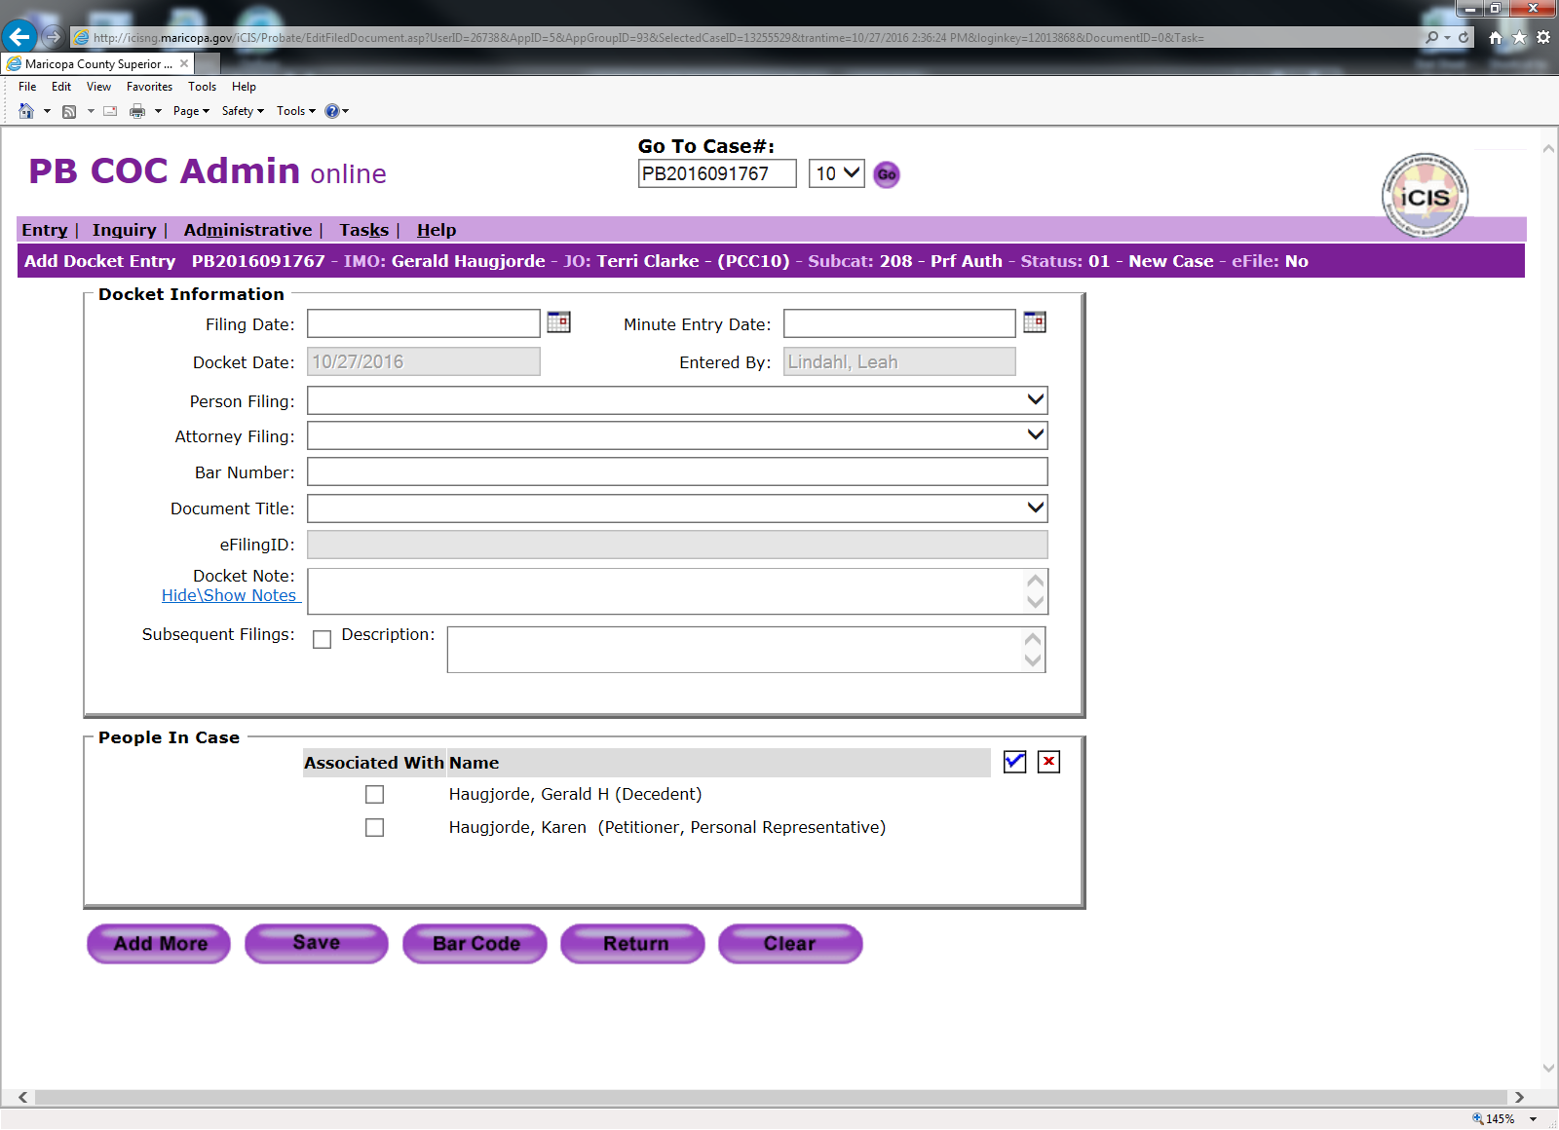

- Enter the Document Title: Docket codes for all case types can be found in the Docket Quick Glance. Choose the code that best reflects the title of the document.
- Enter Docket Note: See instructions for docket notes on page 4 of this procedure.
- Once all appropriate fields have been completed, select “save.”
- If processing hard copy paper documents, do not select “save.” Select “barcode” and reference the EDM Prepping procedure for further instructions.

Workflow/Predocket Hard Copy Paper

Filing party/Attorney File Date Document Title

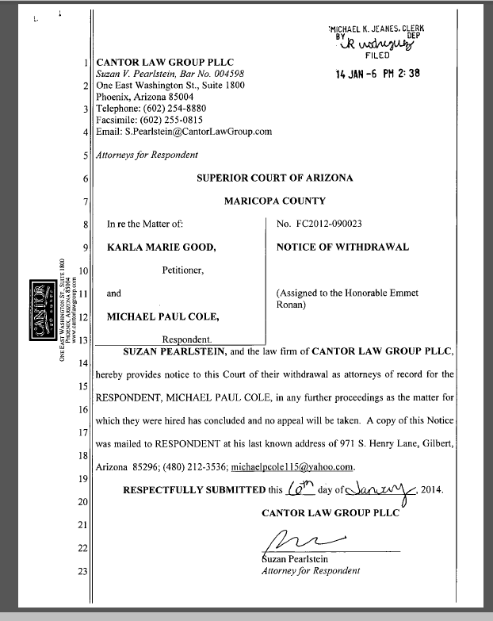

- Docket Note Guidelines and Examples

- Docket notes should always be in all capitalized letters.
- Punctuation should be kept to a minimum and used only when necessary. This includes parenthesis, we would add what is contained in the parenthesis but not the actual parenthesis themselves (see example 3).
- The slash is used to “take the place” of the verbiage in the docket code. There should be a space before and after the slash when used in this capacity (see example 1).
- As a general rule, the rest of the document title should always be added to the docket note.
- When adding dates to the docket note, to save time and keystrokes use the format shown in example 2.

Example 1:
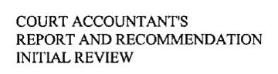
Docket Code: REP
Docket Note: COURT ACCOUNTANTS / AND RECOMMENDATION INITIAL REVIEW

Example 2:
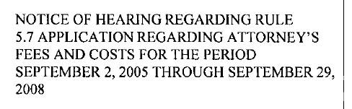
Docket Code: NOH
Docket Note: REGARDING RULE 5.7 APPLICATION REGARDING ATTORNEYS FEES AND COSTS FOR THE PERIOD 9/5/05 THROUGH 9/29/08
Example 3:
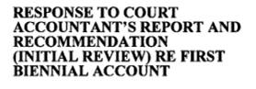
Docket Code: RES
Docket Note: TO COURT ACCOUNTANTS REPORT AND RECOMMENDATION INITIAL REVIEW RE FIRST BIENNIAL ACCOUNT

Example 4:
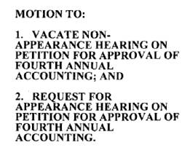
Docket Code: MOT
Docket Note: TO VACATE NON-APPEARANCE HEARING ON PETITION FOR APPROVAL OF FOURTH ANNUAL ACCOUNT AND REQUEST FOR APPEARANCE HEARING ON PETITION FOR APPROVAL OF FOURTH ANNUAL ACCOUNTING

POLICIES / RELATED DOCUMENTS:

OTHER PARTIES INVOLVED:

TIME / VOLUME:

- Varied

FREQUENCY:

- Daily

PERFORMANCE MEASURE:

- N/A

SYSTEM ACCESS REQUIRED:

- OnBase
- iCIS

REPORTS / FORMS:

- N/A

DEFINITIONS:

APPLICABILITY:

This procedure applies to all employees of the Clerk of the Court.

REVISION HISTORY:

Revision Number | Revision Author | Summary of Changes | Approval Date
- | Leah Lindahl | Document Origination | 11/14/17
A
B
C

