PURPOSE:

To provide instructions to staff in the Office of the Clerk of the Court for the processing of Applications for Deferral; as appointed Special Commissioners for the specific purpose of ruling on submitted applications.

OBJECTIVE:

- To determine the eligibility of a person who requests a deferral/waiver of court fees.

EVENT DRIVER:

- Customer files an application for deferral or waiver of fees.

PROCEDURES:
- Determine if a Deferral is Required
- If a customer provides the filing clerk with a New Complaint filing in any case type and would like a fee deferral/waiver, they will be required to completely fill out the Fee Deferral Application packet to be submitted with their new complaint filing.
- If a customer provides the filing clerk with a subsequent filing that requires a fee, the clerk will assess research and determine whether a fee deferral application is needed by inputting the existing case number into ICIS.
- If the customer’s name is flagged with a “$” sign on the main page of ICIS, the customer has a current deferral on file and a new Fee Deferral Application packet is not required.
- If the customer’s name is not flagged with a “$” sign on the main page of ICIS, they will be required to completely fill out the Fee Deferral Application packet.

- Preparation
- Review completed Fee Deferral Application. Entire application should be filled out. Application should be signed and notarized (or if needed, verify their signature). If the applicant chooses not to complete the required information on the application, it will be denied.
- Review completed billing information sheet. Applicant’s information should be filled out. Applicant signature will be needed following approval process.
- Review the documents the customer intends to file to determine Service Code and fees associated with their filing.
  - Service Code is 482 for Deferral Application Fee A.R.S. 12-284(A).
  - Service Code is 485 for Deferral of Service by Publication (if applicable).
  - Service Code for their filing will vary depending on documents filed.

- Ask the customer how they are completing service:
If using the Sheriff or Publication, make sure the customer completes the Affidavit in Support of Application for deferral or waiver of service of process costs.
- Inform the customer of the amount required to be deferred/waived including the application fee.

- Deferral
- Full deferral:
  - Provide supporting documentation of current enrollment (an award/eligibility letter, verification card, etc.) in TANF (assistance to needy families) or SNAP (US Food Stamp Program). OR
  - Provide supporting documentation of Legal Aid (eligibility letter or documents display legal services organization’s information) if the proof is not available, have customer complete financial information on the application and base eligibility on standard criteria. OR
  - Have an income of 150% or less of current US poverty guidelines.
    - Review total monthly income and number of dependents listed (page 2 of application).
    - Utilize the current HHS Poverty Guidelines grid provided on the Quick Glance to determine qualification.
    - Size of family includes applicant and all dependents listed.
  - Application fee is added to the deferral amount and no down payment is required.
- Partial deferral:
  - Have an income greater than 150% and less than 175% of current US poverty guidelines.
- Application fee is added to the deferral amount.
- Down payment no less than $10 required at time of filing.
  - Have an income greater than 175% and less than 225% of current US poverty guidelines.
- Application fee is added to the deferral amount.
- Down payment no less than 25% of total is required at time of filing.
- If the customer qualifies, print applicant’s name on the Order regarding Deferral or Waiver and check box #2 for deferral of fees or check box #5 for waiver of fees. See Figure 1.

Figure 1
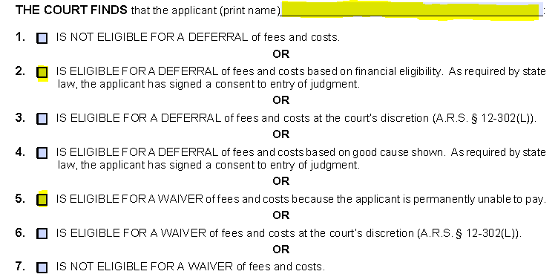

- On page 2 of the Order regarding Deferral or Waiver indicate deferral is granted and check all options that apply. Based on information provided by applicant check either no payments or schedule of payments (do not check both). See Figure 2.
  - If schedule of payments is required, complete all information required.
  - The beginning date will be the same day deferral is requested.

Figure 2
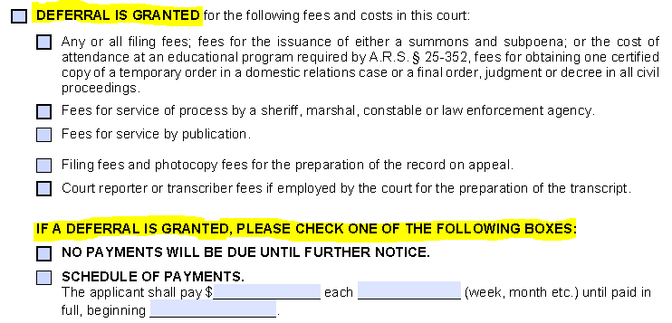

- Page 3 of the Order regarding Deferral or Waiver:
  - Date and sign the order using your full name.
  - Check [ ] Special Commissioner.
- Make a copy of the order for the customer and explain the conditions if it is a deferral.
- Have applicant sign billing information sheet (in the self-service deferral packet) on the appropriate line. Place billing information sheet in designated area to be scanned daily to COCbillingdeferrals@mail.maricopa.gov.
- If the customer does not qualify for a deferral within guidelines, will not complete the application, does not have acceptable identification, OR they cannot/will not pay the required down payment, they may be directed to a judicial officer for approval. Each facility has an on-site procedure for contacting and remitting the application/order to the appropriate judicial officer as set out by Court Administration.

- Waiver
- If the customer has a current eligibility letter as proof of enrollment in the Supplemental Social Security Income (SSI) program under Title XVI, a waiver will be granted. No application fee (Service Code 482) is assessed.
- Letter will be titled Social Security Administration Supplemental Security Income.
- Letter will be for applicant—not the child or other dependent of the applicant.
- SSI is a needs based program that pays minimal amounts monthly.
- For parties that do not qualify for a requested waiver; inform them of the supplemental process available at the end of the case and proceed with the deferral process.

- Receipting
- Enter transaction into the COSC Receipting application system.
  - Enter the service code for document being deferred.
  - Enter service code 482 for Deferral Application and/or 485 for Service by Publication.
  - Select deferral or waiver in the field marked D/W/P.
  - Do not collect the Deferral Application Fee (Service Code 482) when application is solely for Sheriff’s fees or the Parent Education Class fee – See instructions for these services at the end of this procedure.

- Updating ICIS to Reflect Current Status of a Deferral
  - All deferral applications are valid for a period of 24 months or when the matter being deferred is resolved, whichever comes first.

  - Filing counter staff will review the status of a deferral by referring to the case matter in ICIS.
- The determination for whether or not a deferral application is required is based on the applicant’s status in the Fees portion of ICIS.
- If the Fee Screen indicates Deferred2016, the clerk will only require a completed Billing Information Sheet, applying the applicable fee for the customers filing matter before following standard procedure for forwarding these sheets to Billing and Deferral (Deferred2016 indication notes that there is a deferral on file that is within the 24 month period of use or, has not yet been ruled on).
- The clerk will place the billing information sheet in designated area to be scanned daily to COCbillingdeferrals@mail.maricopa.gov.
- If the Fee Screen does not indicate a fee type with the applicant, this will alert the clerk that an entire Deferral Application is required for processing.
- In the event that an entire Deferral Application is required, the clerk will follow standard procedure for review of Deferral Applications.
- After a Deferral Application has been granted, the filing counter clerk will notate this in the Fee Screen by accessing the drop down menu next to the applicants name and selecting Deferred2016.
- This will indicate that any subsequent filings that require a deferral will be covered under the umbrella of this Deferral Application (24 months or resolution of the matter this deferral was required for).

- Reminders
- If Legal Aid is filing on behalf of a customer, they are to provide to the filing counter clerk a Verification letter stating representation.
- If a New Complaint or Respondents initial appearance document is being filed, whether the Verification letter is provided or not, a completed Fee Deferral Application will be required, signed by the customer and notarized.
- If an Verification letter is not provided on subsequent filings that are determined to require a fee, the customer will be required to complete a Fee Deferral Application packet.
- If an Verification letter is provided and it has been determined that a filing fee is needed, the clerk will only require a completed Billing Information Sheet, applying the applicable fee for the customers filing matter before following standard procedure for notifying Billing and Deferral of fees to be applied.
- A Deferral for Sheriff’s fees only does not constitute an active Deferral.
- Research only needs to be done on cases to determine the 24 months/ruling on a case that has the $ on the main page. If there is no $ sign, you can assume that we will need a completed deferral application to process their filing.

- If a case is researched and it is determined there is an active deferral (even if there is currently a $ sign on the main page), the fee screen should be updated by changing the drop down to Deferral2016.
- Docket staff have/will be notified of the change for all new cases and ANS documents that are deferred, they will be using the new designation of Deferral2016 on the fee screen.
- A shortcut to locate the deferral documents in iCIS would be to check the Cashiering system for any transactions that were rung up as deferred; this will narrow down the search.
- Once a party has a deferral the $ will always remain on the main page – we can check the fee screen first to see if the Deferral2016 designation is there and if it is, we would not require a new application only the billing and deferral sheet. If the $ sign is on the main page and the fee screen does not reflect Deferral2016 you will need to research the age of the last deferral and/or if there has been any ruling.
- A partial ruling is still considered a pending action or pending deferral – no new application is required only the billing and deferral form.
- Supplemental applications are not filed in. Each facility shall follow on-site procedures where applicable.
- We are unable to approve a deferral application without verifying the applicant’s signature. The billing information sheet may be accepted without a signature if presented by someone other than the applicant.
- We are unable to grant a deferral for fees associated with the form packets offered by the Self-Service Center. The customer must either purchase these packets from the Self-Service Center or print them online.
- Deferral applications to purchase transcript CD’s have to be signed by the assigned Judicial Officer.
- Probate-Applications for deferral regarding ‘Accountings’ and ‘Adult Adoptions’ have to be signed by the assigned Judicial Officer.
- Probate-In Adult Guardian Conservator the application is based on the incapacitated person’s income.
- Probate- Maricopa Public Fiduciary and AZ Dept of Veterans Service are automatically deferred. The information sheet only is filled out and submitted to Financial Services.
- Civil Only - We are unable to grant a deferral for service by publication.
- We are unable to grant a deferral to a minor. See your supervisor for options.
- We can defer limited copy fees and the certification fee of a judgment/final order as stated on the deferral order. Consult with the area supervisor for specifics.

- Post-judgment filings that require a fee, along with miscellaneous fees (Copy of judgment, Subpoenas, Writs, etc.) can be added to an existing/previous deferral, so long as that deferral is within 24 months of filing or the matter it is regarding has not been ruled on. Have applicant fill out and sign the billing information sheet. Place billing information sheet in designated area to be scanned daily to COCbillingdeferrals@mail.maricopa.gov.
- We CANNOT defer the following: Copies, Bond & Handling fee, Parenting Conference, Mailing fee, pay histories, arrearage calculations, and modification appointments.
- Customers may pay their deferral payments across the counter. Using the cash receipting system. Process the payment using service code 600 and create a credit memo for the file. Do not collect deferred fees for Sheriff’s service or Parent Education Classes.

- Deferrals for Service of Process by MCSO
- Filing Procedure:
- The customer must fill out the application for deferral.
- The customer must fill out the Affidavit Supporting Deferral or Waiver of Service Costs (in the self-service deferral packet) in addition to the standard forms. The customer must provide the address of the party to be served in order to qualify. The affidavit will be filed by the Deputy Clerk. Note: The party to be served must reside in Maricopa County.
- The Deputy Clerk must check the second box on page two under section two of the Order that says “Fees for service of process by a sheriff, marshal, constable or law enforcement agency” if the deferral is approved (in addition to the standard processing steps for signing the order). Provide a certified copy of the completed signed order to the customer to take with them to the Sheriff’s office.
- Fees:
The deferral covers the initial $200 service/administrative fees. The Sheriff’s office handles the billing of the customer directly. Additional fees can be incurred during the service process (ex. mileage). The customer will be billed at a later time by the Sheriff’s office for the additional fees. If the customer can’t pay the additional fees billed, the Sheriff’s office may direct the customer to the Clerk’s office to pick up a supplemental application for deferral. DO NOT COLLECT PAYMENTS FROM CUSTOMERS FOR THE SERVICE FEES THAT HAVE BEEN DEFERRED. REFER THEM TO THE SHERIFF’S OFFICE.

Note:
The Sheriff's office will not accept a deferral order for service fees that was signed over 6 months ago. A new deferral packet will need to be submitted by the customer. Exception: In regards to inmates only, a new order may be issued without completion of a new application.

- Deferrals for Parent Education Class
If the request for deferral of fees is solely for the Parent Education Class, the clerk must circle the Parent Education Class on the Order Deferring fees.
- Filing Procedure:
- The customer must fill out the application for deferral.
- On the Order Deferring fees, the Deputy Clerk must check that the Deferral is Granted, CIRCLE PARENT EDUCATION CLASS, check the first box that includes the Parent Educational Program (in addition to the standard processing steps for signing the order). Provide a certified copy of the completed signed order to the customer to take with them to the Class.
- Fees:
DO NOT COLLECT PAYMENTS FROM CUSTOMERS FOR THE PARENT EDUCATION CLASS FEES THAT HAVE BEEN DEFERRED. REFER THEM TO THE PROVIDER WHERE THEY TOOK THE CLASS.

POLICIES / RELATED DOCUMENTS:

- A.R.S. 12-284: Fees
- A.R.S. 12-302: Extension of time for payment of fees and costs; relief from default for nonpayment; deferral or waiver of court fees and costs; definitions
- Administrative Order 2011-04: Fee Deferral and Waiver Procedures and Forms (replaced 06/07/2016 by ACJA 5-206)
- ACJA 5-206: Fee Deferrals and Waivers
- Supreme Court AO2014-72: Amending Arizona Code of Judicial Administration § 5-206: Fee Deferrals and Waivers

OTHER PARTIES INVOLVED:

- Special Commissioners
- Judicial Officers

TIME / VOLUME:

- Varied

FREQUENCY:

- Varied

PERFORMANCE MEASURE:

- N/A

SYSTEM ACCESS REQUIRED:

- Cash Receipting System
- email

REPORTS / FORMS:

- Application for Deferral/Waiver packet and documents for filing.
- Billing Information Sheet
- Deferred Fee Application Information sheet
- Supplemental Application
- Affidavit Supporting Deferral or Waiver of Service Costs form
- Legal Services Verification letter

DEFINITIONS:

- N/A

APPLICABILITY:

This procedure applies to all employees of the Clerk of the Court.

REVISION HISTORY:

Revision Number | Revision Author | Summary of Changes | Approval Date
- | Lori Cummings | Document Origination | 07/19/2009
A | Kathy Whittiker | New waiver protocol | 08/11/2010
B | Jody Fisher | Added new AO 2011-04 | 03/17/2011
C | Sheri Jaffe | Updated to include signing with full signature as special commissioner and email address added for remittance to COCbillingdeferrals | 12/16/2013
D | Kathy Whittiker | Re-worded Things to Remember | 04/10/2014
E | Sheri Jaffe | Added Parenting Class information | 06/05/2015
F | Sheri Jaffe | Updated to comply with ACJA 5-206 and Supreme Court AO2014-72 | 06/14/2016
G | Mike Mejia | Updated to include new determination process for Deferral Applications. Filing Counter staff processes for updating iCIS to reflect deferral status and how to process deferrals presented by Legal Aid entities. | 12/28/2016
H | Shannon Branham | Changed the term “Affidavit” on page 5 only (4 occurrences) to the term “Verification letter”; added Legal Services Verification letter to the list under Reports/Forms. | 06/19/2017

