ARIZONA STATE RETIREMENT
Enrollment Guidelines
Employee’s that are eligible to contribute to the Arizona State Retirement fund must enroll and set up a personal account.

- To enroll go to the ASRS website www.azasrs.gov and follow the Online Enrollment Guide. You must enroll in ASRS before any of the processes below can be completed.

- When enrollment is complete you must register to set up a personal account. Once the personal account is set up the users’ personal data will appear as seen below:

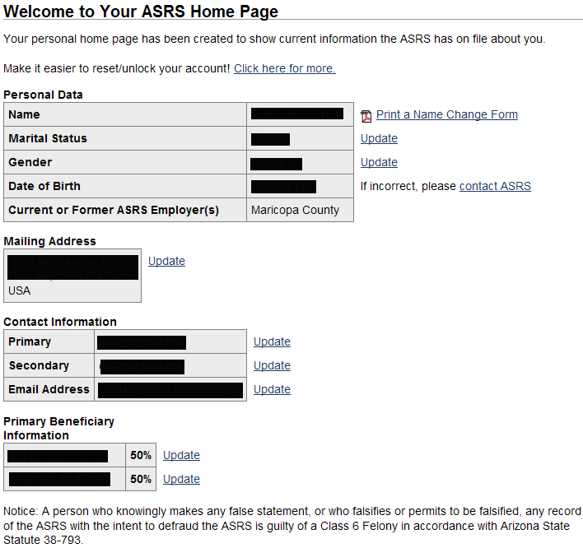

  - Your personal home page enables the user to update all of the following (with the exception of the Name Change), without having to provide forms:

- Name Change - (Documentation is required)
- Marital Status and Gender Update
- Change of Address
- Contact Information - Phone/Email
- Beneficiary Information

Name Change Procedure

  - Login to your personal account.
  - Go to Your Profile link: Edit Profile/Email. 
  - Your Personal Data will appear.

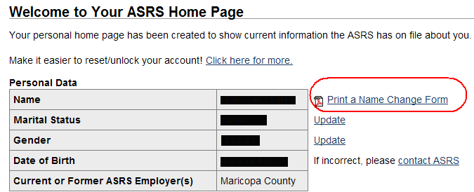

  - To the right of the Personal Data is the Print a Name Change Form.
  - Complete the form as instructed and print.
    - Once the form is printed, sign it, attach any of the legal documents that are being provided and mail or fax to ASRS. DO NOT email these forms.
Arizona State Retirement Address and Phone Numbers:
ASRS
PO Box 33910
Phoenix, AZ 33910

Phoenix Phone / Fax:
(602)240-2000 / (602)240-2017

