PURPOSE:

To provide instruction for processing Emergency Orders of Protection.

OBJECTIVE:

- To provide the necessary direction to ensure that Emergency Orders of Protection are processed properly and consistently over time.

GENERAL INFORMATION:

Pursuant to A.R.S. §12-282 and AZ Rules of Supreme Court, Rule 123 (a)-(h), the Clerk of the Court shall maintain and provide access to court records in accordance with applicable law. Rule 123 is adopted to govern public access to the records of all courts and administrative offices of the Judicial Department of the State of Arizona. Emergency Orders of Protection are generated by Judicial Officers.

EVENT DRIVER:

- An original Emergency Order of Protection is received by the Court Operations Manager from the Clerk of the Court Receptionist or various law enforcement agencies.

PROCEDURES:
- Scan Emergency Order and email to your email address.
- Open OnBase Thick Client using individual login procedures. Under Document Type Groups, click on Miscellaneous Documents. Under Document Types, select Emergency Orders of Protection. (See Figure 1.)

Figure 1
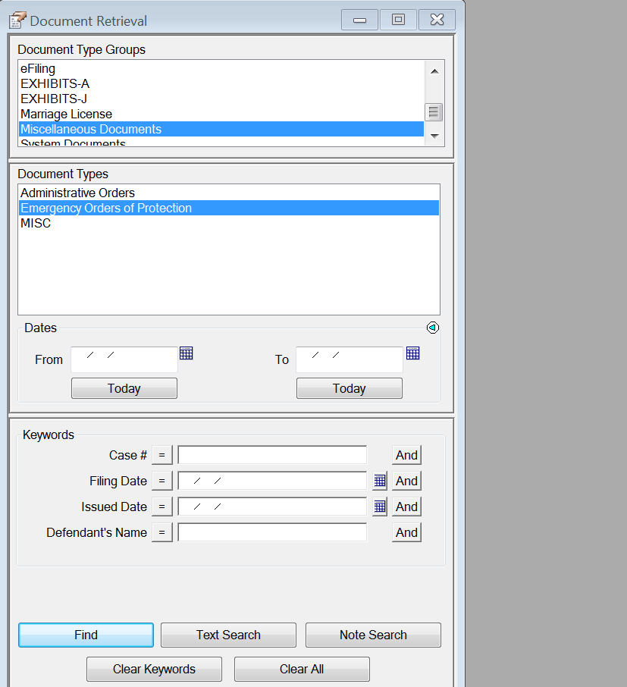

- Access the e-mail, right click the PDF attachment and save to your desktop under the cause number (e.g., 2012-00023).
- Left click on the PDF icon and drag to OnBase Thick Client and release.
- A pop up menu will appear. ( See Figure 2) Under Document Type Group, dropdown and select Miscellaneous Documents; under document type, drop down and select Emergency Orders of Protection.

Figure 2
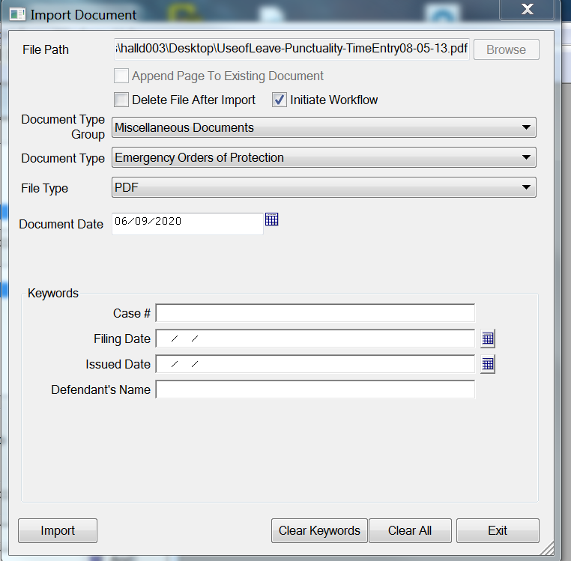

- Enter the “keywords” for each emergency order of protection. List the following:
  - Case number (e.g., 2012-00023).
  - Filing Date – can be left blank.
  - Issued Date – this is the date the judicial officer issued the order.
  - Defendant’s name – last name, first name, middle initial or name (all capital letters).
- Click Import. The Emergency Order of Protection has been saved and is accessible in OnBase.
- Delete the PDF icon on your desktop.
- Follow above procedure for each Emergency Order of Protection.
- Retain original Emergency Orders of Protection for one calendar year, then dispose of following disposal protocol.

POLICIES / RELATED DOCUMENTS:

- ARS 12-282: Custody of records filed; purging; destruction; microphotography; electronic imaging; evidence; withdrawal of voucher; exemption; child support information
- 17A A.R.S. Sup.Ct.Rules, Rule 123: Public Access to the Judicial Records of the State of Arizona

OTHER PARTIES INVOLVED:

- Clerk of the Court Receptionist
- Various Law Enforcement Agencies

TIME / VOLUME:

- Varied

FREQUENCY:

- Daily

PERFORMANCE MEASURE:

- N/A

SYSTEM ACCESS REQUIRED:

- OnBase Thick Client
- COCWeb (Secured Applications)
- e-mail

REPORTS / FORMS:

- N/A

DEFINITIONS:

- N/A

APPLICABILITY:

This procedure applies to all employees of the Clerk of the Court.

REVISION HISTORY:

Revision Number | Revision Author | Summary of Changes | Approval Date
- | N/A | Document Origination | 04/20/2012
A | N/A | N/A | 07/14/2015
B | Larry Urewicz | Reformatted for the CDI | 12/02/2016
C | Donna Hall | Procedural Contents Updated | 06/09/2020

