At the time ASRS verifies your enrollment form with your contributions you will receive an email alerting you that it is now time to complete your beneficiary information.

Designate a Beneficiary
It is vital that the ASRS have a beneficiary on file for you. A beneficiary is the person(s) you choose to receive any available funds upon your death. When your employer receives your enrollment request, your data will be verified and submitted to the ASRS so that an account can be created for you. (Note: The process of creating an account may take several weeks.) However, your account information is not complete until you designate a beneficiary.
As the employee you will need to go to www.azasrs.gov when you have been notified an account has been established to designate a beneficiary.
You will receive an email from ASRS confirming that an account has been established. At that time, you will be asked to register to access your ASRS account via the ASRS website and to appoint a beneficiary. (Note: It may be several weeks before your account is created by the ASRS and for you to receive this email).

The print screen below identifies the two options you have can choose to access the log in.

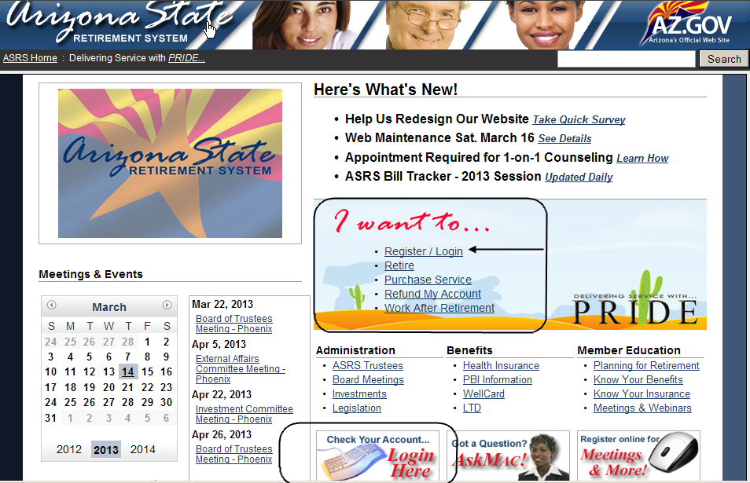

Note: It may be several weeks before your account is created by the ASRS. You will not be able to successfully register for access until your account is created.
New employee with previous ASRS enrollment

As a current ASRS member, an ASRS account has already been created for you. If you have already registered to access your account via the ASRS website, please take the opportunity to review the current beneficiary information on file and provide any changes or updates. If you have not yet registered for access, please visit www.azasrs.gov .

The print screen below identifies the two options you have can choose to access the log in.

The ASRS welcomes you as a member, and encourages you to visit our website to learn more about the benefits of being a member. We offer an online Know Your Benefits webinar that you may find informative. To learn more, visit the Interactive Center on our website.
Thank you for enrolling online!

