PURPOSE:

To provide instructions for processing grand jury case dismissals for one defendant in XGJ.

OBJECTIVE:

- To provide the necessary directions to ensure grand jury case dismissals are processed correctly and accurately.
- To ensure consistent filing and accountability of all grand jury dismissal filings.

EVENT DRIVER:

- A Case Dismissal filing is received from the Grand Jury Clerk and provides the following documents:
  - Original Motion to Dismiss
  - Original Order to Dismiss
  - Original Minute Entry entitled “Case Dismissed”
- A Case Dismissal XGJ filing is processed by the staff member assigned to XGJ and can be found in the XGJ bin.

PROCEDURES:
- Process Dismissal Documents:
- Verify that the Motion, Order, and Minute Entry have a matching case number and defendant name and all documents match to the indictment.
- Use redaction tape and redact the defendant’s name on the original Motion, Order, and Minute Entry.
- Make a copy of the redacted documents.
- Set aside the copies of redacted documents .

- Docket Redacted Documents:
- Open iCIS and docket the Motion, Order, and Minute Entry.
- Fill in the case number.
- Docket the Motion
- Click on Entry; Docket
- Click on Add
- Filing Date: Use file date on Motion
- Person Filing: State of Arizona
- Document Title: MTD – Motion to Dismiss
- Docket Note: With/Without Prejudice
- Click on Barcode
- Docket the Order
- Filing Date: Use file date on Order
- Person Filing: State of Arizona
- Document Title: ODI – Order of Dismissal
- Docket Note: With/Without Prejudice
- Click on Barcode
- Docket the Minute Entry
- Filing Date: Use file date on Minute Entry
- Minute Entry Date: Use date on Minute Entry
- Attorney Filing: Court
- Document Title: 620 – ME: GJ Order Dismissing Case
- Click on Barcode

- Update iCIS:
- Update name and Gender in iCIS.
- Click on Entry; Main Page
- Click on Grand Jury (highlighted in blue)
- Select Role
- Change from Deft Grand Jury to Defendant
- Click Save
- Delete First, Middle, and Last Name
- First Name: Type in, CASE
- Last Name: Type in, DISMISSED
- Fill in Gender (this information can be found in the XGJ bucket and located on the CIS Sheet)
- Click Save
- Update Case Notes in iCIS.
- Click on Entry; Case Notes
- Click on Add
- Case Note Date: This date is when XGJ is processing the documents
- Case Note Type: Case Note
- Note Content: Defendant (000) or (Letter) Dismissed per Court Order Date MM/DD/YYYY (This date is in the body of the minute entry, not the File Date)

- Verify WorkView is Updated:
1. Log into OnBase Thin Client from the COC Web under Application Auto Login. See Figure 1.

Figure 1
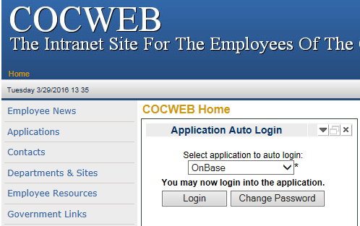

- Click on Document and select Workview from the drop down menu. See Figure 2.
Figure 2
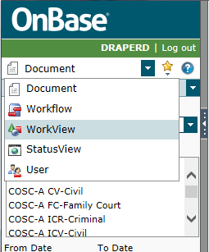

- Click Select Application and select Grand Jury from the drop down menu. See Figure 3.

Figure 3
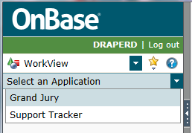

- Click Case Search and type in the case number under the Case Number search field and double click the case entry. See Figure 4.

Figure 4
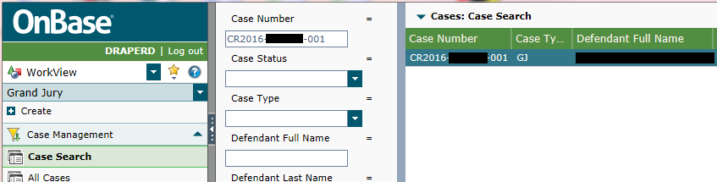

- Verify the case has been updated in WorkView. The Case Status should read Dismissed, and Dismissed Date should match the Minute Entry date in the body of the Minute Entry. See Figure 5.
- If the case has not been updated in WorkView. Double click the case number listed. Update the following:
- Case Status: Dismissed
- Dismissed/Open Date: Date Original Order to Dismiss was signed
- Click: Save and Close. See Figure 5.

Figure 5
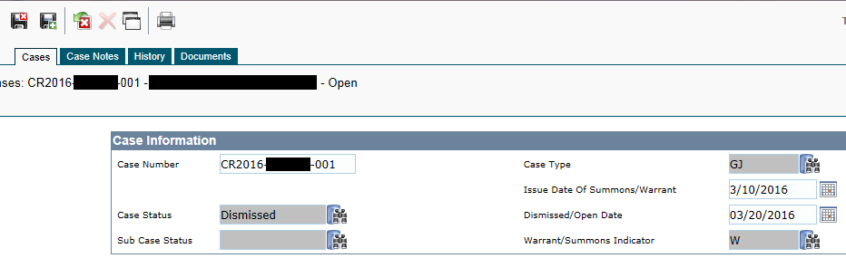

- Prepare Original Documents for EI Barcode:
- Remove the Redact Tape off of the original documents.
- Open Express Indexing and fill in the following information:
- Case Type: CR
- Docket Code: XGJ
- Case Year
- Filing Date
- Click on: Start Express Indexing
- Fill in Case Sequence
- Fill in Def. ID
- Click: Print
- Click: OK
Please note: Only one EI Barcode need be printed. All three original Dismissal documents will be placed together behind the one barcode.

- Prepare Dismissal Documents to Scan:
- Pull a Blue Docket Sheet from Distribution Bin.
- Fill out the following information:
- Circle: CR
- File Date: File Date from documents (If processing more than one dismissal with different file dates, fill in VAR)
- Document Type: XGJ
- Document Count: Count Barcodes
- Sorted By
- Docket/Barcode By
- Prepped By
- Date Received
- Date Docket/Barcoded
- Place Blue Docket sheet on top of all documents and place in XGJ Scan Bin.

- Processing a Dismissal with more than one defendant on the Indictment:
The procedure in dismissing a case with multiple defendants is the same as the procedures for single defendants with the following exceptions:
- Redact the original Indictment. Please see PRO-CROPS-XXXX: Grand Jury Redaction procedure.
- Redact the name of the defendant(s) that are dismissed off of the original indictment.
- After redacting, make one copy and rescan back into XGJ bucket.
- Delete original indictment from XGJ Bucket.
- The copy retained is now the “new Original Indictment for Openings on the remaining multiple defendant(s)”.

POLICIES / RELATED DOCUMENTS:

- PRO-CROPS-XXXX: Grand Jury Redaction procedure

OTHER PARTIES INVOLVED:

- County Attorney’s Office
- Attorney General’s Office
- Judges/Commissioners
- Criminal Court Admin
- Sheriff’s OIC

TIME / VOLUME:

- Varied

FREQUENCY:

- Varied

PERFORMANCE MEASURE:

- N/A

SYSTEM ACCESS REQUIRED:

- iCIS – Grand Jury COC
- OnBase – COSC-A-GJ
- Minute Entry Typeover: S:Drive/Doc_Management/Grand Jury/Minute Entry Typeovers-Sample
- OnBase Thin Client
- WorkView – Grand Jury

REPORTS / FORMS:

- N/A

DEFINITIONS:

- Dismiss With Prejudice – This is a court action which means an identical lawsuit cannot be filed in the future
- Dismiss Without Prejudice – The plaintiff is allowed to bring a new suit on the same claim within the period of limitation

APPLICABILITY:

This procedure applies to all employees in the Grand Jury department of the Clerk of the Court.

REVISION HISTORY:

Revision Number | Revision Author | Summary of Changes | Approval Date
- | Marcie Tarin | Document Origination | 05/18/2017
A
B
C

