PURPOSE:

The purpose of this procedure is to provide instructions for Statutes Orientation preparation.

OBJECTIVE:

- The objective of this procedure is to assure that the proper documents and forms needed to record the GJ information in the Statutes Orientation presentation is available and accurate.

EVENT DRIVER:

- A new Grand Jury has been impaneled. Documents must be ready when the County Attorney or Attorney General notifies the GJ clerk that all 26 jurors have arrived on the morning of orientation.

PROCEDURES:
- Prepare Orientation Documents
- Jury Roster – print two copies, located in S:\Doc_Management\Grand Jury\Rosters & Worksheets\XXXth Roster. Stamp today’s date.
- Jury’s Calendar – print one copy, located in your Microsoft Outlook calendar, click on Other Calendars, and click on the specific Grand Jury calendar. Print from the first month to the last month of service. Select: Print, Print Options, Monthly Style, Start date (today’s date), and End date (last day of jury service). See Figure 1.
Figure 1
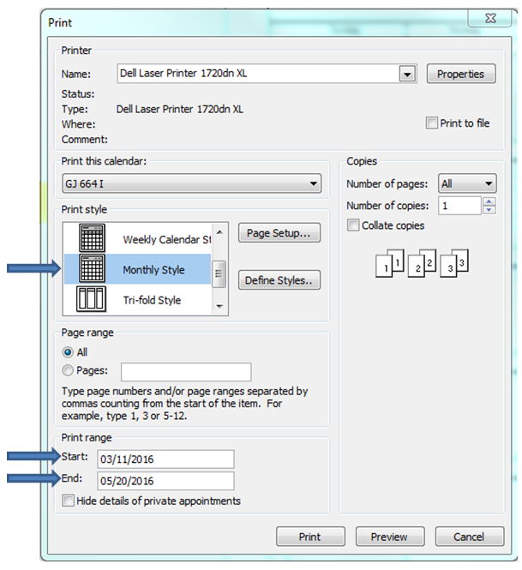

- Pink Attendance – this document is created in Post Impanelment, held by the Clerk and is located in the Jury’s File on the wall.
- Payroll Roster – pull one copy, the document is received from the Jury Commissioner and placed in the Jury’s Payroll File on the wall. If the Payroll Roster from the Jury Commissioner’s Office has not received, print an extra Jury Roster and Label on top of the roster, “PAYROLL ROSTER”. Stamp today’s date.
- Yellow Address Form – this form is created in Post Impanelment, held by the Clerk and is located in the Jury’s File in the cabinet.
- Clerk Notes for GJ Statutes – print one copy, located in S:\Doc_Management\Grand Jury\Impanelment & Statutes.

- Deliver Documents And Orientation Overview
- Read to the jury the Clerk Notes for GJ Statutes to inform and instruct jurors.
- Hand the following document to the Court Reporter:
- Jury Roster
- Hand the following documents to the Foreperson:
- Jury Calendar
- Jury Roster
- Pink Attendance
- Yellow Address Form
- Payroll Roster
- Ask the jurors if they have any questions.

POLICIES / RELATED DOCUMENTS:

- N/A

OTHER PARTIES INVOLVED:

- County Attorney
- Attorney General
- Jury Foreperson
- Court Reporter
- Selected Jury Panel

TIME / VOLUME:

- Varied

FREQUENCY:

- Statutes Day – First day of new Grand Jury service

PERFORMANCE MEASURE:

- N/A

SYSTEM ACCESS REQUIRED:

- Microsoft Outlook Grand Jury Calendars
- Jury Roster - S:\Doc_Management\Grand Jury\Rosters & Worksheets\XXXth Roster
- Clerk Notes for GJ Statutes - S:\Doc_Management\Grand Jury\Impanelment & Statutes\Clerk Notes for GJ Statutes

REPORTS / FORMS:

- Jury Roster
- Jury’s Calendar
- Pink Attendance
- Payroll Roster
- Yellow Address Form
- Clerk Notes for GJ Statutes

DEFINITIONS:

- Post Impanelment – Preparation of statutes.

APPLICABILITY:

- This procedure applies to all Grand Jury employees of the Clerk of Court.

REVISION HISTORY:

Revision Number | Revision Author | Summary of Changes | Approval Date
- | Marcie Tarin | Document Origination | 10/13/2016
A
B
C

