PURPOSE:

To provide instructions for processing grand jury petition and order to secure attendance.

OBJECTIVE:

- To provide the necessary directions to ensure grand jury petition and order to secure attendance are processed correctly and accurately.
- To ensure consistent filing and accountability of all petition and order to secure attendance filings.

EVENT DRIVER:

- A Petition and Order to Secure Attendance filing is received from one of the following:
  - County Attorney’s Office
  - Attorney General’s Office
- A Petition and Order to Secure Attendance filing is processed by the staff member assigned to Quashes/OSA’s/Dism and can be found in the OSA bin.
- Each Petition and Order to Secure Attendance will contain:
  - 1 Original Petition to Secure Attendance
  - 1 Original Order to Secure Attendance
  - 3 Copies of the Order to Secure Attendance

PROCEDURES:
- Verify Case In iCIS
  - Upon receipt of a Petition and Order to Secure Attendance filing, verify if the case is open or closed on the Main Page in iCIS.
- Closed Case: The defendant’s name will appear as Grand Jury on the Main Page in iCIS. Proceed to Step 2. See Figure 1A
Figure 1A
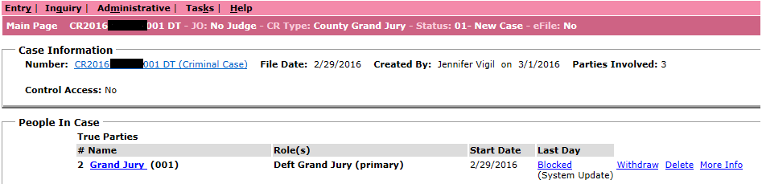
- Open Case: The defendant’s name will appear on the Main Page in iCIS. Call and return the Petition and Order to Secure Attendance to the filing agency.
- County Attorney filing – contact the County Attorney Grand Jury Supervisor
- Attorney General filing – contact the Attorney General Grand Jury Supervisor
  - Click on Grand Jury and verify the defendants name in the green Protected Grand Jury Person Information section and the name on the Original Indictment in COSC-A GJ in OnBase match the name on the Petition and Order to Secure Attendance. See Figure 1B/1C
    - If the Protected Grand Jury Person Information name does not match the Petition and Order to Secure Attendance documents call and return the documents to the filing agency
      - County Attorney filing – contact the County Attorney Grand Jury Supervisor
      - Attorney General filing – contact the Attorney General Grand Jury Supervisor
Figure 1B
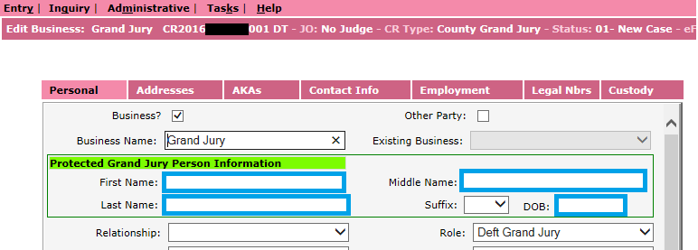

Figure 1C
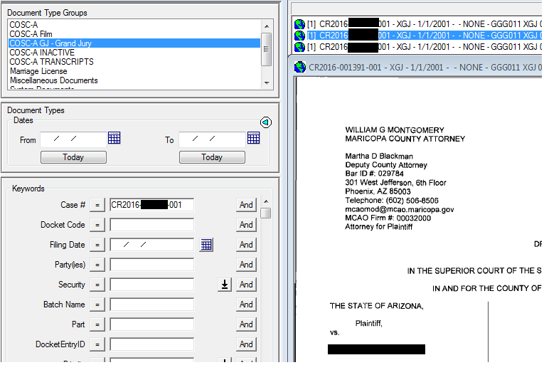

- Prepare Petition And Order To Secure Attendance Documents
  - File in the Original Petition to Secure Attendance and the Original Order to Secure Attendance
  - Certify the 3 copies of the Order to Secure Attendance. See Figure 2
    - Certified Copy Stamp – Top middle of the first page
    - Attest Stamp – Bottom right of the last page
      - Date Stamp – Attest Stamp
      - Sign – Attest Stamp
    - Crimp – Over completed Attest Stamp
Figure 2
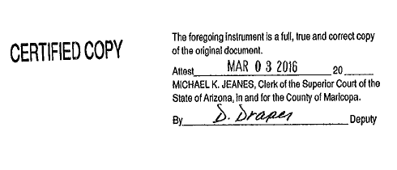

- Create Minute Entry
  - Open the Order Securing Attendance typeover from S:Drive/Doc_Management/Grand Jury/Minute Entry Typeovers-Sample/Order Securing Attendance-086
  - Complete the Minute Entry (ME) updating the following information: See Figure 3
    - File Date: File stamped date on Original Petition and Order
    - ME Date: Date Order was signed by a Judge/Commissioner
    - Case Number
    - Honorable/Commissioner: Signing Judge/Commissioner
    - Deputy Clerk: Your name
    - Attorney: Attorney name on the filing information in the upper left corner of the Order
    - Defendant Name: As it appears in iCIS/Original Indictment
    - D.O.B: As it appears in iCIS
    - Prisoner #: Provided on Order
    - Signed by the Court (in the body): Date Order was signed by a Judge/Commissioner
  - Save As to personal Grand Jury R:Drive
    - CR20[16]-[XXXXXX]-001-086-[MMDDYYYY]
  - Print 2 copies of the Minute Entry (ME)
    - Original Minute Entry
    - Copy Stamped Minute Entry

Figure 3
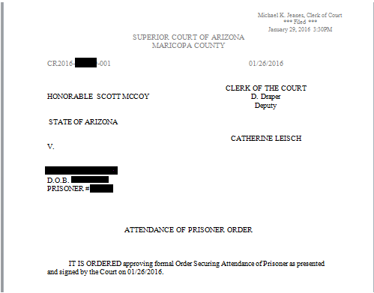

- Distribute Documents
  - Grand Jury XGJ
    - Original Minute Entry (ME)
    - Original Petition to Secure Attendance
    - Original Order to Secure Attendance
  - Attorney
    - Copy Stamped Minute Entry (ME)
  - Sheriff’s
    - 3 Certified Order to Secure Attendance

POLICIES / RELATED DOCUMENTS:

- N/A

OTHER PARTIES INVOLVED:

- County Attorney’s Office
- Attorney General’s Office
- Judges/Commissioners
- Sheriff’s Office
- Criminal Court Admin

TIME / VOLUME:

- Varied

FREQUENCY:

- Varied

PERFORMANCE MEASURE:

- N/A

SYSTEM ACCESS REQUIRED:

- iCIS – Grand Jury COC
- OnBase – COSC-A GJ
- Minute Entry Typeover: S:Drive/Doc_Management/Grand Jury/Minute Entry Typeovers-Sample

REPORTS / FORMS:

- N/A

DEFINITIONS:

- Crimp: Application of the embossed (raised) court seal.

APPLICABILITY:

- This procedure applies to all employees in the Grand Jury department of the Clerk of the Court.

REVISION HISTORY:

Revision Number | Revision Author | Summary of Changes | Approval Date
- | Danielle Draper | Document Origination | 03/08/2016
A
B
C

