PURPOSE:

To provide instructions for processing amended direct complaint filings for in custody, summons and warrant no probable cause complaint types.

OBJECTIVE:

- To provide the necessary direction to ensure amended direct complaint filings are processed correctly and accurately.
- To ensure consistent filing and accountability of all amended direct complaint filings.

EVENT DRIVER:

- An Amended Direct Complaint filing is received from one of the following:
  - County Attorney’s Office
  - Attorney General’s Office
  - Various Police Agency Officers/ Liaisons
- An Amended Direct Complaint filing is processed by the staff member assigned to Baskets/Warrants the following business day after they are received and can be found in the Warrants - Review bin.
- Amended Direct Complaint filings may have a flag sheet that reads one of the following:
  - Amended Direct Complaint
  - Amended Form IV
  - Amended Direct Complaint & Amended Form IV

PROCEDURES:
- Verify Case In iCIS
  - Upon receipt of an Amended Direct Complaint filing, identify the original complaint type by reviewing the original Direct Complaint (DCO) docket event in iCIS: See Figure 1
Figure 1
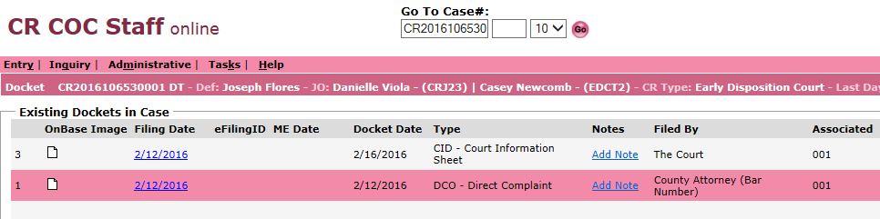
- In-Custody Complaint: The Direct Complaint will list a date in the upper right hand corner near the file stamp. These are complaints that had incorrect verbiage or missing verbiage and an Amended Direct Complaint is being filed to correct.
Proceed to Section IV.
- Summons Complaint: The Direct Complaint will list an S in the upper right hand corner near the file stamp.
- These are complaints that had incorrect verbiage or missing verbiage and an Amended Direct Complaint is being filed to correct. Proceed to Section IV.
- These complaints may have been filed without a mailing address and the attorney has decided to ask for a warrant instead. Proceed to Section II.
- Warrant No Probable Cause (WNPC) Complaint: The Direct Complaint will list WNPC in the upper right hand corner near the file stamp.
- These are complaints with rejected warrants that a reviewing Judge/Commissioner did not find enough probable cause to have a warrant issued.
- These Amended Direct Complaints will be accompanied with an Amended Form IV and an Original Warrant to be re-reviewed by a Judge/Commissioner. Proceed to Section II.

- Preparing The Amended Complaint Packet For Judicial Officer Review
  - Complete the Amended Direct Complaint packet and order as follows:
    - Rejected Warrant Email –
      - This email will be located in your Rejected Warrants email folder.
      - If you do not have the rejected warrants email – ask your Lead or Team to forward you the rejected email.
    - Amended Flag Sheet – If applicable. File stamp flag sheet with today’s date.
    - Direct Complaint –
      - Amended Direct Complaint provided, if applicable – File stamp.
      - If not, print Direct Complaint in the iCIS docket screen from the DCO docket entry. See Figure 2A.
    - Warrant Fact sheet – Print Warrant Fact Sheet in the iCIS docket screen from the DCO docket entry. See Figure 2A.
    - Original Warrant – Included in the Amended Direct Complaint packet.
    - Court Information Sheet (CIS) – 2 copies.
      - Included in the Amended Direct Complaint packet.
      - If not: Print the Court Information Sheet (CIS) in the iCIS docket screen from the CID docket entry. See Figure 2A.
    - Form IV
      - Amended Form IV: Included in the Amended Complaint packet.
      - Original Form IV: Print from the Direct Complaint in the iCIS docket screen from the DCO docket event. See Figure 2A.

Figure 2A

  - Tag pages for Judge/Commissioner review
    - Blank Tag: On Warrant Fact Sheet for quick reference.
    - Sign Here Tag: On Warrant for Arrest.
    - Sign Here Tag: On Form IV page that has the Judicial Officer Review Stamp. See Figure 1B.
    - Double check the Form IV for the Swear Stamp. See Figure 2B

Figure 2B
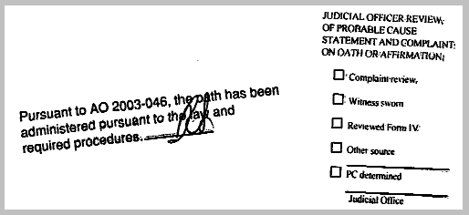

- Emailing The Reviewing Commissioner
  - Open the CR EDC/RCC-DT Work calendar in Microsoft Outlook and verify which Judge/Commissioner is assigned to review direct complaints. See Figure 3A.

Figure 3A
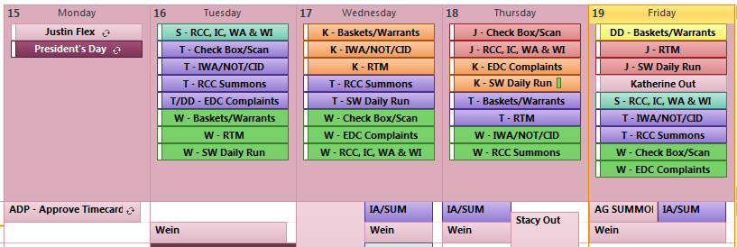
  - Compose an email to the assigned Judge/Commissioner providing the following information:
    - To: Judge/Commissioner and their Judicial Assistant.
    - CC: RCC/EDC Staff, Team Lead and Supervisor.
    - Subject: Morning Warrants.
    - Body: State what types of warrants there are for review, how many warrants, where they will be taken, and request for e-mail notification when they are completed. See Figure 3B.
Figure 3B
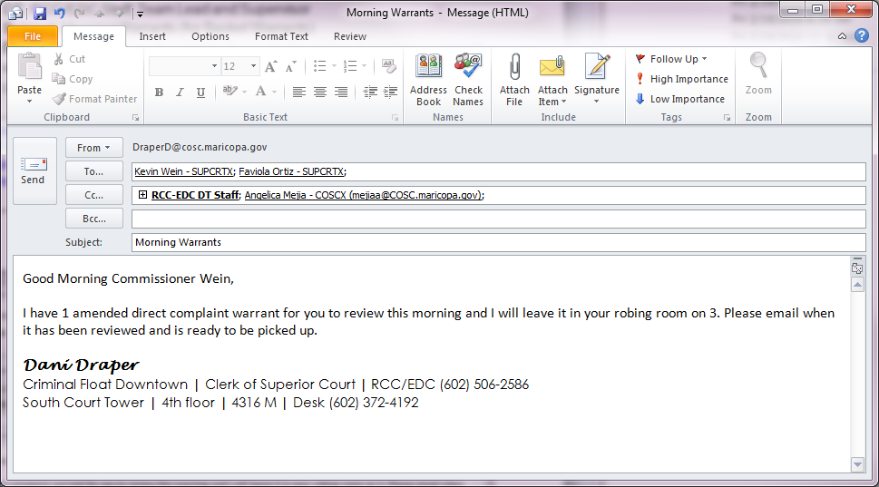
Note: This process takes place once in the morning with the Morning Warrants. The e-mail notification of completion only applies to the Morning Warrants as they will be dropped off. The Afternoon Warrants will be hand delivered and completed before returning to the RCC/EDC area. Amended Direct Complaints are processed in the morning, not in the afternoon.

  - Deliver the warrant complaint packets to the assigned Judge/Commissioner.
    - Amended Direct Complaints with warrants should be processed first thing at the start of your shift once the packets have been prepared for the Judge/Commissioner.
    - All morning warrants including Amended Direct Complaint warrants should be delivered to the assigned Judge/Commissioner all together.
  - Email notification will be sent when warrants are ready to be picked up.
  - Review all necessary signature pages before leaving the Judge/Commissioner.
    - Warrant for Arrest – verify date, signature and bond amount.
    - Form IV – verify signature on Judicial Officer Review Stamp.
  - If the Amended Complaint warrant is Accepted refer to PRO-CROPS-1003: Processing a Direct Complaint with Warrants – Section IV Step 2.
  - If the Amended Complaint warrant is Rejected refer to PRO-CROPS-1003: Processing a Direct Complaint with Warrants – Section IV Step 3B, 3F, 3G.
- Add Amended Complaint Docket Event Into iCIS
  - In the Docket Screen in iCIS Click Add. See Figure 4A
Figure 4A
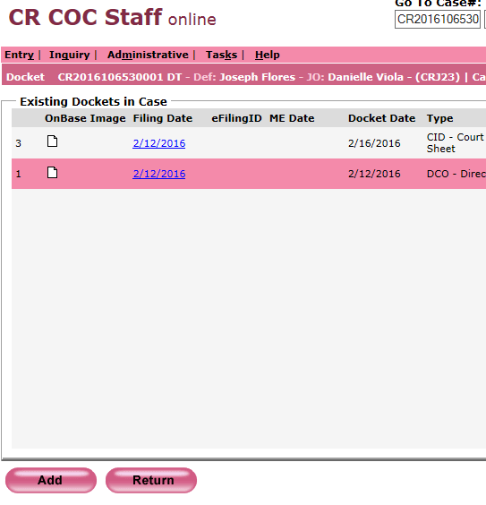
  - Complete the Add Docket Event Screen.
    - Amended Direct Complaint and Amended Direct Complaint / Amended Form IV as follows: See Figure 4B.
      - Filing Date: File stamp date on Amended Direct Complaint
      - Bar Number: Attorney bar number (Found in the upper left hand corner filing information on the Amended Direct complaint as Bar ID #)
      - Document Title: DCO (Direct Complaint)
      - Docket Notes: (in CAPs Lock)
        - Amended Direct Complaint → AMENDED
        - Amended Direct Complaint and Form IV → AMENDED/AMENDED FORM IV
      - Check Mark State of Arizona
      - Click Barcode

Figure 4B
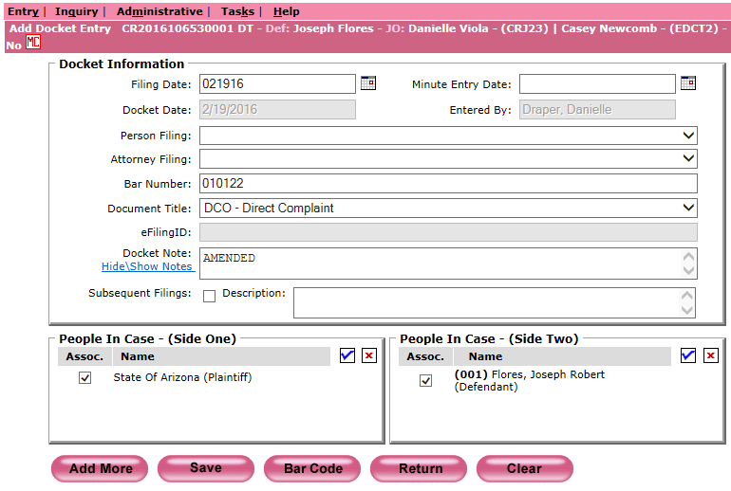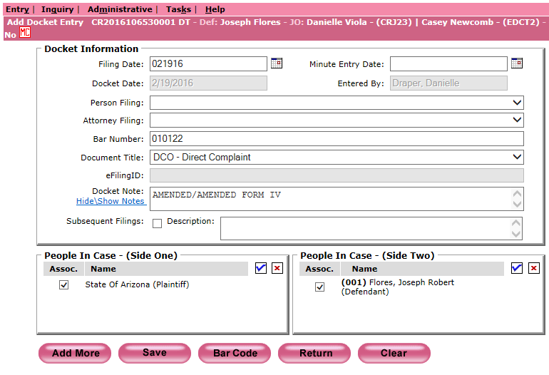

    - Amended Form IV as follows: See Figure 4C.
      - Filing Date: File stamp date on the Amended Complaint Flag Sheet
      - Attorney Filing: Court
      - Document Title: NTF (Notice to the File)
      - Docket Notes: AMENDED FORM IV (in CAPs Lock)
      - Click Barcode
Figure 4C
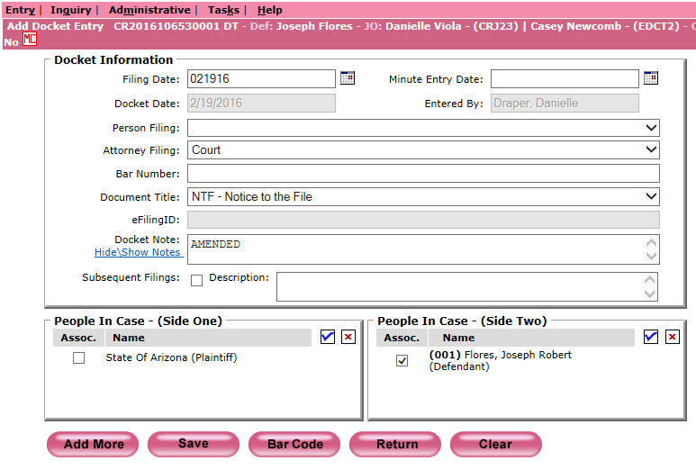

  - On one copy of the Court Information Sheet (CIS) write Amended DCO or Amended Form IV for Court Admin’s reference

- Log Complaint In Case Number Log Book
Add the Amended Direct Complaint information into the Case Number Log Book on the DT IA Assigned Numbers tab with the appropriate notes in the Complaint Type column. See Figure 5.
Figure 5

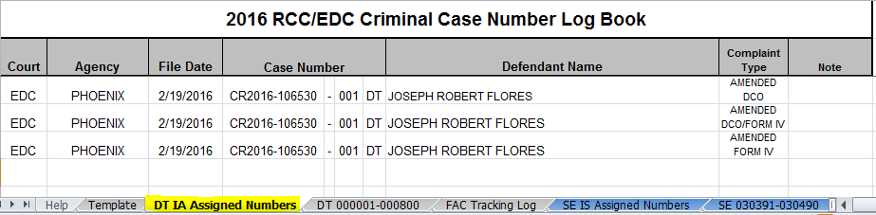

- Print Barcodes And Prep For Scanning
  - Open Express Indexing 2.5 and Print All barcodes. See Figure 6.
Figure 6
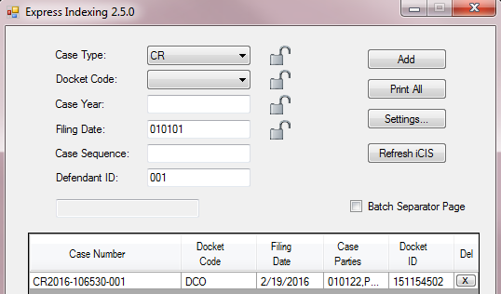
  - Merge all barcodes in front of each correlating Amended Direct Complaint filing. Make sure to double check the case number on the Barcode to the case number on the Amended Direct Complaint while merging.
  - Create a Batch Slip for the barcoded documents as follows: Circle CR at the top.

    - Year: Case number year. If there are multiple case years on the documents (Example: CR2015 & CR2016) write VAR on this line.
    - File Date: File stamp date
    - Document Type: DCO or NTF
    - Document Count: Number of barcoded documents
    - Received Date: Date processing Amended Direct Complaints
    - Sort By: Your 3 initials
    - Docketed/Barcoded By: Your 3 initials
    - Date Docketed/Barcoded: Date docket event/barcode was created
    - Prep By: Your 3 initials
  - Attach the Batch Slip to the front of the barcoded documents and place in the scanning basket.
  - Place the Court Admin Copy of the Court Information Sheet (CIS) with Amended DCO or Amended Form IV written on it in the designated court bin.
    - Court Admin – RCC
    - Court Admin – EDC

POLICIES / RELATED DOCUMENTS:

- PRO-CROPS-1003: Processing a Direct Complaint with Warrants Complaints
- PRO-CROPS-1009: RCC/EDC Daily Run
- PRO-CROPS-1010: Barcoding Documents using the Express Indexing Program

OTHER PARTIES INVOLVED:

- County Attorney’s Office
- Attorney General’s Office
- Judges/Commissioners
- Sheriff’s Office
- Criminal Court Admin

TIME / VOLUME:

- Varied

FREQUENCY:

- Varied

PERFORMANCE MEASURE:

- N/A
SYSTEM ACCESS REQUIRED:

- iCIS
- Express Indexing 2.5
- Case Number Log Book: S:\Doc_Management\RCC & EDC\RCC-EDC Log Books - Current & Archived\DT RCC-EDC 2016 Case Number Log Book
- Microsoft Office Outlook

REPORTS / FORMS:

- Warrant Delivery Log
- F-EDMQC-1016-1: Batch Slip – Priority

DEFINITIONS:

- Basket(s): Non-priority direct complaint case type.

APPLICABILITY:

- This procedure applies to all employees in the RCC/EDC department of the Clerk of the Court.

REVISION HISTORY:

Revision Number | Revision Author | Summary of Changes | Approval Date
- | Danielle Draper | Document Origination | 02/22/2016
A
B
C

