PURPOSE:

To provide instructions for processing juvenile direct complaint filings.

OBJECTIVE:

- To provide the necessary direction to ensure juvenile direct complaints are processed correctly and accurately initiated.
- To ensure consistent filing and accountability of all juvenile direct complaints.

EVENT DRIVER:

- A juvenile direct complaint filing is hand delivered via interoffice from juvenile courts.
- A juvenile direct complaint is a case where the defendant is under the age of 18 and is to be tried as an adult.

PROCEDURES:
- Verify Complaint Paperwork:
  - Ensure the following documents are received upon receipt of a Juvenile Direct Complaint filing:
    - Direct Complaint (DCO) Packet
      - Direct Complaint – from the Juvenile Division
      - Form IV – also known as the Release Questionnaire
    - Court Information Sheet (CIS)
  - File stamp both documents and ensure the case number is written on the first page of both documents.

- Manually Initiate The Juvenile Direct Complaint In iCIS And Add Docket Events:
  - Click Task → COC Case Initiation See Figure 1A
Figure 1A
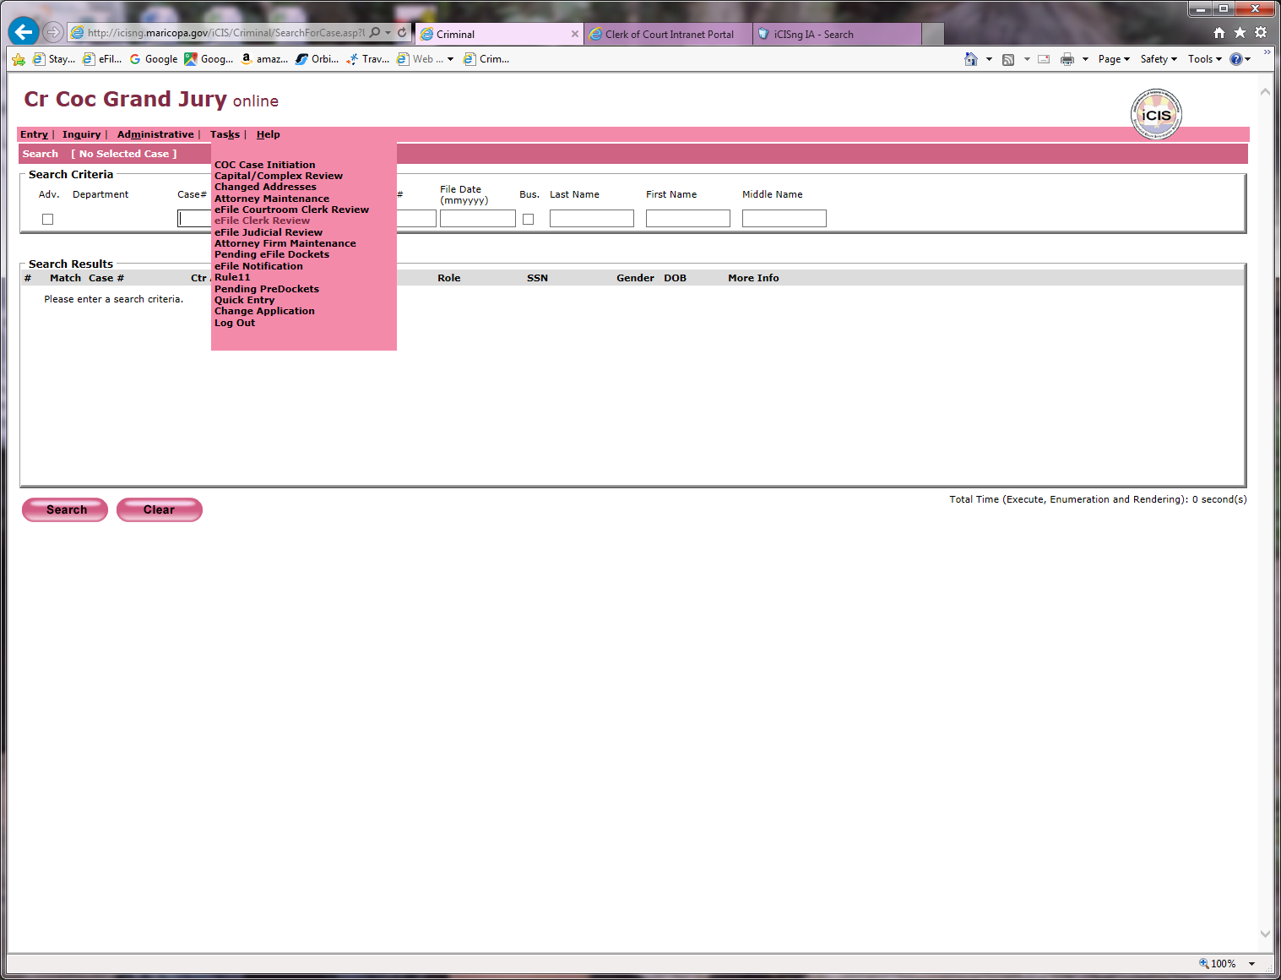

  - Complete the Case Initiation Screen as follows: See figure 1B
    - Case Type: Criminal
    - Case Number: Written on paperwork
    - CR Type:
      - Juvenile Direct Complaint: If filed during the work week
      - Direct Complaint: If filed on the weekend
    - Facility: Downtown
    - File Date: File stamp date
    - Click Continue
Figure 1B
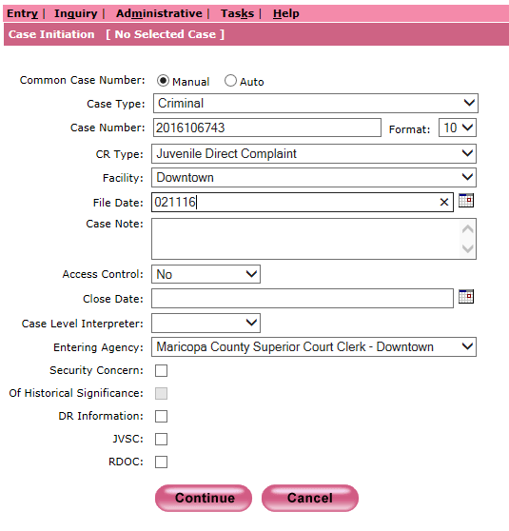
  - Complete the Add Parties to Case Screen as follows: See Figure 1C
    - First Name: As it appears on the Direct Complaint
    - Middle Name: If applicable
    - Last Name: As it appears on the Direct Complaint
    - Suffix: If applicable
    - Primary Role: Defendant
    - Start Date: File stamped date
    - Def ID: Ending 3 numbers of Case number – Typically 001
    - Sex: M or F – Found on CIS sheet
    - DOB: Found on CIS Sheet
    - SSN: If applicable – Found on CIS Sheet
    - Filing Agency: Maricopa County Attorney
    - Click Continue

Figure 1C
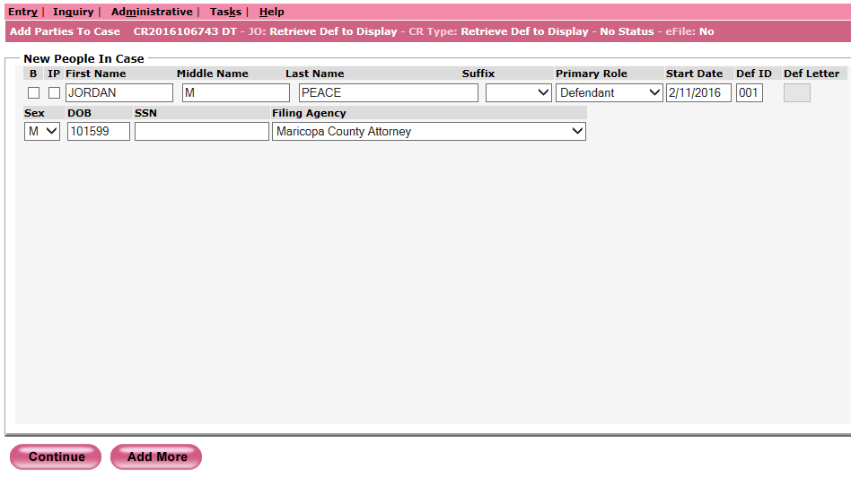
  - Verify DCO (Direct Complaint) docket entry. See Figure 1D
    - Click to check mark State of Arizona
    - Click Barcode
Figure 1D
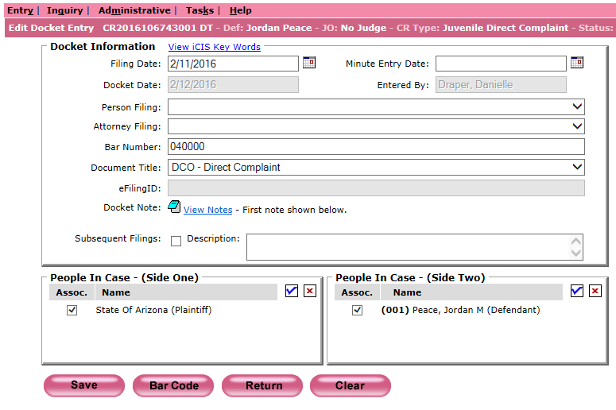

  - Add the CID (Court Information Sheet) docket event
    - In the Docket Screen click Add. See Figure 1E
Figure 1E
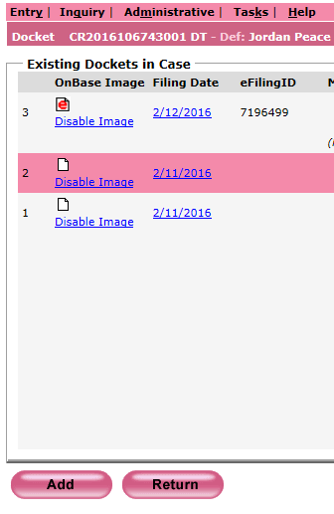
    - Complete the CID docket event as follows: See Figure 1F
      - Filing Date: File stamp date
      - Attorney Filing: Court
      - Document Title: CID (Court Information Sheet)
      - Click Barcode
Figure 1F
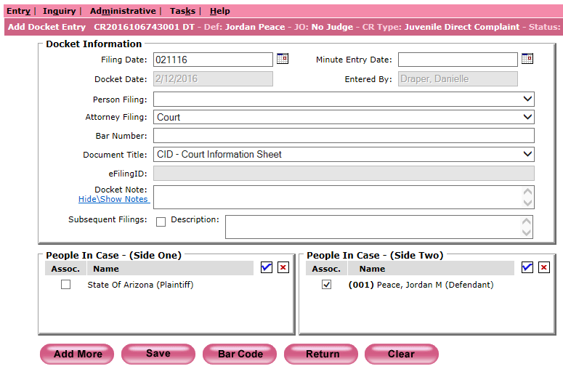

- Emailing The Juvenile Case Filed Distribution:
  - Compose an email to the Juvenile Case Filed distribution list providing the following information: See Figure 2
    - To: Juvenile Case Filed
    - Subject: Juvenile Case(s) Filed
    - Body: provide the PbK number, defendant’s entire name and case number
Figure 2
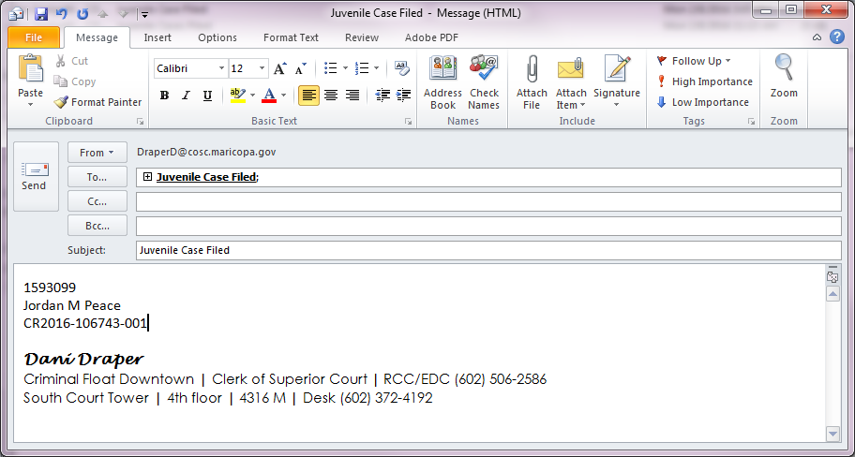

- Print Barcodes And Distribute Paperwork
  - Open Express Indexing 2.5 and Print All barcodes. See Figure 3
Figure 3
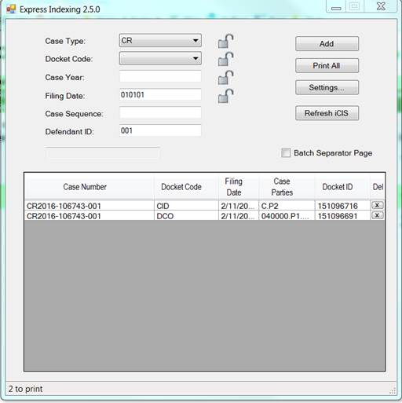
  - Make a copy of the Court Information Sheet (CIS) sheet for Court Admin and write Juvenile DCO on the copy.
  - Merge Barcodes in front of their correlating document: DCO or CID.
  - Create a Batch Slip for the barcoded DCO and CID as follows:
    - Circle CR at the top
    - Year: Case number year (If there are different case years on the documents [Example: CR2015 & CR2016] write VAR on this line)
    - File Date: File stamp date (If there are different file stamp dates on the documents write VAR on this line)
    - Document Type: DCO
    - Document Count: Number of barcoded documents
    - Received Date: Date processing the juvenile direct complaint for scanning
    - Sorted By: Your 3 initials
    - Docketed/Barcoded By: Your 3 initials
    - Date Docketed/Barcoded: Date docket event/barcode was created
    - Prep By: Your 3 initials
  - Attach the Batch Slip to the front of the barcoded documents and place in the scanning basket.
  - Place the Court Admin Copy of the CIS sheet with Juvenile DCO written on it in the Court Admin - RCC bin

POLICIES / RELATED DOCUMENTS:

- ARS 13-501: Persons under eighteen years of age; felony charging; definitions
- PRO-CROPS-1010: Barcoding Documents using the Express Indexing Program

OTHER PARTIES INVOLVED:

- Maricopa County Attorney’s Office
- Juvenile Division
- Criminal Court Admin

TIME / VOLUME:

- Varied

FREQUENCY:

- Varied

PERFORMANCE MEASURE:

- N/A
SYSTEM ACCESS REQUIRED:

- iCIS
- Express Indexing 2.5
- Microsoft Office Outlook

REPORTS / FORMS:

- F-EDMQC-1016-1: Batch Slip – Priority

DEFINITIONS:

- PbK number: County Attorney filing number found on the upper right hand corner of the Court Information (CIS) Sheet and the right hand corner of the Direct Complaint under the filing agency.

APPLICABILITY:

- This procedure applies to all employees in the RCC/EDC department of the Clerk of the Court.

REVISION HISTORY:

Revision Number | Revision Author | Summary of Changes | Approval Date
- | Danielle Draper | Document Origination | 02/22/2016
A
B
C

