PURPOSE:

To provide instructions for creating a basic case shell in iCIS.

OBJECTIVE:

- To provide the necessary instruction to ensure the Juvenile Direct Complaint filings are accurately initiated.
- To ensure consistent filing and accountability of all Direct Complaint filings.

EVENT DRIVER:

- A Juvenile Direct Complaint filing is received from one of the following:
  - Clerk of Court Juvenile
  - County Attorney’s Office
  - Or various Police Agency Officers / Liaisons

PROCEDURES:
- Refer to the Direct Complaint heading to confirm it is in fact a “Juvenile Direct Complaint”. See Figure 1.
- Log into iCIS
- Select CR COC Staff. See Figure 2.

Figure 1
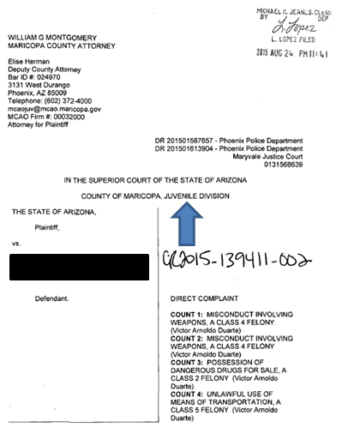

Figure 2
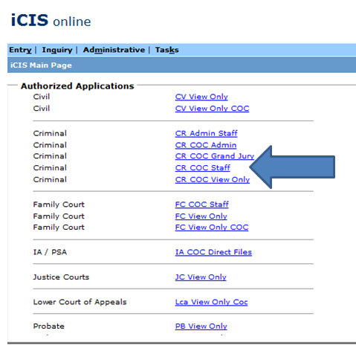

- Hover over the Tasks option and select COC Case Initiation. See Figure 3.

Figure 3
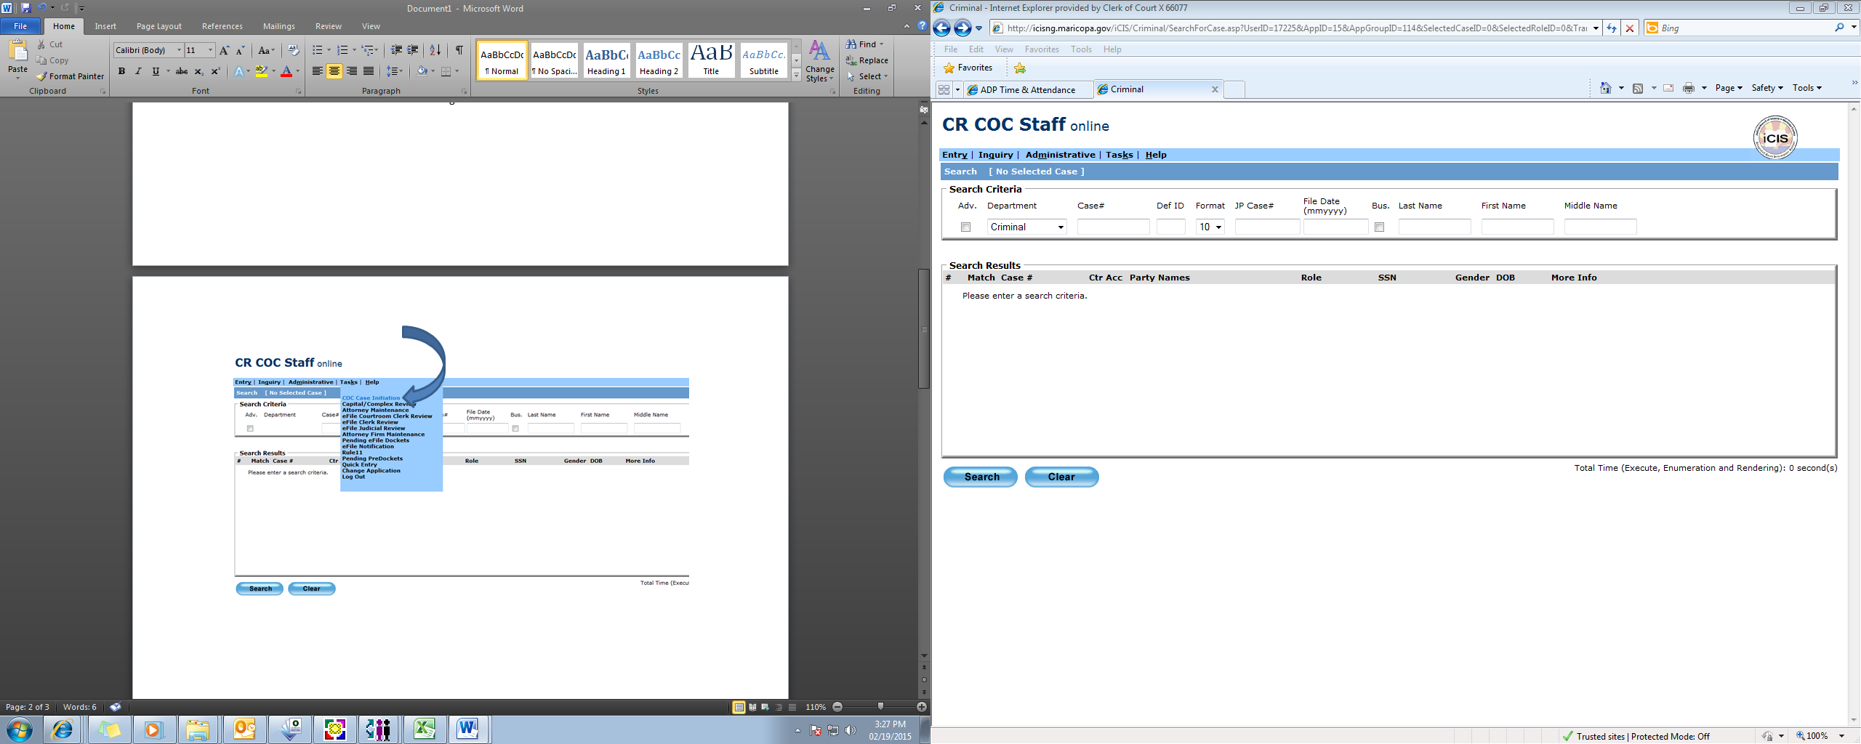

- The Case Initiation screen will default with “Criminal” in the Case Type field as shown in Figure 4.

Figure 4
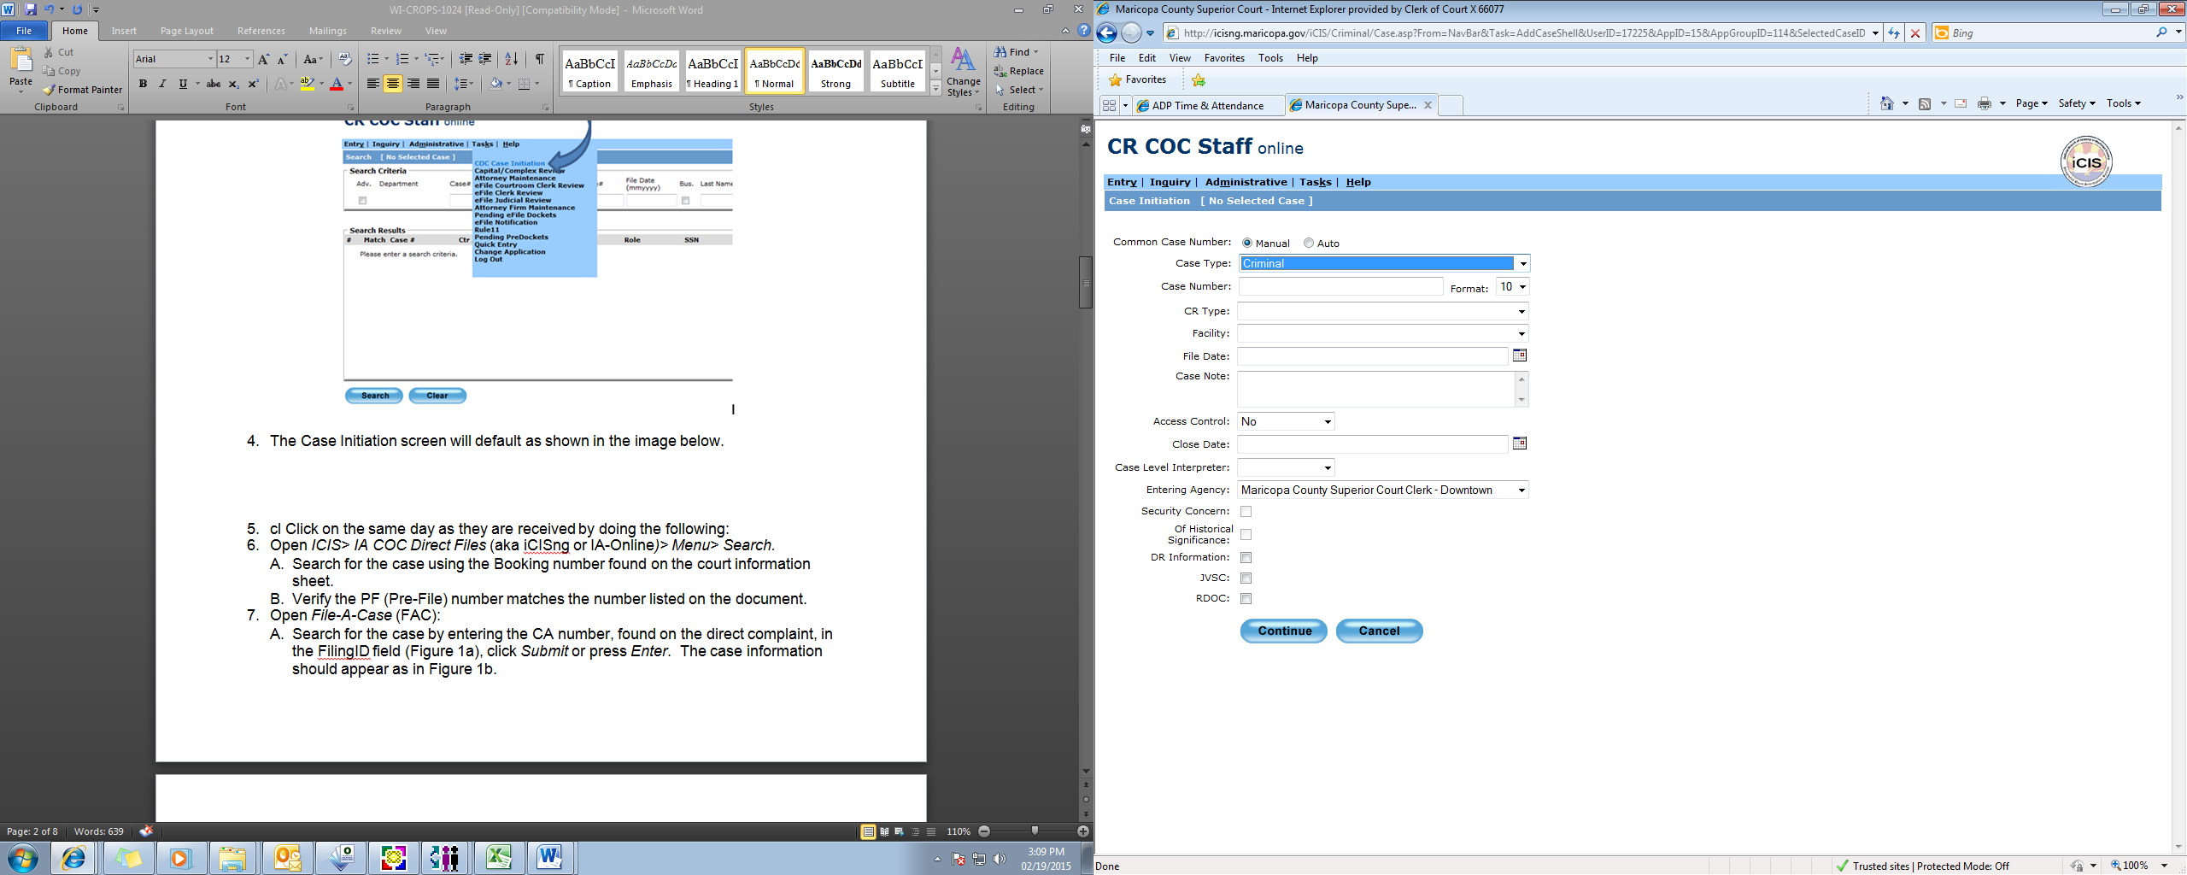

- Tab down to the Case Number field. Enter the year and six digit case number with no dash. See Figure 5.
Figure 5
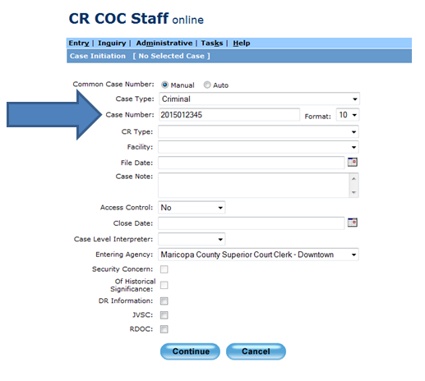

- Bypass the Format field and tab to the CR Type field.
- Refer to the Direct Complaint paperwork and select the appropriate option per the two listings below. Please note that the day of the week will depend on whether to select “Direct Complaint” or “Juvenile Direct Complaint”. See Figure 6.
  - Direct Complaint
    - Select if the complaint is filed on a weekday.
  - Juvenile Direct Complaint
    - Select if the complaint is filed on the weekend.

Figure 6
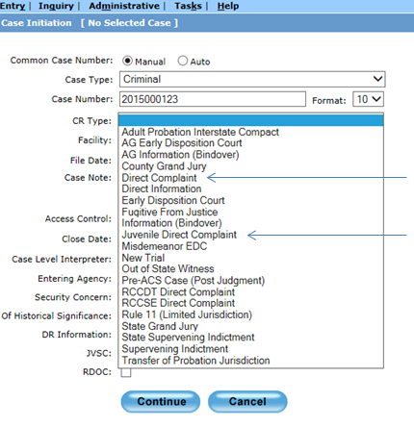

- Tab to the Facility field and select the Downtown option. See Figure 7.

Figure 7
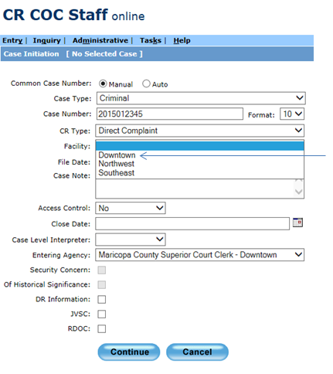

- Tab to the File Date field. See Figure 8. Enter the file date on the upper right hand corner of the Direct Complaint.
- Note: No dashes are necessary.
9. Tab all the way to the blue Continue button and press Enter.

Figure 8
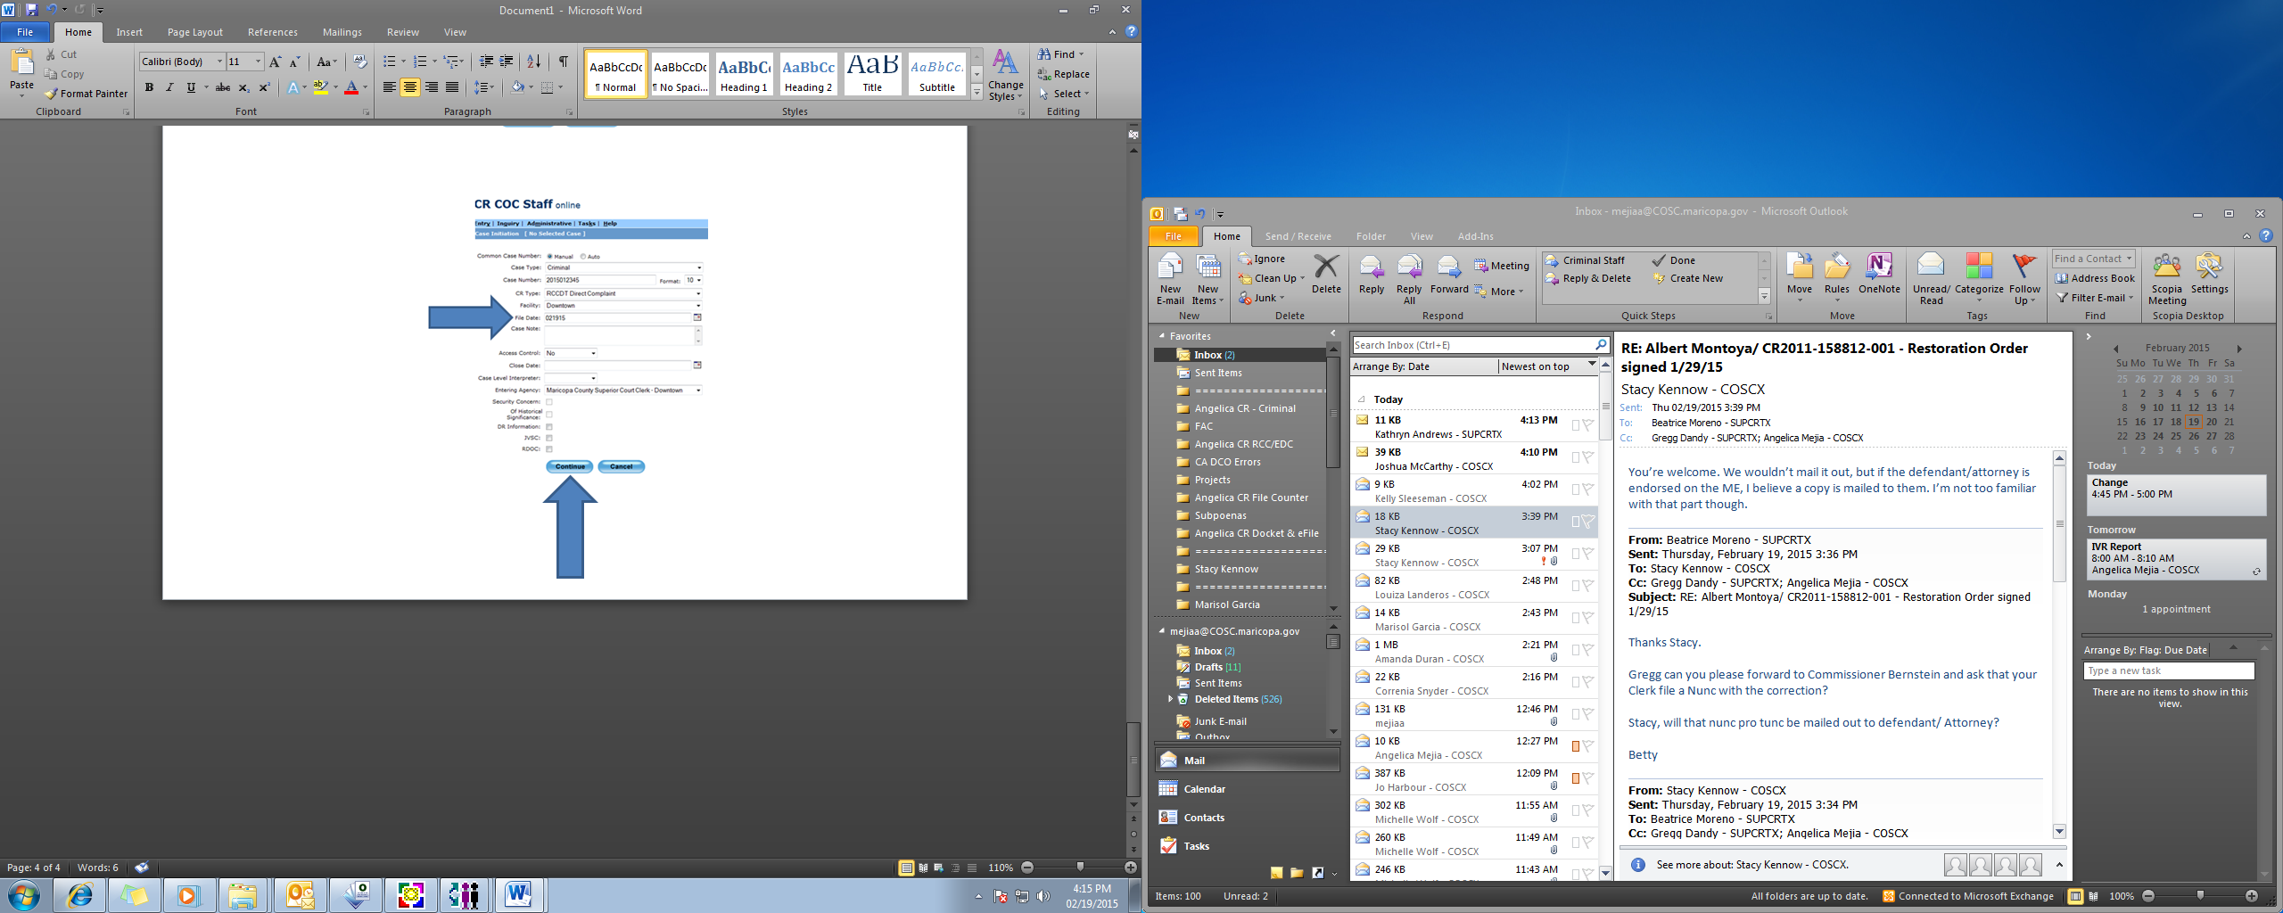

- The Add Parties To Case screen will default as shown in Figure 9.
- Note: The Primary Role field defaults to Defendant.

Figure 9
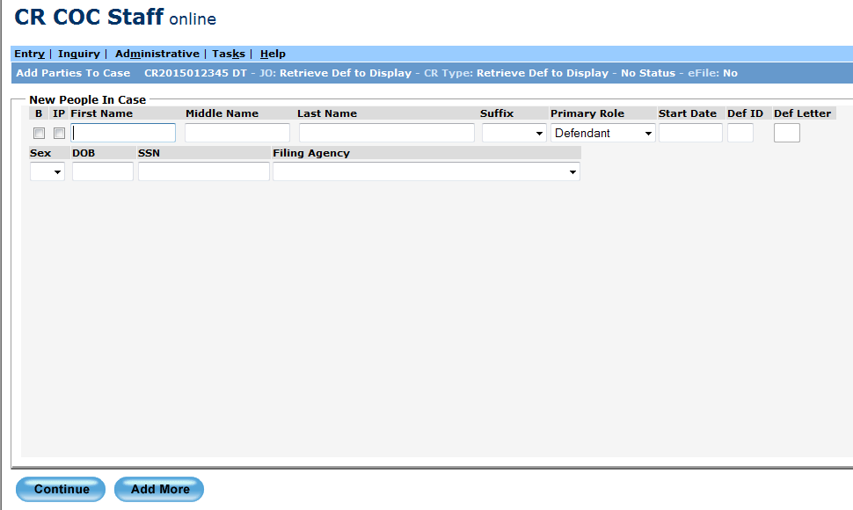

- Type in the name as it appears on the Direct Complaint in the First Name and Last Name field. Enter the Middle Name if listed on the Direct Complaint. See Figure 10.
- Note: Type with the Caps Lock on.

Figure 10
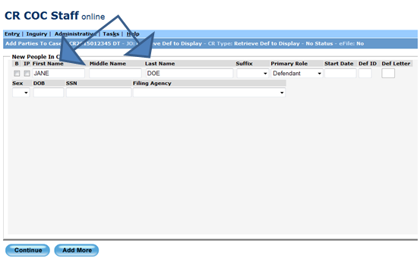

- Tab to the Sex field and enter the sex based off of the Court Information Sheet (CIS).
- Tab to the DOB field and enter based off of the Court Information Sheet (CIS).
- Tab to the SSN field and enter based off of the Court Information Sheet (CIS).
- Tab to the Filing Agency field and select Maricopa County Attorney. See Figure 11.

Figure 11
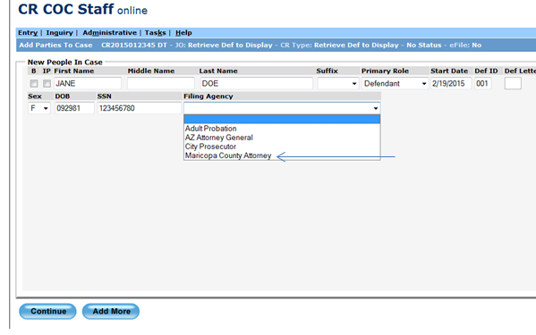
- Tab to Continue and press Enter.
- Note: If the case is a multiple defendant select Add More and enter the co-defendant’s information. Once completed press Continue.
- The screen will roll to the Edit Docket Entry screen and at that point the case initiation will be completed. See Figure 12.

Figure 12
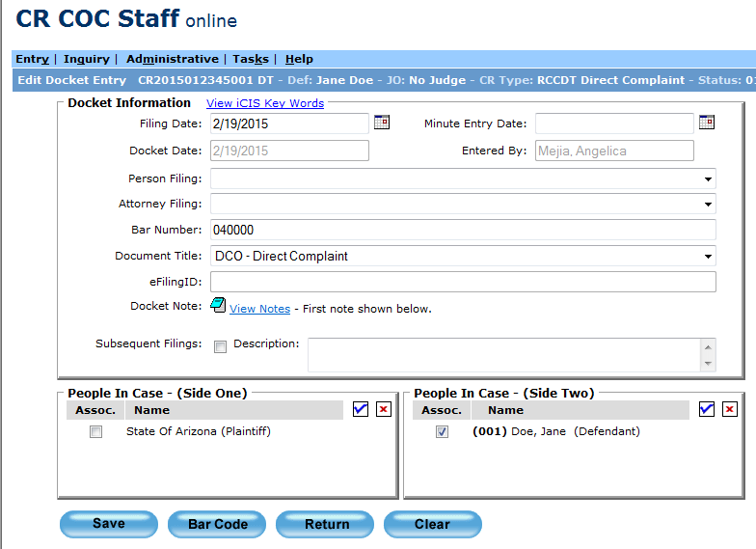

- Repeat steps 3-13 to complete another case initiation, or right click in an open space and select Main Page, or exit out of iCIS if completed.
- Deliver the Juvenile Direct Complaint paperwork the following business morning to the EDC/RCC department located on the 4th Floor of 175 W. Madison, Phoenix, AZ 85003.

Note: If a case shell is entered and saved under the incorrect case number in the Case Information screen email the EDC/RCC Court Operations Supervisor or Court Operations Lead to delete the incorrect case shell. Staff can still proceed to create another case shell under the correct information.

POLICIES / RELATED DOCUMENTS:

- N/A

OTHER PARTIES INVOLVED:

- County Attorney’s Office
- Initial Appearance Court Staff
- Clerk of Court Staff
- Maricopa County Sherriff’s Office
- Various Police Agency Officers/Liaisons
- Court Administration

TIME / VOLUME:

- N/A

FREQUENCY:

- N/A

PERFORMANCE MEASURE:

- N/A

SYSTEM ACCESS REQUIRED:

- iCIS
- CR COC Staff

REPORTS / FORMS:

- N/A

DEFINITIONS:

- IA Court: Initial Appearance Court
- DCO: Direct Complaint

APPLICABILITY:

This procedure applies for all IA Court staff of Maricopa County Superior Court.

REVISION HISTORY:

Revision Number | Revision Author | Summary of Changes | Approval Date
- | Angelica Mejia | Document Origination | 08/28/2015
A
B
C

