PURPOSE:

To provide instructions for IA Court Judicial Officer’s with Direct Complaint Warrant review.

OBJECTIVE:

- To provide the necessary instructions to guide Judicial Officer’s for Direct Complaint Warrant review.
- To ensure consistent filing and accountability of all Direct Complaint Warrant filings.

EVENT DRIVER:

- A Warrant or Warrant In-Custody Direct Complaint filing is received from one of the following:
  - County Attorney’s Office
  - Or various Police Agency Officers / Liaisons

PROCEDURES:
- There are two types of Direct Complaint Warrant packets.
  - Warrant (WA)
  - Warrant In-Custody (ICOC) – Warrant In-Custody Other Charges
- After IA Court staff do their portion with the Direct Complaint, they will provide you with the following paperwork:
  - Direct Complaint
  - Court Information Sheet
  - Warrant Fact Sheet
  - Warrant
  - Form IV
3. Warrant Review
- Confirm the AO stamp is on the last page of the Form IV with IA Court staff’s initials. See Figure 1.

Figure 1

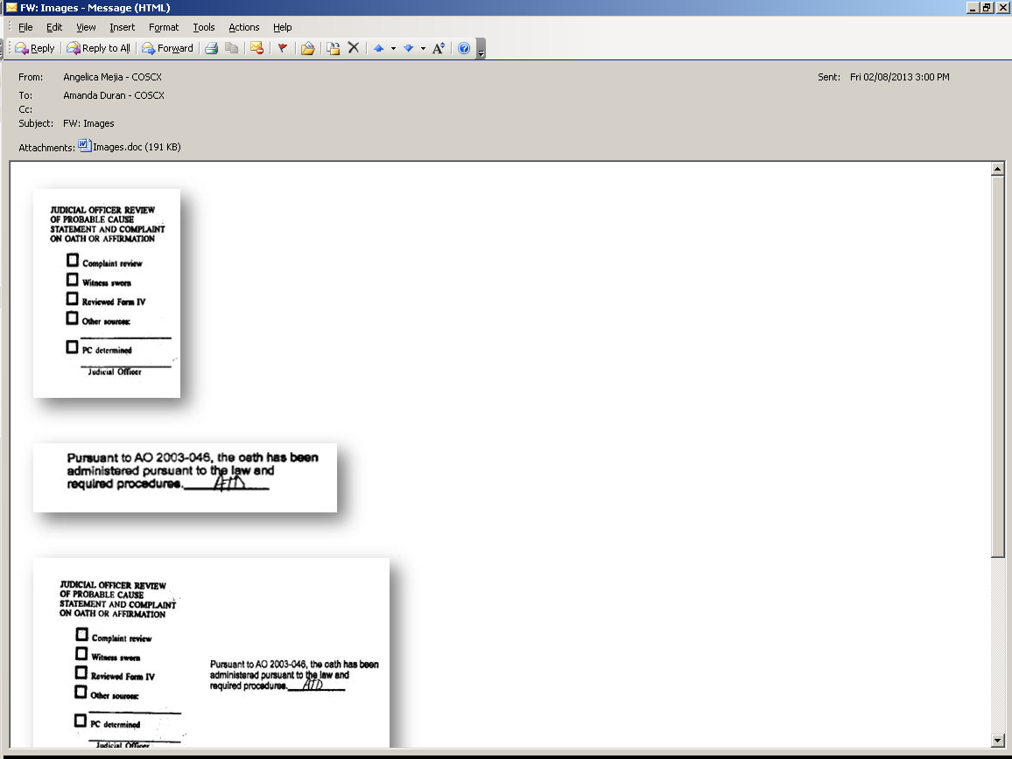

- If the AO stamp is missing proceed to swear in the officer/liaison.
- Check the Witness Sworn box on the Judicial Review stamp located on the last page of the Form IV. See Figure 2.

Figure 2
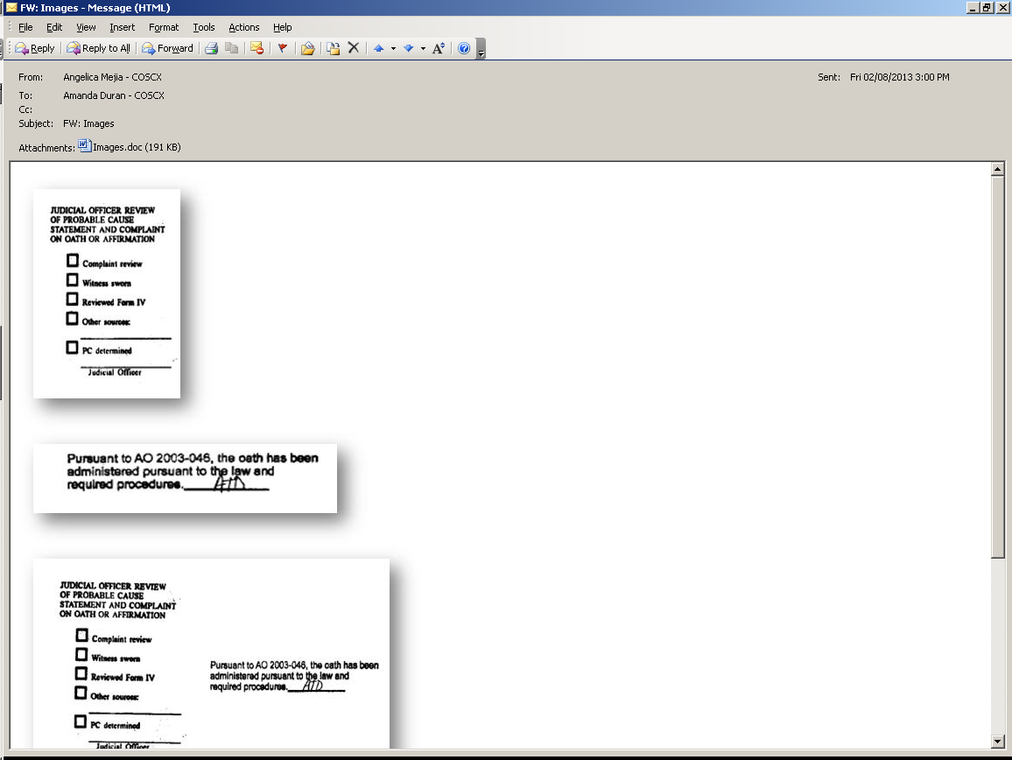

- Review the packet and Form IV.
- Steps if probable cause is found:
- If probable cause is found for the charges in the Direct Complaint proceed to check the appropriate boxes on the Judicial Review stamp.
- Sign your name on the Judicial Officer line located on the Judicial Review stamp. See Figure 3.
Figure 3
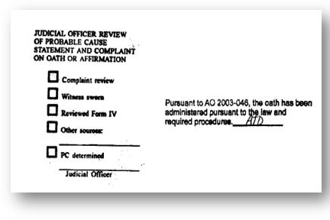

- Fill in the appropriate areas and set the bond amount on the Warrant. If the defendant is to be held non-bondable proceed to check the box stating “Defendant is to be held without bond”.
- Sign the Warrant. See Figure 4.

Figure 4

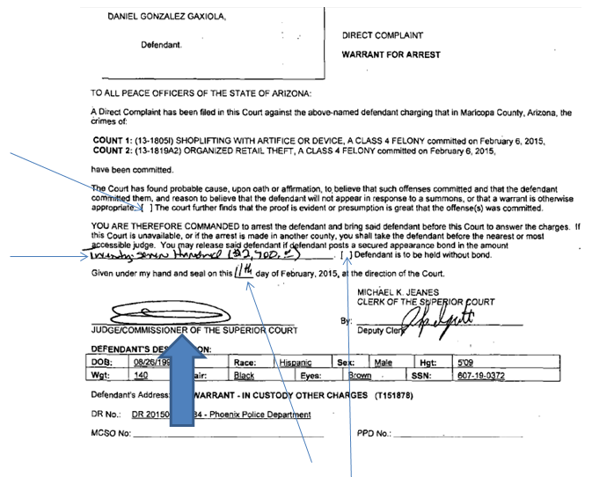
- Return the entire packet to IA Court Staff.
- Steps if probable cause is not found on a Warrant:
- If PC is not determined do not sign the Judicial Review stamp.
- Proceed to write on a sticky note the reason(s) for the rejection.
- Put the sticky note on the front page of the Direct Complaint.
- Return the entire packet to IA Court Staff.

- Steps if probable cause is not found on a Warrant In-Custody:
- If the matter is an ICOC refer to the officer/liaison for further information and/or clarification.
- If PC is then found, follow steps 3,E - a through e.
- If PC is still not found, follow steps 3,F – a through d.

POLICIES / RELATED DOCUMENTS:

- N/A

OTHER PARTIES INVOLVED:

- County Attorney’s Office
- IA Court Staff
- Clerk of Court Staff
- Maricopa County Sherriff’s Office
- Various Police Agency Officers/Liaisons

TIME / VOLUME:

- N/A

FREQUENCY:

- N/A

PERFORMANCE MEASURE:

- N/A

SYSTEM ACCESS REQUIRED:

- N/A

REPORTS / FORMS:

- N/A

DEFINITIONS:

- IA Court: Initial Appearance Court
- ICOC : Warrant In-Custody – Warrant In-Custody Other Charges
- PC: Probable Cause
- WA: Warrant

APPLICABILITY:

This procedure applies to all Judicial Officer’s assigned to IA Court Direct Complaint Warrant review for Maricopa County Superior Court.

REVISION HISTORY:

Revision Number | Revision Author | Summary of Changes | Approval Date
- | Angelica Mejia | Document Origination | 03/17/2015
A
B
C

