PURPOSE:

To provide instructions for permanent excusal of a Grand Jury juror.

OBJECTIVE:

- Grand Jurors periodically request to be permanently excused from jury duty service. The Criminal Presiding Judge is the only one with the authority to permanently excuse a juror. If the Juror can provide a sufficient reason to the judge, their request may be granted. Otherwise, the juror may be denied and/or placed on the alternate juror list.

EVENT DRIVER:

- When a Grand Juror requests permanent excusal from service on a Grand Jury (GJ).

PROCEDURES:
- Juror Permanent Excusal Request:
- Jurors must submit a written request to the Grand Jury Clerks Office. The letter should be addressed to the Presiding Criminal Judge, and should be detailed as to the reason for the request. The request may be e-mailed, faxed, or hand delivered to the Grand Jury Clerk’s Office.

Note: The juror can attach a supporting letter from their employer or doctor if they feel it is necessary. Each letter that is faxed or hand delivered must be file stamped.

Note: Alternate juror’s sometimes request permanent excusal from serving as an alternate. The same process is followed, with the only difference being the form that is used for the Minute Entry.

- Upon receipt of a letter, the juror is to be advised by the Grand Jury Clerk that they are still a member of the jury and must continue to attend jury duty service until the judge makes a ruling.
- If the letter is received in hard copy, the clerk will scan the letter and save in the folder for the corresponding jury.
    - Open the Grand Jury folder.
    - Double click on the Jury Folders file to access.
    - Save the electronic version of the letter into the appropriate jury folder.
- The Grand Jury Clerks will forward all permanent excusal requests to the Criminal Presiding Judge. The clerks must also provide the Judge with the number of remaining alternate jurors and the date the jury panel will end.
- Open the Grand Jury folder.
- Double click on the Rosters and Worksheets folder to access.
- Find and go into the jury panel that the requesting juror belongs to. Obtain the number of alternate jurors still available and the last day of jury service. This information is then to be provided to the Judge.
- If the excusal letter was e-mailed to the Grand Jury Clerks, forward the e-mail to the appropriate Criminal presiding judge and the information obtained from the jurors Rosters and Worksheets folder included in the body of the e-mail. See Figure 1 for an example of how the e-mail should read. The Criminal Presiding Judicial Assistant, Criminal Presiding Bailiff, GJ Manager, GJ Supervisor, GJ Lead and GJ Staff should all be copied on the e-mail.
Figure 1
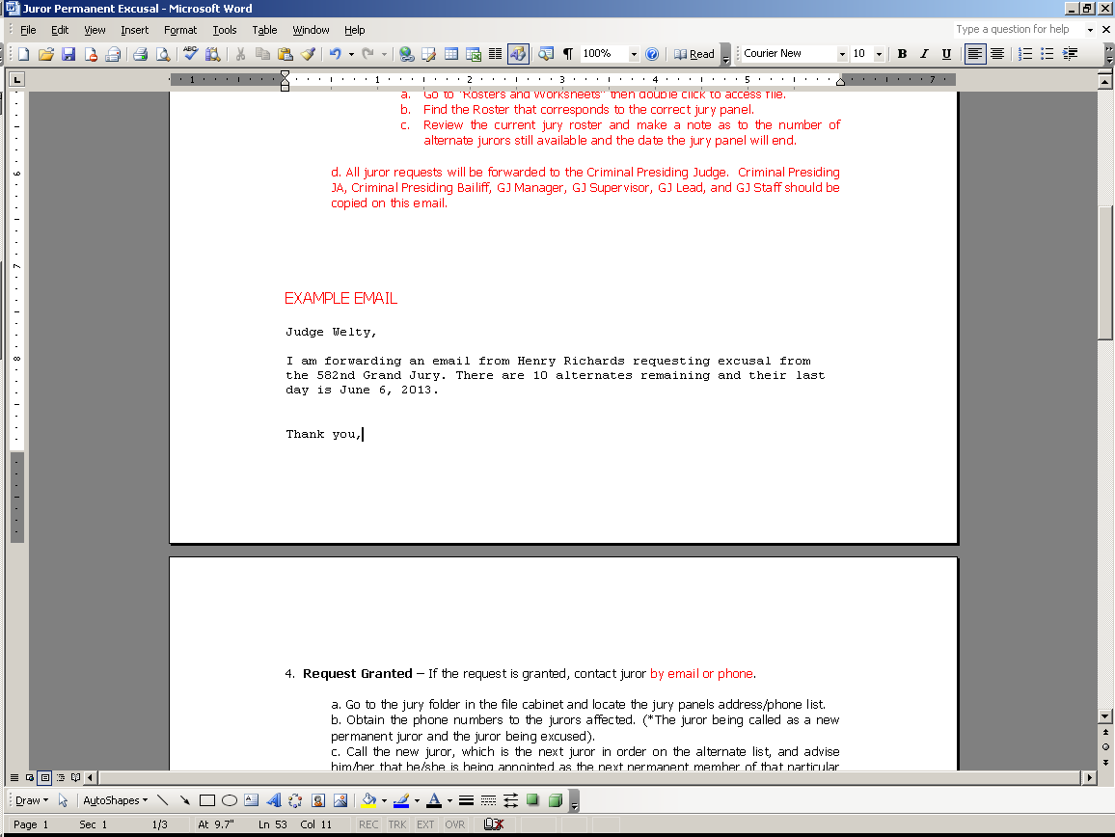

- If the excusal letter is faxed or hand delivered, the Grand Jury Clerks must file in the letter and any supporting letters provided with the excusal.
- The letter can then be forwarded to the Judge by scanning and e-mailing it.
- The letter can also be sent interoffice to the Judge within a RED folder.

Note: E-mailing the excusal letter to the Judge is the quickest way to get a response.

- Request Granted:
- If the request is granted, contact the juror by e-mail or phone to notify them that have been excused. Notify the next alternate juror that they have been appointed as a permanent member of that particular jury panel.
  - Obtain the contact information for the jury panel within their designated folder that is located in the large file cabinet.
  - Locate the phone numbers to both jurors affected. (The juror being called as a new permanent juror and the juror being excused.)
    - Call the juror being excused and inform them that the judge has granted their request. Thank them for their service on the Grand Jury.
        - If the juror cannot be contacted by phone, a message may be left and an e-mail may also be sent to their e-mail address on file.
    - Call the new juror, which is the next juror in order on the alternate list, and advise them that they are being appointed as the next permanent member of that particular jury panel.
- Remind the juror of the days the jury panel meets, the time, location, etc.
- The juror may need to miss a day or two of service to get their affairs in order, re-schedule work, arrange for a babysitter, etc.
- Remind the new permanent juror to bring their parking pass that was provided to them at orientation.

Note: If the juror must miss upcoming days of service, note the juror’s absence on the jury panel’s calendar in Microsoft Outlook.

- Prepare a minute entry to account for the change to the Grand Jury panel.
  - Open the Grand Jury folder.
  - Double click on Jury Folders to access the file.
  - Double click on Juror Excusal-000th-Name-Name-023-0002013, Juror Excusal-Move to Alternate-000th-Name-023-0000000 or Juror Excusal-Alternate-000th-Name-023-00000000(whichever is applicable) to open the file.
  - Fill in the required blanks on the minute entry typeover template. Fill in the following areas:
    - The date the Minute Entry (ME) is being filed.
    - The ME date.
    - The first initial and last name of the clerk creating the minute entry.
    - The jury panel number.
    - The name of the juror being excused.
    - The name of the replacement juror.
  - Save the ME that was just created into the Jury Folders file.
    - From the Microsoft Word document, go to File and then Save As.
    - Click on the jury panel’s folder
    - Save the document titled with following format: Juror Excusal-578th-Smith-Jones-023-04092013 (the last string of numbers is the date the juror was excused in the date format of mm/dd/yyyy).

Note: The first last name (Smith) is the last name of the juror excused. The second last name (Jones) is the last name of the replacement juror.

Figure 2
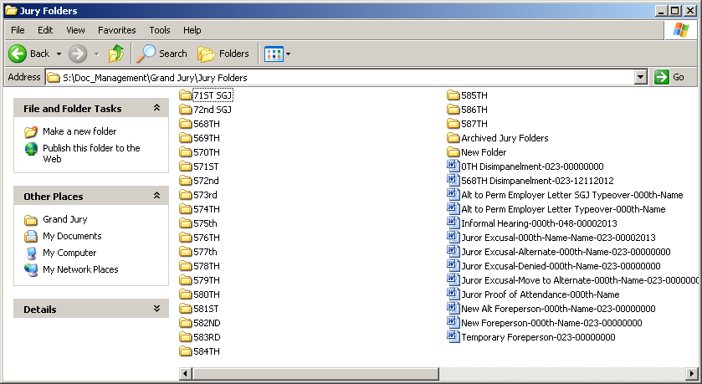

  - Print two copies of the completed ME on pink paper.
    - Stamp one of the copies with the COPY stamp.
    - The original ME will get filed in the Grand Jury file cabinet, within the respective jury’s folder.
    - The copy of the ME will go to the County Attorney or the Attorney General, depending on whether it is a County Grand Jury or a State Grand Jury.
- Update the Jury Roster to reflect the change made to the Grand Jury panel.
  - Open the Grand Jury folder.
  - Double click on Jury Rosters & Worksheets to access the file.
  - Double click on the corresponding jury folder to open the file.
  - Update the roster to reflect whether the excused juror has been permanently excused or placed as an alternate to call upon an emergency.
  - Update the roster to reflect the new juror to appear as a permanent juror. An example of what the updated roster should look like is shown in Figure 3.
  - Hit Save on the Word document to save the new changes made to the jury roster.

Figure 3
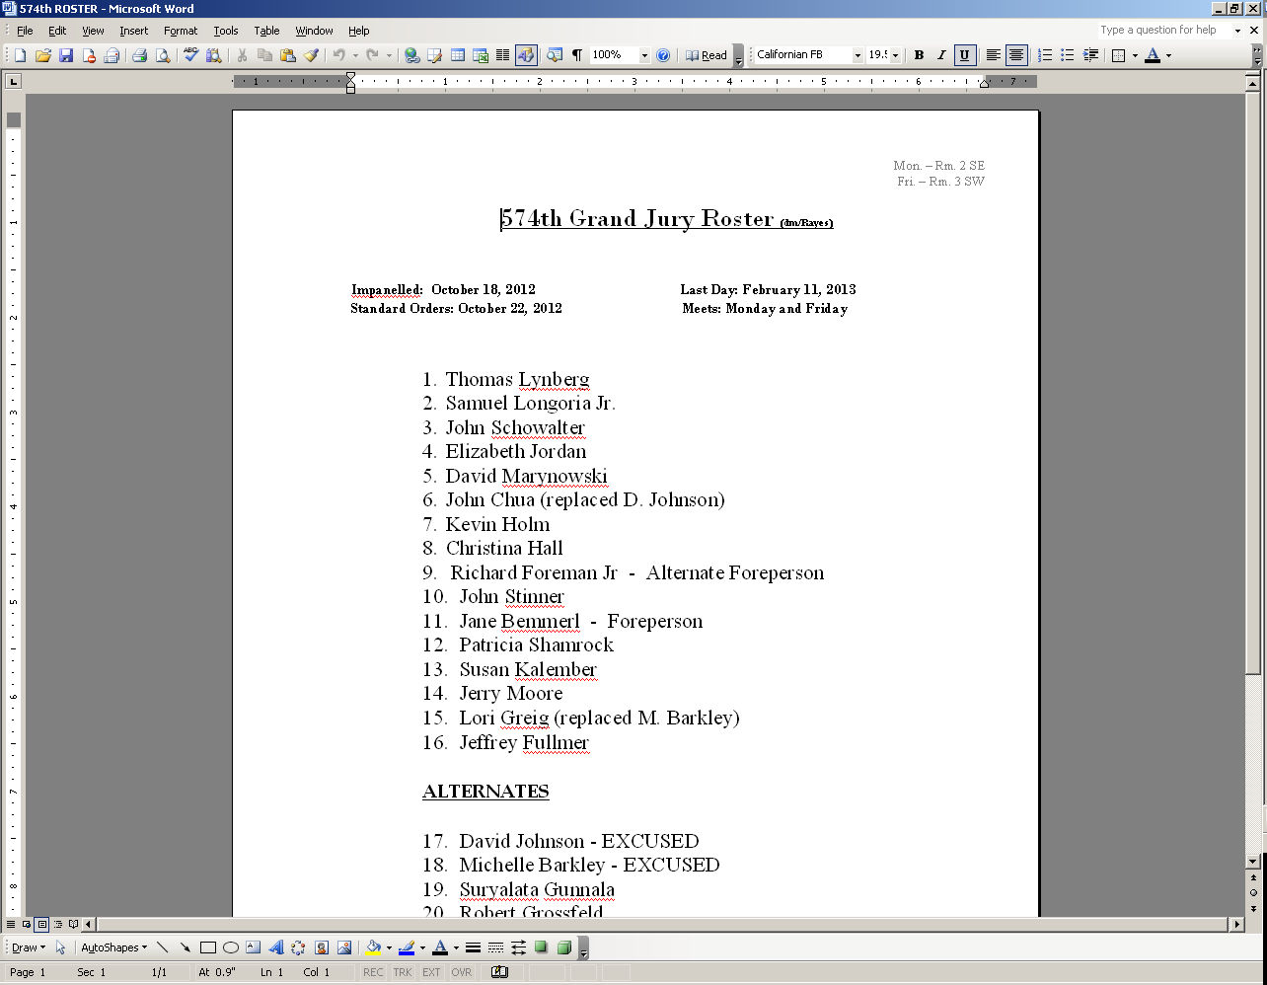

- Write a letter for the new juror, which indicates their status change from alternate to permanent juror on the Grand Jury panel.
- Open the Grand Jury folder
- Double click on Forms & Other to access file.
- Double click on the Letters folder.
- Within the Letters folder, click on the Word document titled Alt to Perm Juror Letter for a juror on a county grand jury, or SGJ Alternate to Perm Letter for a juror that is on a state grand jury. Verify the letterhead has the 201 W. Jefferson address.
- Using the typeover sample template letter, fill in the blanks.
- Date.
- Juror name.
- Jury panel number.
- Juror name.
- Effective begin date of jury service.
- The days of the week that particular jury panel meets.
- The last day of jury service.
- Print the letter, then sign and crimp with the court seal
- Hit Save As and save the document within the folder for the corresponding jury with the following filename format: Alt to Perm-JSmith-570th-04092013.
- Place the letter in the bin located on the cubicle that is closest to the front door. The juror will be able to pick up the letter on their first day of service.

Note: If the juror is starting at a later date, then the date on the letter should be dated for the first date the juror is to be present.

POLICIES / RELATED DOCUMENTS:

- N/A
OTHER PARTIES INVOLVED:

- Judicial Officer
- Grand Jury clerks
- Grand Jurors

TIME / VOLUME:

- Varied

FREQUENCY:

- Varied

PERFORMANCE MEASURE:

- N/A

SYSTEM ACCESS REQUIRED:

- S:\Doc_Management\Grand Jury\Jury Folders

REPORTS / FORMS:

- F-CROPS-1006: Alt to Perm Juror Letter form
- F-CROPS-1007: SGJ Alternate to Perm Letter form
- F-CROPS-1008: Juror Excusal-000th-Name-Name-023-00002013 form
- F-CROPS-1009: Juror Excusal-Move to Alternate-000th-Name-023-0000000 form
- F-CROPS-1010: Juror Excusal-Alternate-000th-Name-023-00000000 form

DEFINITIONS:

Minute Entry (ME): The entry used to record documents within the clerk’s office.
Grand Jury (GJ): A jury selected to examine the validity of an accusation before it goes to trial.

APPLICABILITY:

This procedure applies to all employees of the Clerk of the Court.

REVISION HISTORY:

Revision Number | Revision Author | Summary of Changes | Approval Date
- | N/A | Document Origination | 04/26/2013
A
B
C

