PURPOSE:

To provide instructions for processing Returned Mail on a Criminal Summons.

OBJECTIVE:

- When RCC/EDC staff receives Returned Mail, it is processed and e-filed for the court record. Based on this information, the Judicial Officer will make a determination on whether to issue a warrant or reissue the summons.

EVENT DRIVER:

- When a summons Direct Complaint is filed, RCC/EDC staff send out via certified mail the summons notifying the defendant when they need to appear for their Initial Appearance hearing. RCC/EDC staff will receive back returned mail in the form of either the certified mail receipt card (green card), or the original certified envelope sent back indicating that it was undeliverable. RCC/EDC staff must then process the returned mail for e-filing into the court record.

PROCEDURES:
- Return mail is delivered each day by the mail room. The RCC/EDC staff member that is assigned to RTM on the RCC/EDC calendar is the one responsible for processing the returned mail.
  - Once it is received, separate the certified mail receipt cards (green cards) from the original certified envelopes.
  - Sort the returned mail by the hearing date. The hearing date is viewable on the envelope.
  - Return mail is processed daily, if there is an excessive amount to process, staff should prioritize based on the hearing date that is indicated on the envelope or return receipt card, closest date first.
    - Current hearing dates and hearing dates that are scheduled in the nearest future should be prioritized so that the Judicial Officer has access to the e-filed image prior to or at the time of the Initial Appearance.
  - For the original certified envelopes, proceed to the next step of this procedure.
  - For certified mail receipt cards (green cards), see procedure PRO-CROPS-1052 - Certified Mail Receipt Cards

- After sorting and prioritizing, RCC/EDC staff must create a Return Mail (RTM) coversheet form for each returned envelopes.

- Open each envelope and remove the copy of the summons and the summons mailing insert.
- Set the summons mailing insert aside to be reused.
- Unfold the defendant’s copy of the summons and paperclip it to the returned envelope.
- Complete the above steps for all returned mail that is to be processed that day, creating a stack of all of the summons copies and returned envelopes.

Important Note
If RCC/EDC staff receives a return mail envelope with the green card that is either missing or is signed as if it has been received by the defendant, RCC/EDC staff should immediately bring that piece of returned mail to the attention of the Criminal Lead or Supervisor. Returned mail envelopes should NOT be missing the green card and the green card should NOT be signed.

- Create a Returned Mail Template as in steps 4-14 below.

- Access the RCC-EDC Summons Returned Mail Template located at S:\Doc_Management\Returned Mail\CR See Figure 1.
Figure 1.
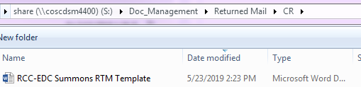

- Right click on Returned Mail Template.

- Select Send to then Desktop (create shortcut) from the drop-down menu. See Figure 2.
Figure 2.

- Complete the template.
  - Select View/Edit Document. Data can only be entered in the form fields. See Figure 3 for the description of the form fields.
  - Use the down arrow to move from one field to the next. Only fill in the fields that you have information for, and leave the other fields blank.
  - Text fields will display in ALL CAPS.
  - Date fields must include a dash or slash, and will display in mm/dd/yyyy format.
Figure 3
Form Field | Description
iCIS Docket Number | The line number of the docket event for the original Summons that was mailed. This appears on the far left column of the docket screen.
Document Title | The title of the document as it appears in the “type” column.
File Date | The filing date on the original Summons document.
Hearing Date | Enter the hearing date listed on the Summons.
As of: | The date on the upper right corner of the return mail label.  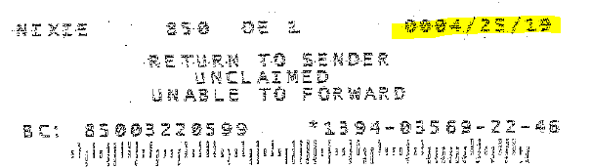
USPS Forwarding Address is | Forwarding address from the USPS. This comes from the returned envelope. Enter N/A if there is no forwarding address.
Case Number | Complete case number from the returned document. Use the case-type prefix, dashes, and defendant identifiers as applicable.
Returned Mail Received For | The complete name or names to whom the mail was sent. This could be a business name.
At the following Address | The address where the mail was originally sent.
Drop-down for “Undeliverable”  Or  “Forwarding Address Provided” | Select one from the drop-down by using your mouse, or by using Alt+arrow, then Enter on the keyboard. Select “Undeliverable” if there is no forwarding address, “Forwarding Address Provided” when the USPS provides a forwarding address on the returned envelope.
Prepared by | This is your first initial, and last name.

- When the form is completely filled in, select File / Save As.
- Enter the case number as the file name.
- Save the template to the folder that corresponds with the current month, located in S:\Doc_Management\Returned Mail\CR. See Figure 4.
Figure 4.
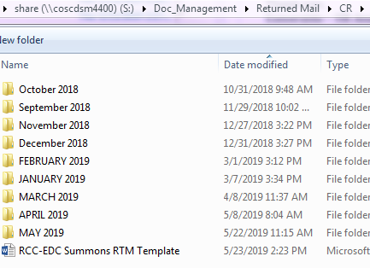

- If the USPS label on the returned envelope gives a forwarding address:
  - Update the party’s address on the address screen in iCIS.
  - See PRO-DRMS-1021 for more on iCIS address changes.

- To eFile the template.
  - Log into eFiling Online located at
https://efiling.clerkofcourt.maricopa.gov/
  - Select File Now.
  - Follow steps 1-7 below to complete the filing. See Figure 5.

Figure 5
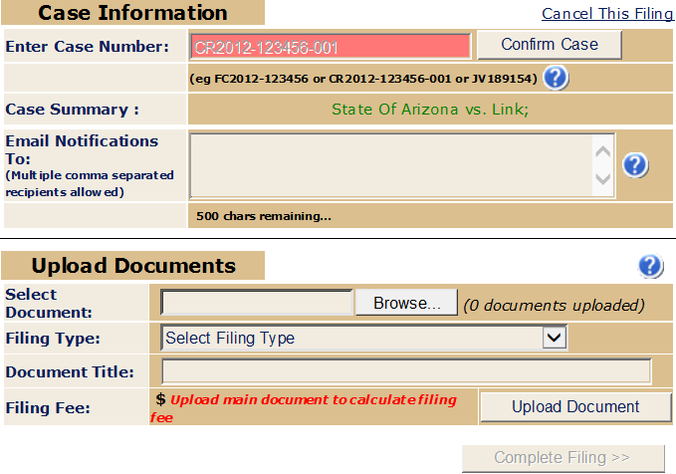

      - Enter the Case Number including the CR and dashes, then click Confirm Case.
      - The case name will display in the Case Summary field. If this is the correct case, continue with step 3.
      - Click Browse to select the template you wish to upload. Note: This is the template that you saved to the folder that corresponds with the current month, located in S:\Doc_Management\Returned Mail\CR
      - Select the Filing Type - RNM.
      - The Document Title will automatically fill in.
      - Select Upload Document.
      - Select Complete Filing.

    - NOTE: Before staff can eFile templates, managers or supervisors must first register staff as users in eFiling Administration on the COC Web under secured applications.
      - Select Manage Users / Add User. See Figure 6.

Figure 6
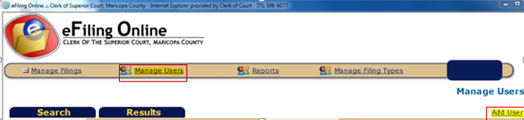

      - Fill out the required fields, using the staff person’s Clerk of Court email address.
      - Select one of the following roles from the Role drop-down menu:
        - COC-DRMS for COC Docket and EDM staff
        - COC-CFO for Criminal Financial Obligations staff
        - Distribution for Distribution staff

- After the RTM has been processed
  - Give the envelopes for all RTM processed to Criminal Lead
  - An audit of 100% of the RTM will be conducted to ensure that the return address appears on the RTM coversheet correctly and has been updated in ICIS appropriately.

POLICIES / RELATED DOCUMENTS:

- https://efiling.clerkofcourt.maricopa.gov/eFileUsersManualCriminal.pdf
- Update Address Procedure - PRO-DRMS-1021

OTHER PARTIES INVOLVED:

- Judicial Officer
- Mail Room

TIME / VOLUME:

- 1.6 minutes per document

FREQUENCY:

- Daily

PERFORMANCE MEASURE:

- N/A

SYSTEM ACCESS REQUIRED:

- Controlled Document Index
- iCIS

REPORTS / FORMS:

- RCC-EDC Summons RTM Coversheet form

DEFINITIONS:

- RTM: Returned Mail
- Returned Mail: Certified mail, or certified mail receipt cards that are returned to the Clerk of the Court after the U.S. Postal Service has either delivered, or attempted to deliver the mail that was sent out certified by RCC/EDC staff.

APPLICABILITY:

This procedure applies to all employees of the Clerk of the Court.

REVISION HISTORY:
Revision Number | Revision Author | Summary of Changes | Approval Date
- | N/A | Document Origination | 04/10/2013
A | Amanda Duran | - Important Note added in a gray box in step 2.B. regarding RTM envelopes with signed green cards attached.  - Important Note added in a gray box in step 2.C. regarding receipt of AFS signed green cards that are not signed by the defendant.  - Deleted the gray box note in step 2.E. regarding the process to follow if there is writing on the back of a returned mail envelope-no longer applicable  - Replaced the Figure 1 image to more accurately reflect the positioning of the RTM when it is taped down.  - Included in steps 2.E.a and 2.E.a.i additional the positioning of the RTM envelope when taping it down to the coversheet.  - Made additions to the gray box note in step 4.B. regarding the process to follow if the green card is missing from the back of the returned mail envelope, we must now pick up a note in the docket entry stating “NO CERTIFIED MAIL RECEIPT ATTACHED”. | 10/10/2013
B | Stephanie Davis | - Remove the AFS procedure. See new procedure for AFS.  - Updated procedure to include e-file procedures, RCC-EDC Summons template, and iCIS address updates. | 06/04/2019

