PURPOSE:

To provide instructions for processing Rule 11 paperwork.

OBJECTIVE:

- To accurately process Rule 11 documents from a lower court to Superior Court.

EVENT DRIVER:

- The Rule 11 division will contact the lead for a case number to be assigned to a Defendant who is being transferred from a lower court to Rule 11 Court. A few days later, the lower court documents for each Defendant will be provided to counter staff so that the cases can be initiated in ICIS.

PROCEDURES:
- Check the Rule 11 Drop Off Bin located at the back counter daily.
- Separate the packet into two stacks:
  - Order: the corresponding Motion (if provided) will be placed underneath the Order.
  - Complaint: any additional and miscellaneous documents will be placed underneath the complaint.
- File in the Complaint and Order and write the case number on each.
- Initiate the case in ICIS and click Continue (see Figure 1).
  - Case Type: Criminal
  - Case Number: Rule 11
  - Facility: Downtown
  - File date: The date on the file stamp
  - Case Note: name of lower court (e.g. City of Phoenix; Arrowhead Justice Court).

Figure 1
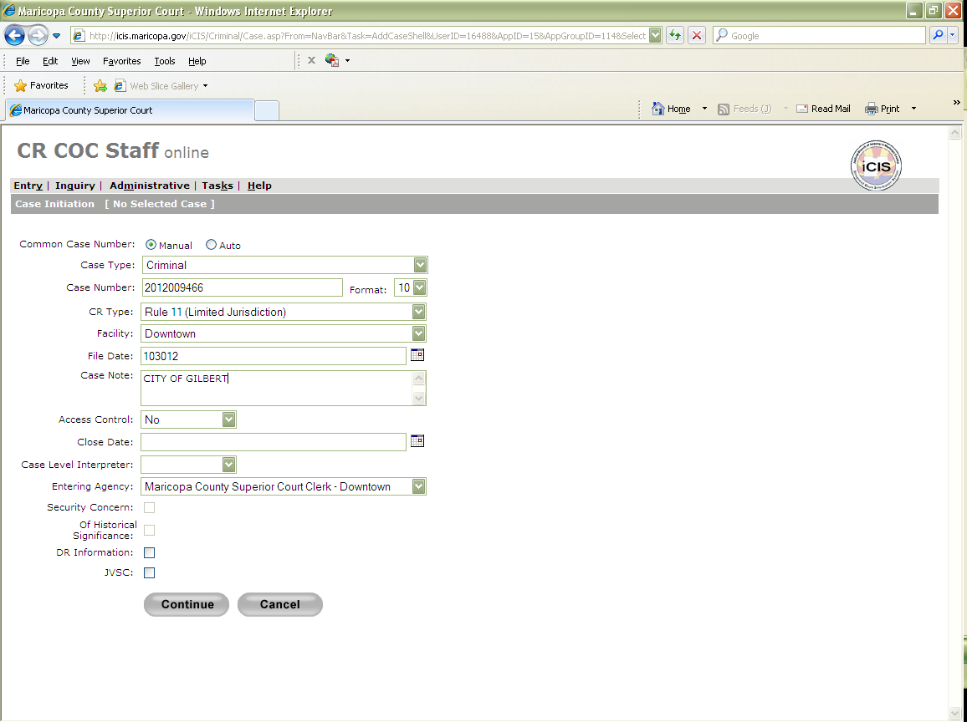

- Enter in party information and click Continue (see example in Figure 2).
  - Name: Enter name exactly how it appears on the complaint.
  - DOB: If not available, it does not need to be captured.
  - SSN: Not necessary
  - Entering Agency: Maricopa County Attorney

Figure 2
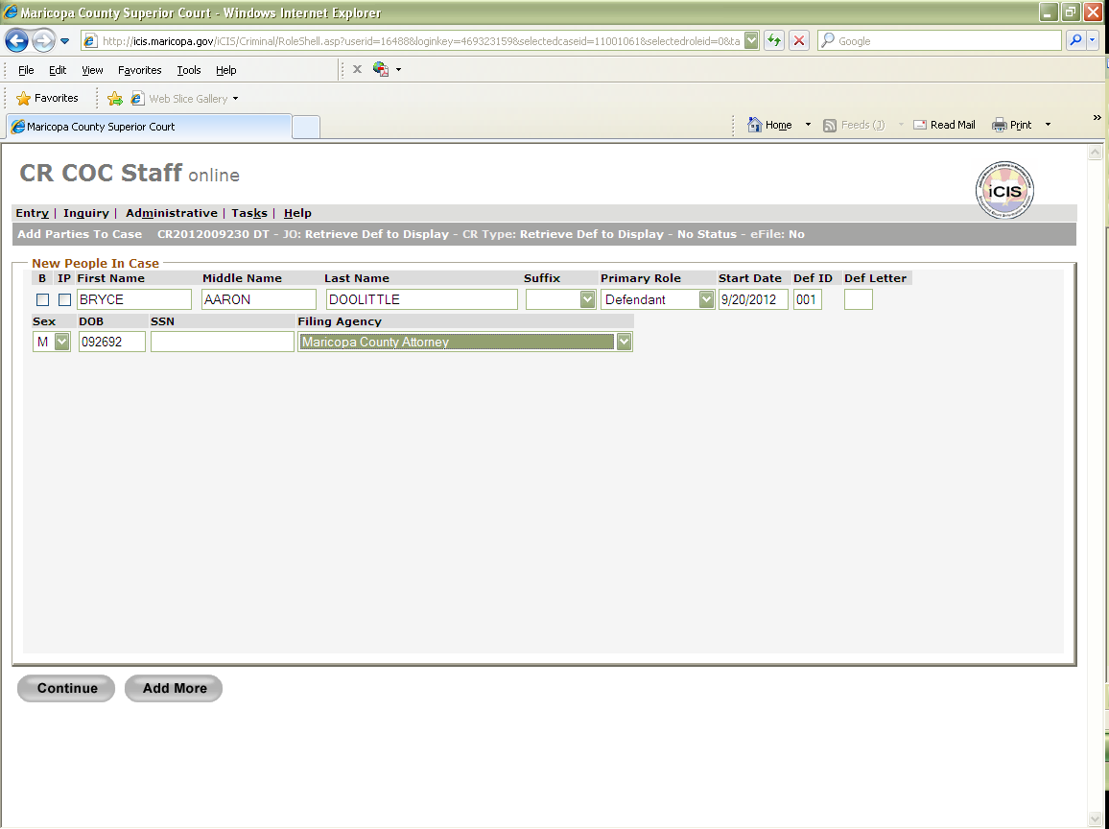
- Add attorney information and click Continue (see Figure 3). You can find attorney information in the Remand Addresses Document. S:\Doc_Management\CR File Counter\Rule 11's\ REMANDS_RULE 11_City, Town, Municipal Prosecutor Listings.doc"
  - Bar#: Attorney's State Bar number
  - Attorney Role: City Prosecutor or Maricopa County Attorney
    - If this is a case from city/municipal court, enter City Prosecutor in the Attorney Role field.
    - If this is a case from justice court, enter County Attorney in the Attorney Role field.
  - Assign Date: same as filing date
  - Side 1: box checked
Figure 3
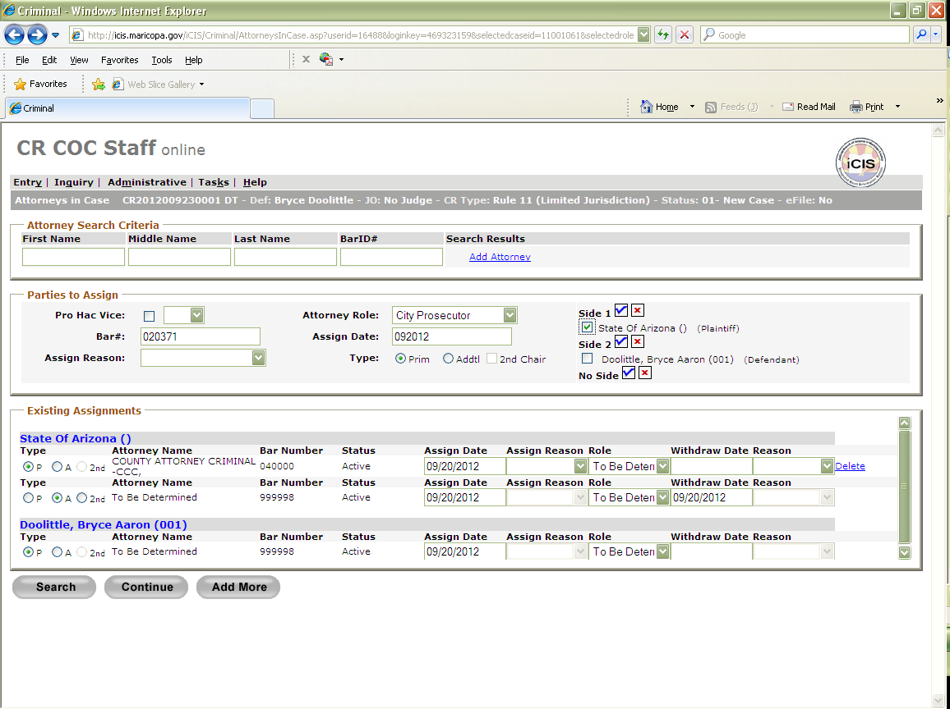

- Do NOT add any address information and click Skip to End (see Figure 4).

Figure 4
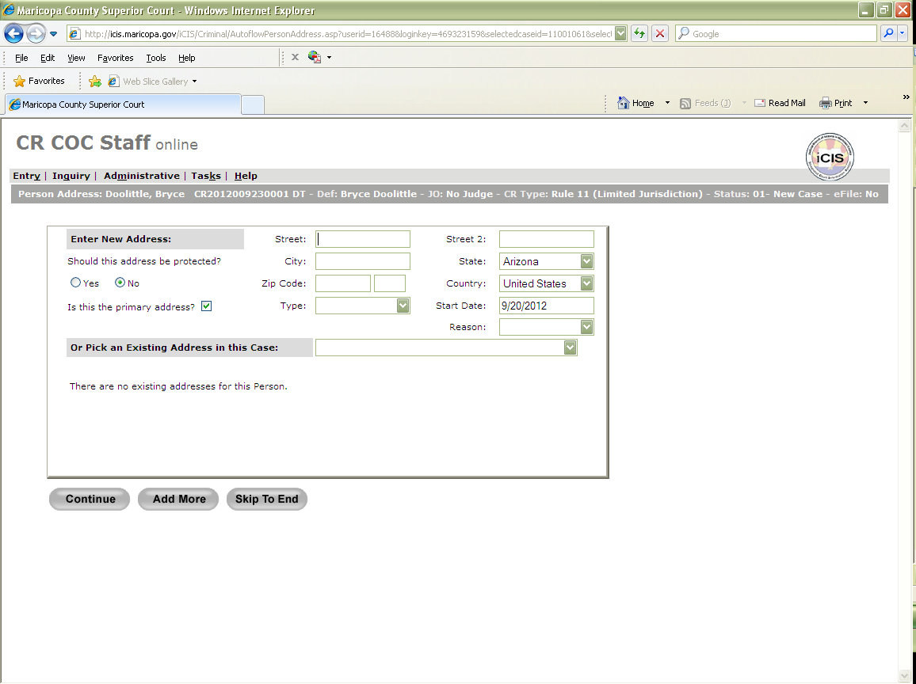

- Docket and barcode the Complaint (see Figure 5 and Figure 6).
  - Filing Date
  - Attorney Filing: Court
  - Document Title: COM
  - Docket Note: The charge/ON OR ABT (the date of charge), and the name of city court.
**If multiple charges, only note the first charge**

Figure 5
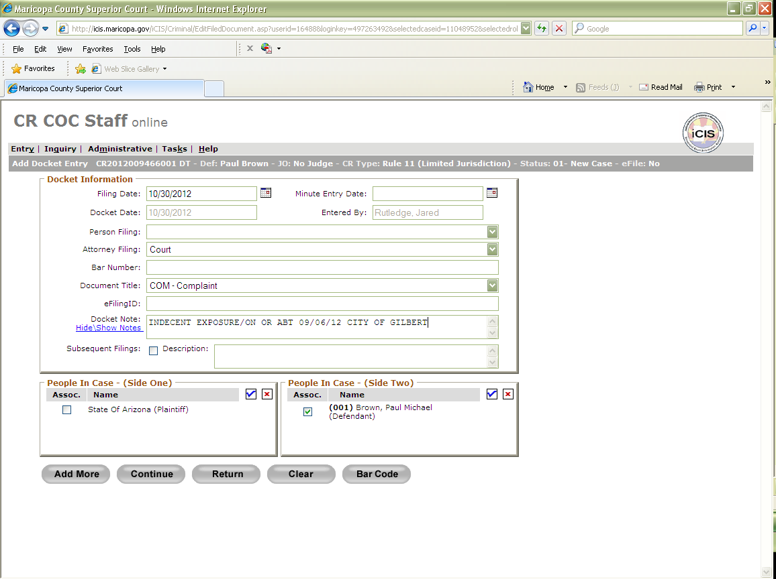

Figure 6
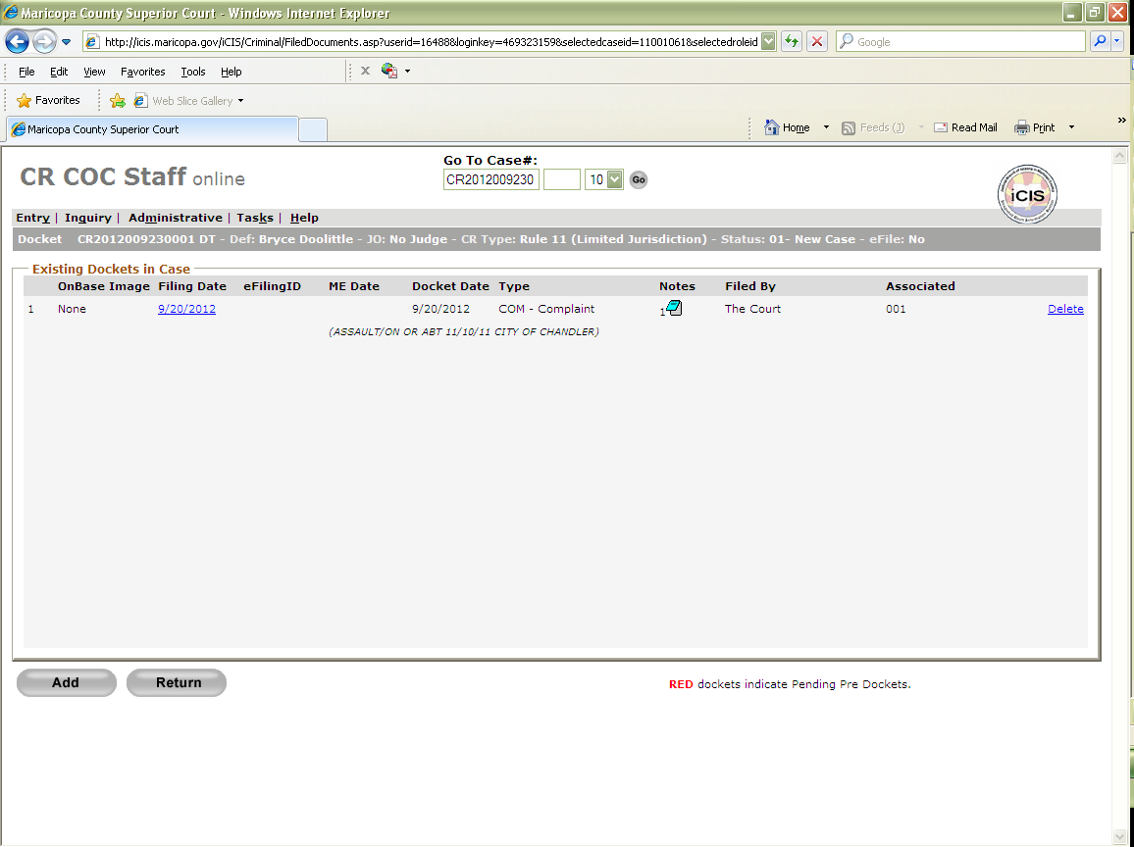

- Docket and Barcode the Order (see Figure 7 and Figure 8).
  - Filing Date
  - Attorney Filing: Court
  - Document Title: ORD
  - Docket Note: Transfer Matter to Superior Court for Rule 11 Exam.

Figure 7
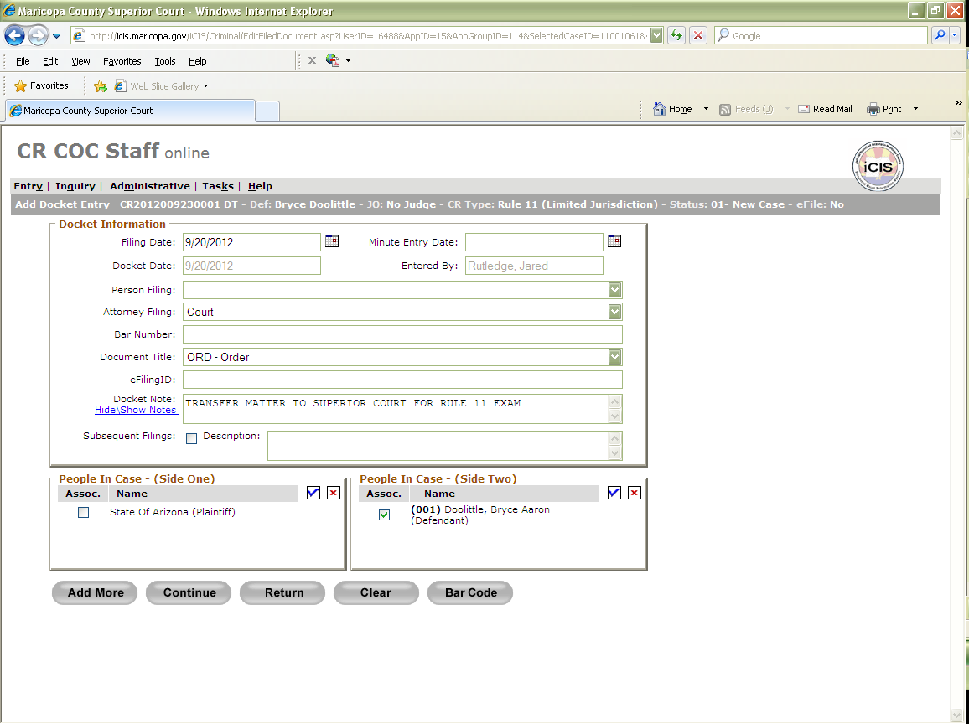

Figure 8
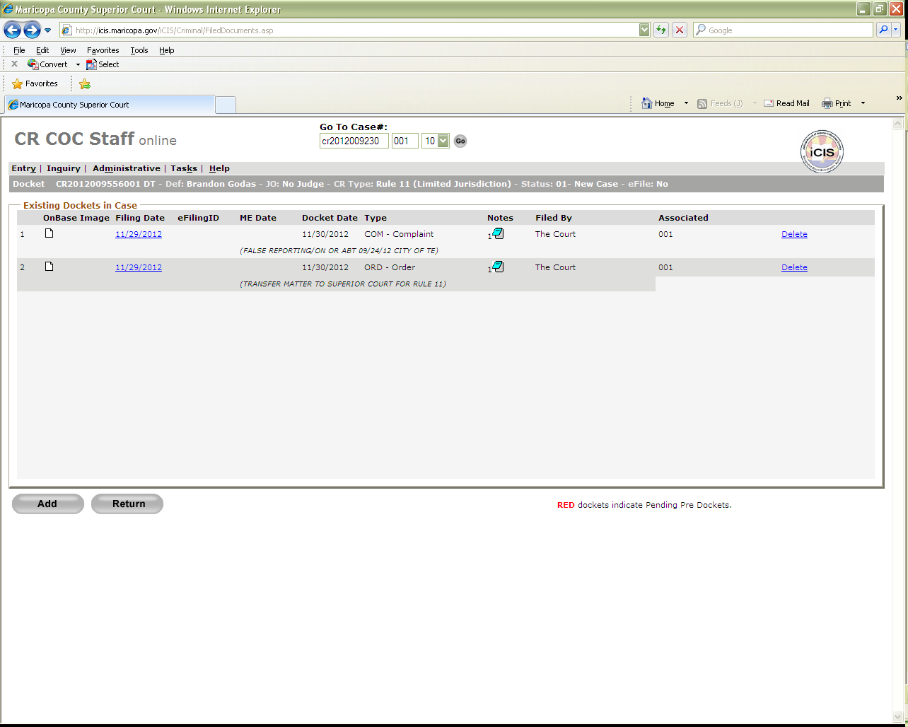

- There may be times in which we receive a duplicate original of an order or complaint. The complaint and/or order will be filed in with the current date. When docketing them, enter Supplemental Original in the Docket Note field (see Figure 9).

Figure 9
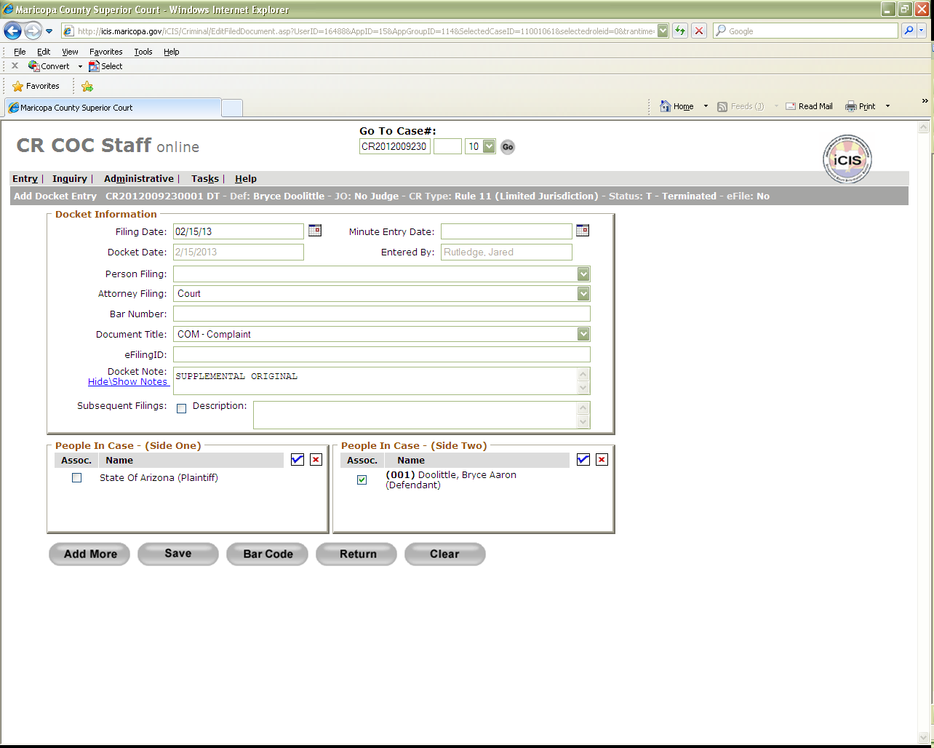

- Once all Rule 11’s have been completed, a green batch slip will be used.
  - The following information needs to be filled out:
- Circle the CR at the top of the slip
- Circle the P1
- Year: Enter the year of the case numbers (If there are various years, input VAR).
- File date: The date on the file stamp (If there are various dates, input VAR.
- Document Type: PRI
- Document Count: How many documents are in the batch
- Received date-:The date you worked on the Rule 11’s
- Sorted by: Your initials
- Docketed/Barcoded by: Your initials
- Date Docketed/Barcoded: Today’s date
- Prep by: Your initials
  - Put the batch slip on top of the docketed Rule 11’s and rubber band or clip them together.
12. Place batch in the designated staging area for scanning.

Note: This is a Lead function only

POLICIES / RELATED DOCUMENTS:

- Rule 11: AZ Superior Court – Probate and Mental Health – Rule 11 Evaluations and Court Process

OTHER PARTIES INVOLVED:

- Forensic Services Division of Superior Court
- Defendant
- Municipal/Justice Courts

TIME / VOLUME:

- 10.5 Minutes

FREQUENCY:

- Varied

PERFORMANCE MEASURE:

- N/A

SYSTEM ACCESS REQUIRED:

- iCIS
- BizHub

REPORTS / FORMS:

- ADDENDUM-CROPS-1001: Remands Rule 11 - City, Town, Municipal & Prosecutor Listing
- Barcode Header Page
- Green Batch Slip

DEFINITIONS:

- Rule 11 Case: A criminal case in which the Forensics Services Division of the Superior Court must evaluate the Defendant for competency. The Court will order a psychological evaluation of the defendant to determine whether the defendant is competent to be adjudicated.

APPLICABILITY:

This procedure applies to all employees of the Clerk of the Court.

REVISION HISTORY:

Revision Number | Revision Author | Summary of Changes | Approval Date
- | N/A | Document Origination | 02/28/2013
A
B
C

