PURPOSE:

To provide instructions for processing restoration worksheets in order to promote the efficiency of the restoration of rights process.

OBJECTIVE:

- Accurately and efficiently process restoration worksheets sent by the Criminal Financial Obligations (CFO) Unit.

EVENT DRIVER:

- The CFO provides notice to the filing clerk that restoration worksheets are ready for processing.

PROCEDURES:

- The filing clerk will receive an email from CFO with notice that Applications set for a certain date are complete. Reply All to the email letting everyone know that these worksheets will be processed. See Figure 1.
Figure 1
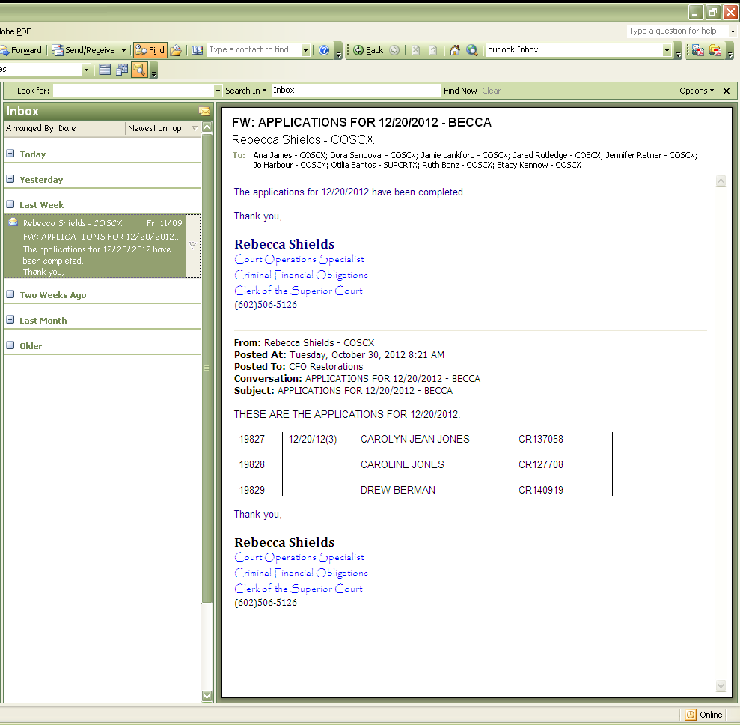

- Open the Restoration Log and click on Open LOG Start Here. See Figure 2.

Figure 2
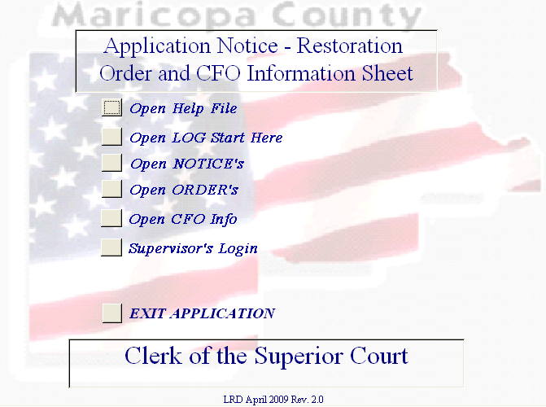

- Click on Open CFO. See Figure 3.
Figure 3
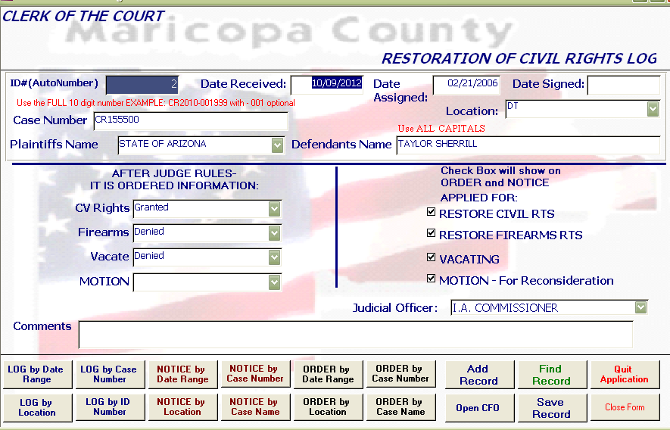

- Click on CFO Rpt by Date Range. See Figure 4.
Figure 4
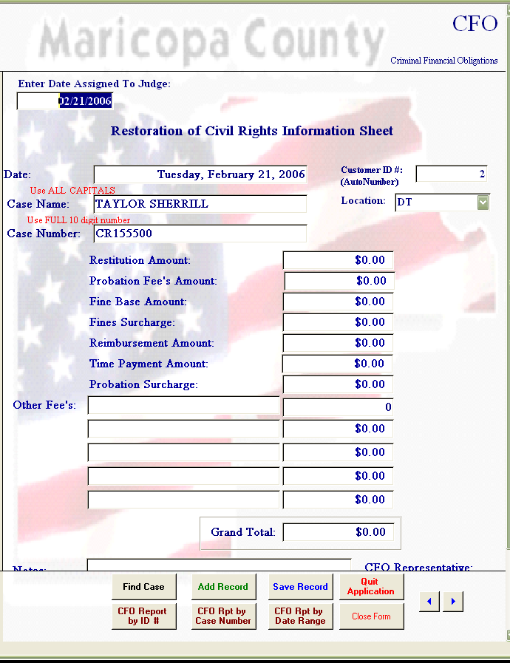

- Enter date that the CFO sent the notice of completion for a start and end date. See Figure 5.
Figure 5
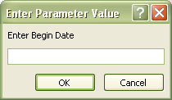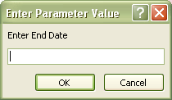

- Print all worksheets populated for that date on white paper. See example in Figure 6.

Figure 6
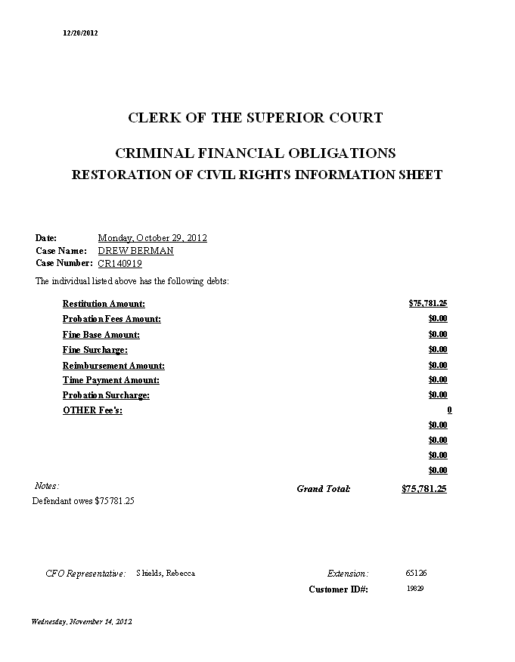

- File all Worksheets and scan them to yourself and e-mail the attachment to the person who processes the applications in Court Administration. (See Lead for most current person)
- Docket/barcode each worksheet in iCIS. See Figure 7:
  - Filing date: Enter the date on the file stamp (top right hand corner of document)
  - Attorney Filing: Court
  - Document Title: Worksheet (WSH)
  - Docket Notes: CFO INFO
  - Click the Barcode Button.

Figure 7
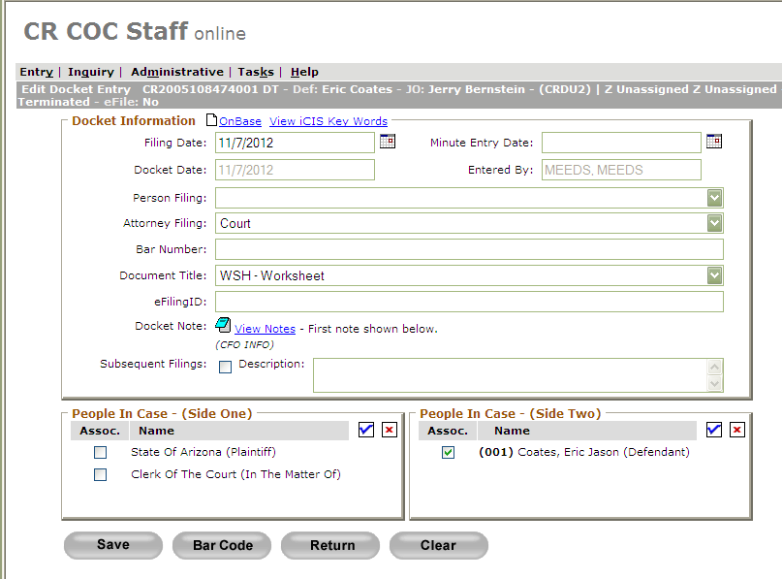

- The barcode sheet is then placed on top of the Worksheet with the bar code facing up.
- Once all Worksheets have been completed, a green batch slip will be used.
  - The following information needs to be filled out:
- Circle the CR at the top of the slip
- Circle the P1
- Year: Enter the year of the case numbers (If there are various years, enter VAR)
- File date: The date on the file stamp
- Document Type-:WSH
- Received date: The date you worked on the Worksheets
- Sorted by: Your initials
- Docketed/Barcoded by: Your initials
- Date Docketed/Barcoded: Today’s date
- Prep by: Your initials
  - Put the batch slip on top of the docketed Worksheets and rubber band or clip them together.
11. Place the batch in the designated staging area for scanning.
POLICIES / RELATED DOCUMENTS:

- ARS Title 13: Criminal Code, Chapter 9
- Processing of Restoration Applications
- Processing of Restoration Orders

OTHER PARTIES INVOLVED:

- Criminal Financial Obligations Unit
- Criminal Court Administration

TIME / VOLUME:

- 1.25 Minutes

FREQUENCY:

- Varied

PERFORMANCE MEASURE:

- N/A

SYSTEM ACCESS REQUIRED:

- iCIS
- Microsoft Outlook
- Restoration Orders and Information Database

REPORTS / FORMS:

- Barcode Header Page
- Scanning Batch Slip

DEFINITIONS:

- Restoration worksheet: A document created by the Criminal Financial Obligation Unit stating the balance, if any, owed by the Defendant who is requesting to restore their rights.

APPLICABILITY:

This procedure applies to all employees of the Clerk of the Court.

REVISION HISTORY:

Revision Number | Revision Author | Summary of Changes | Approval Date
- | N/A | Document Origination | 02/28/2013
A
B
C

