PURPOSE:

To provide instructions for processing Remands.

OBJECTIVE:

- To accurately process Remand documents from Superior Court to a lower court.

EVENT DRIVER:

- A Superior Court Judicial Officer remands the Rule 11 case that was originally transferred over from a lower court back to the originating court.

PROCEDURES:
- Check e-mail in Remand Desk-CR-CCC Mailbox. Each e-mail contains a Remand Minute Entry (see Figure 1).
Figure 1
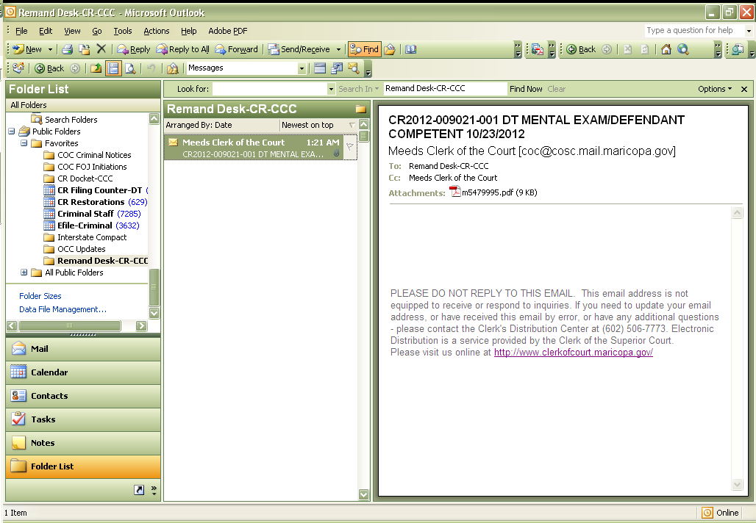

- Open up each PDF and print off the Minute Entry (see Figure 2).
  - Verify which case number(s) are being remanded back to the originating court.

Figure 2
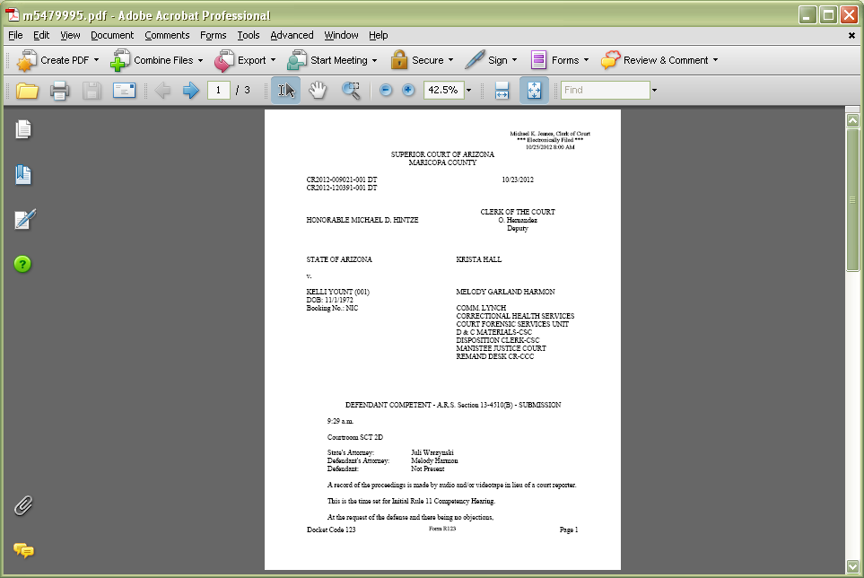

  - The language to look for in the Minute Entry will be similar to what is shown below:

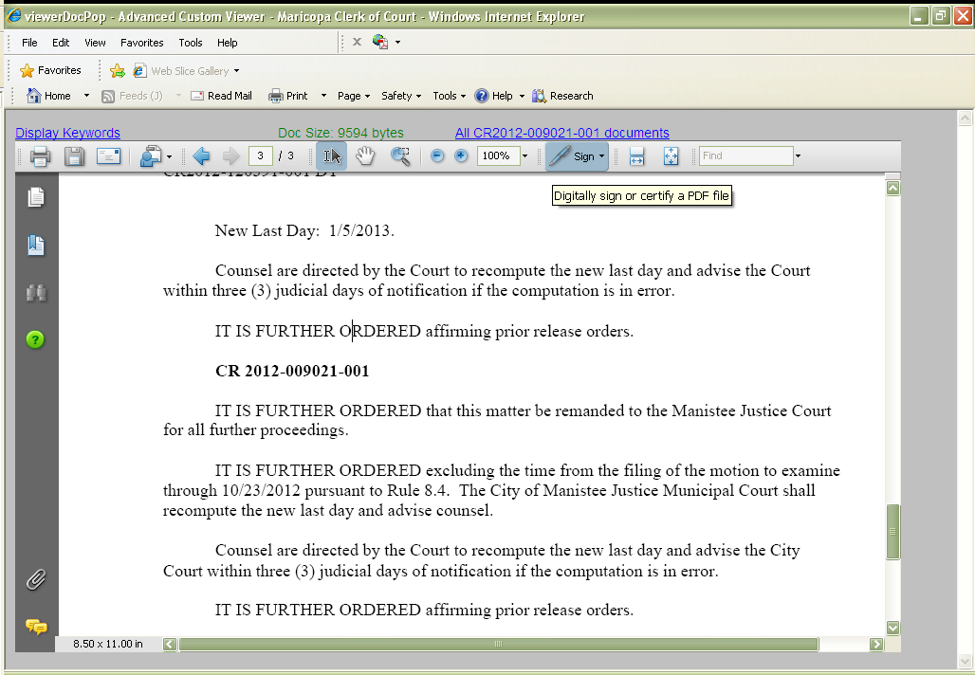

- Pull up the docket screen and print EVERY document of each case that is remanded (the Minute Entry that was just printed from the e-mail may be excluded) (see Figure 3).

Figure 3
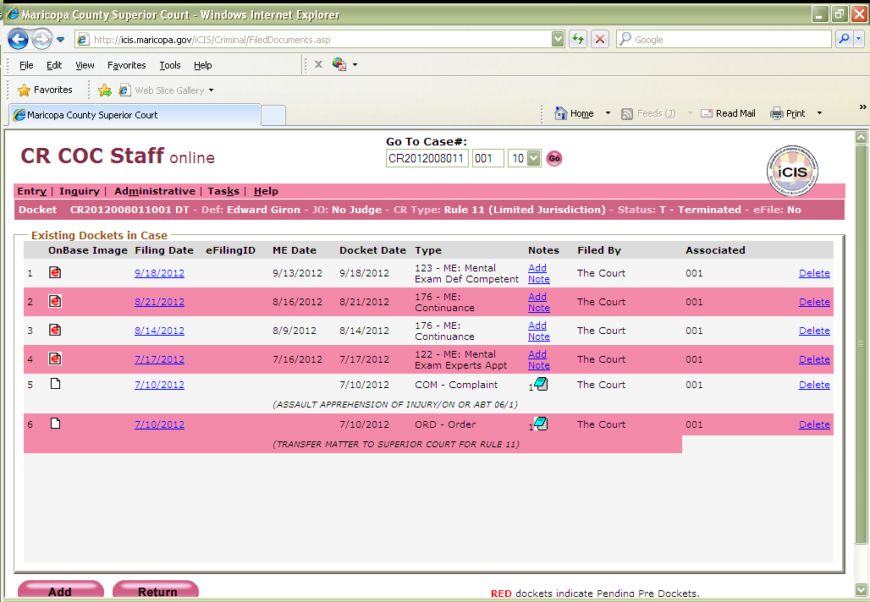

- Once all the documents are printed, make a stack for each case number that is remanded.
- Click on Inquiry>Reports (see Figure 5).

Figure 5
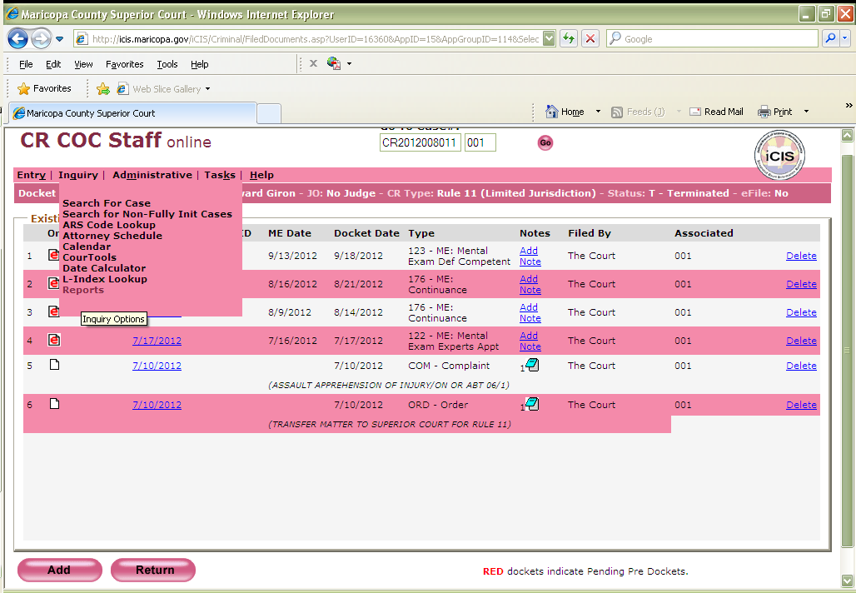

- Select #8: COC Case Summary – Criminal and then click Generate. Then print out the document (see Figures 6, 7, and 8).

Figure 6 Figure 7
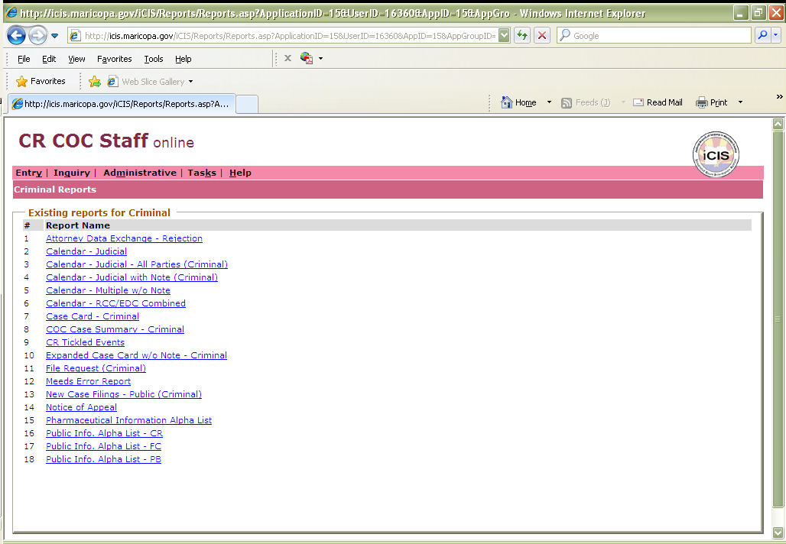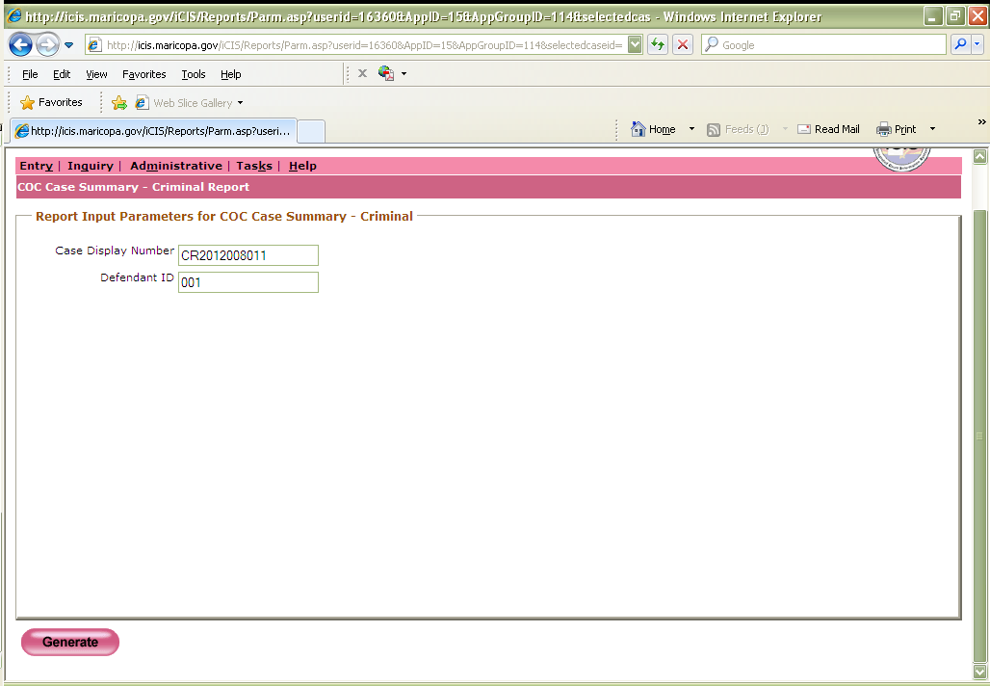

Figure 8
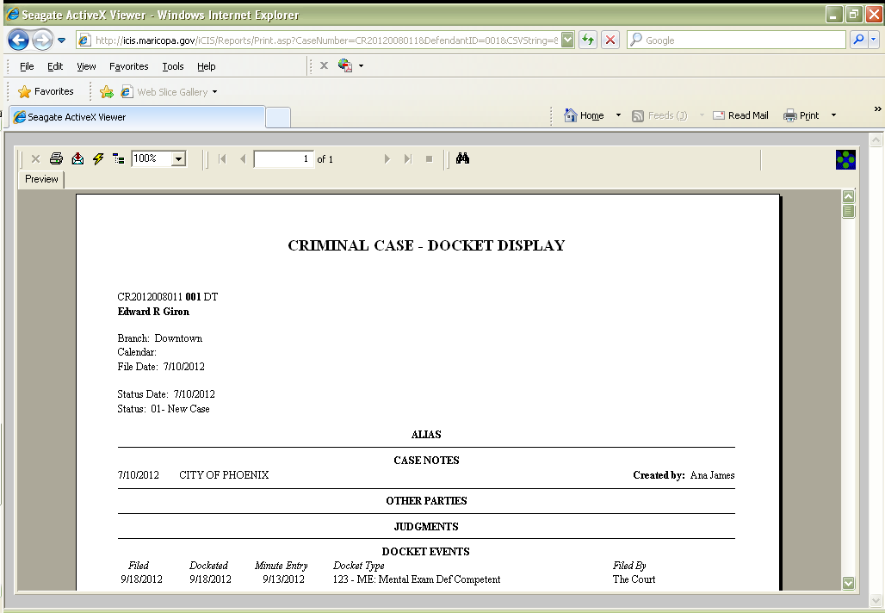

- File in and certify the case card document and then make a copy of it. The original document will be placed on top of the stack of the printed documents and placed in an envelope and mailed to the correct lower court (see Figure 9).
  - The addresses for the lower court can be found on ADDENDUM-CROPS-1001: Remands Rule 11 - City, Town, Municipal & Prosecutor Listing.
Figure 9
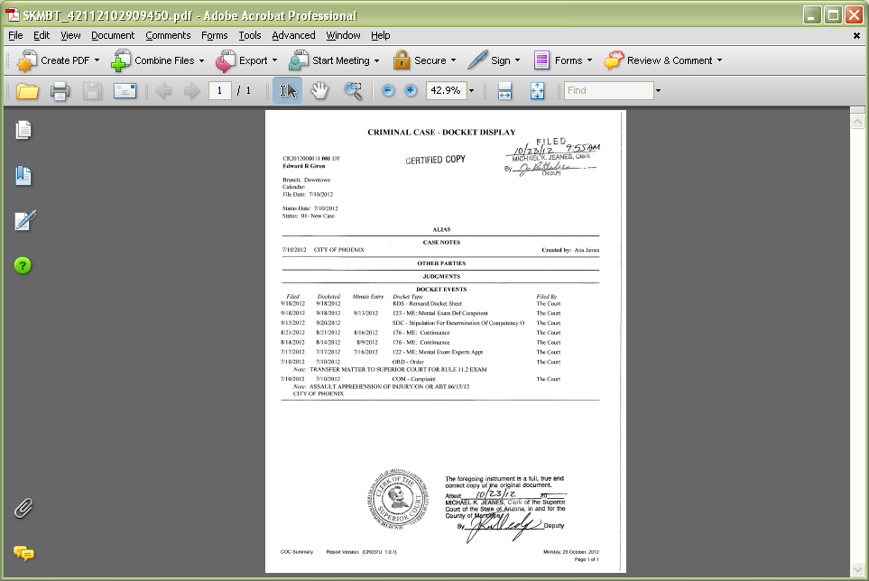

- Docket and barcode the copy of the certified copy of the case card (see Figure 10). The Original Certified Copy will be sent to the lower court.

Figure 10
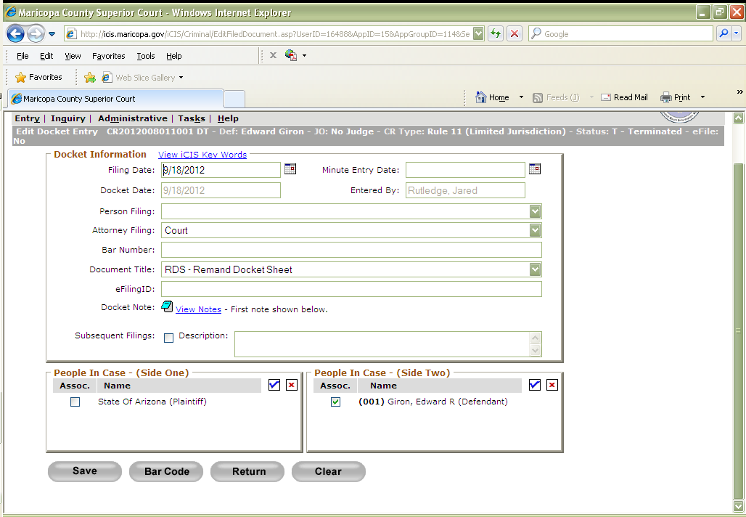

- Let the lead know the Remands are complete so that the e-mails can be deleted from the Remand Desk Mailbox.

POLICIES / RELATED DOCUMENTS:

- ADDENDUM-CROPS-1001: Remands Rule 11 - City, Town, Municipal & Prosecutor Listing

OTHER PARTIES INVOLVED:

- Superior Court Rule 11 Court
- Defendant
- Municipal/Justice Courts

TIME / VOLUME:

- 6.6 Minutes
FREQUENCY:

- Varied

PERFORMANCE MEASURE:

- N/A

SYSTEM ACCESS REQUIRED:

- iCIS
- BizHub
- Microsoft Outlook

REPORTS / FORMS:

- N/A

DEFINITIONS:

- Remand: A Rule 11 case that a Superior Court Judicial Officer has ruled to be sent back to the originating lower court.

APPLICABILITY:

This procedure applies to all employees of the Clerk of the Court.

REVISION HISTORY:

Revision Number | Revision Author | Summary of Changes | Approval Date
- | N/A | Document Origination | 02/28/2013
A
B
C

