PURPOSE:

To provide instructions for processing a payment history.

OBJECTIVE:

- To quickly and efficiently process a payment history for the Customer.

EVENT DRIVER:

- A Customer requests a list of all fines and payments made, or needs a document to show a zero balance.

PROCEDURES:

- Open up the Payment History Form and fill it out. The form can be accessed through the Controlled Document Index. F-CROPS-1011: Payment History form (See Figure 1).
Figure 1
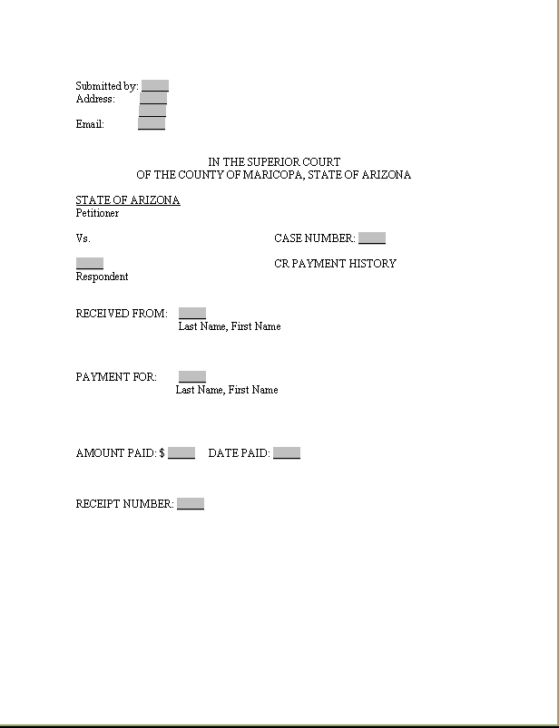

- Run the completed form through the cash receipting system with code 706 ($26.00). See Figure 2.
Figure 2
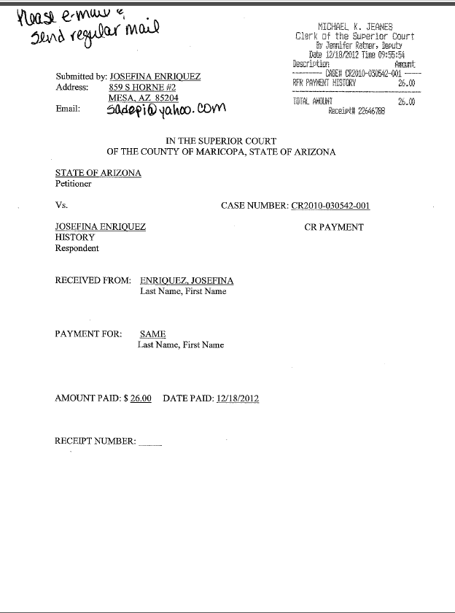

- Scan the completed form and e-mail it to the CFO, who will generate a report and send via mail or e-mail to the person requesting the payment history. **Please keep a copy of the form for your records for a couple of days**.

POLICIES / RELATED DOCUMENTS:

- PRO-ODIR-1001: Receipting
- Acceptable Forms of Draft Payment
- PRO-ODIR-1011: Entering Case Numbers into the Cash Management System

OTHER PARTIES INVOLVED:

- Defendant/Customer
- Criminal Fines and Obligations Unit

TIME / VOLUME:

- Varied

FREQUENCY:

- Varied

PERFORMANCE MEASURE:

- N/A

SYSTEM ACCESS REQUIRED:

- Cash Receipting System
- BizHub

REPORTS / FORMS:

- F-CROPS-1011: Payment History form

DEFINITIONS:

- N/A

APPLICABILITY:

This procedure applies to all employees of the Clerk of the Court.

REVISION HISTORY:

Revision Number | Revision Author | Summary of Changes | Approval Date
- | N/A | Document Origination | 02/28/2013
A
B
C

