PURPOSE:

To provide instructions for processing In-Custody Direct Complaint filings.

OBJECTIVE:

- To provide the necessary direction to ensure In-Custody direct complaint filings are processed correctly and accurately initiated;
- To ensure consistent filing and accountability of all In-Custody direct complaint filings over time.

EVENT DRIVER:

- An In-Custody direct complaint filing is received from one of the following:
  - County Attorney’s Office;
  - Attorney General’s Office;
  - Or various Police Agency Officers / Liaisons

NOTICE: The IA COC Direct Files application may contain information that is not yet part of the official court record. Access to this application is provided to you for the purpose of completing the necessary steps outlined in this procedure and nothing further. Be advised that you are never to print or provide copies of the Form IV using this application.

PROCEDURES:
- In Custody direct complaint filings are time sensitive; therefore they are highest priority and will be processed the same day as they are received by doing the following:

- Open ICIS> IA COC Direct Files (aka iCISng or IA-Online)> Menu> Search.
- Search for the case using the Booking number found on the court information sheet.
- Verify the PF (Pre-File) number matches the number listed on the document.

- Open File-A-Case (FAC):
  - Search for the case by entering the CA number, found on the direct complaint, in the FilingID field (Figure 1a), click Submit or press Enter. The case information should appear as in Figure 1b.

Figure 1a
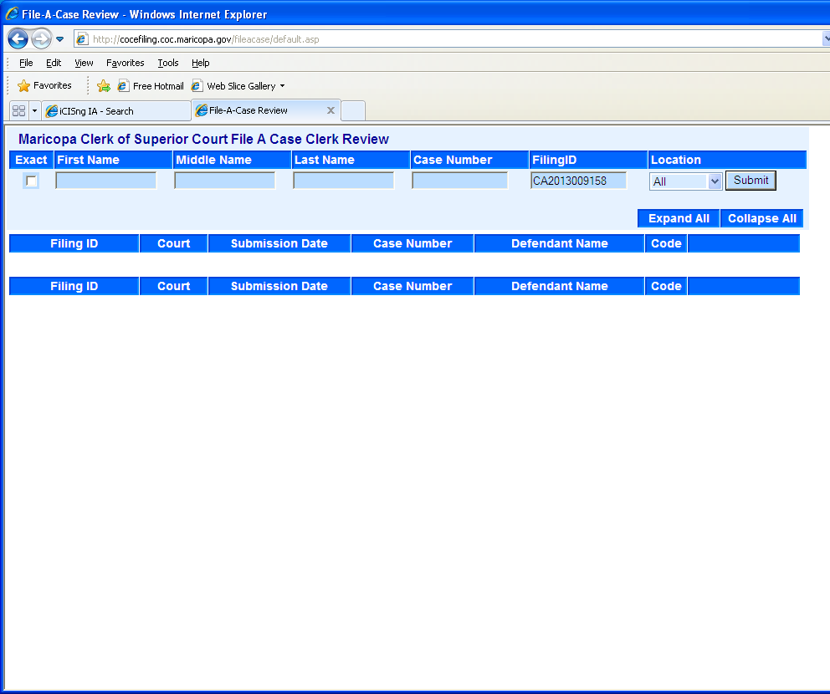

Figure 1b
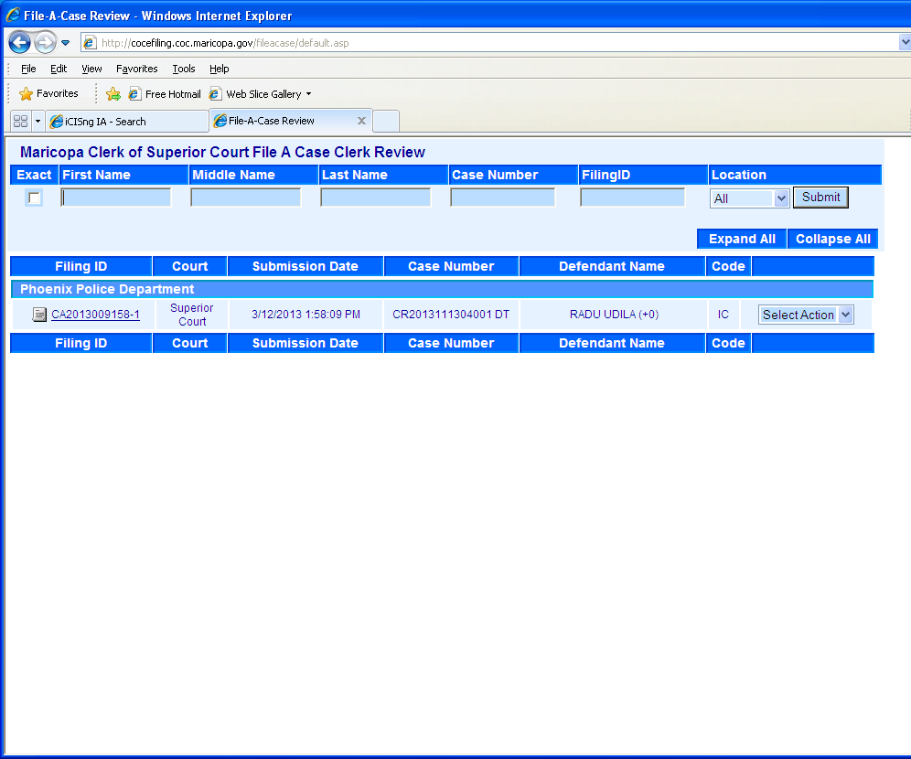

  - Verify the following information matches the findings in IA COC Direct Files:
- Case Number
- Defendant Name
  - Verify the following information in comparison to the direct complaint document:
- Court: Should be Superior Court.
- Defendant Name: Verify spelling and/or missing information.
- Code: Should be IC.

Note: If the case does not come up or if any information is incomplete, incorrect or missing please refer to the PRO-CROPS-1005: Troubleshooting Direct Complaints.

- After all information has been verified, use the drop down list to select Accept NP.
- Go back to IA COC Direct Files and refresh the search. Click on Defendant’s name to open. See Figure 2.

Figure 2
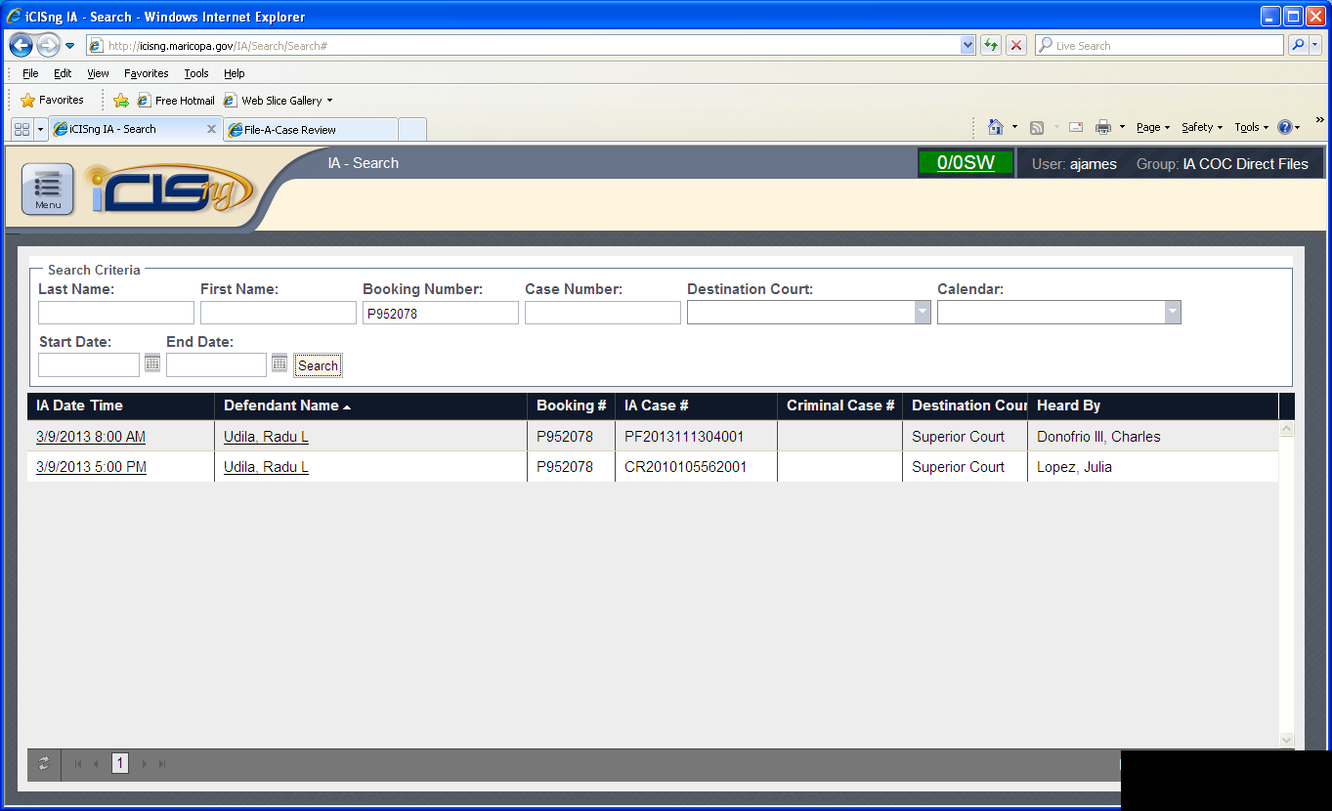

- Verify the filing information has been updated as follows (Figure 3):
- Action Date: Current date
- Action Status: Filed
- COC File Date: Current date
- Case Number: As listed on the document and FAC

NOTICE: The IA COC Direct Files application may contain information that is not yet part of the official court record. Access to this application is provided to you for the purpose of completing the necessary steps outlined in this procedure and nothing further. Be advised that you are never to print or provide copies of the Form IV using this application.

Figure 3
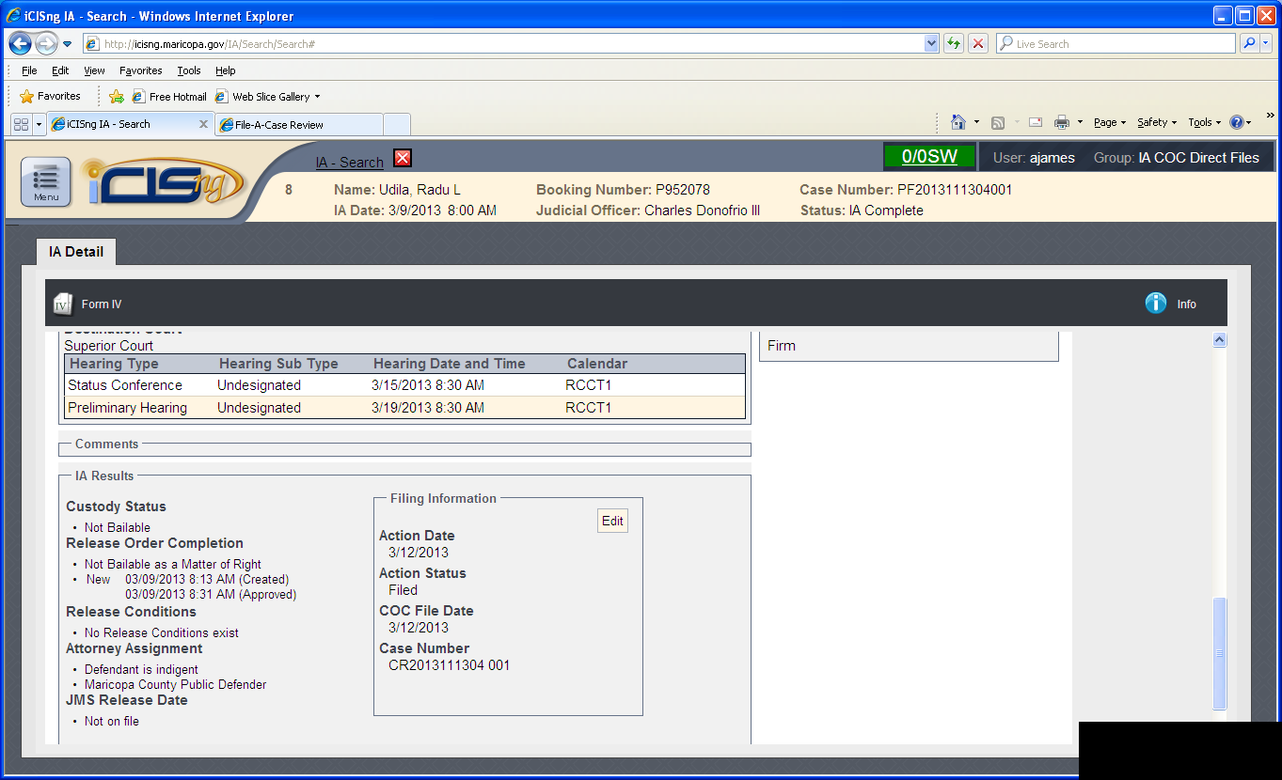

- Write the next court date in the top right hand corner of the original direct complaint
- Open iCIS. Search for the Case Number>Entry>Docket. Click on the file date for the DCO docket entry. Click Bar Code; the Bar Code sheet will print on yellow paper
- Clip the barcode sheet to the back of the packet.
- Repeat steps 1 through 9 until all In-Custody cases have been accepted, updated, and bar coded.
- Stamp the packets as follows:
- Case number (If not listed): On first page of all documents excluding the Form IV, and Victim Information Sheet (VIS).
- Filestamp: On the original Direct Complaint and CIS Sheet
- Conforming Stamp: On the copy of the direct complaint.
- Remove one copy of the Direct Complaint and one copy of the CIS Sheet
  - Staple the copies together with the CIS sheet on top
  - Sort stapled copies by court (RCC or EDC)

  - Place stapled copies in the bins labeled Court Admin RCC or Court Admin EDC
- Repeat steps 10 and 11 until all packets are stamped.
- Sort the original packets by court (RCC or EDC) and place in the respective labeled bin located in the RCC/EDC area

POLICIES / RELATED DOCUMENTS:

- PRO-CROPS-1005: Troubleshooting Direct Complaint Filings

OTHER PARTIES INVOLVED:

    - County Attorney’s Office
    - Attorney Generals Office
    - Various Police Agency Officers/ Liaisons

TIME / VOLUME:

- Varied

FREQUENCY:

- Daily

PERFORMANCE MEASURE:

- N/A

SYSTEM ACCESS REQUIRED:

- iCIS
- IA COC Direct Files
- File-A-Case (FAC)

REPORTS / FORMS:

- Barcode header page

DEFINITIONS:

None

APPLICABILITY:

This procedure applies to all employees of the Clerk of the Court.

REVISION HISTORY:

Revision Number | Revision Author | Summary of Changes | Approval Date
- | N/A | Document Origination | 03/22/2013
A | Ana James | Added Notice regarding dissemination of information from the IA COC Direct Files application. Updated approving authority. | 07/07/2017
B
C

