PURPOSE:

To provide instructions for sending out the Direct File List for the Office of the Clerk of the Court.

OBJECTIVE:

- The Direct File List is sent out at the end of each day to Clerk of the Court staff and all other ancillary departments in order to indicate new cases that were accepted and filed during that day.

EVENT DRIVER:

- The acceptance or creation of new Criminal Direct Complaints within the iCIS court database.

PROCEDURES:
- The Direct File List is sent out at the end of each day after all new Criminal Direct Complaints have been accepted and initiated as cases within iCIS.
- The RCC/EDC staff that is assigned to Baskets/Warrants for the day is the one responsible for sending out the Direct File List.
  - The designee should first check with all other RCC/EDC staff to ensure that all new complaints delivered that day have been processed and accepted.

Note: The deadline for sending out the Direct File List is 5:00PM.

- When it is verified that all complaints have been accepted, then it is time to get the Direct File List ready to be e-mailed out to all ancillary departments that require verification of cases accepted that day.
  - First open the link to the Direct File List Template.
  - Then open the link to DT-EDC Case Number Log Book.
    - Click on the second tab entitled IA Assigned Numbers first.
    - Highlight all of the information for cases that were filed in that day, right click on the highlighted area and select Copy.
    - Paste the information into the Direct File List Template that has already been opened.

Note: The DT-EDC Case Number Log Book requires a password; this can be obtained from the RCC/EDC Team Lead or Supervisor.

Note: The shortcuts to both the Direct File List Template and DT-EDC Case Number Log Book should be saved to the desktop of each RCC/EDC staff member. The original links can be found in the EDC and RCC folder.

  - Go back in the DT-EDC Case Number Log Book and click on the third tab entitled 000001-000301.
    - Highlight all of the information for cases that were filed in that day, right click on the highlighted area and select Copy.
    - Paste the information into the Direct File List Template directly underneath the information that was previously pasted.

Note: The number title of the third tab may change when the RCC/EDC Team Lead obtains a new set of CR numbers for issue.

  - Open the link to FAC Completed Filings.
    - Highlight all cases that were filed and accepted that day and right click on the highlighted area and select Copy.

Note: The shortcut to the FAC Completed Filings should be saved to the desktop of each RCC/EDC staff member. The original link can be found within the EDC and RCC folder.

Note: Be sure to look at the File Date before highlighting all of the cases. Only copy the cases filed in that day. It is possible that cases filed the day before are still on the list and those cases should not be included in the e-mail. See Figure 1 for an example of multiple File Dates.
Figure 1
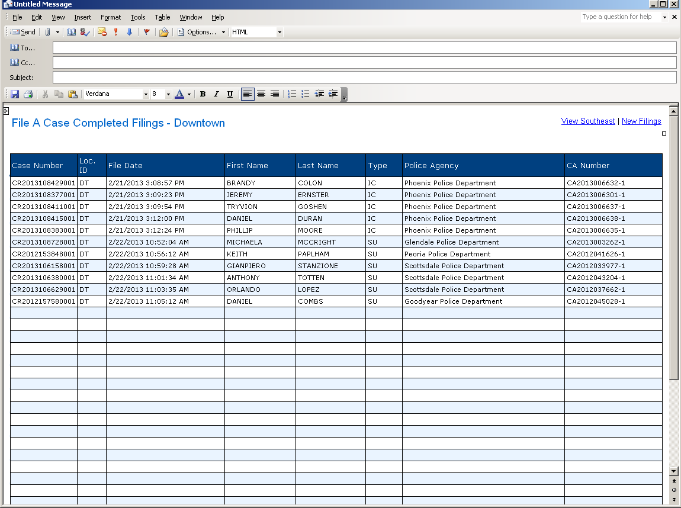

  - Return to the Direct File List Template that has just been created. Click on File in the toolbar, scroll down to Send To and then select Mail Recipient (as Attachment).
    - Microsoft Outlook will automatically bring up an empty e-mail with the Direct File List that has just been created attached to the e-mail.
    - Click the cursor into the blank body, then right click and select Paste.
    - This should paste the File A Case Completed Filings for Downtown into the body of the e-mail.
  - The e-mail is now ready to be sent.
    - Click on the To… Subject line in the e-mail.
    - The Select Names box will automatically pop up.
    - At the top where it states Global Address List, open the drop down menu (click on the down arrow) and select Contacts.
    - In the Contacts List, there should be a group titled Direct File List. Select this group.
    - Once the group is selected it will automatically be entered into the To… subject line of the e-mail.
    - Title the E-mail with Direct File List and the date the e-mail is being sent. For example: Direct File List 02/19/2013.
    - Click Send at the top.

Note: The Direct File List Contact will need to be obtained from the Team Lead or Supervisor.

The Direct File List process is complete

POLICIES / RELATED DOCUMENTS:

- PRO-CROPS-1003: Processing Direct Complaint Filings with Warrants
- PRO-CROPS-1014: Processing Direct Complaint Filings with Summons
- PRO-CROPS-1024: Processing Direct Complaint Filings with In-Custodies

OTHER PARTIES INVOLVED:

- RCC/EDC
- Maricopa County Sherriff’s Office
- Maricopa County Attorney’s Office
- Arizona Attorney General’s Office
- The Jail

TIME / VOLUME:

- Varied

FREQUENCY:

- Daily

PERFORMANCE MEASURE:

- N/A

SYSTEM ACCESS REQUIRED:

- S:\Doc_Management\EDC and RCC
- S:\Doc_Management\EDC and RCC\New Employee Links
- FAC Completed Filings

REPORTS / FORMS:

- N/A

DEFINITIONS:

Direct File List: The list that is sent out at the end of the day after all new Criminal Direct Complaints have been accepted into iCIS.

APPLICABILITY:

This procedure applies to all employees of the Clerk of the Court.

REVISION HISTORY:

Revision Number | Revision Author | Summary of Changes | Approval Date
- | N/A | Document Origination | 03/01/2013
A
B
C

