PURPOSE:

To provide instructions for accepting new and renewed Bondsman Registration and updating the Bondsman List.

OBJECTIVE:

- To maintain the Bondsman List Database for use by the jail system.

EVENT DRIVER:

- A request from a Bondsman to either register or renew their license.

PROCEDURES:
- REQUIRED FORMS:
- Bondsman will need to bring the following completed documents: Information Sheet, Notarized Affidavit and Original Power of Attorney. (Figure 1)
Figure 1
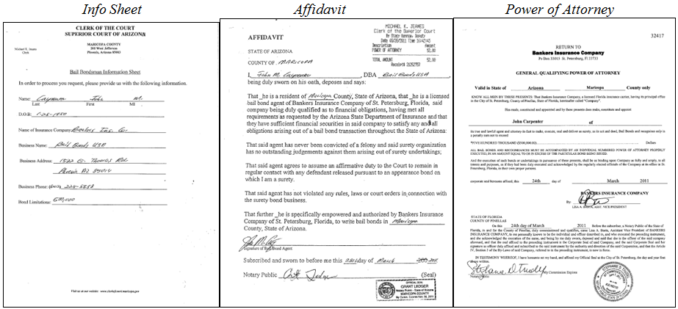

Note: If the Bondsman is Renewing their license the Power of Attoney sheet is not required

- EDITING RECORDS:
- Open the Bondsman List and click into Open Data Edit Form. (Figure 2)
Figure 2
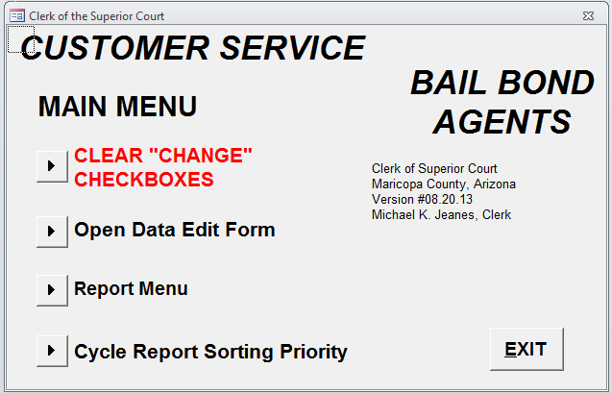
Note: If this is your first entry in the Bondsman List click Clear “Change” Checkbox before opening the Open Data Edit

- Once you are in the Open Data Edit Form window, click on Find. (Figure 3)
Figure 3
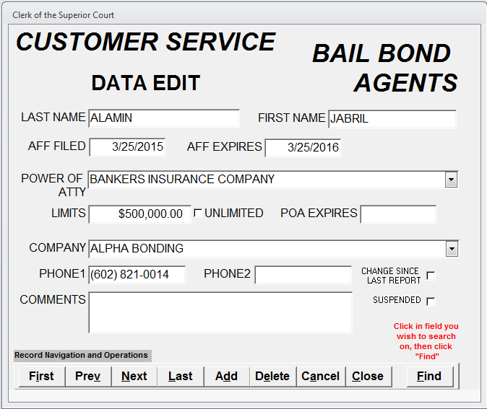
- Search Bondsman database information by individual’s Last name and click Find Next. (Figure 4)
Figure 4
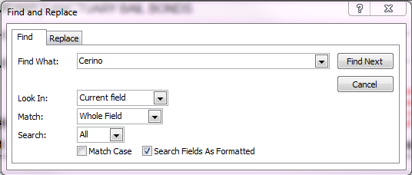
- Edit the Bondsman record according to the renewal information on the Information Sheet. The AFF Filed date will be the filed date and the AFF Expires date will be a year from the filed date. (Figure 5)
Figure 5
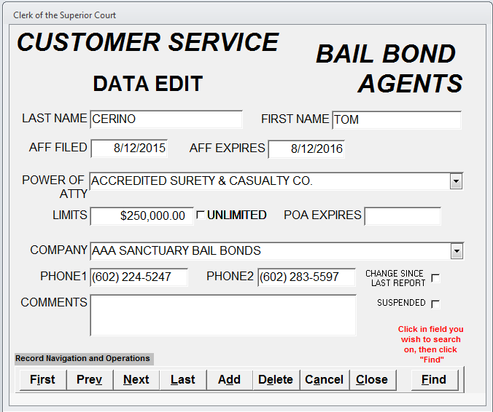
- ADDING NEW RECORD:
- Open the Bondsman List and click into Open Data Edit Form. (Figure 6)
Figure 6
- Once you are in the Open Data edit Form window, click on Add and complete all data entry fields according to the Bondsman documentation provided. (Figure 7a & 7b)

Figure 7a Figure 7b
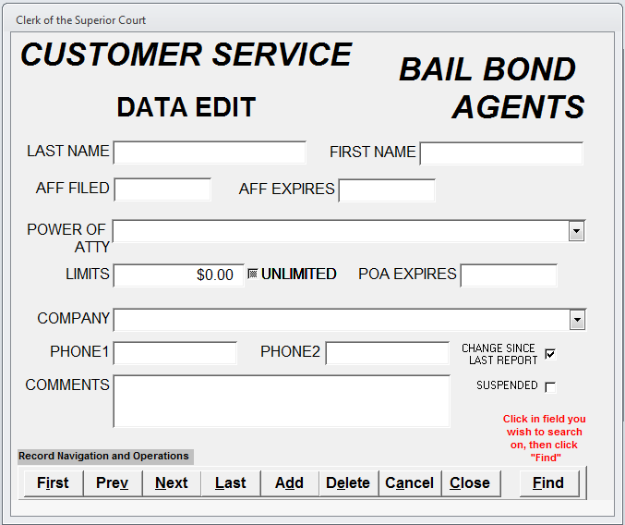
Note: An electronic copy of any edited or added Bondsman information may be printed and retained for your records.

- CASH RECEIPTING:
- Run the Information Sheet through the cash system. Enter the Bondsman's name and company in the Comments section of the Cash Receipting System.
  - If it is a license renewal, use code 480 and run the Affidavit through the Cash Receipting System.
  - If it is a new license, use code 465 and run the Affidavit through the Cash Receipting System.
  - If it is a new power of attorney only, treat as a new license. Use code 465 and run the Affidavit through the Cash Receipting System.
- Staple the documents together and place them in the top bin of the designated filing cabinet, which are sorted in alphabetical order.

- GENERATING REPORTS - DAILY:
    - Around 3:30 pm any changes to the Bondsman List will be pulled and emailed to the Bondsman Distribution list. To generate report click on Report Menu on the database home menu screen. (Figure 8)
Figure 8

    - Click into Changes Only – Portrait to generate the report. Select the email button at the top of the screen and send the email to the Bondsman Distribution list. (Figure 9a & 9b)

Figure 9a Figure 9b
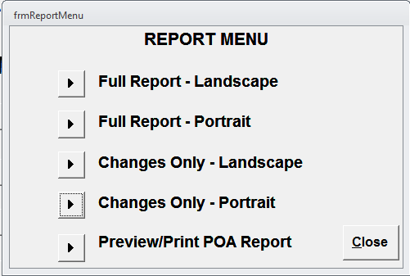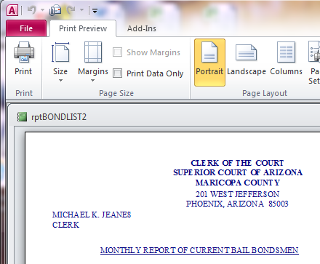

Note: If there are no changes or updates to the Bondsman List, an email does not need to be sent.

- GENERATING REPORTS - MONTHLY:
- On the first of the month a full Bondsman List report will be generated and emailed to the Bondsman Distribution list. To generate the report click on Report Menu on the database home screen. (Figure 10)
Figure 10

- Click into Full Report – Portrait to generate the report. Select the email button at the top of the screen and send the email to the Bondsman Distribution list. (Figure 11a & 11b)
Figure 11a Figure 11b
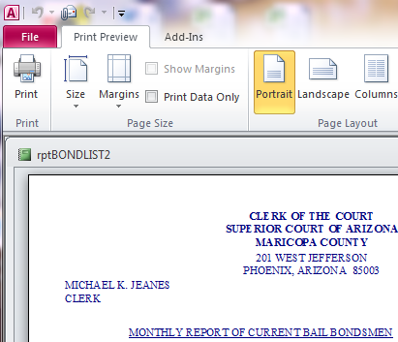

POLICIES / RELATED DOCUMENTS:

- ARS Title 13: Criminal Code
- ARS Title 20: Insurance

OTHER PARTIES INVOLVED:

- Bondsman
- Bail Bond Companies
- Sheriff's Office
- Arizona Department of Insurance

TIME / VOLUME:

- 5 minutes

FREQUENCY:

- Daily
- Monthly

PERFORMANCE MEASURE:

- N/A

SYSTEM ACCESS REQUIRED:

- Bond List Database – S:/AccessDatabaseShortcuts-Staff
- Cash Receipting System – COC Website Secured Applications
- Microsoft Outlook – Bondsman Distribution List

REPORTS / FORMS:

- F-CROPS-1016: Bail Bondsman Information Sheet
- F-CROPS-1017: Bail Bondsman Affidavit
- Original Power of Attorney

DEFINITIONS:

- N/A

APPLICABILITY:

This procedure applies to all employees of the Clerk of the Court.

REVISION HISTORY:

Revision Number | Revision Author | Summary of Changes | Approval Date
- | Angelica Mejia | Document Origination | 02/28/2013
A | Danielle Draper | Revised title and the associated procedures accordingly. | 08/28/2015
B | Ana James | Revised to reflect current approving authority | 06/23/2017
C

