PURPOSE:

To provide instructions for processing bond exonerations for the release of bond monies to individuals and bonding companies who posted bond.

OBJECTIVE:

- To provide timely release of bond monies to the posting party.

EVENT DRIVER:

- Customer brings a signed Order Exonerating Bond to the filing counter window.

PROCEDURES:
- RECEIPT OF THE ORDER
- The release of bond funds from the Trust accounting system requires a court order.
  - Criminal Cases: The original or certified copy of the order must be presented to the filing counter. The order must include the following:
    - The Judicial Officer's actual signature, not a facsimile stamp.
    - The Defendant's Name.
    - A CR, PF, or booking number.
    - Amount of the bond (the order may state that the bond is released to "the posting party".)
  - Non-criminal Cases: The original or certified copy of the order must be presented to the filing counter. The order must be specific and include the following:
    - The Judicial Officer's actual signature, not a facsimile stamp.
    - The exact amount of money to be released.
    - The name of the person(s) to whom the money is to be released.
    - The address to which the check can be mailed.

- VERIFICATION OF THE ORDER
- Ask the Customer whether the bond was posted by:
  - An individual at the jail, or
  - By a bail bondsman.
- Upon the Customer’s response to the previous step, access the COC Trust Database located in the Secured Applications on the COCWEB and click on Inquiry (see Figures 1 and 2).

Figure 1
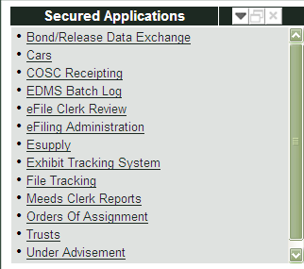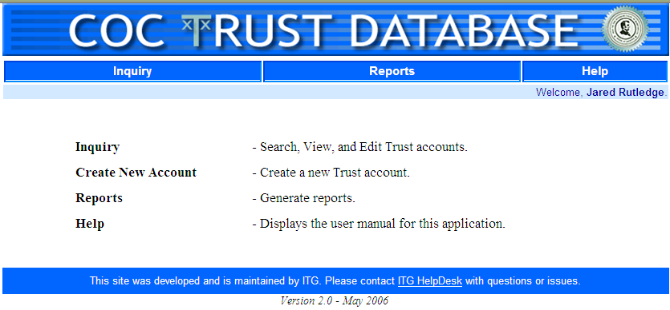
Figure 2

- On the Inquiry screen, enter at least one of the required pieces of information (usually the case number) and click Search (see Figure 3).

Figure 3
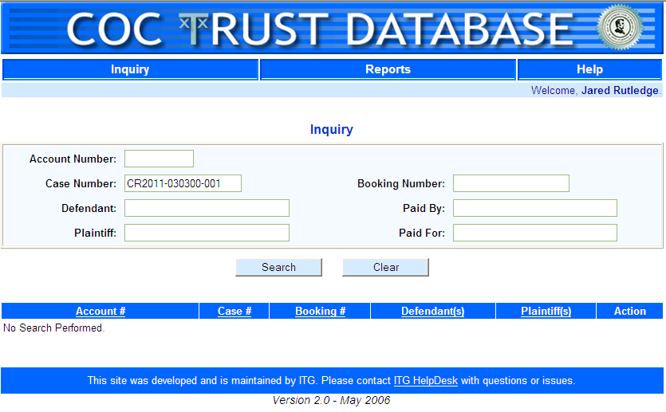

- When the bond information appears, verify that the case is the one desired and click on View Account Detail (see Figure 4). Then click on the hyperlinked date which will bring up the record in detail (see Figures 5 and 6).

Figure 4
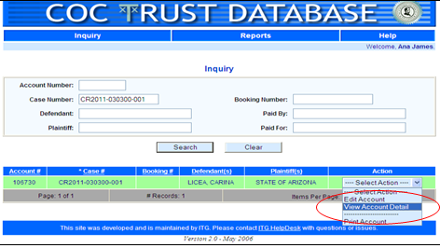

Figure 5
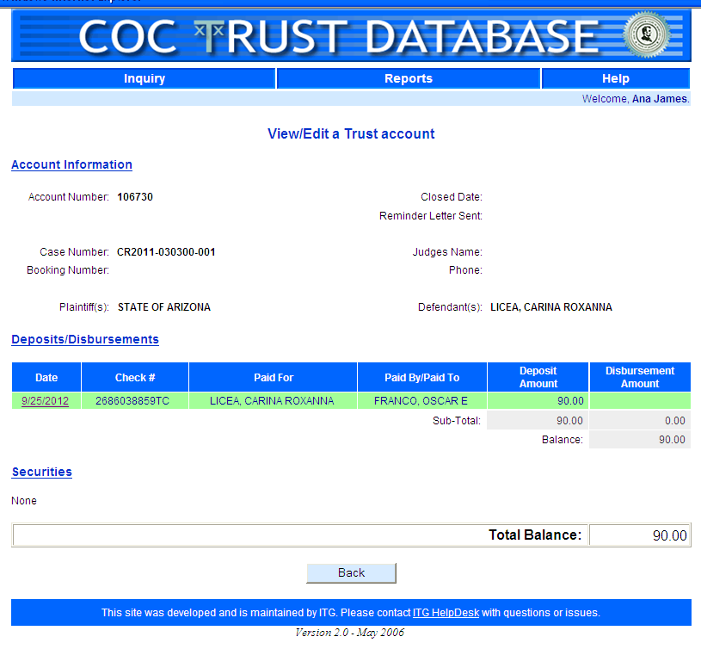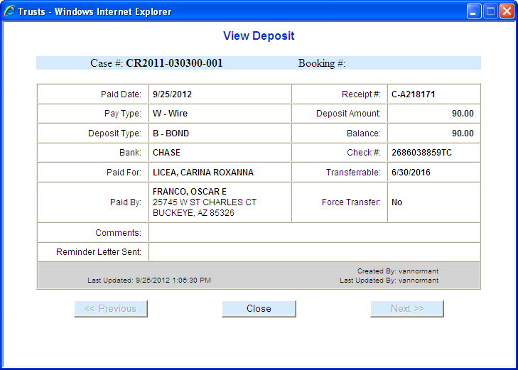
Figure 6

  - The bond information might NOT appear in the database for the following reasons:
    - The bond money paid at the jail has not been sent to the Accounting Division yet (there is a waiting period of 7-10 business days); or
    - The bail bondsman used a surety bond instead of cash (see Step III. Processing the Order).

- If the name and address of the posting party is correct, advise the Customer that orders for release of bond funds received before 5:00 p.m. will be processed the next business day and mailed to the address provided in the court order. For Criminal cases, the check will be mailed to the address provided at the time bond was posted. Bond money will be released only in the form of a Clerk of the Superior Court check.

- PROCESSING THE ORDER
- If the bond information does not appear in the database AND the Customer has stated that a bail bondsman posted the bond:
  - File the original order and issue a certified copy:
    - Filestamp the original.
    - Make a photo copy of the stamped original.
    - Apply the certified copy stamp to the top of the copy, apply the certification stamp to the bottom or back of the copy.
    - Complete the certification stamp by filling in the current date and signing.
    - Crimp over the completed certification stamp using the clerk of court embossed seal.
  - Advise the Customer to take the certified copy to the bail bond company for release of the bond.
  - Place the original order in the EDM bin for processing.
- If the bond information does appear in the database AND the Customer has stated that the bond was paid in cash at the jail, make a copy of the Order to give to the Customer, advise the Customer that orders for release of bond funds received before 5:00 p.m. will be processed the next business day, and that the check will be mailed to the address provided at the time bond was posted. Bond money will be released only in the form of a Clerk of the Superior Court check. Also provide to the Customer the phone number to the Accounting Department (602-506-7757), so they can call if any issues arise.
- Once the original Order has been filed in, fill out the Daily Bond Release form (see Figure 7) on the clipboard and place the Order under the Daily Bond Release form.

Figure 7
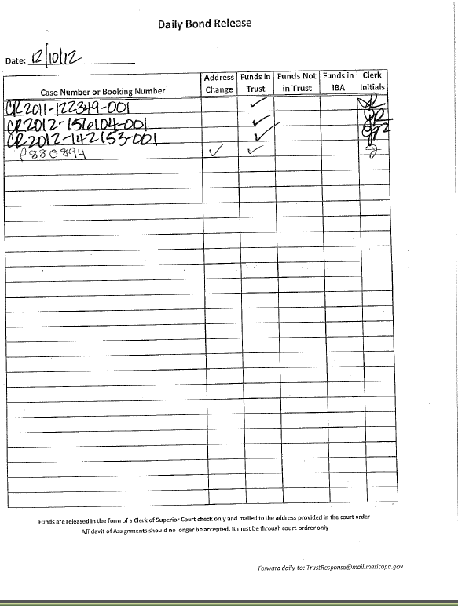

- Scan and e-mail the Daily Bond Release form along with the stack of documents to TrustResponse@mail.maricopa.gov at the end of the day. If no orders exonerating bond are processed that day, the Notice of No Orders Exonerating Bond form (see Figure 8) is scanned and e-mailed to the above email address to advise the Accounting Department that no Orders were received.

Figure 8
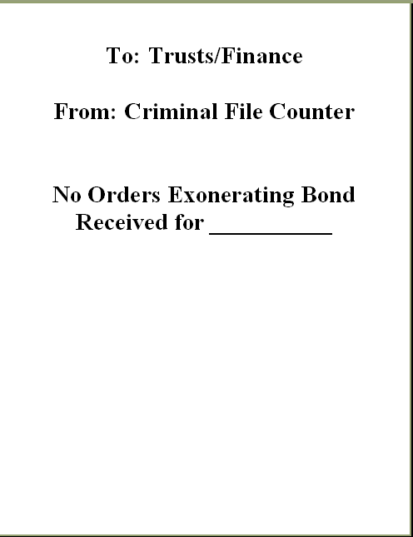

- After the documents are scanned, the sort through the stack:
  - Place in the EDM bin:
    - The Orders with CR numbers and
    - The Affidavit of Address Change Forms signed by the Defendant.
  - Place in the designated staging area at the filing counter:
    - The Bond Exoneration Log Sheet,
    - The Orders with PF and Booking #'s, and
    - The Affidavit of Address Change Forms signed by a non-party.
- At times the filing counter will receive certified copies of PB or CV cases from customers ordering the release of monies.
  - Take the certified copy from the Customer.
  - Record the document information on the Bond Exoneration Log.
  - Scan to TrustResponse@mail.maricopa.gov at the end of the day.
  - Interoffice mail the certified copy to Accounting, who will mail the certified copy back to the Customer along with the check.
  - Advise the Customer that the certified copy will be returned to them in the mail with the check.

- AFFIDAVIT OF ADDRESS CHANGE FORM
- At times, the mailing address of the posting party may be incorrect or outdated. In these instances, the posting party is required to fill out an Affidavit of Address Change form (see Figure 9) and have it notarized by a Notary Public. The completed form is then sent along with the rest of the documents to Accounting at the end of the day.
Figure 9
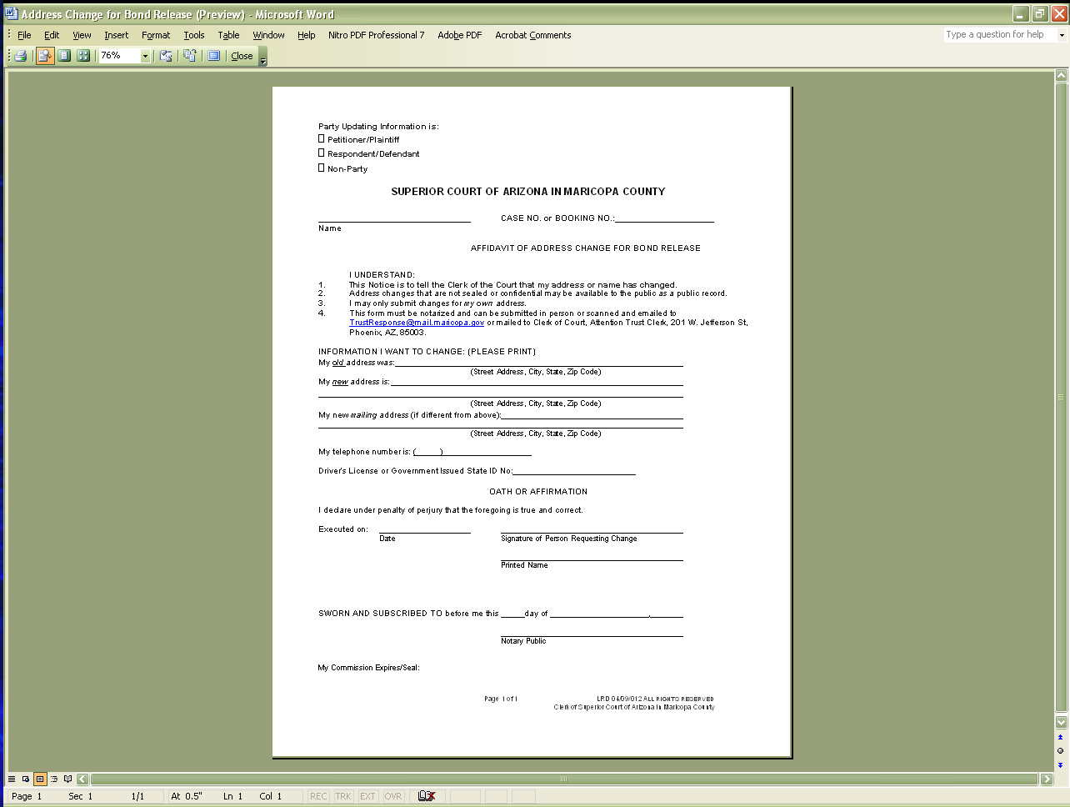
POLICIES / RELATED DOCUMENTS:

- ARS Title 13: Criminal Code
- ADDENDUM-ACC-1001: Trust Tutorial

OTHER PARTIES INVOLVED:

- Customer/Defendant
- Judicial Officer
- Accounting Department (Trust/Finance)
- Jail
- Bail Bond Companies

TIME / VOLUME:

- Varied

FREQUENCY:

- Daily

PERFORMANCE MEASURE:

- N/A

SYSTEM ACCESS REQUIRED:

- COC Trust Database
- BizHub
- E-mail

REPORTS / FORMS:

- Order exonerating bond (provided to the customer from the Judge)
- Order releasing funds (provided to the customer from the Judge)
- F-CROPS-1001: Daily Bond Release Log form
- F-CROPS-1002: Notice of No Orders Exonerating Bonds form
- F-CROPS-1003: Affidavit of Address Change FOR Bond Release form

DEFINITIONS:

- Order exonerating bond: An order signed by the Judge releasing the bond monies back to the posting party.

APPLICABILITY:

This procedure applies to all employees of the Clerk of the Court.

REVISION HISTORY:

Revision Number | Revision Author | Summary of Changes | Approval Date
- | N/A | Document Origination | 03/22/2013
A | Ana James | Revised to reflect current approving authority | 06/23/2017
B
C

