PURPOSE:

To provide instructions for processing Interstate Compacts.

OBJECTIVE:

- To quickly and efficiently initiate and/or docket all incoming Interstate Compacts.

EVENT DRIVER:

- An email is sent from the Adult Probation Department to the Interstate Compact Mailbox with a document to be added to the docket in iCIS.

PROCEDURES:
- Prepare Instate Compact Documents
- Check e-mail in the Interstate Compact Mailbox. Each e-mail contains either an Interstate Compact ACCEPTED or CLOSED Information Sheet for Clerk’s File document. See Figure 1

Figure 1A
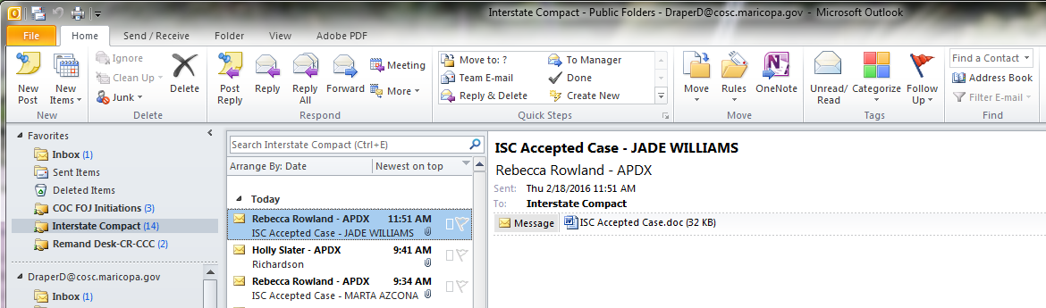

- Print all Interstate Compact Information Sheets
- Red Flag all emails that the Interstate Compact Information Sheets have been printed
  - This communicates with the staff that this email is in the process of being completed and to avoid duplicate work. See Figure 1B.

Figure 1B
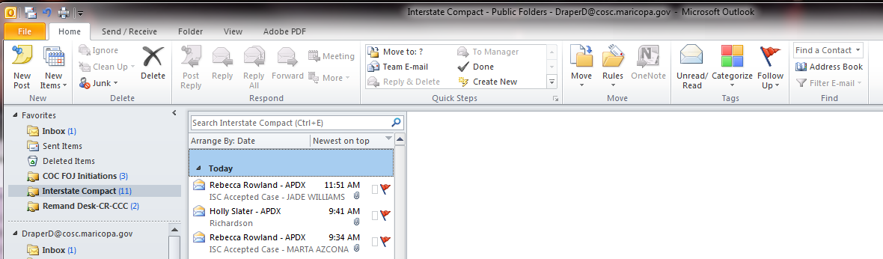

- Remove any additional pages that are not part of the filing
  - Case Closure Notice
- File stamp all Interstate Compact Information Sheets
- Sort Interstate Compact Information Sheets into the following piles:
  - Accepted – Proceed to Section II
  - Closed – Proceed to Section III

- Accepted Interstate Compact Cases – Manually Initiate In iCIS
  - Click Task → COC Case Initiation. See Figure 2A

Figure 2A
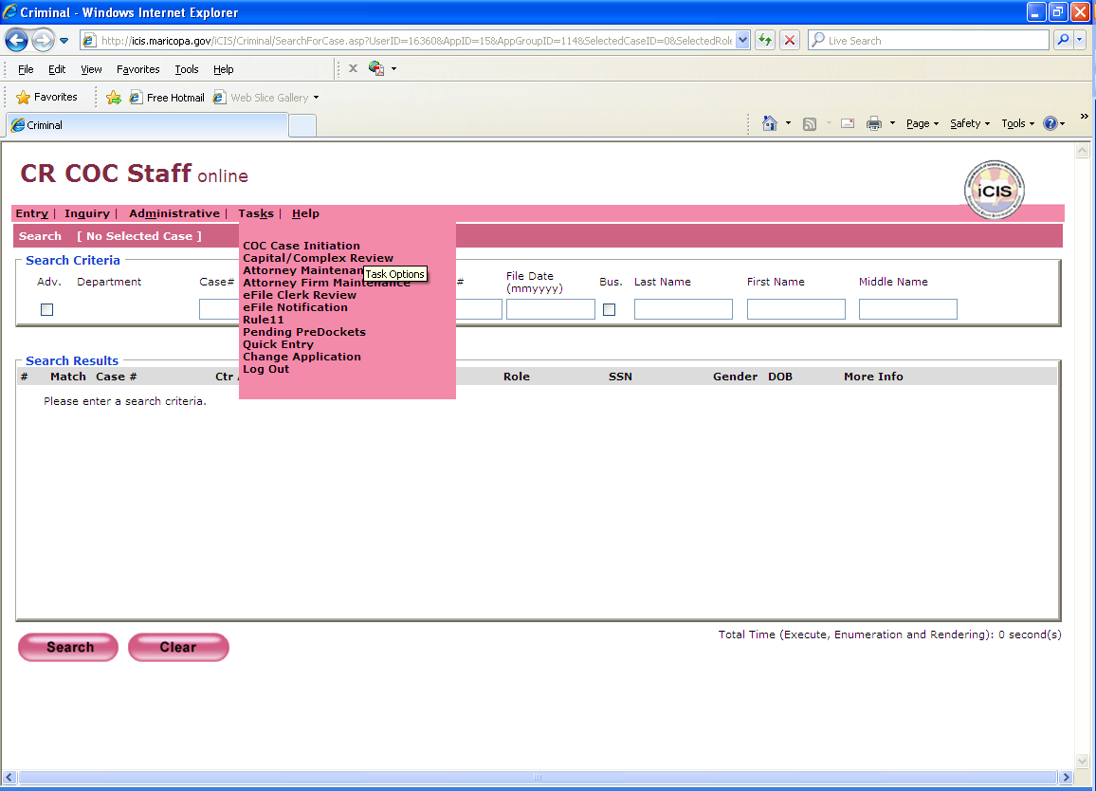

  - Complete the Case Initiation Screen as follows: See Figure 2B.
    - Case Type: Criminal
    - Case Number: Provided on document
    - CR Type: Adult Probation Interstate Compact
    - Facility: Downtown
    - File Date: File stamp date
    - Click Continue

Figure 2B
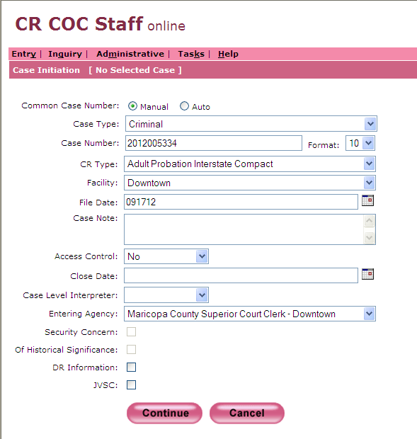

  - Complete the Add Parties to Case Screen as follows: See Figure 2C.
    - First Name: As it appears on the form
    - Middle Name: As it appears on the form – If applicable
    - Last Name: As it appears on the form
    - Suffix: If applicable
    - Primary Role: Defendant
    - Start Date: File stamp date
    - Def ID: Ending 3 numbers of case number – Typically 001
    - Sex: M or F
    - DOB: Found on form
    - SSN: If applicable
    - Filing Agency: Adult Probation
    - Click Continue

Figure 2C
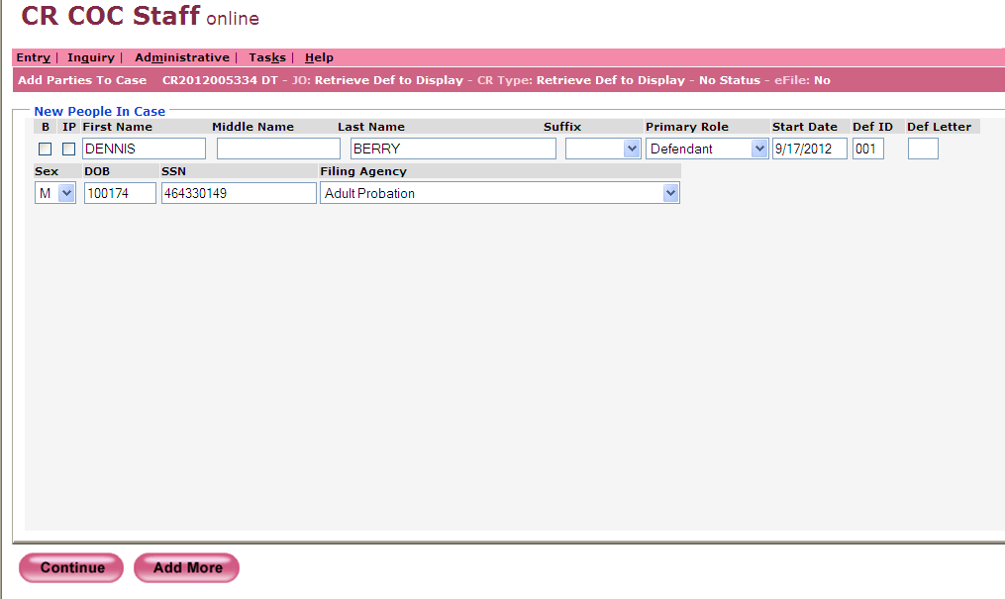

  - Attorney in Case Screen
    - Do NOT enter any Attorney information
    - Click Continue. See Figure 2D.
Figure 2D
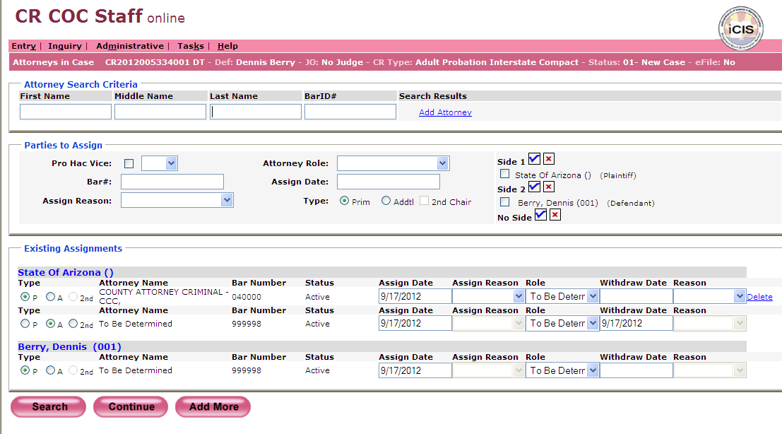

  - Person Address Screen
    - Do NOT enter an address
    - Click Skip To End. See Figure 2E.

Figure 2E
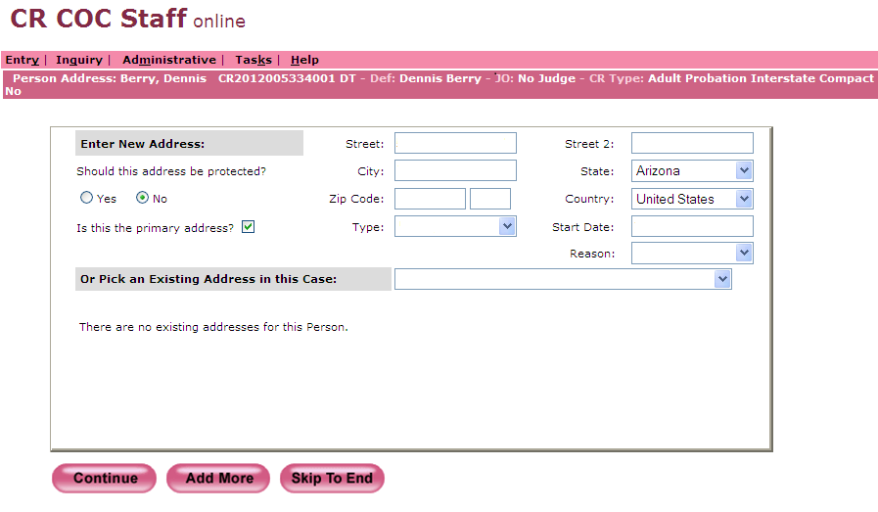

  - Complete the Docket Event Screen as follows: See Figure 2F
    - Filing Date: File stamp date
    - Attorney Filing: Court
    - Document Title: PBC (Interstate Probation Supervision Compact)
    - Click Barcode
Figure 2F
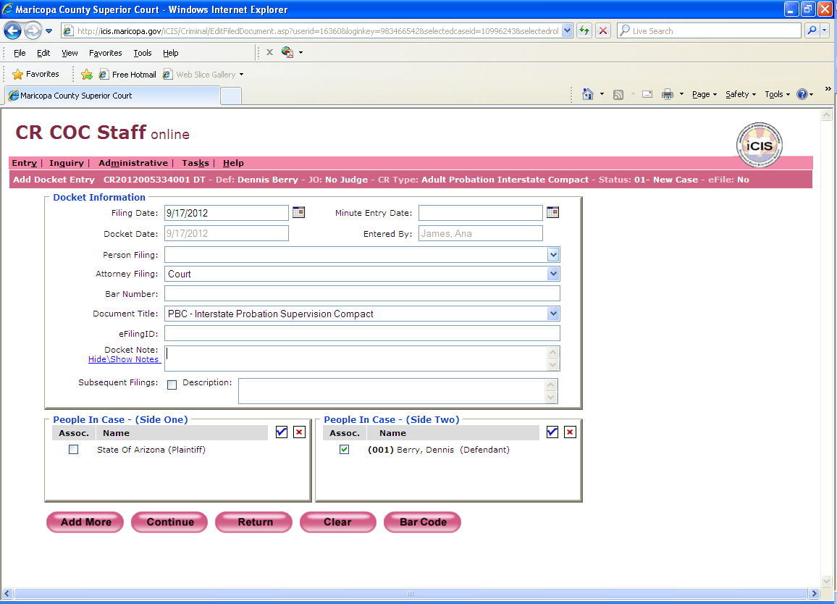

- Closed Interstate Compact Cases – Add Docket Event
  - In the Docket Screen click Add. See Figure 3A.
Figure 3A
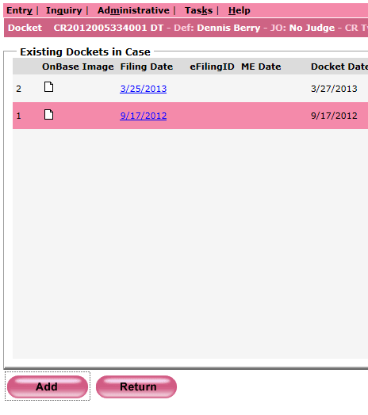
  - Complete the Add Docket Event Screen as follows: See Figure 3B
    - Filing Date: File stamp date
    - Attorney Filing: Court
    - Document Title: CCN (Case Closure Notice)
    - Click Barcode
Figure 3B
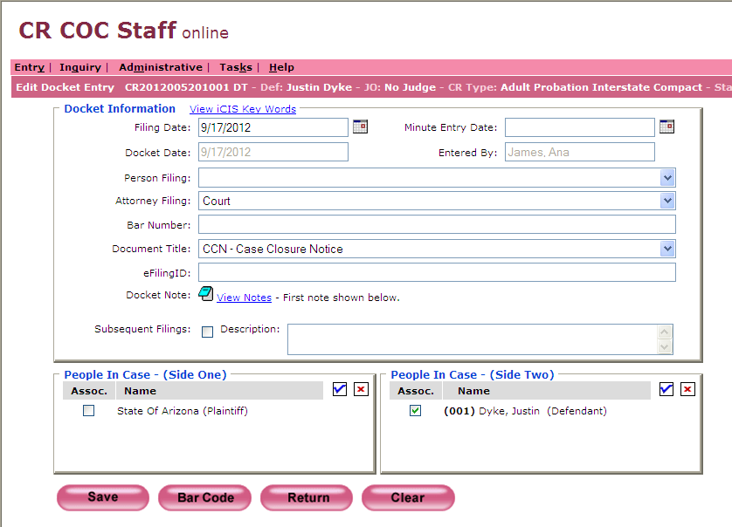

- Print Barcodes And Batch Documents For Scanning
  - Open Express Indexing 2.5 and Print All barcodes. See Figure 4
Figure 4
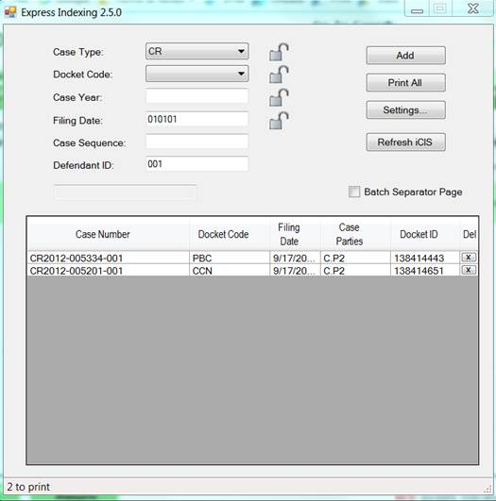
  - Merge Barcodes in front of their correlating documents: PBC or CCN
  - Create a Batch Slip for the barcoded documents as follows:
- Circle CR at the top
- Year: Case number year. If there are multiple case years on the documents (Example: CR2015 & CR2016) write VAR on this line
- File Date: File stamp date
- Document Type: PRI – Priority
- Document Count: Number of barcoded documents
- Received Date: Date processing Interstate Compacts
- Sort By: Your 3 initials
- Docketed/Barcoded By: Your 3 initials
- Date Docketed/Barcoded: Date docket event/barcode was created
- Prep By: Your 3 initials
  - Attach the Batch Slip to the front of the barcoded documents and place in the scanning basket
  - Delete the email from the Interstate Compact Mailbox after the entire process is completed and documents appear on the docket in iCIS

POLICIES / RELATED DOCUMENTS:

- PRO-CROPS-1010: Barcoding Documents using the Express Indexing Program

OTHER PARTIES INVOLVED:

- Adult Probation

TIME / VOLUME:

- 3.35 minutes for each Accepted Case
- 1.55 minutes for each Closed Case

FREQUENCY:

- Varies

PERFORMANCE MEASURE:

- N/A

SYSTEM ACCESS REQUIRED:

- iCIS
- Microsoft Outlook
- Interstate Compact Mailbox
- Express Indexing 2.5

REPORTS / FORMS:

- Interstate Compact Accepted Form
- Interstate Compact Closed Form
- F-EDMQC-1016-1: Batch Slip – Priority

DEFINITIONS:

- Interstate Compact: A case in which a Defendant from another jurisdiction brings his/her case over to Maricopa County
- ISC: Interstate Supervision Compact
APPLICABILITY:

- This procedure applies to all employees in the RCC/EDC department of the Clerk of the Court.

REVISION HISTORY:

Revision Number | Revision Author | Summary of Changes | Approval Date
- | N/A | Document Origination | 02/28/2013
A | Danielle Draper | Revised screenshots, more detailed steps and updates to the ending bullet points | 02/22/2016
B
C

