PURPOSE:

To provide instructions for processing Warrants for Arrest for the Office of the Clerk of the Court.

OBJECTIVE:

- To establish a procedure for the processing of Warrants for Arrest, which are brought to RCC/EDC by judicial staff.

EVENT DRIVER:

- RCC/EDC staff mail out summonses with the date that the defendant is to appear at court for their Initial Appearance hearing. If the defendant does not appear for their Initial Appearance hearing, the court will issue a Warrant for Arrest. After the warrant has been signed by the Judicial Officer, the judicial staff delivers the Warrant(s) for Arrest to RCC/EDC to be processed by RCC/EDC staff.

PROCEDURES:
- Warrants for Arrest are brought to RCC/EDC by judicial staff.
  - The warrants are placed in the Warrants for Arrest bin until they are ready to be processed by RCC/EDC staff.
- When the designated staff is ready to process the Warrants for Arrest, they will pull all of the warrants that have been delivered out of the bin.
  - First check that the Judicial Officer (JO) has completed all necessary portions of the warrant.
  - The warrant must have the Judicial Officer’s signature.
  - The warrant must be dated with the date the Judicial Officer signed the warrant.
  - The warrant must have a bond amount.

Note: If the defendant is to be held without bond, the non-bondable check box should be marked off by the Judicial Officer, or non-bondable should be written in the bond amount for the warrant.

- If the Warrant for Arrest contains all of the above pieces of information it is ready to be processed.
  - Note: If the warrant is missing any of the required pieces of information, it will need to be sent back to the court to be corrected. A cover sheet should be placed on top of the warrant with an explanation of what needs to be corrected.
  - Sign your name on the Clerk of the Superior Court line.
  - Crimp the court seal over your name as shown in Figure 1.
Figure 1
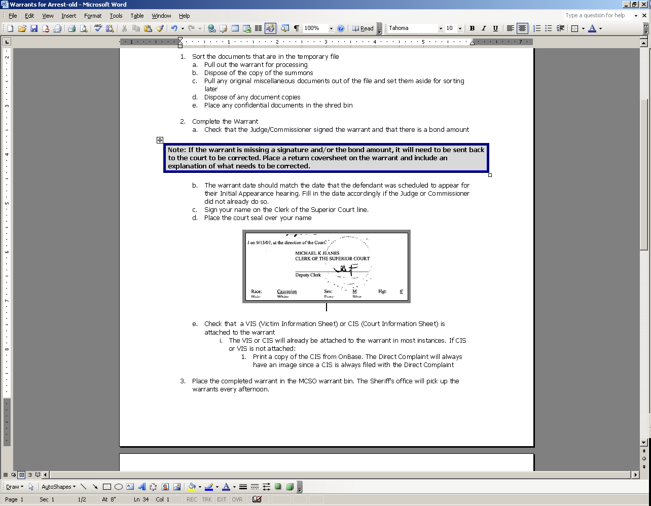

- Check that there is a Victim Information Sheet (VIS) or Court Information Sheet (CIS) present with the warrant.
  - The CIS or VIS needs to be attached to the warrant when it is delivered to the Maricopa County Sherriff’s Office (MCSO).
  - If the Warrant for Arrest was delivered to RCC/EDC without a CIS or VIS attached, then the CIS must be printed out.
      - To print the CIS, first login to iCIS.
      - Search the Criminal Case Number associated with the defendant.
      - When the defendant’s case information populates, click on the defendant’s name.
      - Next, right click and select from the pull-down menu Docket as shown in Figure 2.
Figure 2
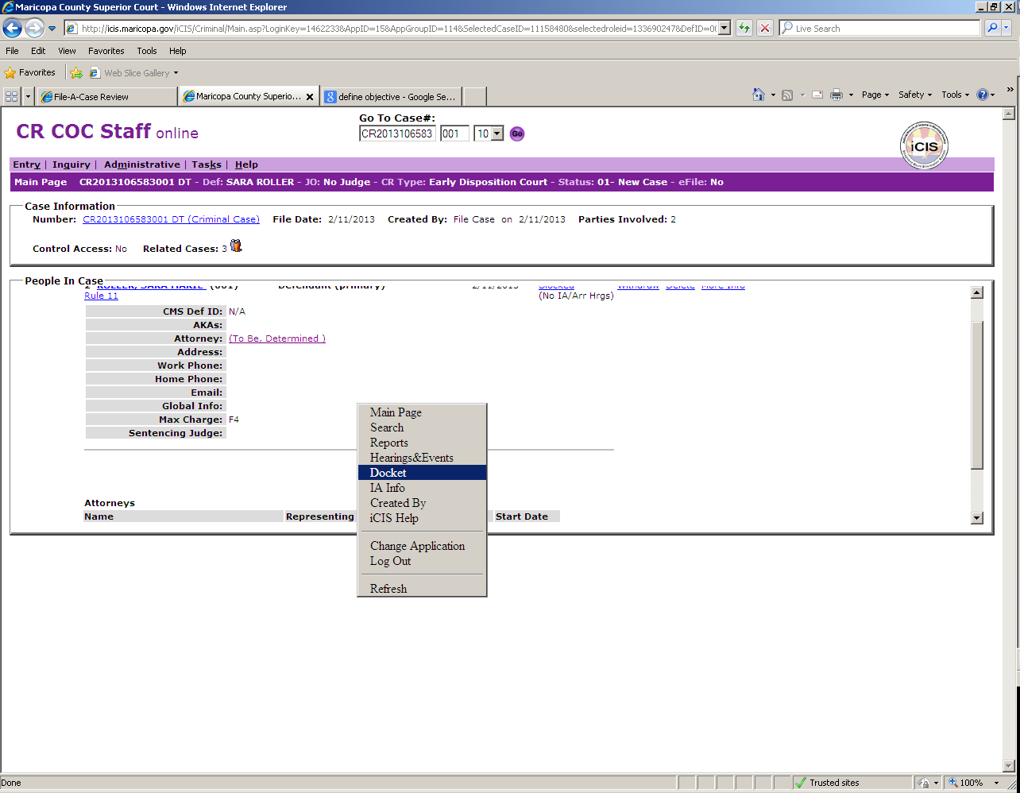

      - Find the defendant’s Direct Complaint (DCO) docket. Click on the image and the CIS can be found within the DCO packet. Print just the CIS page.
- Make a copy of each Warrant for Arrest that has been signed and sealed by RCC/EDC staff.
  - Note: Only copy the warrant; do not copy the CIS or VIS sheet that goes with the warrant.
  - Place all of the copies made into the Issuance of Warrants for Arrest (IWA’s) bin. These will be docketed later by RCC/EDC staff designee as proof that the warrant was processed and delivered to the MCSO Office.

- After the copy of the warrant has been made, attach the CIS or VIS to the original Warrant for Arrest. It is now ready to be delivered to the MCSO Office.
  - Open the RCC/EDC Warrant Delivery Log.
  - Enter the following pieces of information on the log:
      - Date.
      - Name of the person delivering the warrants to the Sherriff’s office (this can be found on the RCC/EDC calendar). The person assigned to RCC Summons is the one who will be delivering the warrants to the Sherriff’s office.
      - Fill in the Criminal Case Numbers of each warrant that was signed and sealed.
      - Print two copies of the completed Warrant Delivery Log on yellow paper.
Note: One copy is the original to be signed by Sherriff’s office staff and delivered back to the RCC/EDC team lead. The second sheet is kept by the Sherriff’s office staff as verification that the warrants listed on the log were delivered.

- Place all of the completed Warrants for Arrest, with the Warrant Delivery Log on top, in the Warrants for Sherriff bin. They will be delivered to the Sherriff’s office by the designated staff member.

The Warrant for Arrest process is complete

POLICIES / RELATED DOCUMENTS:

- PRO-CROPS-1007: Processing IWA
- PRO-CROPS-1009: the RCC/EDC Daily Run

OTHER PARTIES INVOLVED:

- RCC/EDC
- Judicial staff
- Maricopa County Sherriff’s Office

TIME / VOLUME:

- 1.8 minutes/ each warrant issued

FREQUENCY:

- Daily

PERFORMANCE MEASURE:

- N/A

SYSTEM ACCESS REQUIRED:

- S:\Doc_Management\EDC and RCC\Forms
- iCIS

REPORTS / FORMS:

- Warrant Delivery Log

DEFINITIONS:

- Issue Warrant: Describes the preparation of a warrant to be delivered to the Maricopa County Sherriff’s Office. RCC/EDC staff must ensure the necessary pieces of information have been completed by the Judicial Officer, and then sign, seal and attach the CIS/VIS sheet to the warrant before it can be delivered.
- Warrant Delivery Log: The log to be completed and delivered with all issued Warrants for Arrest to the Maricopa County Sherriff’s Office, as verification that the warrants were delivered.
- Court Information Sheet (CIS): Contains all demographic information, address, and summary of charges related to the defendant.
- Victim Information Sheet (VIS): Contains all demographic information, address, and summary of charges related to the defendant, as well as information related to the Victim.

APPLICABILITY:

This procedure applies to all employees of the Clerk of the Court.

REVISION HISTORY:

Revision Number | Revision Author | Summary of Changes | Approval Date
- | N/A | Document Origination | 02/21/2013
A
B
C

