PURPOSE:

To provide instructions for processing direct complaint filings with summons

OBJECTIVE:

- To provide the necessary direction to ensure direct complaint filings with summons are processed correctly and accurately initiated
- To ensure consistent filing and accountability of all direct complaint filings with summons

EVENT DRIVER:

- A direct complaint filing with a summons is received from one of the following:
  - County Attorney’s Office;
  - Attorney General’s Office;
  - Various Police Agency Officers/ Liaisons
- Direct complaint filings with summons are considered Basket Cases because they are not high priority complaint types
- Direct complaint filing with a summons are sworn in the day prior to initiating and are found in the bin labeled Basket Cases

PROCEDURES:
- Verify Court Designations
  - Upon receipt of direct complaint filings with a summons sort complaints by facility
    - RCC or EDC Downtown: Proceed to Step 2
    - RCC or EDC Southeast: Do not process - Interoffice to the Southeast Facility
      - Complete an interoffice transmittal sheet with the following information:
        - To Facility: SEA-1
        - To Section: RCC/EDC SE
        - To Phone: 61078
        - From Facility: SCT-4
        - From Section: RCC/EDC DT
        - From Phone: 62586
        - Comments: Hand Deliver Complaints
        - Body: PbK Number and Defendant’s Last Name
        - Prepared By: Your First Initial and Last Name
        - Prepared By Date: Date Sending Complaints

- Initiate Summons Case into iCIS
  - Open File-A-Case Review:
    - Search for File-A-Case entry by entering the PbK number found in the upper right-hand corner of the direct complaint or CIS sheet into the FilingID field. See Figure 1A

Figure 1A
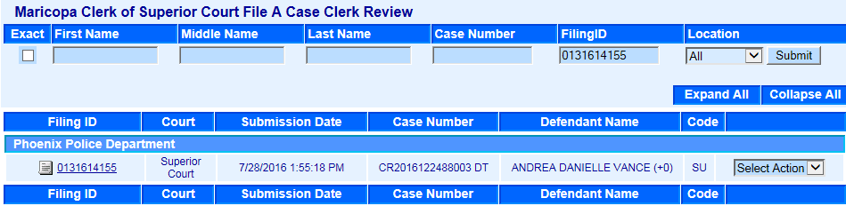

    - Verify the following information of the File-A-Case entry to the direct complaint filing: See Figure 1B
      - Court: Should be Superior Court for Downtown cases
      - Defendant Name: Should match the main name on the direct complaint
      - Code: Should be SU for Summons complaint type

Figure 1B

  - Highlight and copy (Ctrl+C) the case number from FAC
  - Paste (Ctrl+V) the case number into iCIS without the identifier and search
    - If the number is not in iCIS, you may use that number for that direct complaint
    - If the number is in iCIS, do not use that number. Refer to Pro-Crops-1005: Troubleshooting Direct Complaints
  - Write the case number on the top Court Information Sheet (CIS)
  - Use the Select Action drop menu and click Accept NP. See Figure 1C

Figure 1C
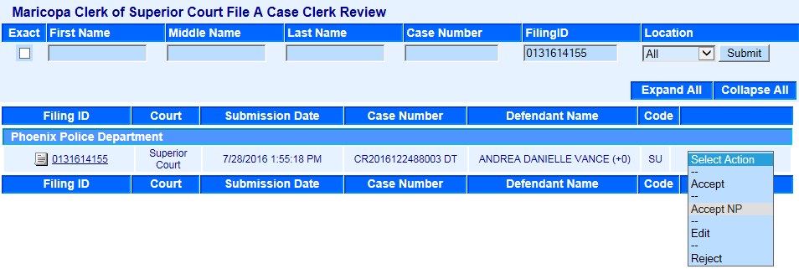

  - In iCIS paste (Ctrl+V) the case number into the Docket Screen. Click on the Filing Date for the DCO (Direct Complaint). See Figure 1D

Figure 1D
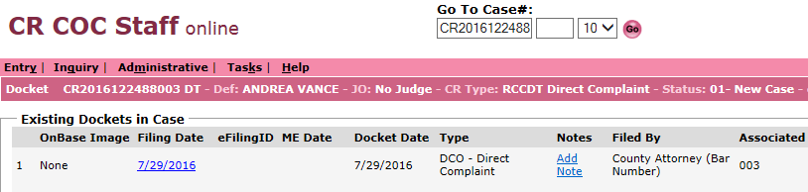

  - Click Barcode. See Figure 1E
Figure 1E
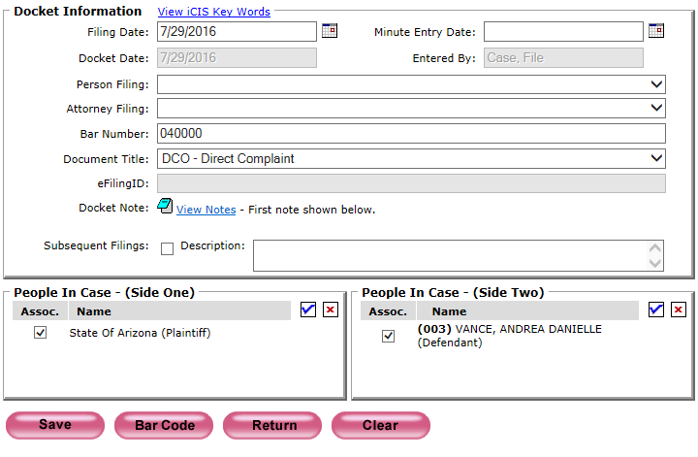

  - Repeat Steps 1 through 7 for all Summons

- Barcode And Prep The Summons Complaint Packet
  - Open Express Indexing 2.5 and Print All barcodes. See Figure 2
Figure 2
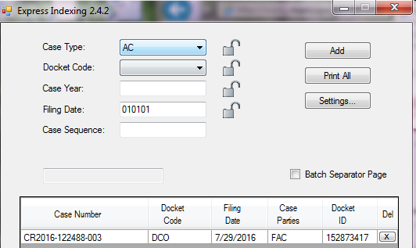

  - Merge all Barcodes to the back of each correlating direct complaint packet. Make sure to double check the case number on the Barcode to the case number written on each top Court Information Sheet (CIS) while merging.
  - Order all the complaint packets in numerical order to make case number stamping quicker and more accurate
  - Stamp the complaint packet and order as follows:
    - Original Direct Complaint
      - File Stamp: Today’s Date
      - Complaint Label: Write an S near the file stamp
      - Case Number Stamp: Accepted number in File-A-Case
    - Court Admin Copy Direct Complaint
      - Conform Copy Stamp
      - Case Number Stamp: Accepted number in File-A-Case
    - Original Summons
      - File Stamp: Today’s Date
      - Case Number Stamp: Accepted number in File-A-Case
    - Blank Summons
      - Case Number Stamp: Accepted number in File-A-Case
    - Court Information Sheet (CIS)
      - File Stamp 1 Copy: Today’s Date
      - Case Number Stamp All Copies: Accepted number in File-A-Case
    - Form IV
    - Miscellaneous Documents
      - Victim Notice Form
        - File Stamp: Today’s Date
        - Case Number Stamp: Accepted number in File-A-Case
      - Flag Sheet
      - Disposition Report
    - Sort all Direct Complaints with Summons by court designation and place in their respective labeled bin
      - RCC Court Designation: RCC Summons Bin
      - EDC Court Designation: EDC – DT Bin

POLICIES / RELATED DOCUMENTS:

- PRO-CROPS-1005: Troubleshooting Direct Complaint Filings

OTHER PARTIES INVOLVED:

    - County Attorney’s Office
    - Attorney General’s Office
    - Various Police Agency Officers/ Liaisons

TIME / VOLUME:

- Varied

FREQUENCY:

- Daily

PERFORMANCE MEASURE:

- N/A

SYSTEM ACCESS REQUIRED:

- iCIS
- File A Case (FAC)
- Express indexing 2.5

REPORTS / FORMS:

- N/A

DEFINITIONS:

- Basket(s): Non-priority direct complaint case type.

APPLICABILITY:

This procedure applies to all employees in the RCC/EDC department of the Clerk of the Court.

REVISION HISTORY:

Revision Number | Revision Author | Summary of Changes | Approval Date
- | N/A | Document Origination | 02/15/2013
A | Dani Draper | More details to the Event Driver; Updated procedures to include program/terminology changes; Easier to follow break down of the entire function; More detailed procedural steps | 08/11/2016
B
C

