PURPOSE:

To provide instructions for using the Express Indexing (EI) software application to generate barcodes for scanning documents.

OBJECTIVE:

- Express Indexing is used to quickly create a barcode (EI Barcode) with minimal docket information.

EVENT DRIVER:

- Receipt of batches of documents that have not been barcoded but will be scanned.

PROCEDURES:
- EI Barcoding:
  - Separate the documents by the docket code type.
    - There are ten Criminal sub-category pre-docket codes used in the EI Bar-Coding program. See Figure 1.
    - Each of the pre-docket codes contains particular documents that fall under its category. Anything that does not fit under a particular category will default to the OTH (Other) category.
    - Staff will sort the documents by the document title to determine the correct category.

Figure 1
Documents for EI are listed under the following sub-categories:

MRP |  |  | RRN |  |  | ORD |  |  | OTH
MOT | Motion |  | RES | Response |  | ORD | Order |  | OTH | Other
REQ | Request |  | REL | Reply |  | ODI | Order of Dismissal |  | IAD | Initial Appearance Document
PTT | Petition |  | NOT | Notice
STP | Stipulation |  | AFF | Affidavit
RTM |  |  | DRE |  |  | SWW |  |  | JUW
RTM | Return Mail |  | DRE | Disposition Reports |  | SWW | Search Warrant |  | JUW | Judgments
POW |  |  | NAW
POW | Priority |  | NAW | Appeals

- Click on the Express Indexing icon.
  - Set up a shortcut if one hasn’t already been done so on your desktop so the icon will be easily accessible. See Figure 2.

Figure 2
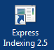
Note: Ask your supervisor to provide the following path to the ITG Department if you require access: C:\edm\ExpressIndexing\ ExpIndProto_new.exe.

- The Express Indexing Main page will open. Select the following values (See Figures 3a and 3b):
  - Keep same values for fields
  - Case Type - Enter CR (Figure 3a) or SW (Figure 3b) in the case type field.
  - Docket Code - Select an option from the drop down list.
  - Case Year (If applicable) - Search Warrant cases will likely have the current year.
  - Filing Date (If applicable) - Search Warrant cases will likely have same filing date.
Note: Most of the batches will contain different case years and filing dates. The fields will then be left blank and the case year will be typed in for each individual document to be barcoded.
      - If the filing date is left blank it defaults to 010101.
      - Again, Search Warrants (SW) will likely be the exception to this.
  - Clicking on the image of the Pad Lock - Saves the fields that have been selected.

Figure 3a
CR Example:
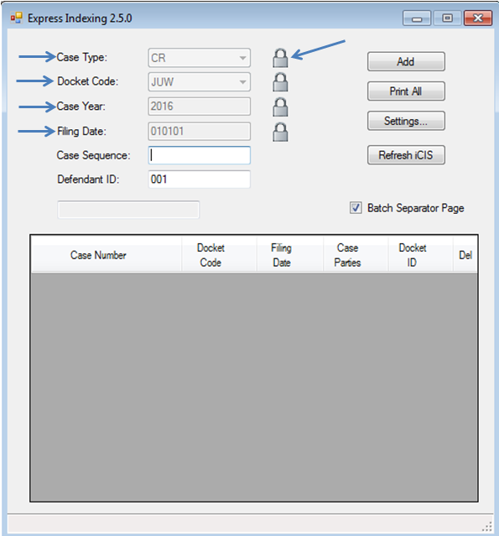

Figure 3b
SW Example:
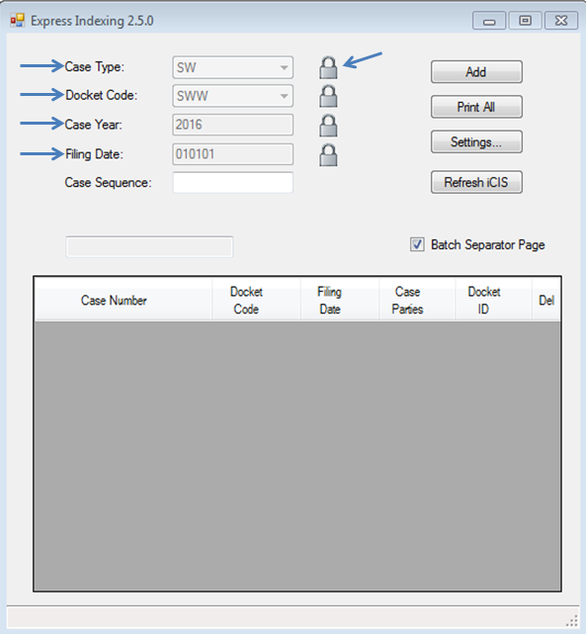

- Type in the remaining information in the appropriate fields:
- Case Year(if unlocked)
- Case Sequence - Six digit case number
- Defendant Identifier:
  - Three digits listed after the six digit case number.
  - A defendant identifier window will not appear if the case number is 2002 or older.
  - A defendant identifier is not needed when processing SWs.
- Select Add.
- Repeat steps 4A through 4D for each document
  - If you have multiple case types, you may need to adjust previously locked settings to the correct case type.
  - For each document that you enter and select Add, the information will drop into a list in sequence of its entry, see figure 4

Figure 4
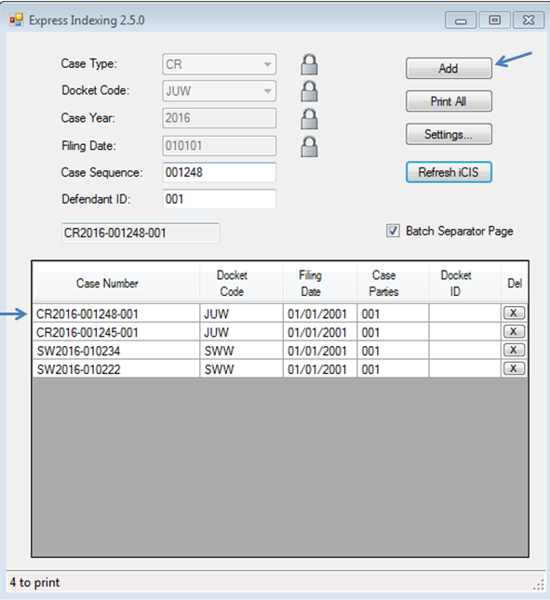

- Once all the barcode information has been entered, select the Print All button. If a coversheet is desired to separate the documents from others, ensure that the Batch Separator Page box is checked.
  - Proceed to the printer, log on and select Start to print the barcodes.
- Once the barcodes are printed, place the barcode page on top of the document to be scanned, ensure that the barcode matches the document. Repeat until all documents have a barcode placed on top.
  - Check printed barcodes periodically to ensure they are clear and dark. Replace the printer’s toner or clean the printer as necessary to ensure quality barcodes.
    - If printing to a Ricoh, report print issues to your supervisor so that the machine can be serviced.
  - Discard any gray or streaky barcode sheets and re-print.

- Fill out the batch slip –
  - A Blue batch slip is for EI batches in CR and SW case types.
- Prep the batch by removing all staples, clips, and rubber bands.
- Deliver the completed batch to the designated scanning area.

Note: If incorrect information is entered during the EI Bar-Coding process and a barcode with incorrect information is printed, the barcode can be thrown away because no link to iCIS was created. The system only links after the document has been scanned.

POLICIES / RELATED DOCUMENTS:

- Miscellaneous and priority documents.

OTHER PARTIES INVOLVED:

- CR File Counter
- RCC/EDC
- Grand Jury
- EDM

TIME / VOLUME:

- 0.45

FREQUENCY:

- Daily

PERFORMANCE MEASURE:

- N/A

SYSTEM ACCESS REQUIRED:

- C:\edm\ExpressIndexing\ExpIndProto_new.exe

REPORTS / FORMS:

- N/A

DEFINITIONS:

- Express Indexing: EI Barcoding is used to quickly create a barcode with minimal docket information. The only information included on an EI Bar-Code is the case type, case number, a generic docket event code and a generic filling date.

APPLICABILITY:

This procedure applies to all employees of the Clerk of the Court.

REVISION HISTORY:

Revision Number | Revision Author | Summary of Changes | Approval Date
- | N/A | Document Origination | 01/01/2013
A | Ana James | Major revision of procedure to reflect current process | 06/14/2017
B
C

