PURPOSE:

To provide instructions for processing IWA (Issuance of Warrants).

OBJECTIVE:

- To provide the necessary direction to ensure that the docketing of issued warrants is correctly and accurately initiated,
- To ensure consistent handling of the docketing of issued warrants over time.

EVENT DRIVER:

- An warrant is received for issuance from:
  - New direct complaint filings with warrants from the County Attorney’s Office;
  - Breaking of Criminal Direct Complaints from the County Attorney’s Office;
  - The courtrooms;
  - Other areas as they occur.

PROCEDURES:
- Upon receipt of a signed warrant from the Courtroom/Judge/Commissioner, do the following:
- Sign and crimp the original warrant.
- Make a copy of the sign and crimped warrant (only the warrant, not the CIS or VIS). With this copy, do the following:
  - Apply the filestamp.
  - Apply the COPY OIC/Warrant stamp to each page of the warrant. See Figures 1a and 1b.

Figure 1a Figure 1b
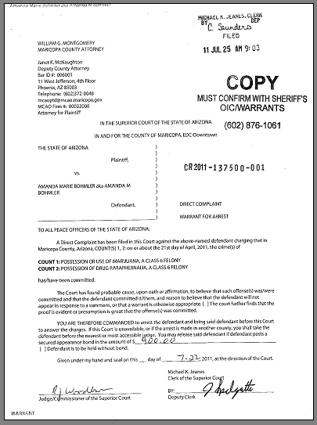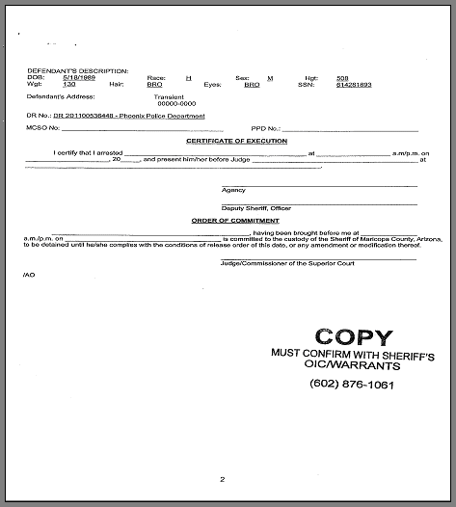

  - Open iCIS>Entry>Docket. Click Add. See Figure 2.
Figure 2
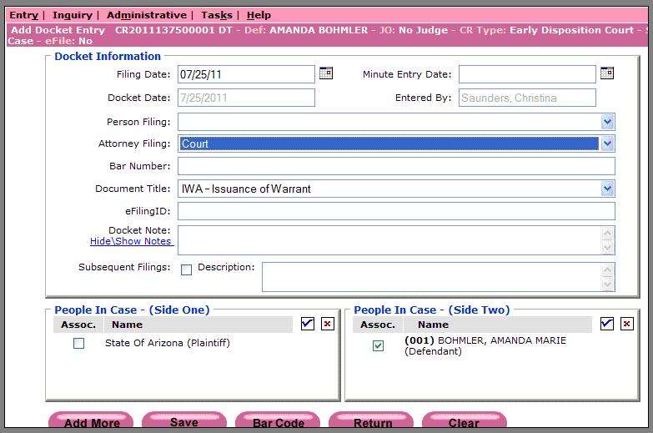

  - Enter the following:
    - Filing Date: the date shown on the filestamp.
    - Attorney Filing: Court (from the pull-down menu).
    - Document Title: Docket Code IWA (from the pull-down menu).
    - Click Bar Code.
  - The barcode page will print.
    - Collate the barcode page on top of the copy of the warrant.
    - Stage the document set for batching.
- Repeat steps 1.A. and B. until all warrants received are docketed and ready for batching.
- Prepare a batch slip naming the batch IWA and place it on top of the stack of document sets. Place the batch in the designated staging area for scanning.
- Deliver the original warrant (with the associated CIS or VIS) to the Sheriff’s Office per PRO-CROPS-1009: the RCC/EDC Daily Run.

POLICIES / RELATED DOCUMENTS:

- The original warrant
- Court Information Sheet (CIS) or Victim Information Sheet (VIS)
- PRO-CROPS-1003: Processing Direct Complaint Filings with Warrants
- PRO-CROPS-1004: Breaking of Criminal Direct Complaints
- PRO-CROPS-1009: the RCC/EDC Daily Run

OTHER PARTIES INVOLVED:

- County Attorney’s Office
- The Courtroom/Judge/Commissioner
- Sheriff’s Office

TIME / VOLUME:

- Varied

FREQUENCY:

- Daily

PERFORMANCE MEASURE:

- N/A

SYSTEM ACCESS REQUIRED:

- iCIS
- RCC/EDC Scanner

REPORTS / FORMS:

- Barcode header page
- Scanning Batch Slip

DEFINITIONS:

- Crimp: Application of the embossed (raised) court seal.

APPLICABILITY:

This procedure applies to all employees of the Clerk of the Court.

REVISION HISTORY:

Revision Number | Revision Author | Summary of Changes | Approval Date
- | N/A | Document Origination | 02/08/2012
A
B
C

