PURPOSE:

To provide instructions for breaking direct complaint filings with summons

OBJECTIVE:

- To accurately issue available summons hearing dates based off the EDC/RCC Work Calendar.
- To accurately complete the breaking and sorting of direct complaint filings with summons by 10:00AM – in time for the Daily Run.
- To accurately add issued summons to the case file and mail out summons to the defendant.

EVENT DRIVER:

- A direct complaint filing with a summons is received from one of the following:
  - County Attorney’s Office
  - Attorney General’s Office
  - Various Police Agency Officers/ Liaisons
- RCC/EDC staff receive Direct Complaint filings the prior business day and initiate the case into iCIS

PROCEDURES:
- Verify Summons Filing Agency
  - Upon receipt of a direct complaint filing with a summons, identify the summons type by reviewing the filing agency located in the upper left hand corner of the Direct Complaint and sort together according to filing agency:
    - County Attorney Summons: (See Figure 1A).
      - These read Maricopa County Attorney in the filing information. Proceed to Section II.
    - Attorney General Summons: (See Figure 1B).
      - These read Attorney General in the filing information. Proceed to Section II.
Figure 1A Figure 1B
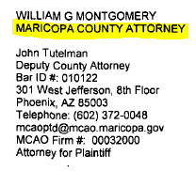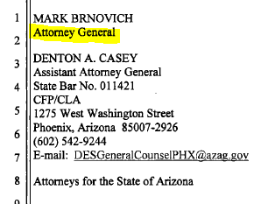

  - Verify verbiage in the body of the summons has the correct address and time of arrival
    - After You Are Hereby Summoned, it should include 175 W Madison and 10:30am as the arrival time.

- Assign Summons Dates
  - Summons dates are assigned 25 or more days from the file stamped date on the summons.
  - Available Summons dates are highlighted on the EDC/RCC Work Calendar.
See Figure 2A.
    - County Attorney Summons Dates
      - Appear on work calendar as purple IA/SUM.
    - Attorney General Summons Dates
      - Appear on work calendar as AG SUMMONS.
Figure 2A
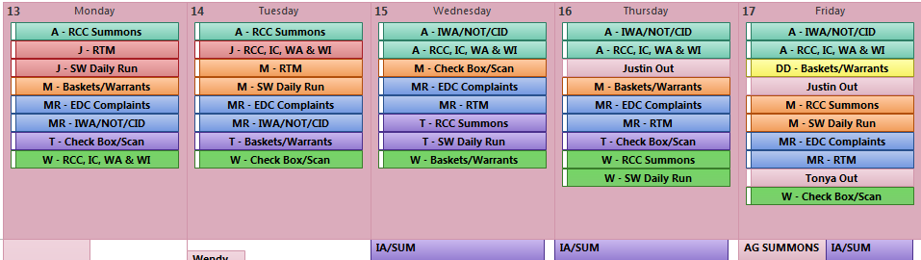

  - After an available date is determined each case needs to be logged into the correct Summons Log in Microsoft Outlook. See Figure 2B.
    - County Attorney Summons Log
      - Appears in your Favorites Folder as RCC Summons-DT.
      - A maximum of 80 cases are allowed to be logged on available dates.
    - Attorney General Summons Log
      - Appears in your Favorites Folder as EDC-AG Summons-DT.
      - A maximum of 8 cases are allowed to be logged on available dates.

Figure 2B
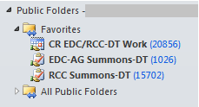

  - Complete the new item row as follows: See Figure 2C.
    - Due Date: Available summons date from EDC/RCC Work Calendar.
    - File Date: File stamped date on original summons.
    - Case Number: CR number including dashes.
    - Defendant Name: Main name as it appears on the summons.
    - Court: Designated court either EDC or RCC.

Figure 2C
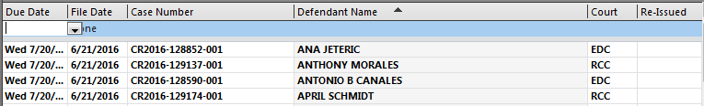

  - Stamp the assigned summons date on the following documents:
    - Copy Stamped Direct Complaint
      - Court Admin Copy – stamp at the top near the copy stamp.
    - Filed Summons
      - Original Summons – stamp on the blank date line.
    - Blank Summons
      - Mailer Summons – stamp on the blank date line.
  - Repeat steps 4 and 5 for all summons complaints.

- Breaking Summons Packets
  - Create sort piles as follows: See Figure 3.

Figure 3
Qty. | Form | What the copy is for | Additional Notes
1 | Barcode Sheet | 1 for DCO scanning batch | Verify case number to documents
2 | Direct Complaint | 1 Original for DCO scanning batch | Verify county attorney signature
 |  | 1 Copy for Court Admin
2 | CIS Sheets | 1 Original for CID bin
 |  | 1 Blank for Court Admin | Shred any extra blank CIS sheets
2 | Summons | 1 Original for SUM batch | Verify summons court information
 |  | 1 Blank to mail to defendant
1 | Form IV | 1 Original for DCO scanning batch | Verify defendant name matches DCO and swear stamp is included
* | Flag Sheet (RDOC/JVSC) | 1 for DCO scanning batch | *This is not in every packet
* | VIS Sheet | Not used for this case type – Shred | * This in not in every packet
* | Disposition Sheet | Sort into Dispo Sheet bin | *This is not in every packet
* | Notice Rule 2.3 | Sort into NOT bin | *This in not in every packet

  - Create a Batch Slip for the DCO (Direct Complaint) batch and send to scanning.
    - Circle: CR at the top.
    - File Date: File stamp date.
    - Document Type: DCO.
    - Document Count: Number of barcoded documents.
    - Sort By: Your 3 initials.
    - Date Received: Date breaking complaints.
    - Docketed/Barcoded By: FAC (File-A-Case).
    - Date Docketed/Barcoded: Date docket event/barcode was created.
      - Direct Complaint barcodes are created the previous business day.
    - Prep By: Your 3 initials.
    - Attach the Batch Slip to the front of the DCO scanning batch and place in scanning basket.
  - Disseminate other documents into the proper bins as labeled above.

- Prepare and Issue Summons
  - Stamp the summons documents as follows:
    - Original Summons.
      - Sign: First initial and last name on the Deputy Clerk line.
      - Circle Stamp: Stamp on the right of your signature.
      - Crimp: Over your signature.
    - Blank Mailer Summons.
      - Conform Copy Stamp: Set the date to today and stamp on Deputy Clerk line.

- Add Summons Docket Event Into iCIS and Print Barcodes
  - In the Docket Screen in ICIS Click Add. See Figure 4A.

Figure 4A
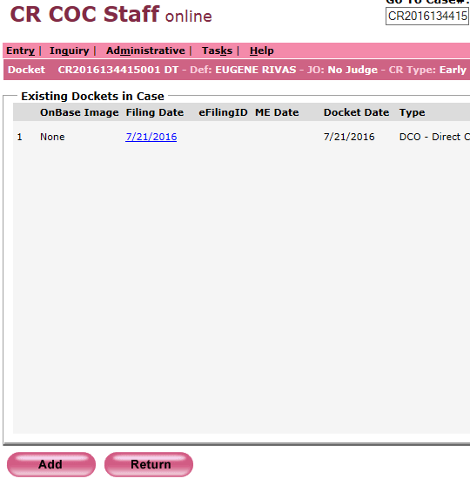

  - Complete the Add Docket Event Screen. See Figure 4B.
    - Filing Date: File stamp date on Original Summons.
    - Bar Number: Attorney bar number.
      - Found in the upper left hand corner filing information as Bar ID #.
    - Document Title: SUM (Summons).
    - Check Mark: State of Arizona.
    - Click Barcode.

Figure 4B
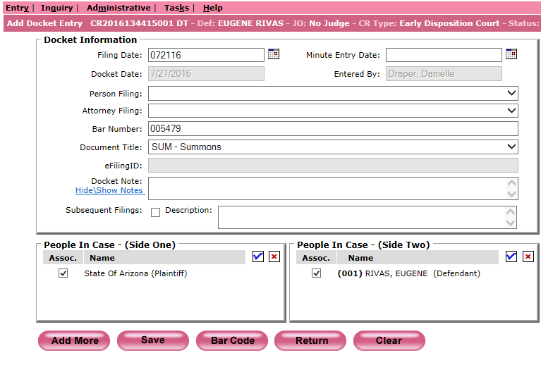

  - Repeat Step 2 for all summons.
  - Open Express Indexing 2.5 and Print All barcodes and set aside. See Figure 4C.

Figure 4C
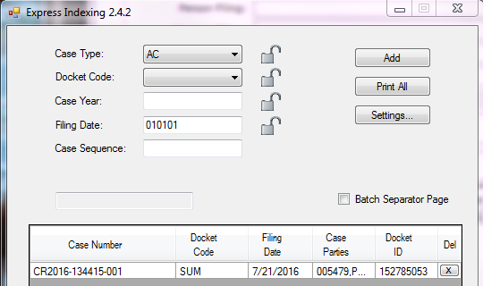

- Create Address Labels and Mail Out Summons
  - Create 3 address labels for each summons with the following information: See Figure 5A.
    - Case Number (Space x3) Hearing Date.
    - Defendants Main Name: CAPS lock.
    - Street Address: CAPS lock without any punctuations.

Figure 5A
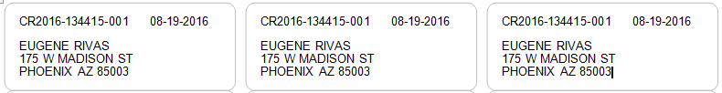

  - If the summons paperwork does not include a mailing address verify with the correct attorney office.
    - County Attorney: Email the County Attorney distribution list.
    - Attorney General: Call the attorney office provided in the filing information on in the upper left hand corner of the summons.
  - Mail out each summons as follows: See Figure 5B
    - Envelope: Attach address label.
      - Stamp Mail Code above return address.
    - Green Certified Card: Attach address label.
      - Check Mark Certified Mail and Return Receipt for Merchandise.
    - Certified Mail Receipt: Attach address label.
    - Tri-Fold the Blank Mailer Summons and Summons Initial Appearance Inserts and place into envelope.
      - County Attorney Summons Insert: Insert reads Summons Initial Appearance Hearing at the top.
      - Attorney General Summons Insert: Insert reads Early Disposition Court at the top.
    - Seal envelope and attach Green Certified Card to the back of the envelope.
    - Attach Tracking Number from Certified Mail Receipt to the Green Certified Card on the Article Number line.
    - Attach Certified Mail Receipt Barcode to the front of the envelope and fold over top edge
    - Set aside Certified Mail Receipt.

Figure 5B
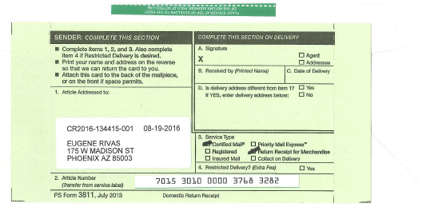
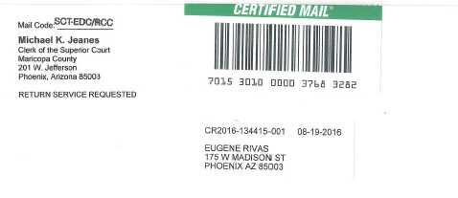

- Merge Barcodes and Prep Original Summons for Scanning
  - Merge all Barcodes and Certified Mail Receipts for each correlating Original Summons as follows:
    - Barcode: Make sure to double check the case number on the Barcode to the case number on the Original Summons.
    - Original Summons: File stamped summons with hearing date and issued summons signature, circle seal and crimp.
    - Certified Mail Receipt: Tape to the back of the Original Summons.
  - Create a Batch Slip for the SUM (Summons) batch and send to scanning
    - Circle: CR at the top.
    - File Date: File stamp date.
    - Document Type: SUM.
    - Document Count: Number of barcoded documents.
    - Sort By: Your 3 initials.
    - Date Received: Date mailing summons.
    - Docketed/Barcoded By: Your 3 initials.
    - Date Docketed/Barcoded: Date docket event/barcode was created.
    - Prep By: Your 3 initials.
    - Attach the Batch Slip to the front of the SUM scanning batch and place in scanning basket.

POLICIES / RELATED DOCUMENTS:

- PRO-CROPS-1009: Instructions for the RCC/EDC Daily Run

OTHER PARTIES INVOLVED:

- County Attorney’s Office
- Attorney General’s Office
- Criminal Court Admin

TIME / VOLUME:

- Varied

FREQUENCY:

- Daily

PERFORMANCE MEASURE:

- N/A

SYSTEM ACCESS REQUIRED:

- File-A-Case (FAC)
- iCIS
- Express Indexing 2.5
- Microsoft Office Outlook
- RCC Summons-DT
- EDC-AG Summons-DT

REPORTS / FORMS:

- Batch Slip
- Summons Initial Appearance Inserts

DEFINITIONS:

- Crimp: Application of the embossed (raised) court seal.

APPLICABILITY:

- This procedure applies to all employees in the RCC/EDC department of the Clerk of the Court.

REVISION HISTORY:

Revision Number | Revision Author | Summary of Changes | Approval Date
- | N/A | Document Origination | 01/01/2013
A | Dani Draper | Complete re-write: more specific, includes both summons types, can be applied to more than one main function in the department and reflects some changes to programs and processing. | 07/25/2016
B
C

