PURPOSE:

To provide instructions for handling Back End Suspense Items within the RFR Financial System in Criminal Financial Obligations Unit, Clerk of the Superior Court.

OBJECTIVE:

- To provide the necessary direction to ensure that Back End Suspense Items are correctly and accurately released within the RFR System,
- To ensure consistent handling of Back End Suspense Items over time,
- To resolve Back End Suspense items.

EVENT DRIVER:

- A receipt item is placed into Back End Suspense in the RFR Financial System for one of the following reasons:

Code Code Description
001 Case Is Inactive
002 Case Is Sealed (not used)
003 No Orders on Case (not used)
004 No Active Orders
- Adjusted Into (not used)
006 Inactive Payer
007 Data Error

PROCEDURES:
Note: User must have a working knowledge of the RFR Financial System and related CFO documents and functions.

- Generating the Back End Suspense Item Report:
- Open the S:\DCMS Reports\DCMS Reports.mdb application.

- Select the Pending – Suspense tab and click on Back End Suspense Items (See Figure 1).

Figure 1
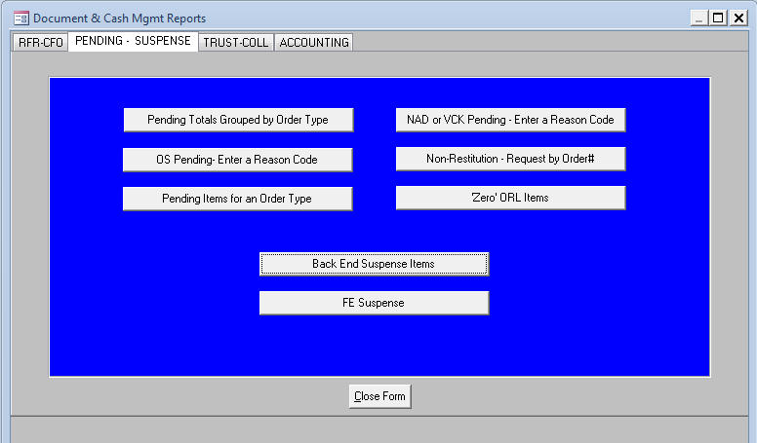

- The report will open in a new window which may be printed or exported to MSExcel or MSWord for further work as desired.
- Begin research to discover the reason why the item is in Back End Suspense and satisfy the conditions so that the item may successfully be resolved from Back End Suspense.
- Once conditions that caused the Receipt Item to be placed into Back End Suspense have been researched and resolved (reactivating payer, setting up order types, etc.), the Back End Suspense Item can be released to the case to which it pertains, or it can be transferred to another case.

- Release Back End Suspense Items into the RFR System:
- Log into the RFR System.
- Select Menu option: 8-RFR>1-Payment Processing>d-B/E Suspense Distribution.
- Select Find, and press Enter.
- Type the case number into the Case Number field. Press Esc. (See Figure 2)

Figure 2
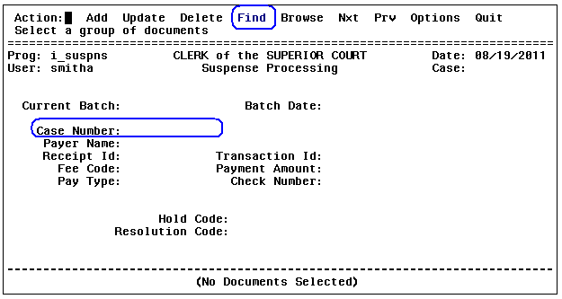

- Select Update and create a batch by entering a batch number in the Current Batch field. Press Enter. (See Figure 3)

Figure 3
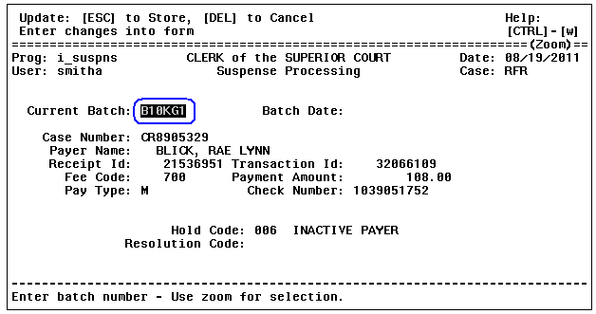

  - Batch number format example: B10KG1 (B signifies Back End Suspense; 10 signifies the day the item is resolved if the current date was the 10th; KG signifies your initials (don’t use KG unless your initials are KG); 1 signifies the first Back End Suspense batch of the day. Should there be additional batches, use 2, 3, 4, etc.).
  - The same batch number may be used for multiple Back End Suspense items when the items are for the same case number and payer.
  - Create a different batch number to resolve multiple items that are not on the same case or have a different payer.

- The message: Batch does not exist for today’s date! Do you want to create it? (Y/N) will be displayed. Type Y, and press Enter.
Note: This message will not be displayed again if the same batch has already been used for the day.
- To transfer the Back End Suspense item to a different case: Press Ctrl+p.
  - Enter the case number that you are transferring the item to and press Enter. The payer’s names for that case number will auto-fill.
  - Enter the amount to be transferred. It can be partial or the full amount of the suspense item.
  - Enter N in the Ret field. Never use Y (See Figure 4). Press Enter.
Figure 4
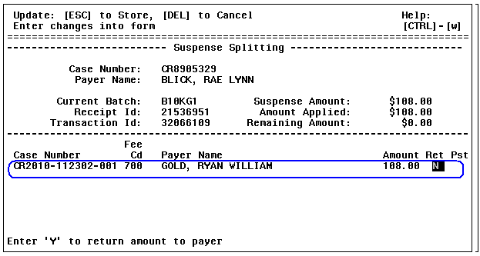

  - Press Enter again if the message in Figure 5 is displayed:
Figure 5
  - Press Esc.
  - Enter the Resolution Code: TRN and press Esc (See Figure 6).
Note: The Resolution Code will always be TRN for items that were transferred to another case or payer.

Figure 6
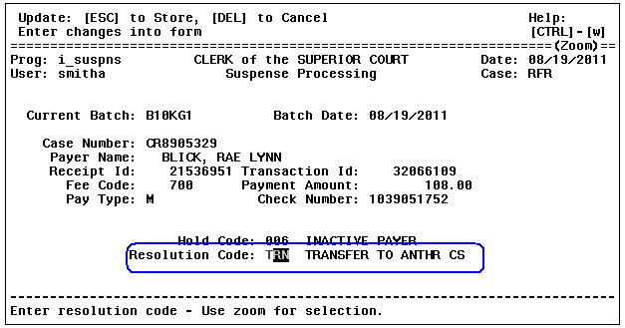

- Releasing the Back End Suspense item to the same case: do not press Ctrl+p. Instead:
  - Enter the Resolution Code. Press Esc (See Figure 7).
Note: The Resolution Code will always be ORL (NEVER use any other code than ORL).
Figure 7
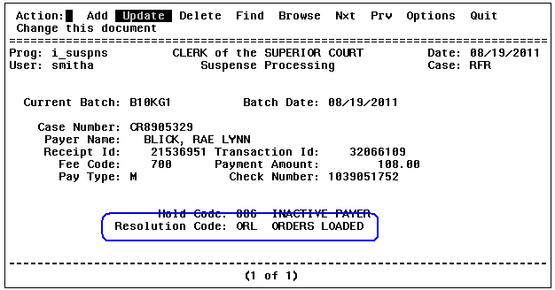

- The Back End Suspense item is now resolved whether the item was transferred or released to the case number to which it belongs. The batch must now be closed. To close the batch select Options (See Figure 8).

Figure 8

- Select Close (See Figure 9).
Figure 9
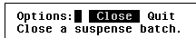

- Enter the batch number to be closed (the system will use lower case, which is fine) (See Figure 10). Press Enter.
Figure 10

- Press Enter when the following message is displayed (See Figure 11).
Figure 11

- End of Process.

POLICIES / RELATED DOCUMENTS:

- N/A

OTHER PARTIES INVOLVED:

- N/A

TIME / VOLUME:

- Typical 4.75 minutes per item / Varies.

FREQUENCY:

- Review the Back End Suspense report minimum once monthly.

PERFORMANCE MEASURE:

- N/A

SYSTEM ACCESS REQUIRED:

- The DCMS Reports application: S:\DCMS Reports\DCMS Reports.mdb
- The RFR System

REPORTS / FORMS:

- DCMS Reports

DEFINITIONS:

- RFR: Restitution, Fines, and Reimbursements

APPLICABILITY:

This procedure applies to all employees of the Criminal Financial Obligations Unit for Clerk of the Court.

REVISION HISTORY:

Revision Number | Revision Author | Summary of Changes | Approval Date
- | N/A | Document Origination | 08/19/2011
A | Larry Urewicz | Reformatted for the Document Control System | 12/05/2012
B
C

