PURPOSE:

To provide instructions for entering Court Collection Unit’s (CCU) Collection Fees into the RFR System in Criminal Financial Obligations Unit, Clerk of Superior Court.

OBJECTIVE:

- To provide the necessary direction to ensure that CCU Collection Fees are correctly and accurately entered into the RFR System,
- To ensure consistent handling of CCU Collection Fees over time.

EVENT DRIVER:

- CCU will calculate the collection fee owed. CCU will notify CFO of the fees owed through e-mail to CFOResponse@maricopa.gov. The e-mail will have an excel file attached that includes the payer’s name, case number and amount of the collection fee to be entered into the RFR System.

PROCEDURES:
- Save the CCU Collection Fee Excel File into the Share Drive:
- The CFOResponse e-mail folder is located in Microsoft Outlook: Public Folders\DEPARTMENTAL DISCUSSIONs\Clerk of the Court\CFO Response
- Upon receipt of the excel file that was e-mailed to CFOResponse@maricopa.gov, save the file to the share drive: S:\Fin_Svc\Accounting CFO\CCU Collection Fees. Select the folder for the corresponding year and save the file. It is not necessary to rename the file.
- Print the file for distribution to employees assigned to enter the collection fee into the RFR System.

- Enter CCU Collection Fees into the RFR System:
- Log into the RFR System.
- Select Menu option: 8-RFR>2-Case Init/Maintenance>a-Case Maintenance.
- Select Find, and press Enter. (See Figure 1)
Figure 1
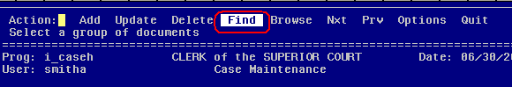

- Type the case number in the appropriate case number format into the Case Number field. Press Esc. (See Figure 2)
Figure 2
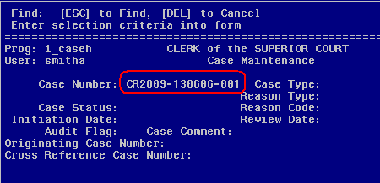

- Select Options by typing “o” or moving the cursor with the right arrow key over to Options, and press Enter. (See Figure 3)
Figure 3
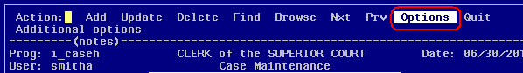

- Select Menu by pressing Enter. (See Figure 4)
Figure 4
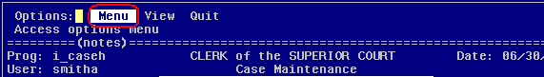

- Select Add Orders by moving the cursor down with the arrow key. (See Figure 5)

Figure 5
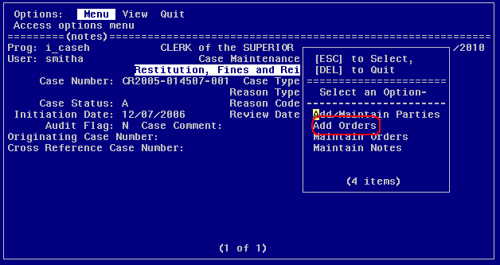

- Add the Order Type 89 as a CCU Collection fee owed by the offender (See Figure 6):
  - Type 89 Order Type in the Order Type field.
  - Type today’s date and your initials in the Comments field.
  - Type today’s date in Order Date field.
  - Type today’s date in First Due Date field.
  - Change Frequency from and M to a T, making the amount due as a One-Time Payment.
  - Enter the CCU Collection Fee that is listed on the worksheet for the amount due in the Total Due field.

Figure 6
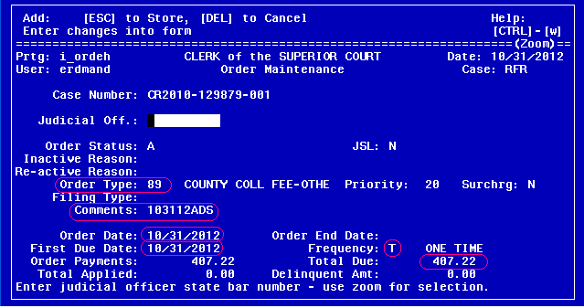

  - Press ESC to save.
- Select Update Order Parties. Press Enter or Esc. (See Figure 7)
Figure 7
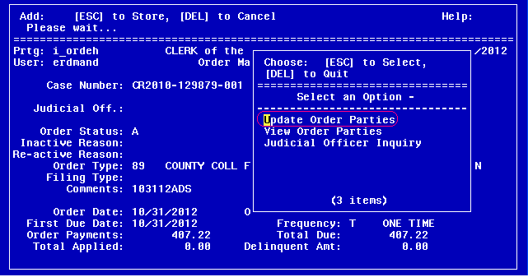

- Press Ctrl + z to select the payer that owes the CCU Collection Fee. Press Esc.
  - If there is only one payer available, the name will automatically populate in the Payer Name field. (See Figure 8)
  - If there is more than one payer available, the appropriate payer must be selected from the list of names.

Figure 8
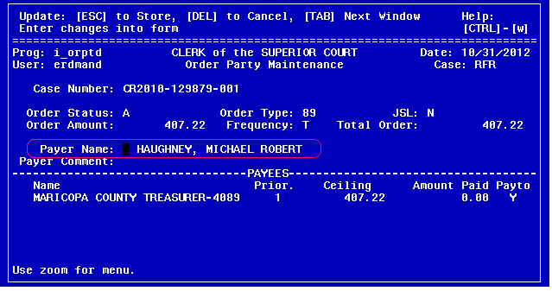
- Select Quit. Press Enter. (See Figure 9)
Figure 9
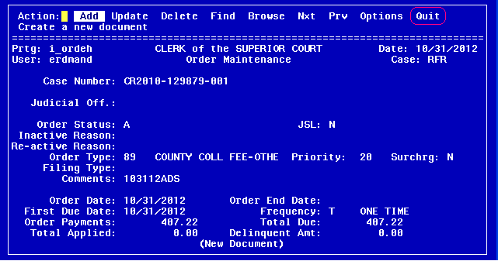

- Select Maintain Notes by moving the cursor down with the arrow key. Press Enter. (See Figure 10)

Figure 10
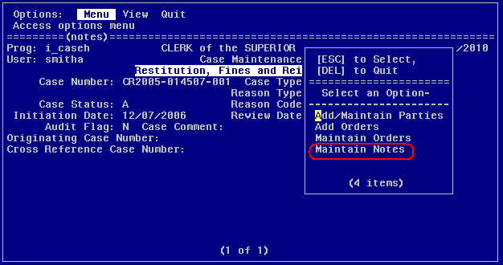

- Use the arrow keys to scroll down to the next available line. Type CSE in the first blank field. (See Figure 11)

Figure 11
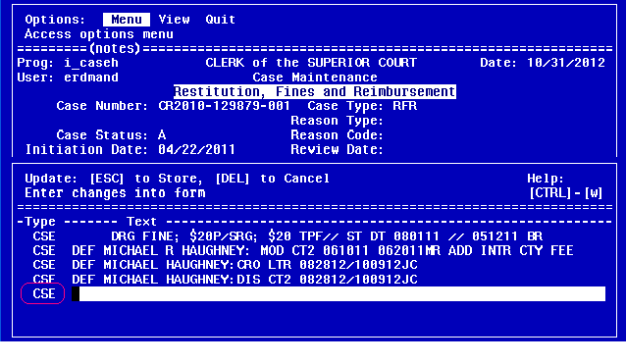
- Type any case notes. (See Figure 12) The case note contains the following information as listed in the example: DEF JOHN DOE: CCU COLL FEE $77.88 / 063010ADS . Press Esc to save the Case Note.
Figure 12
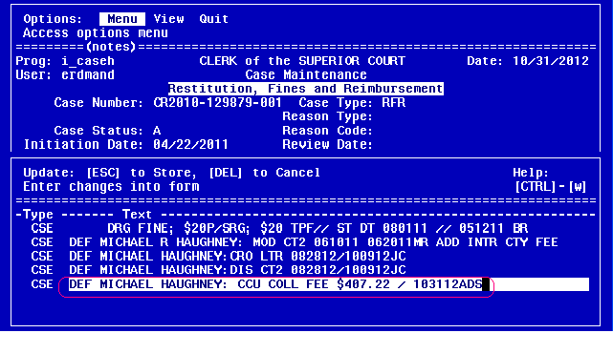
- Press Ctrl + c to cancel out of the Option Menu.
- Repeat steps II.3 through 15 until all CCU Collection fees have been entered.
- The printed CCU Collection Fee worksheet is to be turned into CFO Auditor at the end of the work day.

POLICIES / RELATED DOCUMENTS:

- ARS13-805, Arizona Revised Statutes: Criminal Restitution Order
- A Criminal Restitution Order (CRO) is prepared pursuant to ARS13-805. Once the CRO is signed by the court and filed with the Clerk’s Office, the CRO is recorded with the Recorder’s Office electronically through an automated process.
- After the CRO is recorded, County Collections Unit (CCU) begins their collection efforts and will calculate a collection fee based upon a percentage of the judgment. The percentage is determined each fiscal year by CCU.
- The collection fee rate is:
  - 14.9% Collection Fee effective July 1, 2010 – Current Date
  - 5.9% Collection Fee effective July 1, 2009
  - 11.2% Collection Fee effective May 12, 2008

OTHER PARTIES INVOLVED:

- CCU
- The Criminal Court

TIME / VOLUME:

- Varied

FREQUENCY:

- A CCU Collection Fee excel file is received approximately 1 – 2 times per month.

PERFORMANCE MEASURE:

- N/A

SYSTEM ACCESS REQUIRED:

- E-mail access to CFOResponse@mail.maricopa.gov
- Microsoft Outlook: Public Folders\DEPARTMENTAL DISCUSSIONs\Clerk of the Court\CFO Response
- S:\Fin_Svc\Accounting CFO\CCU Collection Fees
- The RFR System

REPORTS / FORMS:

- N/A

DEFINITIONS:

- CCU: Court Collection Unit
- CRO: Criminal Restitution Order
- CFO: Criminal Financial Obligations

APPLICABILITY:

This procedure applies to all employees of the Clerk of the Court.

REVISION HISTORY:

Revision Number | Revision Author | Summary of Changes | Approval Date
- | Angela Smith | Document Origination | 07/01/2010
1 | Angela Smith | Corrected CCU Fee from 15% to 14.9% | 07/12/2010
2 | Diane Erdman | Deleted 87 order type | 10/31/2012
3 | Larry Urewicz | Reformatted for the Document Control System | 12/05/2012
4 | Anthony Bach | Updated CFO email, updated figures, updated to new administrator. Updated steps 1-6 | 3/5/2021

