PURPOSE:

To provide instructions for entering new Post Decree Suspense accounts into Revenue Results for use within the Clerk of Court, Billing and Deferral Unit.

OBJECTIVE:
- To provide the necessary direction to ensure that new Post Decree Suspense accounts are correctly and accurately initiated,
- To ensure consistent handling of new Post Decree Suspense accounts over time. Accounts affected by this document are: DEFW; CEFW; PBW; and JEFW.

EVENT DRIVER:
- Customer requests a deferral

PROCEDURES:
- Search by Debtor SSN, Case Number, or Name in RevQ for an established Debtor Profile. See Figure 1.
Figure 1
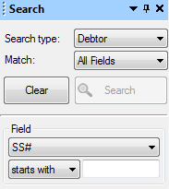

- If no Debtor profile is found, follow PRO-BILL1002: Entering New Suspense Accounts Into Revenue Results.

- If Debtor profile is found, click on New Account . See Figure 2.
Figure 2
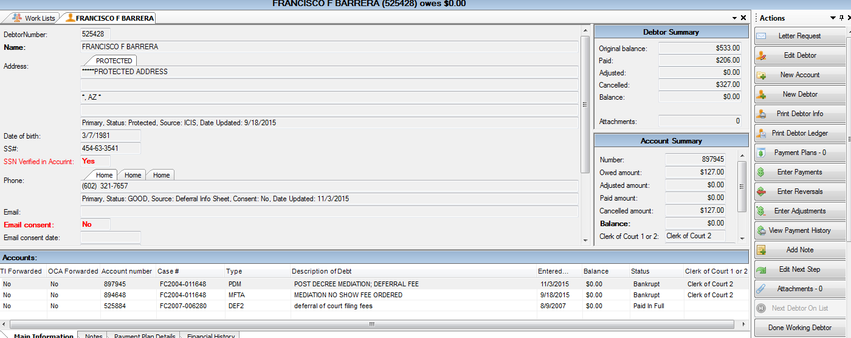

- The Account screen will be displayed. See Figure3.
Figure 3 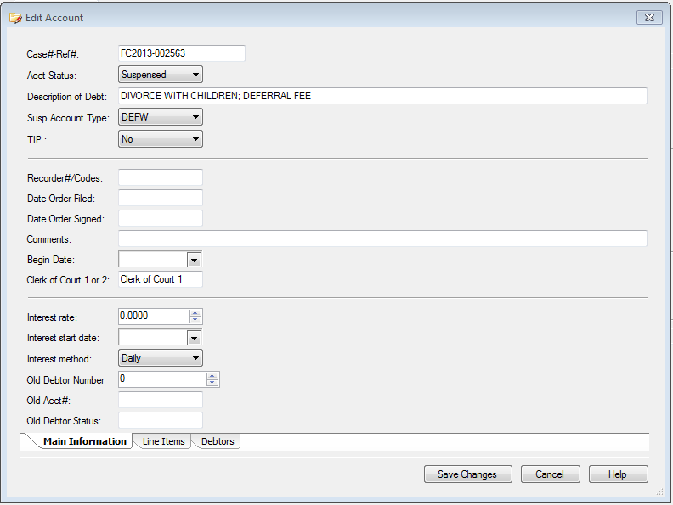
- Enter the Case Number.
- Select Suspensed from the Account Status pull down window. Type in the Description of Debt (NO ABBREVIATIONS TO BE USED IN THIS FIELD).
- Select appropriate Suspense Account Type from the Suspense Account Type pull down window.
- Click on the Line Items Tab.
Figure 4 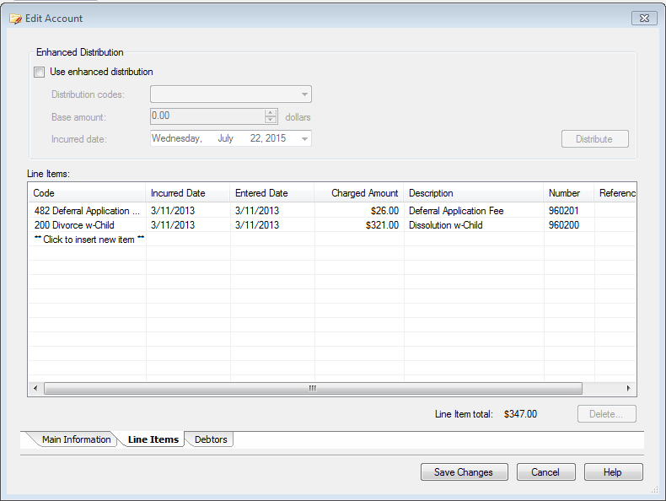
- Enter the line item(s); be sure to enter the date of the deferral under Incurred Date and click Save Changes. See Figure 4.
- VERY IMPORTANT: If Customer files any other Post Decree deferred filings and the debtor profile has a previous Post Decree filing account, edit the account, add to the Description of Debt, enter the line item(s), enter the Incurred Date, and click on Save Changes.
- All Post Decree deferrals are to remain in Suspense Status until the last Post Decree filing is adjudicated; once that occurs, the account can be started up for billing purposes (see PRO-BILL-1005: Starting Accounts In Suspensed Status in Revenue Results).

POLICIES / RELATED DOCUMENTS:

- ARS 12-302, Arizona Revised Statutes: Request for Deferral/Waiver
- PRO-BILL-1002: Entering New Suspense Accounts Into Revenue Results
- PRO-BILL-1005: Starting Accounts In Suspensed Status in Revenue Results

OTHER PARTIES INVOLVED:

- N/A

TIME / VOLUME:

- Varied

FREQUENCY:

- Daily

PERFORMANCE MEASURE:

- N/A

SYSTEM ACCESS REQUIRED:

- Revenue Results

REPORTS / FORMS:

- N/A

DEFINITIONS:

- Deferral: State law defines deferral as the postponement of an obligation to pay fees or the establishment of a schedule for payment of fees.
- Suspense Accounts: Accounts that are entered in Revenue Results that are not to be billed until notice is received from iCIS.
- Post Decree Filing: "Post-decree" petitions are those filed after a Decree of Dissolution of Marriage, Legal Separation or Annulment, or Judgment of Paternity is entered, and are usually filed to modify or enforce existing orders of the Court

APPLICABILITY:

This procedure applies to all employees of the Clerk of the Court.

REVISION HISTORY:

Revision Number | Revision Author | Summary of Changes | Approval Date
- | Milan Milic | Document Origination | 11/01/2016
A | Bryan Romero | Reviewed | 02/28/2019
B
C

