PURPOSE:

To provide instructions for processing NSF (Non-Sufficient Funds) checks back to the original account after the waiting period designated by policy within the Clerk of Court, Billing and Deferral Unit has elapsed.

OBJECTIVE:

- To provide the necessary direction to ensure that the processing of NSF checks are correctly and accurately done,
- To ensure consistent handling and processing of NSF checks over time.

EVENT DRIVER:

- Monthly report that is run at the first of every month summarizing NSF account status for the period of one month that occurred 6 months ago.

PROCEDURES:
1. Revenue Results:
- Go to S:\Fin_Svc\NSF\6 Month Report
- Look for the latest report run. The subsequent month will be the report to run now.
- Open the file: 6 Month NSF Write-Off. This is the blank form template to use for the data obtained from the report about to be run.
- Open Revenue Results:
  - Click on Reports>Custom Reports>COSC-925-Debtors w/Balance Unpaid.
  - Click on Run Report. The Enter Report Parameters pop-up window will be displayed. Enter the Start Date and End Date for the period to be studied.
  - Click OK. The report will be displayed.
  - Click on the Print icon. The report will print.
- Fill in the following fields of the 6 Month NSF Write-Off form:
    - Prepared by: [your name]
    - Request #: [the designated month]
    - The date will auto populate with today’s date
- In Revenue Results, open the Debtor tab.
- Starting with the first Debtor number on the 925-Debtors w/Balance Unpaid Report, enter the Debtor Number in the Search field. Click on Search to open the Debtor Account.
- On the Debtor Tab, Click on the Edit Debtor icon.
- In the Description of Debt field, enter the following phrase before anything that is in that field already: **6 MONTHS OR OLDER**. Click OK.
- Click on the File Attachment icon (the paper clip in the toolbar).
- The Attachments pop-up window will be displayed. Click Preview. The NSF check is displayed. From this screen, a date identified as BK Stmt will be handwritten near the endorsement. Input this date into the Return Date field of the 6 Month NSF Write-Off form. Also on this screen near the endorsement is the Receipt Number (designated R#...). Input this number in the appropriate column of the 6 Month NSF Write-Off form. Close the Attachments pop-up window and preview screen.
- Refer to the Debtor tab in Revenue Results for the remaining information: Name, Debtor Number, Case Number, Amount Applied (check amount), and Check Number.
- At the bottom of the Debtor tab, beneath the Accounts blue bar, double-click on the account displayed. The Account tab will open. The information in the Comments field will be used in step O.
- Click on the Edit Account icon in the toolbar of the Account tab. The Edit Account pop-up window will open. Click on the Line Items tab on the Edit Account pop-up window.
- Click on “”Click to insert new item””. A drop-down menu will display. Select the Service Code shown in the Comments field of the Account tab and input the associated fee amount for that new Service Code into the Charged Amount field in the Edit Account pop-up window. The Incurred Date field will automatically populate. (see Figure 1)
Figure 1
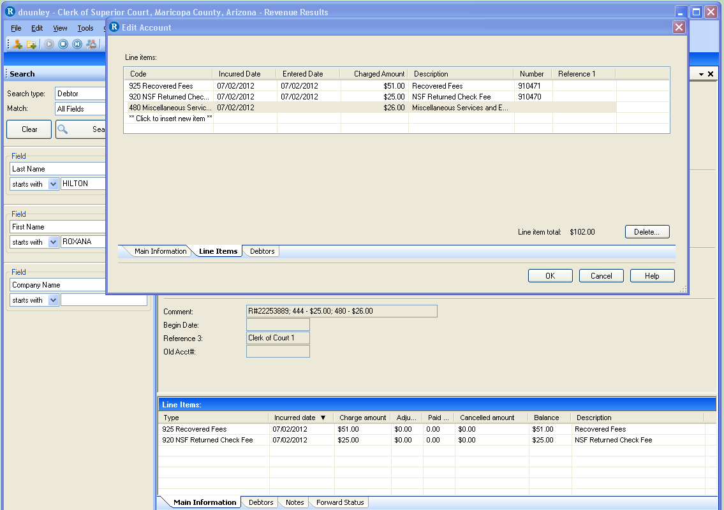
- Repeat steps N & O for all Service Codes and fees shown in the Comments field of the Account tab. Click OK.
- Refer to the Debtor tab. Click on the Enter Adjustments icon in the toolbar. The Make an Adjustment pop-up window opens with the Amount field highlighted. Look for the amount shown for the line item with Service Code 925. Enter the negative of that amount into the amount field (i.e.: -51.00). Remove all the checkmarks EXCEPT for the Service Code 925. Click on Post.
- Repeat steps F through Q for each debtor shown in the COSC-925-Debtors w/Balance Unpaid report run in step 4a.
- Once all the listed debtors are completed, refer to the 6 Month NSF Write-Off report. Click File>SaveAs>S:\Fin_Svc\NSF\6 Month Report\Outstanding NSF [Month & Year under study shown in the Request # on the report]. Click Save and print this report.

2. Cash Receipting:
- Click Inquiry>Receipt Item Inquiry. The Receipt Item Inquiry screen will open.
- For each debtor listed on the 6 Month NSF Write-Off report, do the following:
  - Open the debtor record in Revenue Results.
  - At the bottom of the Debtor tab, beneath the Accounts blue bar, double-click on the account displayed. The Account tab will open. From the Comments field, input the Receipt # into the Receipt # field in the Receipt Item Inquiry screen. Click Search. The Detail tab will open.
  - Look at the Item 1 of x line above the List tab.
  - On the page displayed, right click and select Print. The Print screen pop-up window will appear. Click Print. The Receipt Item Inquiry page will print.
  - If there are more than 1 of 1 pages in c) above, advance to each subsequent page and repeat step d) until all pages are printed.
- Once the Receipt Item Inquiry pages have been printed for each debtor listed on the 6 Month NSF Write-Off report, attached the printouts to the 6 Month NSF Write-Off report and forward the set to Accounting.

POLICIES / RELATED DOCUMENTS:

- None

OTHER PARTIES INVOLVED:

- Accounting

TIME / VOLUME:

- Varied due to number of NSF debtor accounts identified.
FREQUENCY:

- First of every month.

PERFORMANCE MEASURE:

- N/A

SYSTEM ACCESS REQUIRED:

- Revenue Results
- Cash Receipting System
- MSExcel

REPORTS / FORMS:

- COSC-925-Debtors w/Balances Unpaid
- 6 Month NSF Write-Off form

DEFINITIONS:

- Check: Any instrument of payment.
- NSF: Non-Sufficient Funds.
- Report: a form that has been filled out.

APPLICABILITY:

This procedure applies to all employees of the Clerk of the Court.

REVISION HISTORY:

Revision Number | Revision Author | Summary of Changes | Approval Date
- | Dabney Nunley | Document Origination | 08/03/2012
A | Dabney Nunley | Added step 1G, and corrected some numbering errors. | 08/06/2012
B | Bryan Romero | Reviewed | 02/28/2019
C

