PURPOSE:

To provide instructions for changing Principals in Revenue Results that do NOT have a cancelled amount, for use within the Clerk of Court, Billing and Deferral Unit.

OBJECTIVE:

- To provide the necessary direction to ensure that changing Principals in Revenue Results are correctly and accurately initiated,
- To ensure consistent handling of changing Principals in Revenue Results over time.

EVENT DRIVER:

- Changing Principals in Revenue Results is required.

PROCEDURES:
- Open Revenue Results and do the following:
- Open the Debtor Number.
- On the Account side, right click anywhere on the screen and click on Edit Account.
- The 3-digit fee codes should be displayed in the Recorder #/Codes box. If no fee code is available, research the original transaction in the various cashiering systems to obtain the code(s). If multiple codes are listed, make note of all codes listed. 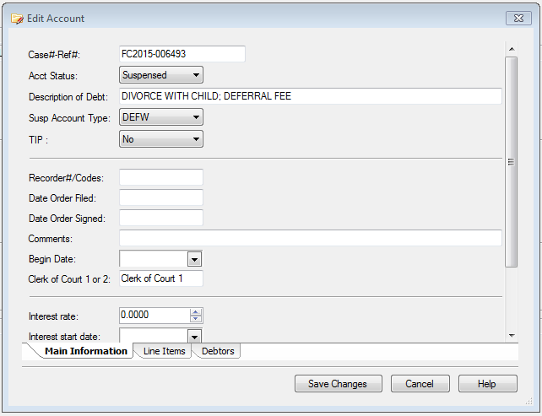
- Click on the Line Items tab at the bottom of the window.
- Click on Click to insert new item.
- Select the fee code(s) that were noted from Step C. Enter a line for each fee code amount. In older cases, see the fee code sheets for reference for the amount/codes if needed.

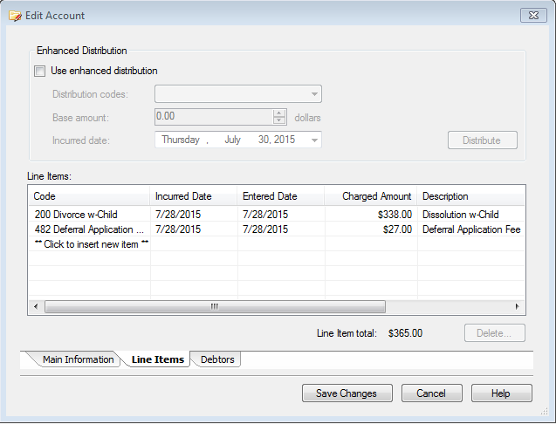

- Tab over and enter the fee amount from the Debtor side in the Charged Amount box and click OK. IMPORTANT: The amount showing in the box is not necessarily the amount owed, so it is important to enter the correct balance amount from the Debtor side.
- The total amount owed will double. Open the Debtor side of Revenue Results to correct the double amount.
- Once on Debtor side, right click and select Enter Adjustments.
- Place a “-“ and the dollar amount of the original fee in the Amount box.
- Click the top box under the Adjustment (Automatic) section to uncheck all boxes. And then check the Principal box only. The top box will remain checked as well as the Principal box.

- Click on the Post button at the bottom.
- Verify the amount shown owed is no longer doubled.
- Proceed to the next document.

POLICIES / RELATED DOCUMENTS:

- ARS 12-302, Arizona Revised Statutes: Request for Deferral/Waiver

OTHER PARTIES INVOLVED:

- N/A

TIME / VOLUME:

- Varied

FREQUENCY:

- Daily

PERFORMANCE MEASURE:

- N/A

SYSTEM ACCESS REQUIRED:

- Revenue Results
- The Cash Receipting System

REPORTS / FORMS:

- N/A

DEFINITIONS:

- Deferral: State law defines deferral as the postponement of an obligation to pay fees or the establishment of a schedule for payment of fees.
- Suspense Accounts: Accounts that are entered in Revenue Results that are not to be billed until notice is received from iCIS.
- Waiver: The court decides that the applicant is not required to pay the fees at all unless the applicant’s financial circumstances have changed during the action.

APPLICABILITY:

This procedure applies to all employees of the Clerk of the Court.

REVISION HISTORY:

Revision Number | Revision Author | Summary of Changes | Approval Date
- | Mike Sims | Document Origination | 06/05/2012
A | Milan Milic | Added screen shots to clarify | 08/03/2015
B | Bryan Romero | Reviewed | 02/28/2019
C

