PURPOSE:

To provide instructions for processing mail that has been returned by the U.S. Postal Service (USPS) within the Clerk of Court, Billing and Deferral Unit.

OBJECTIVE:

- To provide the necessary direction to ensure that the processing of mail that has been returned by the USPS is correctly and accurately done,
- To ensure consistent handling and processing of mail that has been returned by the USPS over time.

EVENT DRIVER:

- Mail is returned to the Clerk of Court by the USPS

PROCEDURES:
Attempt to find the correct address by researching Revenue Results and iCIS:
- Open Revenue Results:
  - If the address is truly incorrect, the address in Revenue Results should be exactly the same as the address on the returned billing notice (no transposed numbers, missing apartment numbers, misspelled street names, etc.). Check all previous addresses in Revenue Results to make sure we are not using an address from which we have already had mail returned.
  - Check the USPS return label for the reason the mail was returned. If the return label states “Insufficient Address”, it is often because the apartment number had not been included. In this situation, just correct the information in Revenue Results.
- Open iCIS:
  - In iCIS, check the most recent address listed on the main page. (Also while in iCIS, update any missing information such as date of birth, or Social Security Number.)

- If a new address is found:

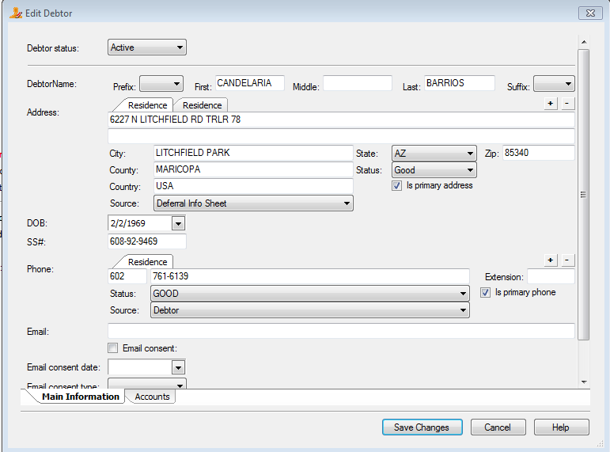

  - On the Edit Debtor screen in Revenue Results, click on the “+” to add a new address.
  - Enter the new address.
  - Make sure the Primary Address box is checked AND choose “Good” as the address status.
  - Select the source of the new address information in the source field.
  - Make sure all other addresses for the account have a status of “Bad” – This is important because Revenue Results will inadvertently send letters to all of the addresses marked “Good”.

- If a new address is NOT found in iCIS, log into Accurint and search for the new address by entering debtor’s SSN. If a new address is found:
  - On the Edit Debtor screen in Revenue Results, click on the “+” to add a new address.
  - Enter the new address.
  - Make sure the Primary Address box is checked AND choose “Good” as the address status.
  - Select “Accurint” as the source.
  - Make sure all other addresses for the account have a status of “Bad” – This is important because Revenue Results will inadvertently send letters to all of the addresses marked “Good”.
- If a new address is NOT found in Accurint either, add asterisk (*) in front of the current/latest address and make sure Primary Address box is checked AND “Good” is selected as the address status.

POLICIES / RELATED DOCUMENTS:

- None

OTHER PARTIES INVOLVED:

- USPS

TIME / VOLUME:

- Varied due to number of envelopes returned.

FREQUENCY:

- Daily

PERFORMANCE MEASURE:

- N/A

SYSTEM ACCESS REQUIRED:

- Revenue Results
- iCIS

REPORTS / FORMS:

- N/A

DEFINITIONS:

- USPS: United States Postal Service

APPLICABILITY:

This procedure applies to all employees of the Clerk of the Court.

REVISION HISTORY:

Revision Number | Revision Author | Summary of Changes | Approval Date
- | Mike Sims | Document Origination | 06/05/2012
A | Milan Milic | Updated numerous procedure steps to current methods. | 07/30/2015
B | Bryan Romero | Reviewed | 02/28/2019
C

