PURPOSE:

To provide instructions for starting accounts in Suspensed status in Revenue Results for use within the Clerk of Court, Billing and Deferral Unit.

OBJECTIVE:

- To provide the necessary direction to ensure that accounts in Suspensed status are correctly and accurately started,
- To ensure consistent handling of starting accounts in Suspensed status over time.
- To ensure the Fee Flag in iCIS is changed to “Adjudicated” for Post Decree filings once billing starts.

EVENT DRIVER:

- A case for starting an account in Suspensed status is required.
- An order from the Court stating the filing has been adjudicated for Pre-Decree filings.
- If filing is Post Decree and all Post Decree matters have been adjudicated, continue with these procedures. If all Post Decree filings for the debtor have NOT been adjudicated, leave account in Suspensed status and do NOT follow the rest of these procedures until all Post Decree matters have been adjudicated.

PROCEDURES:
- Open Revenue Results and do the following (See Figure 1):

Figure 1
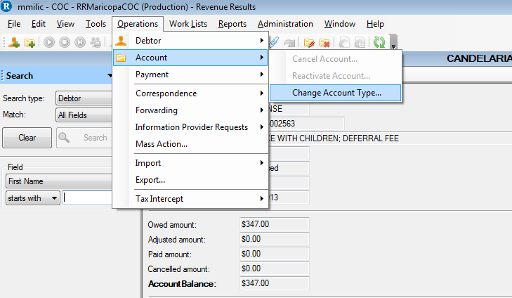

  - In the account screen, click on Operations at the top of the screen.
  - From the drop down menu, click on Account and select Change Account Type.
  - Click YES.
  - From the drop down menu, change the Account Type from SUSPENSE to whatever the appropriate code is (i.e., DEFW, DEFW-EMAIL or CEFW,CEFW-EMAIL etc.) See Figure 2.
Figure 2
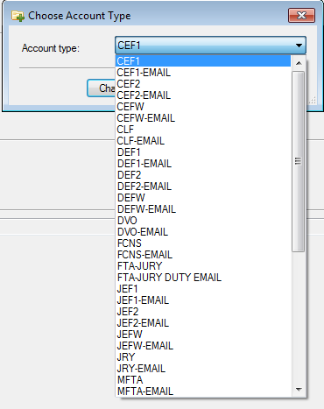

  - Click OK. See Figure 3.
  - Edit the account as necessary.
  - Change the account status from SUSPENSED to A-1.
  - Click on Begin Date and enter the current date.
Figure 3
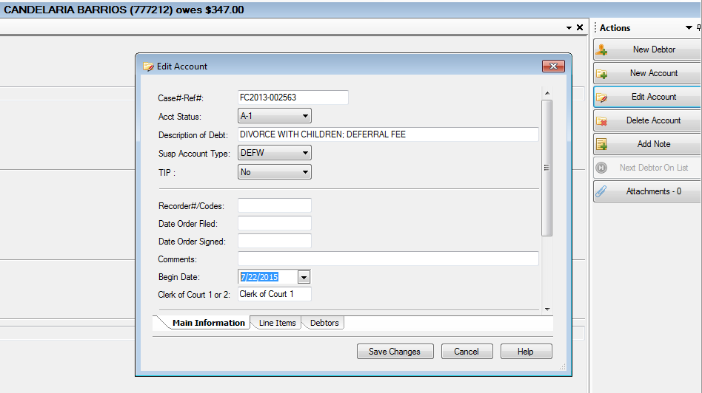
- Click Save Changes on the bottom of the page to save.
- If account is a Post Decree Filing, follow the rest of the procedures below. If account is Pre-Decree, disregard the rest of the procedures.
  - Enter case number in iCIS
  - Click Entry and Fees
  - Locate the correct party’s name that corresponds to the RevQ account
  - Click on the dropdown and choose Adjudicated. See Figure 4.

Figure 4
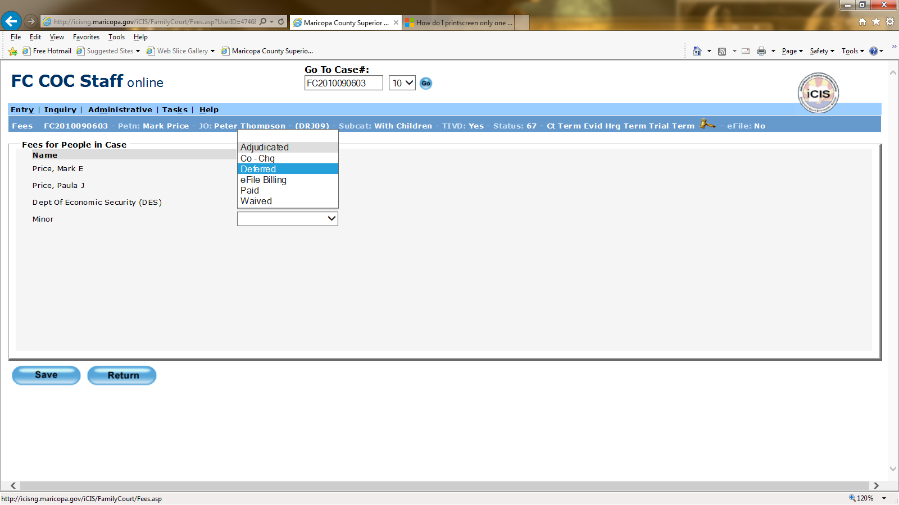

POLICIES / RELATED DOCUMENTS:

- ARS 12-302, Arizona Revised Statutes: Request for Deferral/Waiver

OTHER PARTIES INVOLVED:

- N/A

TIME / VOLUME:

- Varied

FREQUENCY:

- Daily

PERFORMANCE MEASURE:

- N/A

SYSTEM ACCESS REQUIRED:

- Revenue Results
- iCIS

REPORTS / FORMS:

- N/A

DEFINITIONS:

- Deferral: State law defines deferral as the postponement of an obligation to pay fees or the establishment of a schedule for payment of fees.
- Suspense Accounts: Accounts that are entered in Revenue Results that are not to be billed until notice is received from iCIS.
- "Post-decree" petitions are those filed after a Decree of Dissolution of Marriage, Legal Separation or Annulment, or Judgment of Paternity is entered, and are usually filed to modify or enforce existing orders of the Court
- “Pre-decree” petitions are those filed before a Decree of Dissolution of Marriage, Legal Separation or Annulment, or Judgment of Paternity is entered.

APPLICABILITY:

This procedure applies to all employees of the Clerk of the Court.

REVISION HISTORY:

Revision Number | Revision Author | Summary of Changes | Approval Date
- | Mike Sims | Document Origination | 06/01/2012
A | Milan Milic | Updated numerous procedure steps to current methods. | 07/30/2015
B | Milan Milic | Added iCIS Flag change | 11/01/2016
C | Bryan Romero | Reviewed | 02/28/2019

