PURPOSE:

To provide instructions for downloading Old Cash System reports (i.e.: Balance Sheet, G/L Activity, RFR, etc.) into MSExcel for use.

OBJECTIVE:

- To provide the necessary direction to ensure that downloading Old Cash System reports into MSExcel are correctly and accurately done;
- To ensure the consistent downloading Old Cash System reports into MSExcel over time.

EVENT DRIVER:

- There is a need for downloading Old Cash System reports into MSExcel.

PROCEDURES:
- Downloading Process:
- On the desktop, click on the SunBox icon (See Figure 1).
Figure 1


- Enter your Login Name. Click OK.
- Enter your Password. Click OK. The Old Cash System will open (See Figure 2).
Figure 2
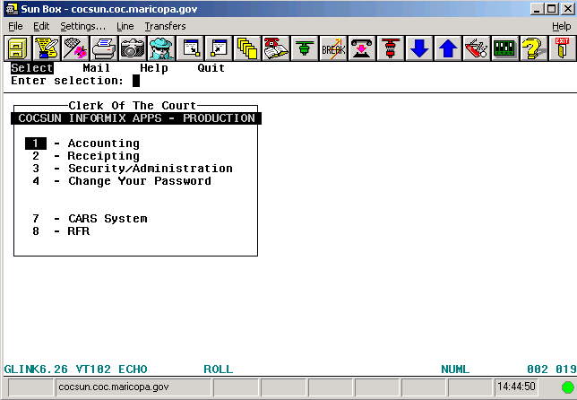

- To choose the report to download, enter the series of selection numbers in the Enter selection field until the desired report is reached. Figure 3 will be displayed.
Figure 3
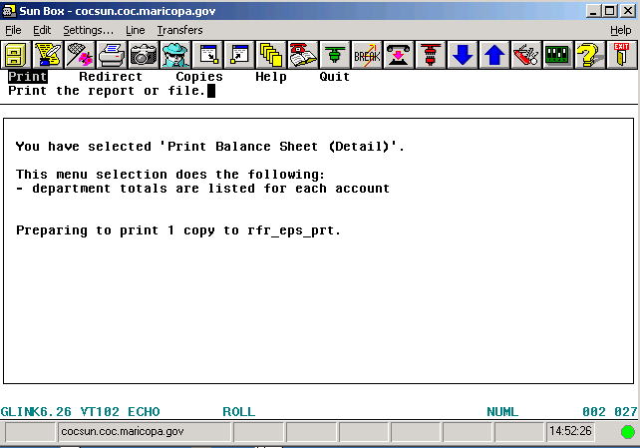

Note: Example text; text will vary depending on the selected report.

- Arrow over to Redirect (see Figure 4) and press Enter.
Figure 4
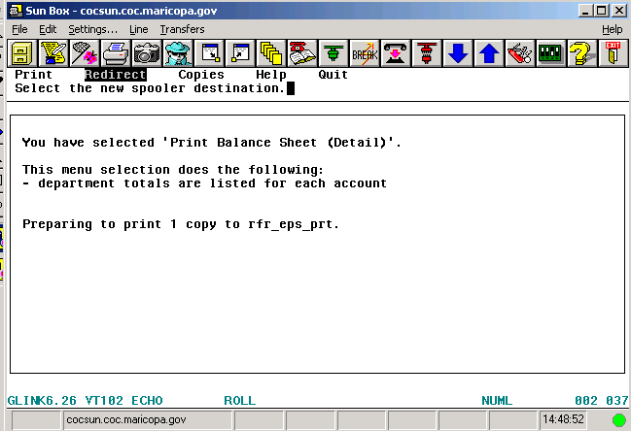

Note: Example text; text will vary depending on the selected report.

- Figure 5 will be displayed. Arrow over to File. Press Enter.
Figure 5
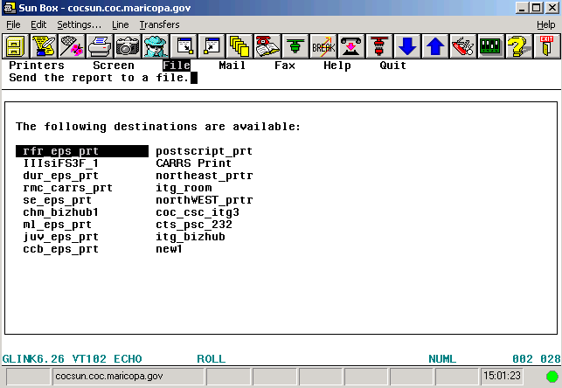

- Figure 6 will be displayed. Enter /tmp/[filename].txt and press Enter. If the filename already exists, a File exists error message will be displayed; to overwrite, press O. Press Enter. The Print window will be displayed with the message Preparing to print 1 copy to file /tmp/[filename].txt. Press Enter.
Figure 6
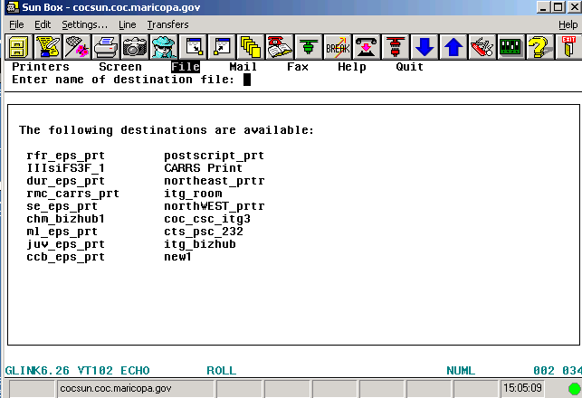

- Enter the parameters and information for the report. Press Esc to spool the report. The report will spool and upon completion, the report selection window will be displayed (see Figure 7). Select Settings…
Figure 7
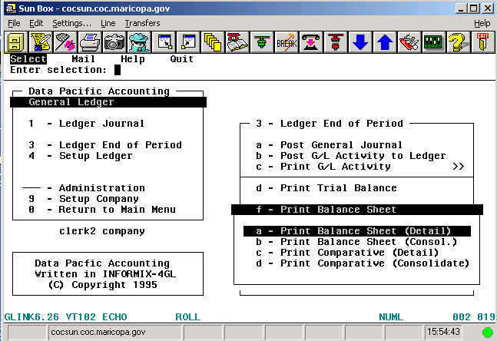

Note: Example text; text will vary depending on the selected report.

- Select File Transfer (See Figure 8).

Figure 8
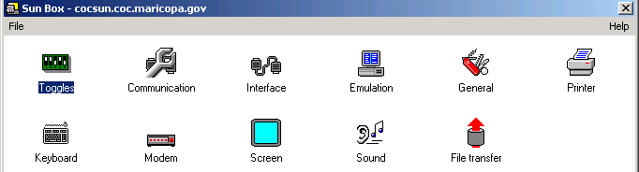

- On the General tab, set the following only (See Figure 9):
- From the pull-down menu in the Default protocol field, select Kermit (text mode).
- From the pull-down menu in the Download directory field, select h:\.
Click Ok and close the SunBox window shown previously in Figure 8. The report selection window shown in Figure 7 will be displayed.

Figure 9
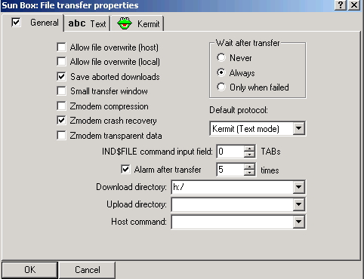

- In the Enter selection field, enter !ksh and press Enter (See Figure 10).

Figure 10
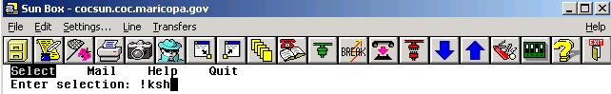

- The SunBox System Access Requested window will be displayed (See Figure 11).

Figure 11
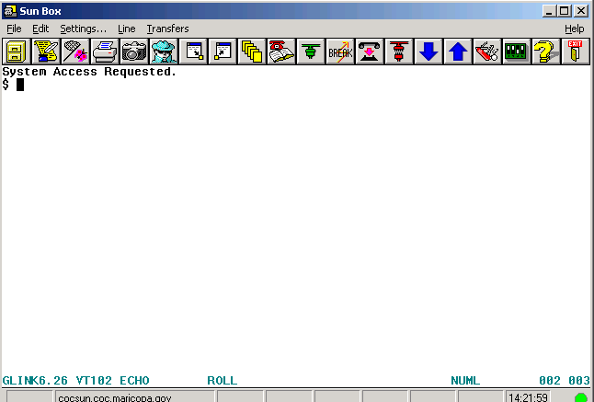

- Type: kermit -s /tmp/[filename].txt. Click Enter.
Please note that there is a space before the “–“ and after the “s”. The window shown in Figure 12 will be displayed.
Figure 12
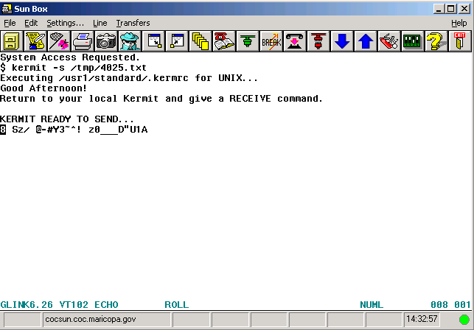

Note: Example text; filename will vary depending on the filename assigned.

- Select Transfers>Download a file from host… (See Figure 13)
Figure 13
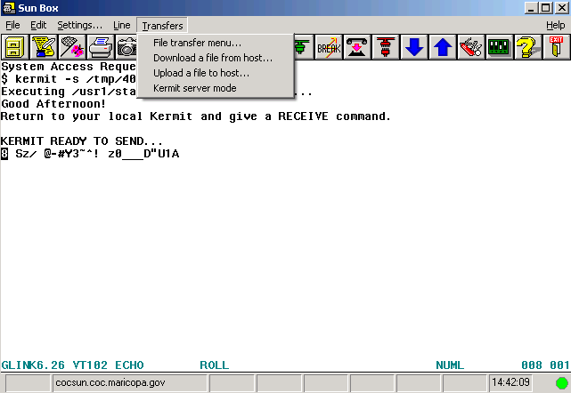

- The window in Figure 14 will be displayed. Select the Kermit (text) radio button. Click OK.
Figure 14
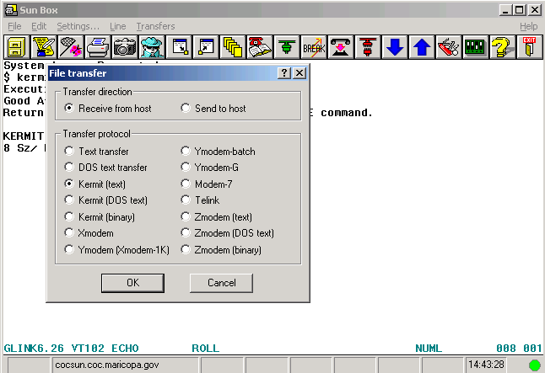

- The dialog box in Figure 15 will be displayed. When the OK button is no longer grayed out, click OK.
Figure 15
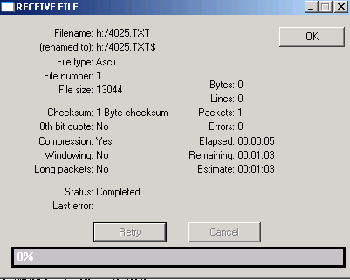

- Type exit, click Enter, and click Enter again to continue. The report selection window shown in Figure 7 will be displayed.

- Processing in MSExcel:
- Open MSExcel: Click File>Open. Change the Files of Type field to All Files. Double-click [the directory on the H: drive]\[filename].
- The Text Import Wizard dialog box will be displayed. Click Next. Adjust the column breaks as needed so that data is not split between columns.
- Click Next>Finish. The data will be displayed in an MSExcel spreadsheet.
- The data are now useable as needed.

POLICIES / RELATED DOCUMENTS:

- N/A

OTHER PARTIES INVOLVED:

- N/A

TIME / VOLUME:

- Varied

FREQUENCY:

- As needed

PERFORMANCE MEASURE:

- N/A

SYSTEM ACCESS REQUIRED:

- SunBox application (Old Cash Receipting System)
- MSExcel
- H:\

REPORTS / FORMS:

- N/A

DEFINITIONS:

- N/A

APPLICABILITY:

This procedure applies to all employees of the Clerk of the Court.

REVISION HISTORY:

Revision Number | Revision Author | Summary of Changes | Approval Date
- | Diana Hoover | Document Origination | 10/09/2015
A | Diana Hoover | Reviewed to ensure document reflected current processing | 03/18/2019
B
C

