PURPOSE:

To provide instructions for printing the CFO checks for restitution to victims.

OBJECTIVE:

- To provide instructions on how to print out the CFO checks for payment to victims.

EVENT DRIVER:

- Receipt of notification from CFO advising that restitution payments are to be made.

PROCEDURES:

      - Open COC RFR
- Click on Check Maintenance on lower side bar.
- Click Post Check Run on upper side bar.
- Change From date to prior business date.
- Review list of check runs populated for the one that shows the status of “Integrated to GP”.
- Open the Restitution to Victims spreadsheet located at: S:\Fin_Svc\Stats\Deposits and Disbursements Stats\Restitution to Victims\Restitution to Victims [Current Year].xls.
- Enter the # of Checks and Check Amounts on the
- Open Microsoft Dynamics GP-PROD select Company Finance from the pull down menu click OK.

Figure 1
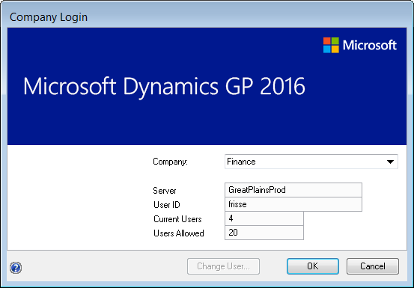

- Click Purchasing from side toolbar.
- Click Transactions-Batches.
- The Payable Batch Entry window will open.
- Click the magnify glass next to the Batch ID field.
- The Payable Batch ID window will open.
- Double click on the Batch ID that matches the Batch Name shown in RFR.
- Verify the number of Transactions and Batch Total matches the # of Checks and Check Amount shown in RFR.
- If both numbers match click Submit from Toolbar.
- Click Submit from the toolbar. The Workflow Action window will open. Click Submit and the window will close.
- Posting Invoices-Click the magnified glass next to the Batch ID field. The Payables Batch ID window will open.
- Select the invoice batch previously submitted. The window will close and return to the Payables Batch Entry window.
- Click Post from the toolbar.
- The Report Destination window will open click Cancel.
- The Progress window will open. Once the invoices have Posted the screen will close.
- Close Payables Batch Entry window.

Creating Check Batch

- Select within Transactions section-Select Check.
- The Select Payables Checks window will open.
- Enter the same Batch ID shown as the Batch Name in RFR.
- Click Add on the pop up window “Do you want to add this batch”.
- The Payables Batch Entry screen will open.
- Click the magnified glass next to the Checkbook ID window.
- Checkbooks window will open select -RFR10004. Save.
- The Checkbook window will close and return you to the Select Payable Checks window.

- Click the drop down arrow next to Select-Vendor ID.

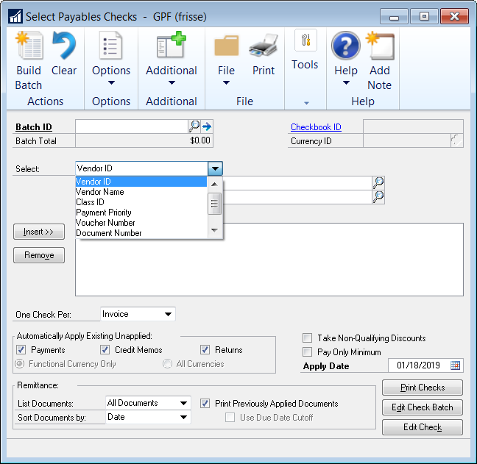

- Select Class ID.
- Select the magnified glass next to the From window.
- The Vendor Classes window will open Select Regular.

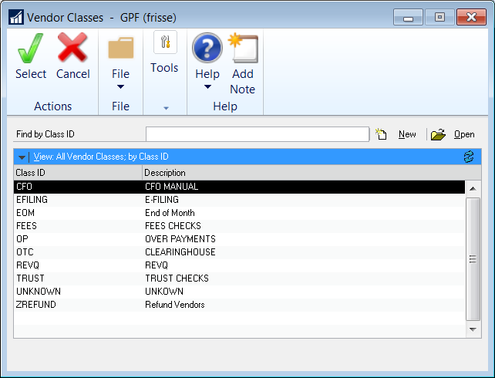

- The To window will auto populate Regular
- Select Insert next to the Restrictions window.
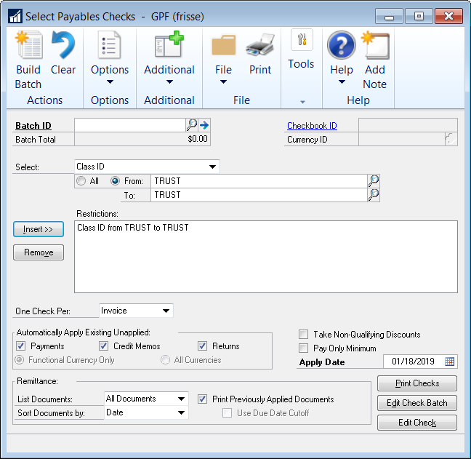

- Select Build Batch from the toolbar.
- If you have multiple Class IDs to add to one check batch repeat steps 10-15. Instead of Building the Batch you will select Add to Batch.

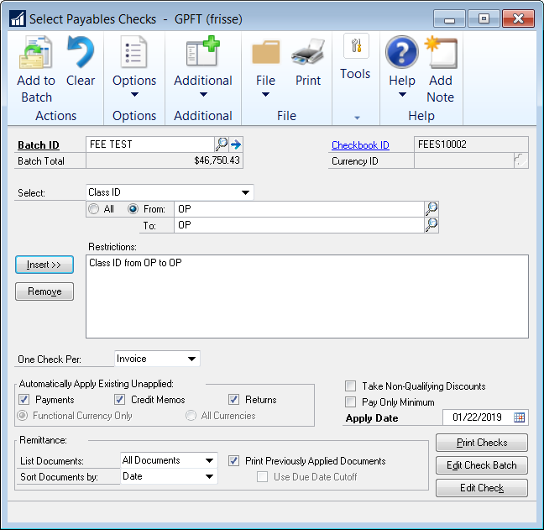

- The Microsoft Dynamics GP pop up window will open after adding each Class ID click Continue.
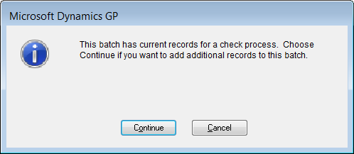

- Click Submit from the toolbar on the Payables Batch Entry screen
- The Workflow Action window will open. Click Submit and the window will close.

Printing Checks

- Select Print Checks from the Purchasing-Transaction window.
- The Print Mekorma MICR Payables Checks window will open.
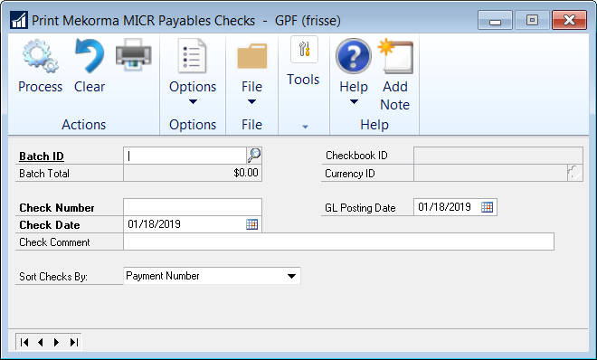

- Click the magnified glass next to the Batch ID field.
- The Payables Batch ID window will open.
- Select the approved batch.
- Select Print from the toolbar.
- The Mekorma MICR Check Printing Window open.
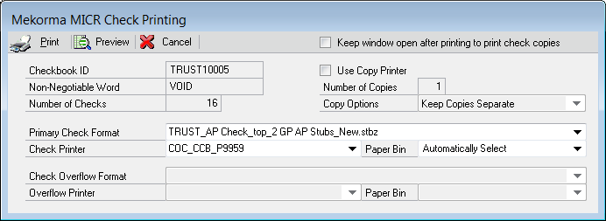

- Select Print from toolbar.

- The Post Payables Checks window will open.
- Verify all checks have printed correctly.
- Select Process and the Report Destination window will open. Select Screen and uncheck Printer. Click OK.
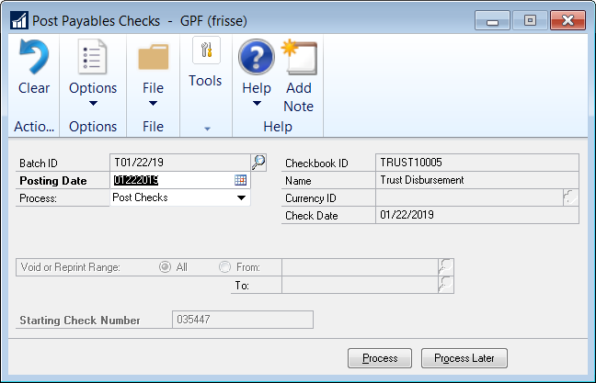
- The Screen Output PM Computer Check Register will open.
- Select Print and Select the Adobe Printer from the list of printers.
- Save in S:\Fin_Svc\AccountingCheckRequests\CFOSystemChecks\(current year)\(current month)\(current date).
- After saving close the Screen Output PM Computer Check Register window.

Posting Checks

Email Accountants the following information so they can post the checks to the RFR system.
        - Beginning check number.
        - Ending check number.
        - Total checks.
        - Total check amount.

POLICIES / RELATED DOCUMENTS:

- N/A

OTHER PARTIES INVOLVED:

- CFO
- Financial Services Manager/Supervisor

TIME / VOLUME:

- Varied

FREQUENCY:

- Daily

PERFORMANCE MEASURE:

- N/A

SYSTEM ACCESS REQUIRED:

- Microsoft Dynamic GP-Prod
      - Restitution to Victims spreadsheet at: S:\Fin_Svc\Stats\Deposits and Disbursements Stats\ Restitution to Victims [Current Year].xls
      - RFR

REPORTS / FORMS:

- Restitution to Victims spreadsheet

DEFINITIONS:

- CFO: Criminal Financial Obligations

APPLICABILITY:

This procedure applies to all employees of the Clerk of the Court.

REVISION HISTORY:

Revision Number | Revision Author | Summary of Changes | Approval Date
- | N/A | Document Origination | 09/21/2012
A | Diana Hoover | Program updated: replaced screen-prints and re-numbered steps | 02/08/2017
B | Edie Friss | Updated for new RFR system | 06/10/21
C

